REDUCING PEDESTRIAN EXPOSURE TO ENVIRONMENTAL POLLUTANTS: A COMBINED NOISE EXPOSURE AND AIR QUALITY ANALYSIS APPROACH

Abstract

It has been estimated that at least one fifth of the population of the EU suffer a reduced quality of life due to exposure to noise. Chief among those affected are city-dwellers. For today’s urban planners environmental noise represents a significant environmental pollutant that must be addressed along with concerns over air quality. Taken together, noise and air pollution represent a significant contribution to the overall reduction in the quality of life of urban residents. The need for good urban planning with particular reference to both air and noise pollution has arisen. This paper examines a case study involving a dividing wall situated between two walkways adjacent to a main road in Dublin’s city centre, with particular attention paid to both air and noise pollution. Both air and noise measurements were conducted on site and compared to modelled results. It was found that the dividing wall decreased noise levels by approximately 55% while a similar improvement in air quality was observed. The study also demonstrated that further reductions in noise and air pollution exposure can be achieved by increasing the height of the boundary wall and/or by lowering the position of the boardwalk relative to the position of the road. In order to present combined results, a joint air and noise pollution index was developed, which was used to quantify the overall improvements due to the presence of the boardwalk. It is proposed that an index of this sort could be a valuable tool for future urban planning.

Keywords: Noise Pollution, Air Pollution, Urban Planning.

1. Introduction

Environmental noise is considered to be one of the few environmental problems in the European Union (EU) that is getting worse (CALM Network, 2007). It is estimated that 20% of the EU is exposed to environmental noise over and above the level whereby it is considered detrimental to public health (Berblund et al, 1999). Excessive exposure to environmental noise during daytime is associated with a number of negative health effects such as annoyance and reduced of quality of life. In urban areas, the dominant source of environmental noise is automobile traffic, the source of which is mainly engine noise and/or rolling noise caused by the friction of tyres on the road surface. Similarly, automobile traffic is the dominant source of air pollution: 60% of all volatile organic compounds (VOCs) have road traffic as their source (O’Mahony et al, 2000). In petrol engines these include the carcinogenic pollutant benzene as well as particulate matter emitted from diesel engines (Taylor and Fergusson, 1997).
Within cities, pedestrians commuting to and from work are highly exposed to harmful environmental pollutants. McNabola et al (2008a; 2008b) have demonstrated levels of benzene (a proven carcinogenic agent) and particulate matter (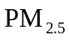) pollution for pedestrians in central Dublin while, on a broader level, Murphy et al (2008) have drawn attention to human exposure to transport noise in the same city. Thus, if noise and air pollution are taken in combination, they represent significant environmental hazards to urban pedestrians.
In Dublin, Ireland, the majority of commuters travel to work by private car (44.7%) while the next largest group is pedestrians (22.3%) (DTO, 2004). Thus, walking is an important mode of transport not only for the journey to work but also for other trip activities. A recent review of exposure assessments of urban commuters highlighted that pedestrians are often omitted from environmental pollution investigations despite it being one of the largest modes of transport used globally (Kaur et al, 2007).

Nomenclature
L_{eq} | The equivalent continuous A-weighted sound pressure level | [dB(A)]
L₁₀ | The A-weighted sound pressure level that is exceed for 10% of the time | [dB(A)]
L₉₀ | The A-weighted sound pressure level that is exceed for 90% of the time | [dB(A)]
A_{div} | Attenuation due to geometric divergence of sound waves | [dB(A)]
A_{bar} | Attenuation due to diffraction over a barrier | [dB(A)]
d | Distance of sound propagation | [m]
d_{o} | Reference Distance for Attenuation due to geometric divergence | [m]
λ | is the wavelength of sound | [m]
C₃ | Coefficient accounting for diffraction over thick barrier
NP_{r} | Proposed Noise Pollution Reduction index
AP_{r} | Proposed Air Pollution Reduction index
ANP_{r} | Proposed combined Noise/Air Pollution Reduction index

Researchers in London have demonstrated that the location of an individual along the footpath has a significant impact on their exposure to traffic air pollutants; effectively, the closer an individual is to the road edge the more exposed they are to harmful pollutants (Kaur et al, 2005). This is due to the fact that pollutants emitted from vehicles will disperse in an exponential fashion with increasing distance from the source(s) (Ning et al, 2005; McNabola et al, 2006). Similarly, in free field conditions, noise exposure declines as the distance from the source (i.e. traffic) increases although the underlying mechanisms governing the dispersion of the two pollutants do indeed differ. In any case, one might expect that pedestrian exposure to noise and air pollution would decline as the distance from the centre of the roadway increased. In a similar manner one might also expect that greater segregation of road and pedestrian traffic, through the use of a barrier, would reduce pedestrian exposure to noise and air pollution even further than distance alone. These are the two areas of focus for the current research.
In Dublin city centre, a boardwalk (Fig. 1) has recently been constructed along the river Liffey to mark the onset of the new Millennium. It was originally constructed along Bachelors walk and Ormond Quay but now extends from Capel Street to the Customs house. The boardwalk is an attractive promenade mounted on the quay wall just below road level overhanging the river Liffey. It consists of wooden benches for seating as well as a number of boardwalk coffee shops and it has quickly become a popular way to walk through the city centre. It comprises a c.3.5m wide walkway segregated from the roadside footpath by a short boundary wall. The footpath is approximately 2.3m wide and is adjacent to a three lane roadway of one-way traffic. The roadway is a major transport corridor in this central area and has hourly traffic volumes, of varying composition, exceeding 2000 vehicles per hour (DTO, 2004). Thus, individuals walking along this route have a choice of either using the footpath or using the boardwalk. Given that the boardwalk allows pedestrians to be approximately 2m further away from the road traffic than pedestrians walking along the footpath, one would expect a reduction in exposure to noise and air pollution. Indeed, previous investigations into air pollution concentrations along the boardwalk have shown this is indeed the case (McNabola et al, 2008a). Accordingly, the boardwalk represents an excellent study area for investigating 1) the combined impact of the boardwalk on reducing pedestrian exposure to road traffic noise and harmful traffic air pollutants, and 2) for modelling the potential impact of greater segregation of road and pedestrian traffic, through the use of a barrier, on pedestrian exposure to road traffic noise and air pollutants.

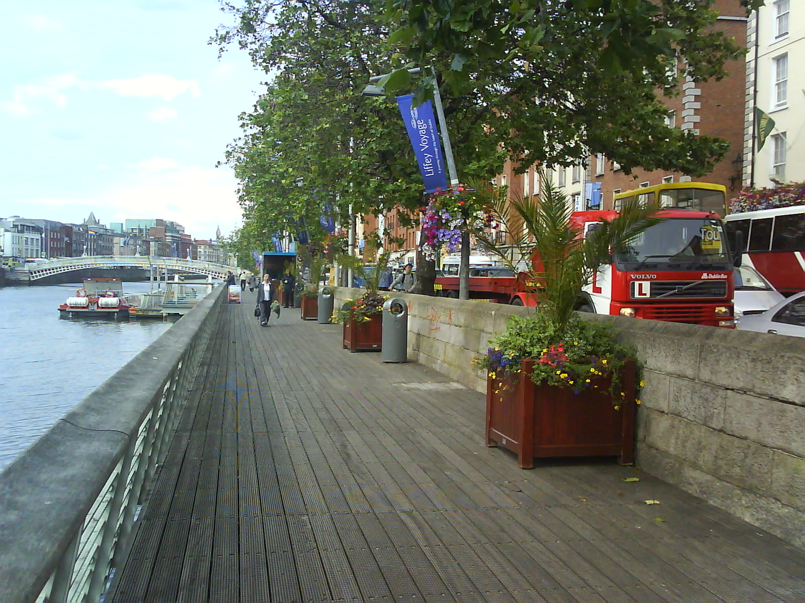

Fig 1. The boardwalk overhanging the river Liffey. Note the close proximity of road traffic to the walkway.

Previous research in this area has tended to concentrate on air and noise pollution exposure separately. Using a combined noise exposure and air quality analysis applied to a specific location along the riverside boardwalk in Dublin, it is hypothesised that the boardwalk has led to a reduction in exposure to environmental pollutants for pedestrians using that particular route. Moreover, it is also hypothesised that greater segregation of road and pedestrian traffic, through the erection of a pollution barrier along the quay wall, would further reduce pedestrian exposure to harmful environmental pollutants.
The next section of this paper concentrates on the methodology employed for the experimental measurement and modelling of noise along the boardwalk and footpath before the corresponding results are presented. Thereafter, section four provides modelling extensions to previous investigations conducted by McNabola et al. (2008a) examining the potential impact of a pollution barrier on pedestrian air quality along the boardwalk. The penultimate section describes the potential for a combined air and noise pollution reduction index to inform design and planning considerations for improved environmental awareness among urban policy-makers and practitioners.

2. Noise measurement and modelling methods

2.1 Measurement procedure

Fig. 2 shows a generic cross-section of the study area under consideration. In reality, slight differences existed in boundary wall height at each location and were noted for the modelling analysis.
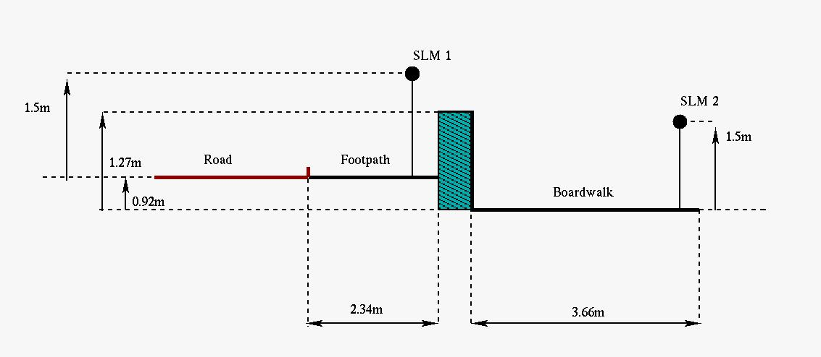

Fig 2. Generic cross-section of a measurement location showing both sound level meter (SLM) locations

To investigate the study hypotheses noise measurements were taken along the boardwalk and along the footpath simultaneously in order to quantify differences in pedestrian exposure to noise. A total of 27 pairs of noise measurements were recorded. Three measurement sites were chosen for analysis along a particular section of the boardwalk. Two sites were chosen at random while one site was chosen because of its proximity to a traffic light junction. Where possible, measurements were carried out in accordance with ISO 1996-2 (ISO 1996-2, 1983), although the nature of the experiment made it impossible to measure at least three metres away from the boundary wall, which is considered a reflective surface. As such, it was expected that footpath measurements would be influenced to some degree by reflections. However, because pedestrians would also by subjected to the reflections, it was concluded that measurement positions were appropriate for this particular case. Each measurement lasted for 15 minutes with both microphones positioned at a height of 1.5m relative to the ground surface.
Noise measurements were conducted with two Bruel & Kjaer Type 2236 sound level meters (Fig. 3). Both instruments were calibrated prior to undertaking measurements. For each measurement L_{eq}, L₁₀ and L₉₀ values were recorded. The date and time of each measurement were also recorded.

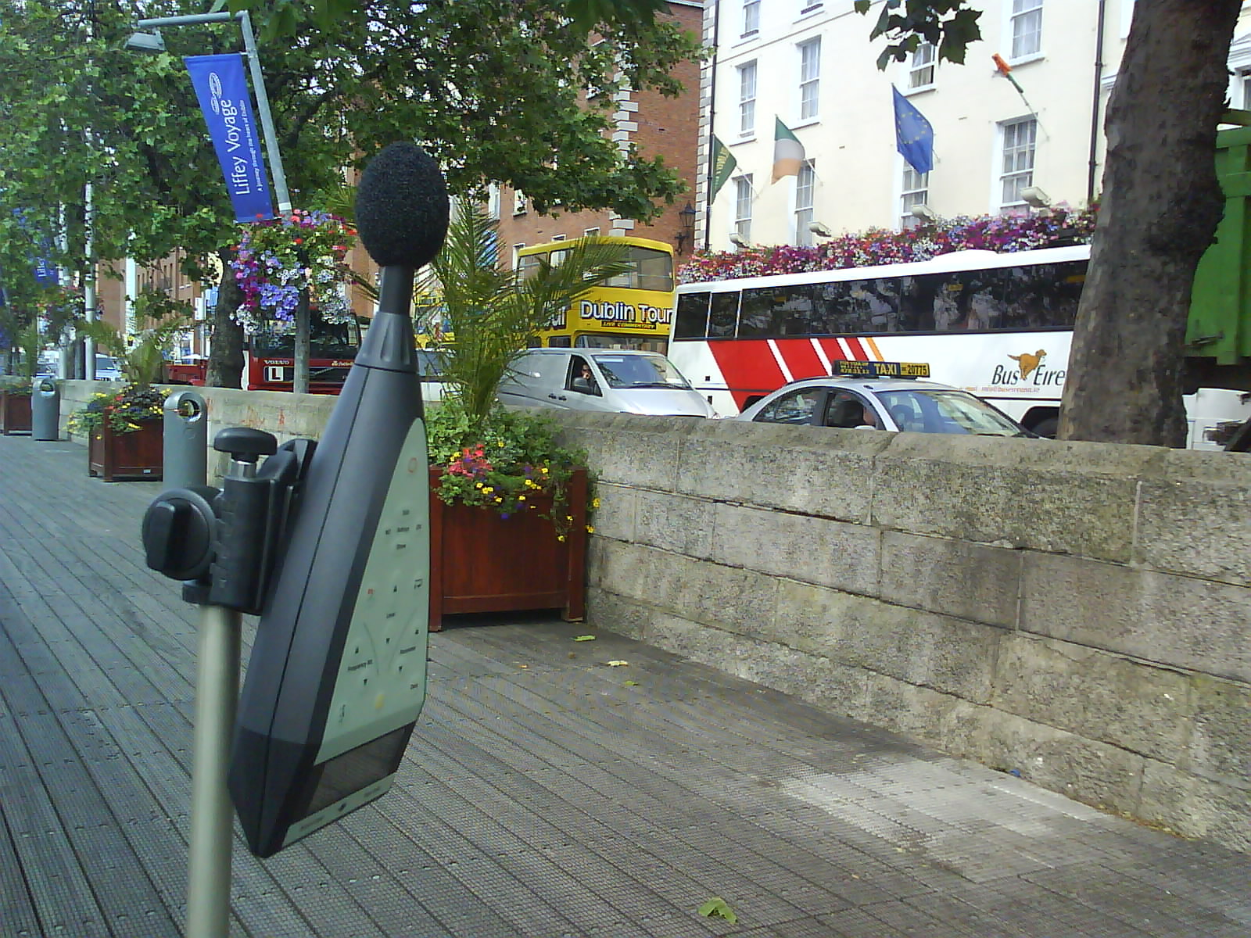

Fig 3. Sound Level Meter positioned on the boardwalk

2.2 Modelling Procedure

In order to investigate whether measured results corresponded with theoretical predictions noise levels in the test locations were also modelled. The calculation model incorporated the method presented in ISO 9613-2 describing the attenuation of sound during propagation outdoors (ISO 9613-2, 1996). Calculations were performed using an adjusted version of the independent noise modelling software previously developed by King et al. (2007).
In the international standard - ISO 9613-2 - the overall attenuation of sound is primarily driven by geometrical divergence, atmospheric attenuation, ground effect and screening. In the current case, geometric divergence and attenuation due to the presence of barrier (i.e. the boundary wall) are the main attenuation factors while the effect of the ground and atmospheric absorption are negligible. Attenuation due to geometric divergence (A_{div}) is given by the following equation:

A_{div} = 20log(d/d_{o}) + 11 [dB] (1)

where d is the distance from source to receiver and d_{o} is the reference distance of 1m. The boundary wall may be modelled as a simple barrier and it’s associated attenuation (A_{bar} ) is calculated from:

A_{bar} = 10log[3 + C₂/ λ)C₃zK_{met}] [dB] (2)

where C₂ is equal to 20 and includes the effect of ground reflections, K_{met} is the correction factor for meteorological effects, λ is the wavelength of sound at the nominal mid-frequency of the octave band, z is the difference of the pathlengths of the direct and diffracted sound as presented in Fig. 4. C₃ accounts for the thickness of the barrier and may be calculated from

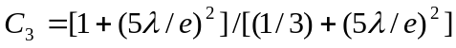 (3)

where e is the distance between the two diffraction edges of the boundary wall (O and P) as shown in Fig. 4.
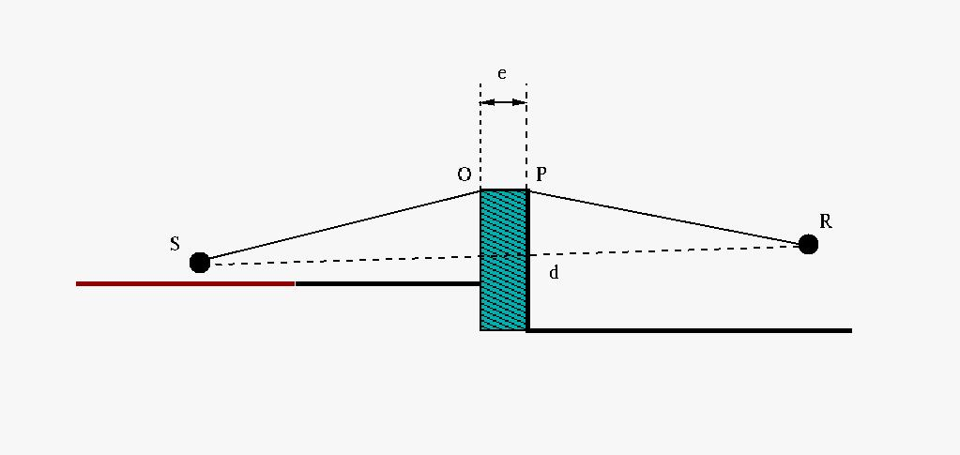
Fig 4. Calculation of pathlength difference for diffraction due to a barrier

3. Noise results:

  - Experimental

Tables 1-3 show the experimental data for the 27 samples pairs taken on the footpath and the boardwalk. It is interesting that the measurement data at site 1 was considerably higher than at site 2 or 3. This was due to the fact that sample site 1 was located at a traffic light junction. The increased acceleration of vehicles at this location resulted in greater noise emissions along the footpath and the boardwalk. The mean difference between boardwalk and footpath measurement were 6.9, 6.8 and 6.3 dB(A) at sites one, two and three respectively. The percentage reduction presented in the tables refers to the percentage reduction in terms of sound pressure in Paschal (Pa). The experimental measurements confirm the hypothesis that pedestrian exposure to noise from road traffic is considerably greater on the footpath route than on the boardwalk route. Thus, one can say that the construction of the boardwalk for use as a pedestrian routeway though the central city has had a positive environmental benefit for its users.

Site 1 | Footpath | Boardwalk | Decrease [dB] | % Reduction
Sample 1 | 73.1 | 65.5 | 7.6 | 58.3
Sample 2 | 71.9 | 65.4 | 6.5 | 52.7
Sample 3 | 73.9 | 67.0 | 6.9 | 54.8
Sample 4 | 73.0 | 66.4 | 6.6 | 53.2
Sample 5 | 74.2 | 67.6 | 6.6 | 53.2
Sample 6 | 71.7 | 65.9 | 5.8 | 48.7
Sample 7 | 76.6 | 68.1 | 8.5 | 62.4
Sample 8 | 73.0 | 65.3 | 7.7 | 58.8
Sample 9 | 74.3 | 68.8 | 5.5 | 46.9

Table 1. Boardwalk measurement data at site 1

Site 2 | Footpath | Boardwalk | Decrease [dB] | % Reduction
Sample 10 | 70.4 | 64.7 | 5.7 | 48.1
Sample 11 | 71.8 | 64.8 | 7.0 | 55.3
Sample 12 | 71.2 | 64.6 | 6.6 | 53.2
Sample 13 | 71.3 | 64.8 | 6.5 | 52.7
Sample 14 | 73.0 | 65.1 | 7.9 | 59.7
Sample 15 | 71.3 | 64.4 | 6.9 | 54.8
Sample 16 | 71.1 | 64.5 | 6.6 | 53.2
Sample 17 | 72.5 | 65.3 | 7.2 | 56.3
Sample 18 | 71.6 | 65.0 | 6.6 | 53.2

Table 2. Boardwalk measurement data at site 2

Site 3 | Footpath | Boardwalk | Decrease [dB] | % Reduction
Sample 19 | 71.8 | 64.8 | 7.0 | 55.3
Sample 20 | 71.5 | 65.1 | 6.4 | 52.1
Sample 21 | 72.1 | 65.3 | 6.8 | 54.3
Sample 22 | 71.2 | 64.5 | 6.7 | 53.8
Sample 23 | 71.0 | 64.9 | 6.1 | 50.5
Sample 24 | 71.3 | 64.9 | 6.4 | 52.1
Sample 25 | 70.8 | 64.3 | 6.5 | 52.7
Sample 26 | 72.3 | 67.1 | 5.2 | 45.0
Sample 27 | 70.1 | 64.8 | 5.3 | 45.7

Table 3. Boardwalk measurement data at site 3

In order to investigate the relationship further a regression analysis was conducted on the experimental data. Because noise, as perceived by the human ear, is measured on a logarithmic scale it was necessary to standardise the data on a continuous scale by converting the experimental measurements to sound pressure values (Pa). Fig. 5 shows the relationship between pedestrian exposure to noise, as measured by sound pressure level, along the boardwalk and along the footpath. A simple linear regression with a 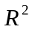 value of 0.69 is shown to fit the data. The relationship, with intercept at zero, shows that pedestrian exposure is 2.15 times that on the boardwalk. Accordingly, it may be concluded that the level of noise on the footpath would be 6 dB(A) greater than the noise on the boardwalk.

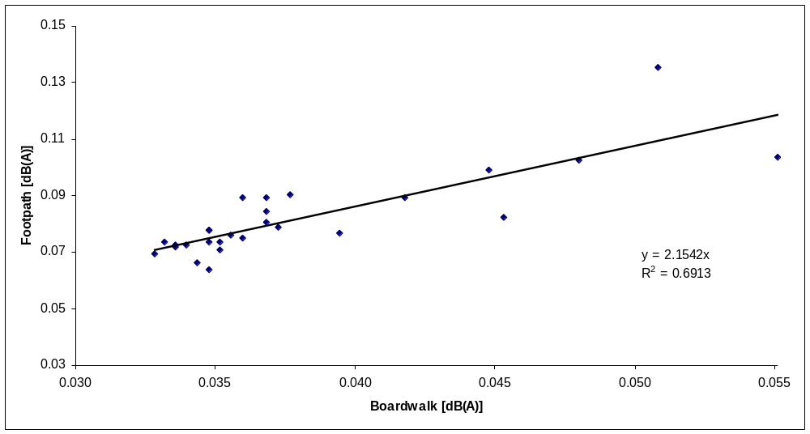

Fig 5. Sound pressure levels [Pa]: boardwalk versus footpath

The value of 0.69 indicates that only 31% of the variation in noise exposure along the boardwalk and the footpath is unexplained by the difference in distance between the measurement locations. This portion of unexplained variation is likely to be due to factors such as variation in reflections of sound along the boardwalk and along the footpath (due to material differences in the footpath and boardwalk surface), slightly different meteorological conditions as well as experimental measurement errors.
The foregoing results are similar to the differences found in air pollution concentrations at the same sites. Pedestrians were found to be exposed to 1.8 to 2.8 times higher concentrations of air pollution on the footpath than on the boardwalk, dependent on the pollutant in question (McNabola et al, 2008a).

  - Modelled

An overall attenuation in noise levels was also predicted using a numerical model for each cross section. In each case the boundary wall dimensions were adapted to match reality and a similar trend in results was observed. However, it should be noted that the impact of the slightly different site location dimensions, which were taken into accounted during the modelling process, had a minimal impact on the results. The average noise reduction at each site location was calculated to be 7.1 dB(A) or approximately 56%. The source of the noise was represented as a collection of incoherent point sources at a height of 0.05m above the surface of the road (Hamet et al, 1998). The model was developed to plot a vertical noise map of the area (Fig. 6) whereby the effect of the boundary wall on noise levels is graphically represented. The model was then used to assess various source to receiver situations and thereby providing a tool for investigating the possible attenuation of noise due to different boundary wall dimensions or footpath positions. This form of sensitivity is crucial for analysing the potential impact of various designs and planning considerations on human-environment interactions.

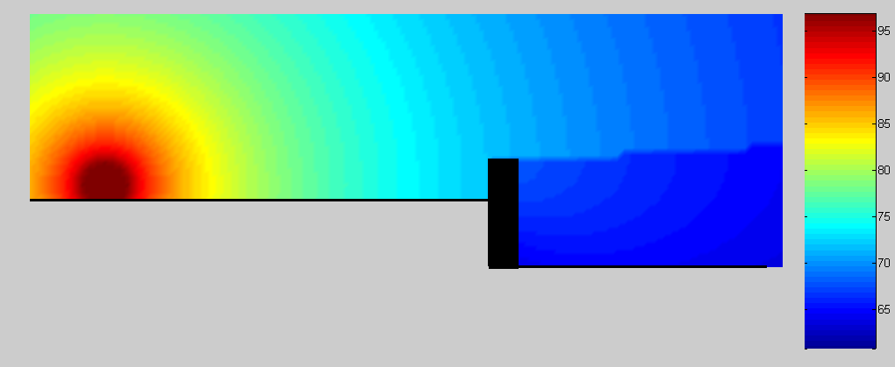

Fig 6. Modelled noise levels for location #1. The effect of the boundary wall on noise attenuation is particularly evident.

3.3 The potential impact of increased boundary wall height and boardwalk repositioning

In order to investigate the impact of increasing the barrier height on the level of noise exposure experienced by pedestrians using the boardwalk, a noise barrier located on the top of the quay wall was modelled at a number of different heights as demonstrated in Fig. 7. A possible relocation of the boardwalk 1m below its current position is also indicated. Each of the Scenarios in Fig. 7 were modelled and the results of the adjustments are presented in Table 4.

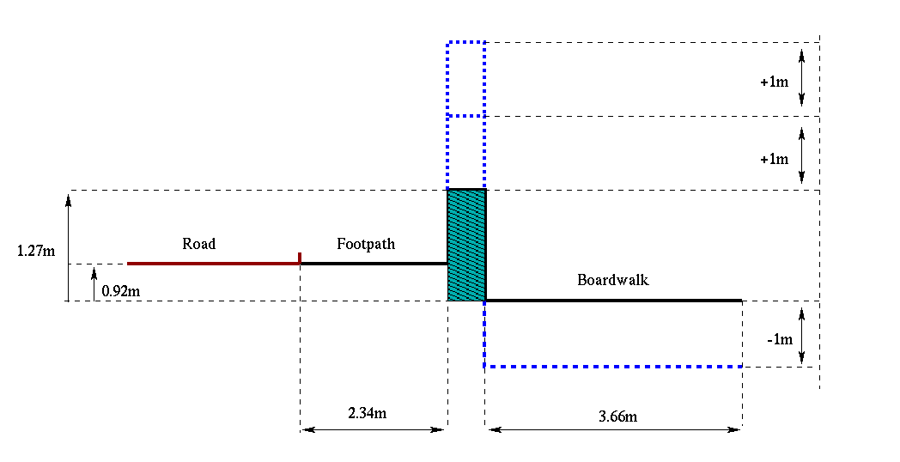
Fig 7. Redesigning the barrier at increased heights and dropping the position of the boardwalk relative to the wall.

Case | Change in wall height [m] | Change in boardwalk position [m] | Calculated Attenuation [dB]
Model 0 - Current Scenario | 0 | 0 | 7.1
Model 1 – increased wall height | 1 | 0 | 8.0
Model 2 – increased wall height | 2 | 0 | 10.3
Model 3 – lowering boardwalk | 0 | -1 | 7.7
Model 4 – Combined approach | 1 | -1 | 9.8
Model 5 – Combined approach | 2 | -1 | 12.9

Table 4. Remodelling the boardwalk for various different heights of the boundary wall

The simulated results show the potential for further noise reduction along the boardwalk for various different boundary wall heights. It is evident that considerable potential exists for improving the noise environment for pedestrians in the study area. Additional attenuation of approximately 3 dB(A) could be achieved by dropping the boardwalk by 1m and extending the height of the boundary by 1m while even greater attenuation could be achieved with the introduction of a 2m high barrier. Nevertheless, the introduction of a barrier along the quay wall or in similar areas around the city would need to be visually discreet if they were to be considered acceptable by the general public.

4. A Combined Noise and Air Quality Approach

4.1 Overview of Air and Noise measurements

As stated above, the investigation of the impact of pedestrians travelling along the boardwalk rather than the footpath was found to reduce pedestrian exposure to noise by a similar magnitude as to that found by McNabola et al (2008a) for air pollutants in the same study area. The mechanisms behind the reduction in noise exposure levels were due to pedestrians activity at an increased distance from source (resulting in noise attenuation) and the impact of the boundary wall in blocking sound waves. The mechanisms behind the reductions found in the air pollution exposure concentrations were also due to increased distance from the source (resulting in increased dispersion/dilution of pollution concentrations) and the impact of the barrier in diverting the natural flow of air way from the pedestrian on the boardwalk (McNabola et al, 2008a). Thus, while the boardwalk and boundary wall produced similar reductions in environmental pollution for pedestrians the underlying mechanisms behind the air and noise pollution reductions were found to be different.

  - Modelling Increased Barrier Height for Air Pollution

Because increasing the boundary wall height between the boardwalk and footpath was found to reduce levels of noise pollution further, the impact of this measure on air pollution exposure was also modelled numerically.
McNabola et al. (2008a) previously developed and calibrated a 3D large eddy scale, computational fluid dynamics (CFD) model of the boardwalk and footpath using a commercial CFD software package. For full details of the development and calibration of this model the reader is referred to the original study (McNabola et al., 2008a).
The calibrated model was modified here to include an increased boundary wall height of 2m (i.e. model 1 and model 2 in Table 4). The model was then re-run for each of the original samples to assess the impact of wall height on personal exposure reduction. Table 5 shows the percentage difference between personal exposure on the footpath and boardwalk for the original model and for the modified model as well as the meteorological conditions for each sample.

Sample | Wind Speed (m/s) | Wind Direction (º) | Model 1* | Model 2⁺ | Model 4⁺⁺
1 | 8.75 | 250 | 0.54 | 0.08 | 0.10
2 | 2.06 | 325 | 0.43 | 0.01 | 0.05
3 | 1.54 | 325 | 0.50 | 0.02 | 0.12
4 | 3.09 | 85 | 0.36 | 0.01 | 0.06
5 | 3.60 | 85 | 0.33 | 0.01 | 0.02
6 | 3.60 | 85 | 0.33 | 0.01 | 0.02
7 | 4.12 | 235 | 0.81 | 0.18 | 0.23
8 | 5.14 | 200 | 0.30 | 0.03 | 0.20
9 | 5.66 | 185 | 0.65 | 0.02 | 0.19
10 | 6.17 | 280 | 0.57 | 0.03 | 0.07
Mean | 4.37 | 205.5 | 0.59 | 0.05 | 0.22

Table 5. Impact of increasing boundary wall height on air pollution exposure.
* Percentage difference between concentrations on footpath and on boardwalk with 1m boundary wall.
⁺ Percentage difference between concentrations on footpath and on boardwalk with 2m boundary wall
⁺⁺ Percentage difference between concentrations on footpath and on boardwalk with 1m boundary wall and 1m lower boardwalk.

The results demonstrate that increasing the height of the boundary wall by 1m leads to a mean reduction of 41% in exposure to pollutants. Increasing the wall height from 1m to 2m was predicted to greatly reduce the personal exposure of pedestrians on the boardwalk by a further order of magnitude. This was indeed the case with the mean reduction being 95% for a 2m boundary wall. As a result of dispersion, air pollutant concentrations reduce in an exponential fashion. Thus, it is worth noting that increasing the height of the boundary wall further would not result in significantly greater reductions due to this exponential relationship (Ning et al, 2005; McNabola et al, 2006). Additionally, the results for model 3 (Table 5) show that increasing the boundary wall by 1m and reducing the level of the boardwalk by 1m leads to a mean reduction in pollution of 78%.
Fig. 8 demonstrates the mechanism behind the reductions in air pollution exposure. Prevailing wind conditions typically direct airflow across the street at an angle perpendicular or near perpendicular to the street. The height to width ratio of the street is low due to the River Liffey which divides the street between incoming and outgoing traffic. Thus, a typical street canyon vortex does not develop. Instead, a more localised vortex develops close to the buildings whereby pollutants emitted at street level are transported in the direction of the boardwalk.
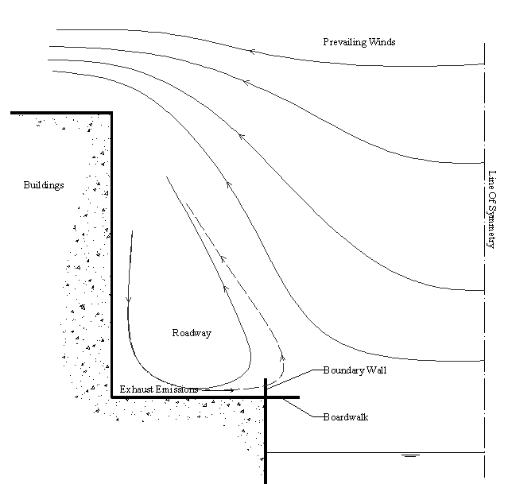
Fig 8. Typical air flow patterns at the boardwalk

As a result of the boardwalk being further from away from the emissions source than the footpath, personal exposure thereon is lower. However this lower exposure is also due to the boundary wall in between the two, which acts to divert the normal flow of air away from the boardwalk thereby reducing personal exposure on the boardwalk even further.
Increasing the wall height was found to increase the reduction in exposure on the boardwalk which is a result of the strengthening the diversion of normal air flow. However, as expected, the positive aspect of increasing the wall height on the boardwalk was offset by a significant increase in personal exposure on the footpath as dispersion was reduced at this location. The 1m increase in boundary wall height was found to increase concentrations on the footpath by 270% on average.
Similarly, it could be expected that concentrations within the roadway would also be increased proportionally as a ‘mini-street-canyon’ is effectively being created by the higher boundary wall height thus reducing dispersion along the roadway. It is therefore important to balance the reductions in pedestrian exposure achieved using the boundary wall with consideration given to other road users.
Reducing the level of the boardwalk was shown to achieve further reductions over the original scenario (model 0), but not to the same degree as raising the boundary wall height. However, in this case, no such increases in personal exposure on the footpath or within the canyon in general, would be expected. Furthermore, while a reduction in position of the boardwalk may be practical in other cities, it is impractical in Dublin due to high water levels along the banks of the River Liffey during the Winter months.

5. Air-Noise pollutant reduction index

Having observed a reduction in both air and noise pollutants along the boardwalk compared to the footpath an overall air-noise pollution index was developed to quantify the level of reduction in environmental pollutants. In current form the index may be regarded as a preliminary tool for informative purposes and undoubtedly needs to be subjected to more rigorous empirical investigation.
In the case of noise abatement the regression analysis in section 3.1 yielded the following equation (from Fig. 5):

y = 2.1542x (4)

while for air pollutions, McNabola et al. (2008a) arrived at the following regression equation for benzene pollutants:

y = 1.76x (5)

Hence it may be concluded that the noise level is reduced by 2.1542 on the boardwalk, or a reduction of approximately 53%, while the air pollutants are reduced by a combined percentage of 55%. These percentage reductions can be used to determine a noise pollution reduction, NP_{r,} and air pollutant reduction, AP_{r}. These may be combined to give an overall air-noise pollutant reduction index, ANP_{r} according to the following equation:

ANP_{r} = (NP_{r} + AP_{r})/2 (6)

Thus, our results suggest a combined ANP_{r} of 54% along the boardwalk as compared to the footpath.
Of course, it is also possible for equation (6) to include weighting factors depending on the proportional reduction of air and noise within particular urban contexts or in situations where it is decided that one pollutant mechanism is more important than the other. However, this is an area where further application and analysis could be considered in the future. For the purposes of illustration, we use a simple arithmetic mean value where both air and noise pollution reduction were given equal weighting. However, the possibility of sophisticated approach is an obvious extension to the current research.
The development of the air-noise pollution reduction index (ANP_{r}) has considerable potential for use in aiding the decision-making of urban planners and policy makers in a variety of urban contexts. In addition, the development of more specific dose-effect relationships in relation to the relative impact of air and noise pollution exposure on human health would enable a more specific combined index to be developed and used in a similar way to strategic noise and air maps. Undoubtedly, this would allow for the assessment of combined air and noise pollution risk within a wider spatial context.

6. Conclusions

A number of conclusions can be drawn form the foregoing analysis. First, and as hypothesised, the results demonstrate that the boardwalk has had a positive environmental impact for its users in terms of reducing pedestrian exposure to both nosie and air pollution. In urban planning terms, this implies that more strict segregation of human and road traffic has the potential to considerably reduce pedestrian exposure to harmful environmental pollutants.
Second, our scenario modelling approach demonstrated that further reductions in noise and air pollution exposure can be achieved by increasing the height of the boundary wall and/or by lowering the position of the boardwalk relative to the position of the road. This was particularly so in the case of noise exposure. While similar reductions can indeed be achieved for air pollution, increasing the height of the boundary wall tends to lead to much higher concentration of air pollutions adjacent to the roadside footpath and reduce dispersion in the roadway more generally.
Finally, the study offers an initial step towards measuring and assessing the combined reduction and assessment of air and noise pollution in urban areas. In this regard, the development of a combined air-noise pollution reduction index is a novel attempt to describe the dual impact of air and noise exposure on city inhabitants. Such an index could potentially be applied to a number of different scenarios in a number of different urban contexts.

7. References

Berblund, B., Lindvall, T. and Schwela, D.H. Guidelines for Community Noise. Geneva: World Health Organisation; 1999.

CALM Network. Research for a quieter Europe in 2020. CALM Network; 2007.

Dublin Transportation Office (DTO). Road user monitoring report. Dublin: DTO; 2004.

Hamet J.F., Pallas M.A., Gaulin D., Bérengier M.(1998) Acoustic modelling of road vehicles for traffic noise prediction: determination of the source heights. Proceedings of the 16th International Congress on Acoustics / 135th Meeting of the Acoustical Society of America, Seattle, Washington, USA, June 20-26, 1998.

ISO 1996-2 (1987) Acoustics – Description and measurement of environmental noise – Part 2: Acquisition of data pertinent to land use

ISO 9613-2 (1996) Acoustics – Attenuation of sound during propagation outdoors – Part 2: General method of calculation

Kaur, S.; Nieuwenhuijsen, M.J.; Colvile, R.N. Pedestrian exposure to air pollution along a major road in central London, UK. Atmospheric Environment; 2005; 39: 7307 – 7320.

Kaur, S., Nieuwenhuijsen, M.J., Colvile, R.N. (2007). Fine particulate matter & carbon monoxide exposure concentrations in urban street transport microenvironments. Atmospheric Environment, Doi:10.1016/j.atmosenv.2007.02.002

King, E.A. and Rice, H. J. (2007), The development of an independent noise prediction model, Proceedings of the 19th International Congress on Acoustics, Madrid, Spain

McNabola, A. and Gill, L.W. , An Experimental and Numerical Investigation of Idling Traffic, Proceedings of the Second IASTED International Conference on Environmental Modeling and Simulation, 2006, pp37 – 42

McNabola, A., Broderick, B., and Gill, L.W (2008a). ‘Reduced exposure to air pollution on the boardwalk in Dublin, Ireland. Measurement and prediction’. Environment International, Vol. 34, No. 1, pp86-93.

McNabola, A., Broderick, B.M and Gill, L.W (2008b). Relative exposure to fine particulate matter and VOCs between transport microenvironments in Dublin. Personal Exposure and Uptake. Atmospheric Environment. Article in Press.

Ning, Z.; Cheung, C.S.; Lu, Y.; Liu, M.A.; Hung, W.T. Experimental and numerical study of the dispersion of motor vehicle pollutants under idle condition. Atmospheric Environment; 2005; 39: 7880-7893.

O’Mahony, M.; Gill, L.W.; Broderick, B.; English, L.; Ahern, A.; Scope of transport impacts on the environment. Environmental Research Technological Development and Innovation (ERTDI) Programme 2000 – 2006.; 2000; Report Series No. 9.

Taylor, D.; Fergusson, M. Road user exposure to air pollution: literature review. Environmental Transport Association; 1997.

