Effect of organic solvents on the activity and stability of halophilic alcohol dehydrogenase (ADH2) from Haloferax volcanii.
Diya Alsafadi • Francesca Paradisi

Abstract
The effect of various organic solvents on the catalytic activity, stability and substrate specificity of alchohol dehydrogenase from Haloferax volcanii (HvADH2) was evaluated. The HvADH2 showed remarkable stability and catalysed the reaction in aqueous –organic medium containing dimethyl sulfoxide (DMSO) and methanol (MeOH). Tetrahydrofuran (THF) and acetonitrile (ACN) were also investigated and adversely affected the stability of the enzyme. High concentration of salt, essential to maintain the enzymatic activity and structural integrity of the halophilic enzyme under standard conditions may be partially replaced by DMSO and MeOH. The presence of organic solvents did not induce gross changes in substrate specificity. DMSO offered a protective effect for the stability of the enzyme at non optimal pHs such as 6 and 10. Salt and solvent effects on the HvADH2 conformation and folding were examined through fluorescence spectroscopy. The fluorescence findings were consistent with the activity and stability results and corroborated the denaturing properties of some solvents. The intrinsic tolerance of this enzyme to organic solvent makes it highly attractive to industry.
Keywords
Halophilic enzyme . alcohol dehydrogenase . Haloferax volcanii . organic solvents tolerance . fluorescence.
Introduction
The possibility of using enzymes in organic solvents offers numerous advantages when compared to traditional aqueous enzymology, such as higher solubility of hydrophobic substrates and reduced water activity which alters the hydrolytic equilibrium and elimination of microbial contamination in the reaction mixture (Gerard and Julian 1999). Enzymes in organic solvents are often denatured and stripped of the essential water layer (Klibanov 2001; Natarajan 1991; Torres and Castro 2004) which allows for both structural stability and catalytic activity. Retention of stability and activity in this medium remains a significant challenge. Solvent-tolerant enzymes that naturally remain stable in organic solvent without the need for special stabilizing techniques such as immobilization (Persson et al. 2002), chemical modification (Szabó et al. 2009) and entrapment of enzyme in reversed micelles (Orlich and Schomäcke 2002) have come to be very useful biocatalysts for non-aqueous enzymology (Gupta and Khare 2009; Doukyu and Oginod 2010). Halophilic enzymes function under extremely high salt concentration and they have been reported to be stable under “dry condition” (low water concentration) (Fukushima et al. 2005). Studies have suggested that the halophilic adaptation strongly correlates with the enzyme structure; halophilic enzymes possess a higher pro-ratio of acidic amino acids and lesser pro-ratio of hydrophobic amino acids when compared to corresponding mesophilic enzymes (Besir et al. 2005; Bracken et al. 2011; Richard et al. 2000). As salt tends to greatly reduce water activity of the medium, halophilic enzymes may become the choice for biocatalytic processes performed in low water activity environments like aqueous/organic and non-aqueous media (Sellek and Chaudhuri 1999).
The efficiency of biocatalytic redox reactions catalyzed by alcohol dehydrogenases (ADHs) have been the subject of research over recent years as they offer a facile route to enantiopure alcohols (Woodley 2008). Microorganisms living under extreme conditions (extremophiles) have been an important source of enzymes with unique structural features and properties (Karan 2012). Several ADHs from these extremophiles have now been identified and proposed as promising biocatalysts with major interests in their ability to work at high temperatures (Guy et al. 2003; Radianingtyas and Wright 2003) focussing therefore on thermophilic sources. ADHs from halophilic microorganisms are relatively less explored (Eichler 2001).
We recently reported on the identification and the biochemical characterization of three novel halophilic ADHs (Timpson et al. 2012a; Timpson et al. 2012b). In particular, ADH2 from the extreme halophile Haloferax volcanii (HvADH2) displayed in an initial screening, the best tolerance to organic solvents and significantly broader substrate specificity.
So far, published studies on the enzymatic behaviour of halophilic enzymes in non-aqueous media are limited to malate dehydrogenase from Halobacterium salinarum encapsulated in reverse micelles (Marhuenda-Egea and Bonete 2002), proteases from Halobacterium halobium (Kim and Dordick 1997), Saliniovibrio sp. strain AF-2004 (Heidari-Karbalaei et al. 2007), and Natrialba magadii (Ruiz and De Castro 2007), organic solvent-tolerant amylases from Haloarcula sp. strain S-1 (Fukushima et al. 2005), Nesterenkonia sp. strain F (Shaﬁei et al. 2011) and Salimicrobium halophilum strain LY20 (Yu and Li 2012) and a glutamate dehydrogenase from Halobacterium salinarum strain NRC-36014 (Munawar and Engel 2012)
The effect of organic solvents on the activity and stability of halophilic enzymes can be unexpected and depending on the enzyme itself, the specific organic solvent, and the amount of salt in the aqueous-organic mixture.
Stability of the halophilic α-amylase from Haloarcula sp. strain S-1 was strongly dependant on the polarity of the organic solvents. The enzyme showed high stability toward non polar organic solvents such as benzene, toluene, and chloroform. However, the enzyme stability was inhibited by polar organic solvents like 1-butyl alcohol, ethyl alcohol, 2-propyl alcohol, DMSO, methyl alcohol, and acetone. At low salt concentration (1.7 M NaCl) in aqueous buffer alone, activity was not detected but the addition of chloroform led to minimal activity (Fukushima et al. 2005). The stability of halophilic protases in organic solvents was proposed to be dependent on the salting –out properties of the solvents. DMSO, which has strong salting –out capacity was shown to stabilize the halophilic protease whereas, THF caused destabilization (Kim and Dordick 1997). Combining high concentration of salt with organic solvents like glycerol, DMSO, DMF and propylene glycol can enhance stability of the halophilic proteases from Natrialba magadii as found by Ruiz and De Castro (2007). However, Munawar and Engel (2012) clearly showed that glutamate dehydrogenase from Halobacterium salinarum was active and stable in the presence of 30 % DMSO without any salt requirement.
Hence, to properly investigate the behaviour of HvADH2, we further examined the effect of water-miscible organic solvents such as dimethyl sulfoxide (DMSO), tetrahydrofuran (THF), acetonitrile (ACN) and methanol (MeOH) in aqueous solution on the activity and conformational stability of this halophilic ADH. The alterations in the tertiary structure of the enzyme were followed by means of ﬂuorescence spectroscopic measurements.

Materials and methods
Reagents, microorganism, culture conditions and enzyme purification.

All chemical reagents, unless stated otherwise, were purchased as analytical grade from Sigma-Aldrich. The cofactor NADP⁺ was purchased from Apollo Scientific Ltd, UK. Haloferax volcanii strains were grown at 45°C on salt medium, as described previously (Guy et al. 2006). The production, purification and identification of HvADH2 was performed as described previously (Timpson et al. 2012).
Determination of HvADH2 activity
Spectrophotometric activity measurements, was determined by monitoring the increase in absorbance of the cofactor NADPH at 340 nm using a Varian Cary 50 Scan UV–visible spectrophotometer equipped with a Cary single cell peltier temperature controller. The experiments were performed in reaction mixtures (1 mL) cuvettes and reaction time two minutes at 50 °C. Unless otherwise stated, the activities measurements were determined by assaying HvADH2 for activity against 100mM of ethanol with NADP⁺ (1 mM) using the buffers 50 mM glycine-KOH, pH 10.0 containing varying amounts of KCl (0-4 M) without organic solvents or with varying amounts of organic solvents (5, 10 and 30 % V/V).
Determination of HvADH2 activity in organic solvents at different pHs
The enzyme activity was determined at 50 °C by assaying HvADH2 with ethanol (100 mM) and NADP⁺ (1 mM) using the following buffers: 50 mM citric acid–K₂HPO₄ pH 6.0, 50 mM Tris–HCl pH 8.0, 50 mM glycine–KOH pH 9.0 and 10.0, 50 mM K₂HPO₄–KOH pH 11.0, all containing 2 M KCl and 10 % of various organic solvents. The formation of NADPH was monitored by UV spectroscopy at 340nm for 2 minutes.
Determination of HvADH2 stability
HvADH2 was pre-incubated for 72h in aqueous/organic solvent mixtures containing various organic solvents (5, 10 and 30 % V/V) and 100 mM Tris-HCl buffer, pH 8 and 2M KCl at 5 °C or 3 M KCl at 50 °C. A sample of HvADH2 incubated without solvent was treated as control, and the residual activity was measured under standard assay conditions, using the buffers 50 mM glycine-KOH, pH 10.0 containing 4 M KCl. All measurements were performed in duplicates.
Solvents stability at different pHs
Samples of HvADH2 were incubated at pH 6.0, 8.0 and 10.0 in solutions containing (2 M KCl) without and with (5 and 10 % V/V) organic solvents. The following buffers were used: 50 mM citric acid-K₂HPO₄ buffer pH 6.0, 50 mM Tris-HCl buffer pH 8.0 and 50 mM glycine-KaOH buffer 10.0. The samples were stored at 5 °C for 20 days and the remaining activity was calculated with respect to the control sample (no solvent, pH 8.0).
Fluorescence spectroscopy measurements
The fluorescence spectrum of HvADH2 was monitored on a Varian Cary eclipse spectrofluorimetre. Enzyme samples were previously incubated for 1 h under various conditions and the final protein concentration was 0.2 mg/ml. To estimate the direct effect of organic solvents on Trp fluorescence 0.24 M L-tryptophan samples were prepared in different conditions as a reference compound. The excitation wave length was performed at 282nm and emission spectra were recorded between 300nm and 450nm. Al the maximum emission wave length measurements were taken in duplicate and averaged.

Results and discussion
Activity of HvADH2 in aqueous-organic solvent systems
From our previously reported work, it is clear that the salt concentration has strong influence on the activity of HvADH2. In aqueous media the enzyme catalyzes the oxidative reaction with ethanol optimally in 50 mM glycine-KOH buffer pH 10 containing 4 M KCl at 50 °C. The activity decreases by decreasing the salt concentration and the enzyme is completely inactive in the absence of salt (Timpson et al. 2012b). In the presence of 5% (V/V) acetonitrile (ACN) and methanol (MeOH) the optimal HvADH2 activity is once again recorded at 4M KCl though 3M KCl appears to be very similar (Fig. 1.A). Interestingly, 5% DMSO has a remarkable effect on the optimal salt requirements, yielding the best activity with only 2M KCl (suboptimal salt concentration) which declines steadily at higher salt concentrations. Increasing the solvent ratio to 10%, lowers in all cases the salt requirements (Fig. 1B). DMSO and MeOH are the best co-solvent and the enzyme retains over 40% of catalytic efficiency at a suboptimal salt concentration. Higher concentration of organic solvents were also attempted (30% V/V) but further decreases in activity was observed and technical difficulties such as salt precipitation also come into play (data not shown).
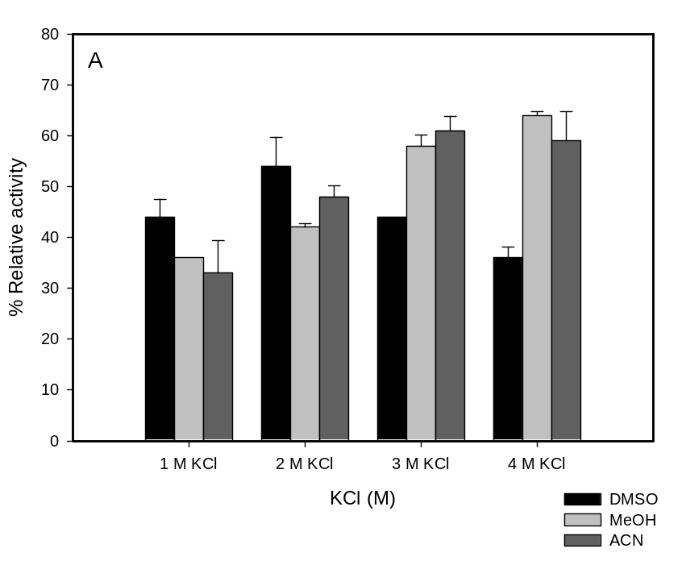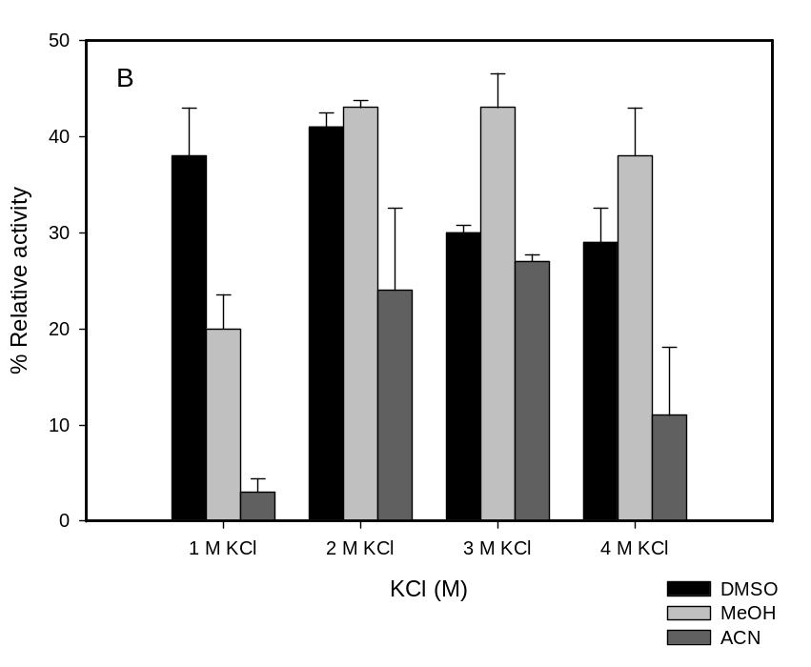
Fig. 1 Organic solvents effect on the activity of HvADH2 at different KCl concentration. (A) Effect of 5 % (V/V) organic solvents. (B) Effect of 10 % (V/V) organic solvents. Enzyme activity was assayed under standard assay conditions and the results were expressed as relative activities (%) with respect to that observed in the absence of solvent at 4M KCl.
Effect of pH on HvADH2 activity in the presence of organic solvents
The effect of pH on HvADH2 activity was measured in 10 % aqueous-organic solvents at pH range of (6-11) using suitable 50 mM buffers (citric acid–K₂HPO₄ pH 6.0, Tris–HCl pH 8.0, glycine–KOH pH 9.0 and 10.0, K₂HPO₄-KOH pH 11.0) and containing 2 M KCl at 50 °C. The results in Fig. 2 show that the presence of organic solvents has no effect on the optimum pH for the oxidative reaction, confirming that pH 10 should be the preferred one.
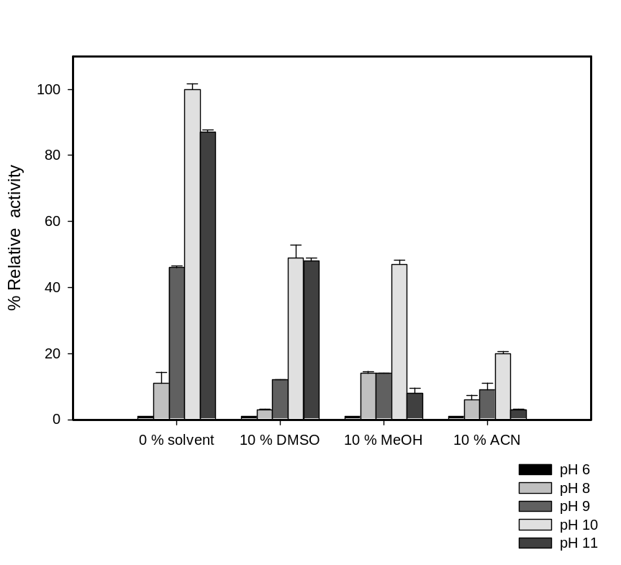
Fig. 2 Activity of HvADH2 in the organic solvents at different pHs.
Effects of organic solvents on HvADH2 stability
The effects of various organic solvents at 5, 10, and 30 % (V/V) on the stability of HvADH2 were studied. HvADH2 was incubated in a mixture of organic solvents and 100 mM Tris-HCl buffer, pH 8 containing 2 M KCl at 5 °C and 3 M KCl at 50 °C. While 3 M KCl would be the best for protein stability, the presence of miscible organic solvents and low temperature caused precipitation of the salt, therefore a lower concentration of 2 M was used for the 5 °C experiment. The remaining activity was measured at appropriate time intervals as indicated in Table 1.
Table 1 Organic solvents effect on the stability of HvADH2
Solvent | Temp | Iª | R.A 5%^{b} |  |  | R.A 10% |  |  | R.A. 30%
 |  |  | 0h | 24h | 72h | 0h | 24h | 72h | 0h | 24h | 72h
Control | 5 °C |  | 100 ± 3 | 85 ± 2 | 78 ± 4 | 100 ± 3 | 85 ± 2 | 78 ± 4 | 100 ± 3 | 85 ± 2 | 78 ± 4
DMSO | 5 °C | 6.4 | 100 ± 1 | 99 ± 2 | 74 ± 5 | 100 ± 1 | 74 ± 4 | 69 ± 4 | 51 ± 5 | 54 ± 6 | 47 ± 3
ACN | 5 °C | 5.8 | 100 ± 1 | 79 ±1 | 65 ± 2 | 100 ± 1 | 74 ± 4 | 62 ± 4 | 5 ± 1 | 0 | 0
MeOH | 5 °C | 5.1 | 99 ± 3 | 83 ± 2 | 70 ± 1 | 100 ± 2 | 77 ± 3 | 67 ± 1 | 49 ± 2 | 43 ± 3 | 38 ± 1
THF | 5 °C | 4.0 | 95 ± 6 | 32 ± 4 | 7 ± 1 | 95 ± 1 | 12 ± 1 | 0 | 4 ± 1 | 0 | 0
Control | 50 °C |  | 100 ± 2 | 77 ± 2 | 57 ± 3 | 100 ± 2 | 77 ± 2 | 57 ± 3 | 100 ± 2 | 77 ± 2 | 57 ± 3
DMSO | 50 °C | 6.4 | 100 ± 4 | 0 | 0 | 100 ± 3 | 0 | 0 | 46 ± 2 | 0 | 0
ACN | 50 °C | 5.8 | 100 ± 2 | 62 ± 4 | 55 ± 2 | 100 ± 2 | 44 ± 2 | 34 ± 1 | 5 ± 1 | 0 | 0
MeOH | 50 °C | 5.1 | 100± 2 | 69 ± 1 | 69 ± 1 | 100 ± 2 | 73 ± 1 | 67 ± 3 | 53 ± 5 | 0 | 0
ª Polarity index (I) is a measure of the ability of the solvent to interact with various polar test solutes and is used as guiding solvent parameter for enzyme stability in aqueous-organic co-solvent mixtures (Gupta et al. 1997).
^{b} The residual activities (R.A) were calculated as mean values ± SD for two independent experiments are shown. Samples were incubated in solution containing 100 mM Tris-HCl buffer, pH 8 and 2M KCl in the presence of organic solvents at 5 °C and 50 °C .

At 5 °C, HvADH2 showed impressive stability when expose to 5 % (V/V) of DMSO, MeOH and ACN. HvADH2 retained (65-75) % of its original activity after 72 h. In particular, no inactivation of the enzyme was observed after 24h of incubation in the presence of 5 % (V/V) of DMSO and the residual activity of the organic solvent mixture was higher than the control sample. Relatively small changes were observed in the residual activity of the enzyme when increasing the concentration of these organic solvents to 10 %. At higher concentration (30 %), the enzyme was tolerant to DMSO and MeOH with 47 % and 38% activity retained after 72 h, respectively. Interestingly, the effect of ACN on the stability of HvADH2 strongly correlated with its final concentration. At 5 % and 10 %, HvADH2 displayed good stability and retained 60 % activity after 72 h incubation. However, the stability was drastically decreased at 30 % ACN which resulted in almost complete loss of activity as soon as the enzyme was tested. THF is the worst co-solvent, with inhibition the catalytic activity by 95 % after 72 hours at 5%, and by 90% after 24 hours at 10% concentration. Similarly to what observed for ACN, 30% of THF is lethal for the enzyme.

In a further experiment, the stability of HvADH2 at 50 °C was investigated in the presence of 5, 10, and 30 % DMSO, MeOH and ACN, and a sample of HvADH2 incubated without solvent was treated as control (Table. 1). THF was excluded from this set of experiments as it was already very poorly tolerated at low temperature. The enzyme in aqueous solution exhibited relatively high thermal stability, retaining 77 % of its activity after 24 h at 50 °C. Surprisingly, the presence of DMSO, even at 5%, killed the enzyme within 24 hours. The stability of HvADH2 in MeOH up to concentration 10 % was higher than the control sample with 67% activity retained after 72 h. This is a welcomed result which correlates with the findings of Pennacchio et al. (2008) on the activating effect of 5 % MeOH and other solvents on an ADH from Thermus thermophilus at 50 °C. The authors propose that both organic solvent and temperature induce a conformational change in the protein molecule which leads to a more relaxed and flexible conformation that is optimal for activity. The concentration of ACN was also important at 50°C. In 5% ACN the enzyme showed good stability and retained 55 % activity after 72 h incubation. However, the stability decreased to 34% at 10 % ACN. At higher concentration of organic solvents (30 %), the enzyme was completely inactivated.
As expected, the choice of solvent is key in retaining a good level of activity overtime; loss of stability in THF was high as compared to other organic solvents such as MeOH and even ACN. DMSO behaves very well a low temperature but is strongly inactivating at higher temperature. The different enzymatic stability could be related to the salting-out properties of these solvents as reported by Kim and Dordick (1997) for halophilic protease from Halobacterium halobium. They observed a strong relation between the halophilic enzyme structure and the salting-in or salting-out nature of an organic solvent. Halophilic enzymes have been found to contain low content of hydrophobic residues in their core (Lanyi 1974), and the salting-out nature of an organic solvent could provide the thermodynamic driving force to stabilize the weakly hydrophobic interactions in the inner part of the protein. On the other hand, with salting-in organic solvents such THF, the enzyme deactivation is most probably caused by the disruption of the hydrophobic core. On the other hand the polarity index (I) values for organic solvents could not explain the behaviour of HvADH2 in all organic solvents. This is not unusual and has been previously reported by other researchers for different enzymes (Gupta and Khare 2006; Heidari-Karbalaei et al. 2007; Ogino et al. 2000; Rahman et al. 2005).
Solvent stability at different pH
To further investigate the stabilising effect of DMSO and MeOH at low temperature, the pH of the buffer solution was varied and activity monitored overtime. Samples of HvADH2 were incubated in either neat buffer solutions at pH 6.0, 8.0 and 10.0 containing 2M KCl or at the same pH and salt concentration with 5% or 10% (V/V) DMSO or MeOH. The samples were stored at 5 °C for 20 days and the remaining activity was compared in each case with the initial activity prior to incubation in the absence of solvent at the same pH. At time zero, in the absence of organic solvents, pH 8 gives the highest specific activity (5.1 U/mg) while the activity recorded at pH 10 and 6 was lower to start with (4.7 and 1.5 U/mg, respectively). Fig. 3 shows that pH 8 is the best buffer in the absence of organic solvents, but the addition of any amount of DMSO or 10% MeOH, shifts the optimal pH to 10. In fact, the presence of DMSO increases the stability of the protein, with almost 100% retention of activity after 20 days with respect to the control. What is striking, is the protective effect that DMSO has on protein stability when the enzyme is stored at pH 6, in fact the retained activity is significantly higher than in the absence of solvent. MeOH does not offer the same stabilising effect at pH 6, and the 5% samples show the same trend as the controls. While this is difficult to explain, one suggestion might be that DMSO contributes to stabilised deprotonated residues at higher pH such as cysteines which we know are involved in the binding of the structural Zn in this class of proteins.
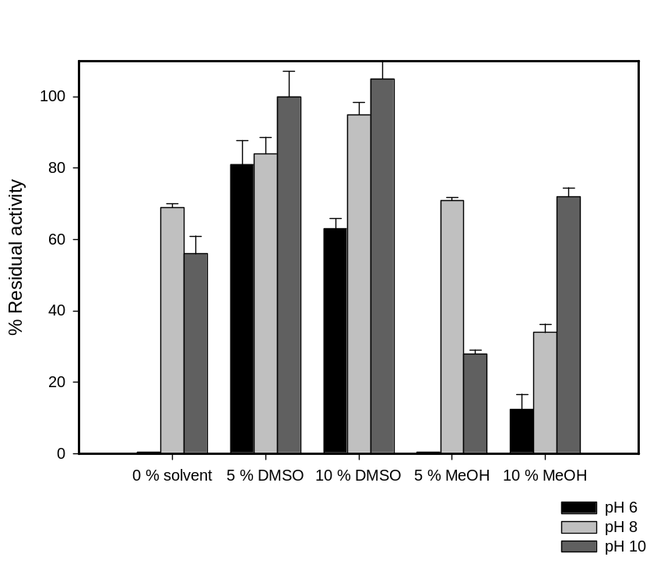
Fig.3 Stability of HvADH2 in the presence of organic solvents at different pHs. HvADH2 was incubated at 5 °C in the presence of organic solvents at pH 6.0, 8.0 and 10.0. The residual activities were measured after 20 days and compared with the control samples.

Solvent effect on substrate specificity
HvADH2 substrate specificity is highly salt dependant; our previous study has established a negative correlation between the substrate chain length and salt concentration required for optimum HvADH2 activity for instance, the enzyme was maximally active with ethanol in 4 M KCl, with 1-propanol in 2 M KCl and with butanol in 1 M KCl (Timpson et al. 2012b). Monitoring changes in the enzymatic environment caused by organic solvents may provide an interesting insight on the substrate specificity of the enzyme. HvADH2 was assayed for activity as described before against 100mM ethanol, 1-propanol, butanol, 2-propanol and benzyl alcohol in a solution of 50 mM glycine-KOH, pH 10.0 containing 2M KCl with 10 % organic solvents (DMSO, ACN and MeOH). The activity was calculated relative to ethanol as substrate in aqueous media.
Results are shown in Fig. 4.In aqueous solution containing 2 M KCl, HvADH2 has a higher activity for 1-propanol. Across the series of substrate tested, no major changes are observed when solvents are added to the mix. The activity towards secondary alcohols, though detectable, remains low, and perhaps the most remarkable effect is the slightly increased activity towards benzyl alcohol when 10% DMSO is added, probably as it enhances the availability of the substrate.
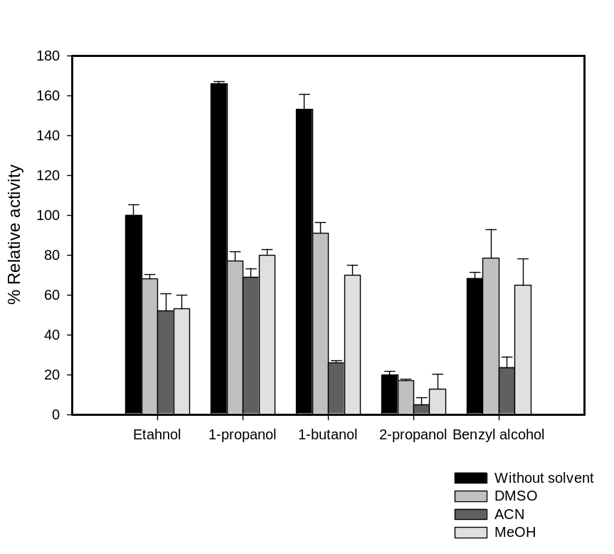
Fig. 4 Substrate specificity of HvADH2 in organic solvent media. Enzyme activity was examined under standard assay (100 mM substrate concentration) against ethanol, 1-propanol, 1-butanol, 2-propanol, and benzyl alcohol. The results were expressed as relative activities (%).

Fluorescence spectroscopic study
To understand the effect of organic solvents on HvADH2 activity and stability, the tertiary structure of the enzyme was investigated in different systems by fluorescence spectroscopic technique. The fluorescence properties of the tryptophan (Trp) residues can be used to follow protein folding. In the native folded sate, internal Trp residues fluorescence at low emission wavelength, whereas in partially folded or unfolded state the residues become exposed to the solvent and the emission wave length will be closer to that of free Trp (Kim and Dordick 1997).
A typical example of the environmental effect on the Trp fluorescence is shown in Fig. 5, in which the maximum emission wavelength of free L-tryptophan (MEW L-Trp) (closed circles) and the maximum emission wavelength of HvADH2 (MEW-ADH2) (open circles) were plotted versus different incubating mixtures.
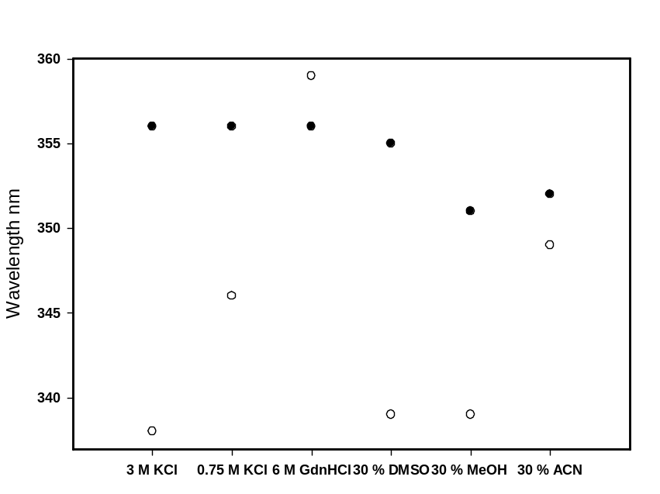
Fig. 5 Changes in the wavelength of maximum fluorescence emission of L-tryptophan (●) and HvADH2 (○) in different conditions.

HvADH2 was fully unfolded when incubated with strong denaturing agent like 6 M guanidine hydrochloride (GdnHCl) for 1 h and the difference in maximum emission wavelengths (∆MEW) between free L-tryptophan (MEW L-Trp) and the maximum emission wavelength of HvADH2 (MEW-HvADH2) was minimal. On the contrary ∆MEW was maximal when the enzyme was incubate under optimal storing conditions (100 mM Tris-HCl buffer, pH 8 and 3M KCl) for HvADH2 stability, indicating the native fluorescent emission of Trp in the folded state of the enzyme. As expected, a clear shift in emission wavelength is observed when the salt concentration is reduced to the suboptimal 0.75M KCl, the MEW-HvADH2 shifts from 338 nm to 346 nm. Therefore, a shift in the MEW-HvADH2 indicates a change in the micro-environments of internal Trp residue due to conformational changes in the enzyme. We reported already on the effect of salt concentration on the quaternary structure of HvADH2. In 2M KCl, HvADH2 exists as a tetramer form but upon decreasing the salt concentration to 1M HvADH2 the enzyme dissociated into a dimer (Timpson et al. 2012b), the fluorescence results showed that salt concentration also has direct affect on HvADH2 folding and conformation, where lowering the salt concentration leads to probable unfolding of enzyme which leads to a shift of MEW-HvADH2 at higher wave-lengths. A similar effect on the tertiary structure of halophilic enzymes have been previously reported (Kim and Dordick 1997; Karan and Khare 2011; Ferrer et al. 1998).The authors reported that reducing the salt concentration generally results in deactivation and destabilization of halophilic enzymes, and this appears to be due to gradual loss of the structure and unfolding of such enzymes.
The fluorescence spectra of HvADH2 in 30% organic co-solvents also showed changes in MEW-HvADH2 depending on the nature of solvent used as reported in Fig. 6. It is well known that solvent polarity can affect the MEW of Trp residues, in order to eliminate this effect and to estimate the direct effect of organic solvents on conformational changes in the enzyme, control samples of free L-Trp in the same incubation systems as the enzyme were also analysed. MEW-HvADH2 was detected and compared with MEW L-Trp in the same environment, as shown in Fig. 5.
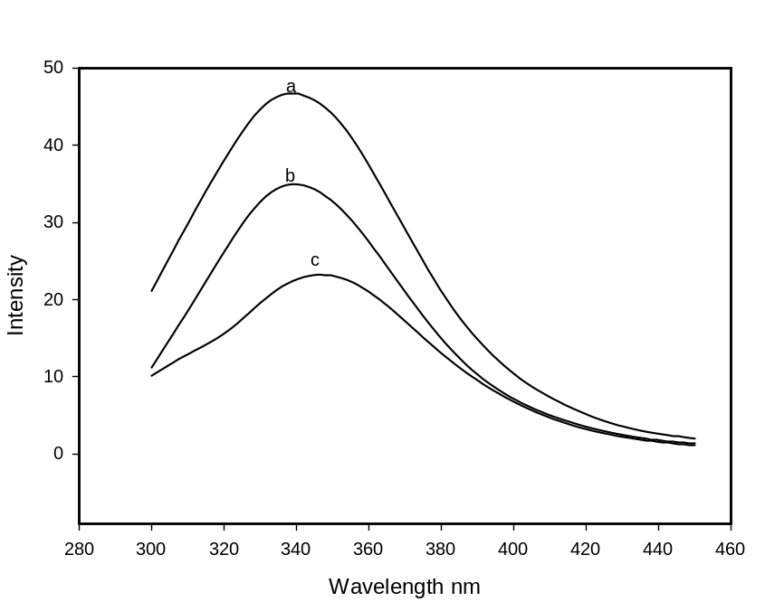
Fig. 6 Fluorescence spectra of HvADH2 with 30 % (V/V) of (a) MeOH (b) DMSO (c) ACN

∆MEW between HvADH2 and L-Trp value in the presence of 30 % DMSO after 1 h incubation was almost the same as when HvADH2 is incubated in aqueous buffer containing 3M KCl. Therefore, DMSO did not have any adverse effect on the tertiary structure of the protein. Upon incubation of the enzyme in 30 % MeOH for 1 h the ∆MEW declined progressively showing changes in the intrinsic emission of HvADH2 to longer wavelength due to partial unfolding of the enzyme.
On the contrary, ACN exhibited a strong denaturation effect on the tertiary structure of HvADH2, with no significant difference between MEW of free L-Trp in 30 % ACN and HvADH2 in the same system. The addition of 30% THF to the buffer caused significant interference in the readings and reliable data could not be recorded. All these results correlates very well with the results obtained based on activity of the enzyme reported above.
Conclusion
We demonstrated a clear correlation between the role of salt and organic solvents in maintaining the stability and catalytic activity of HvADH2. While high salt concentration in suitable buffers protect the overall enzymatic structure, it is possible to replace the salt with suitable organic solvents such DMSO and MeOH to mimic the same behaviour. Similar results were reported for a Natrialba magadii protease (Ruiz and De Castro 2007) and a glutamate dehydrogenase from Halobacterium salinarum (Munawar and Engel 2012).
HvADH2 was stable in the presence of different organic solvents, and retained more than 60% activity at 10% solvents except for THF when stored at 5 °C. Particularly, HvADH2 was highly stable with the addition of DMSO and MeOH up to 30 %. However the stability at 50 °C was severely affected by DMSO while MeOH showed an activating effect. The high stability and activity of HvADH2 in selected organic solvents makes it a very good candidate for further applications as biocatalysts.
Fluorescence was then used to investigate the folding state of the protein and it was concluded that salt has positive effect on HvADH2 folding and organic solvent like DMSO can replace the salt to increase the structural stability of the enzyme at least at low temperatures.
To date it is still not possible to identify a general trend for the behaviour of halophilic proteins in organic solvents, and perhaps only with additional examples and research a pattern may arise in a specific class of enzyme.
Acknowledgements
This work was supported by funding provided by the Islamic Development Bank (IDB) and by Science Foundation Ireland (SFI). We are grateful to Prof. Donal O’Shea for the use of the fluorimeter.

References
Besir H, Zeth K, Bracher A, Heider U, Ishibashi M, Tokunaga M, Oesterhelt D (2005) Structure of a halophilic nucleoside diphosphate kinase from Halobacterium salinarum. FEBS Lett 579: 6595–6600
Bracken CD, Neighbor AM, Lamlenn KK, Thomas GC, Schubert HL, Whitby FG, Howard BR (2011) Crystal structures of a halophilic archaeal malate synthase from Haloferax volcanii and comparisons with isoforms A and G. BMC Struct Biol 11:1–19
Doukyu N, Oginod H (2010) Organic solvent-tolerant enzymes. Biochem Eng J 48:270–282
Eichler J (2001) Biotechnological uses of archaeal extremozymes. Biotechnol Adv 19:261–278
Ferrer J, Cremades R, Pire C, Bonete MJ (1998) Fluorescence and quenching comparative studies of halophilic and bovine glutamate dehydrogenase. J. Photochem. Photobiol. B 47:148–154
Fukushima T, Mizuki T, Echigo A, Inoue A, Usami R (2005) Organic solvent tolerance of halophilic α-amylase from a Haloarchaeon, Haloarcula sp. strain S-1. Extremophile 9:85–89
Gerard AS, Julian BC (1999) Biocatalysis in organic media using enzymes from extremo-philes. Enzyme Microb Technol 25:471–482
Gupta A, Khare SK (2006) A protease stable in organic solvents from solvent tolerant strain of Pseudomonas aeruginosa. Bioresour Technol 97:1788–1793
Gupta A, Khare SK (2009) Enzymes from solvent-tolerant microbes : useful biocatalysts for non-aqueous enzymology. Crit Rev Biotechnol 29:44–54
Gupta MN, Batra R, Tyagi R, Sharma A (1997) Polarity Index: the guiding solvent parameter for enzyme stability in aqueous- organic cosolvent mixtures. Biotechnol Prog 13:284–288
Guy CP, Haldenby S, Brindley A, Walsh DA, Briggs GS, Warren MJ, Allers T, Bolt EL (2006) Interactions of RadB, a DNA Repair Protein in Archaea, with DNA and ATP. J Mol Biol 385: 46–56
Guy JE, Isupov MN, Littlechild JA (2003) The Structure of an alcohol dehydrogenase from the hyperthermophilic archaeon Aeropyrum pernix. J Mol Biol 331:1041–1051
Heidari-Karbalaei HR, Ziaee AA, Amoozegar MA (2007). Purification and biochemical characterization of a protease secreted by the Salinivibrio sp. strain AF-2004 and its behavior in organic solvents. Extremophiles 11:237–243
Karan R, Capes MD, Dassarma S (2012) Function and biotechnology of extremophilic enzymes in low water activity. Aquat Biosyst 8:1–15
Karan R, Khare SK (2011) Stability of haloalkaliphilic Geomicrobium sp. protease modulated by salt. Biochemistry-Moscow 76:686–693
Karbalaei-Heidari H, Ziaee A-A, Amoozegar M (2007) Puriﬁcation and biochemical characteriz-ation of a protease secreted by the Salinivibrio sp. strain AF-2004 and its behavior in organic solvents. Extremophiles 11:237–243
Kim J, Dordick JS (1997) Unusual salt and solvent dependence of a protease from an extreme halophile. Biotechnol Bioeng 55:471–479
Klibanov AM (2001) Improving enzymes by using them in organic solvents. Nature 409:241–246
Lanyi JK (1974) Salt dependent properties of proteins from extremely halophilic bacteria. Bacteriol. Rev 38:272–290
Marhuenda-Egea FC, Bonete MJ (2002) Extreme halophilic enzymes in organic solvents. Curr Opin Biotechnol 13:385–389
Munawar N, Engel PC (2012) Overexpression in a non-native halophilic host and biotechno-logical potential of NAD⁺-dependent glutamate dehydrogenase from Halobacterium salinarum strain NRC-36014. Extremophiles 16:463–476
Natarajan KR (1991) Biocatalysis in organic solvents. J Chem. Educ 68:13–16
Ogino H, Nakagawa S, Shinya K, Muto T, Fujimura N, Yasuda M, Ishikawa H (2000) Puriﬁcation and characterization of organic solvent-stable lipase from organic solvent-tolerant Pseudomonas aeruginosa LST-03. J Biosci Bioeng 89:451–457
Orlich B, Schomäcke R (2002) Enzyme catalysis in reverse micelles. Adv Biochem Eng Biotechnol 75:185–208
Pennacchio A, Pucci B, Secundo F, La Cara F, Rossi M, Raia CA (2008) Purification and characterization of a novel recombinant highly enantioselective short-chain NAD(H)-dependent alcohol dehydrogenase from Thermus thermophilus. Appl Environ Microbiol 74: 3949–3958
Persson M, Wehtje E, Adlercreutz P (2002) Factors governing the activity of lyophilised and immobilised lipase preparations in organic solvents. Chembiochem 3:566–571
Radianingtyas H, Wright PC (2003) Alcohol dehydrogenases from thermophilic and hyperthermophilic archaea and bacteria. FEMS Microbiol Rev 27:593–616
Rahman RN, Baharum SN, Basri M, Salleh AB (2005) High yield puriﬁcation of an organic solvent-tolerant lipase from Pseudomonas sp. strain S5. Anal Biochem 341:267–274
Richard SB, Madern D, Garcin E, Zaccai G (2000) Halophilic adaptation: novel solvent protein interactions observed in the 2.9 and 2.6 A resolution structures of the wild type and a mutant of malate dehydrogenase from Haloarcula marismortui. Biochemistry 39:992–1000
Ruiz DM, De Castro RE (2007) Effect of organic solvents on the activity and stability of an extracellular protease secreted by the haloalkaliphilic archaeon Natrialba magadii. J Ind Microbiol Biotechnol 34:111–115
Sellek GA, Chaudhuri JB (1999) Biocatalysis in organic media using enzymes from extemo-philes. Enzyme Microb Technol 25:471–482
Shaﬁei M, Ziaee AA, Amoozegar MA (2011) Puriﬁcation and characterization of an organic-solvent-tolerant halophilic α-amylase from the moderately halophilic Nesterenkonia sp. strain F. J Ind Microbiol Biotechnol 38:275–281
Szabó A, Kotormán M, Laczkó I, Simon LM (2009) Improved stability and catalytic activity of chemically modiﬁed papain in aqueous organic solvents. Process Biochem 44:199–204
Timpson LM, Alsafadi D, Donnchadha CM, Liddell S, Sharkey MA, Paradisi F (2012a) Char-acterization of alcohol dehydrogenase (ADH12) from Haloarcula marismortui, an extreme halophile from the Dead Sea. Extremophiles 16:57–66
Timpson LM, Liliensiek AK, Alsafadi D, Cassidy J, Sharkey MA, Liddell S, Allers T, Paradisi, F (2012b) A comparison of two novel alcohol dehydrogenase enzymes (ADH1 and ADH2) from the extreme halophile Haloferax volcanii. Appl Microbiol Biotechnol DOI: 10.1007/s00253-012-4074-4
Torres S, Castro GR (2004) Non-aqueous biocatalysis in homogeneous solvent systems. Food Technol. Biotechnol 42:271–277
Woodley JM (2008) New opportunities for biocatalysis: making pharmaceutical processes greener. Trends Biotechnl 26:321–327
Yu HY, Li X (2012) Puriﬁcation and characterization of novel organic-solvent- tolerant β-amylase and serine protease from a newly isolated Salimicrobium halophilum strain LY20. FEMS Microbiol Lett 329:204–211

