Small Business Property Tax Reductions and Firm Productivity

We investigate the productivity spillovers from the UK government’s decision to use extensive property tax reductions as a key instrument to stimulate innovation in smaller businesses and drive local growth. To capture the complex interaction and clustering of hierarchical effects, we apply non-parametric Random Effects Expectation Maximisation algorithm that complements more standard econometric estimators, namely matching to control for endogeneity and control functions to estimate total factor productivity. These approaches enabled us to incorporate various contextual configurations in comparing the recipients of these reductions to non-recipients with regards to productivity, in which the UK has experienced a considerably worse performance than its peers since the great recession. Contrary to policy assumptions and business community expectations, we show that generic tax reductions, when significant, are mostly associated with lower productivity and thus have been unsuitably chosen as a policy mechanism to stimulate productivity growth. We further show how instruments that are not built for causality could be beneficial for policy evaluation.

Introduction
Advanced economies around the world are suffering from weaker levels of productivity growth post-2008 recession, but the UK’s poor performance is particularly pronounced (OECD, 2020). Productivity growth had averaged 0.3% from 2008, compared to 2.3% in the previous decade, and this gap is widening when compared with other advanced economies (HM Treasury, 2020). In this context, UK governments have enacted extensive commercial property tax reductions for smaller firms to incentivise investment, leading to productivity improvements and local growth (HM Treasury 2016b, 2017). Over the past decade, these tax reliefs have increased eight-fold and have now removed approximately one-third of businesses from local tax bases, despite the concerns related to the lack of justification, mistargeting and the subsequent capitalisation of these reductions (Matikonis, 2020 and 2022). This paper aims to empirically explore whether the effects of commercial property tax reductions on productivity vary and interrelate with firm, place, industry and policy characteristics. We use configurational approaches to delineate whether this expensive (more than £16bn to 2022, HM Treasury, 2017) policy works or whether we need more feasible delivery mechanisms.
The contested (e. g. Holtz-Eakin, 2000) policy narrative justifying these substantial tax subsidies rests on supply-side efficiency arguments. The subsidies are meant to overcome funding distortions for smaller firms, which face tighter financial constraints than larger ones. Freed from these constraints, it is assumed that firms invest and innovate (Shane, 2009). They in turn become more efficient and productive as they employ more qualified staff, better technology or improve their management, enabling catch-up with their larger competitors.
Nevertheless, this superficially plausible ‘one size fits all’ logic omits vital contextual location, market and industry factors. For instance, the delivery mechanism fails to account for the divergence between the statutory and economic incidence of taxation and the subsequent uneven appropriation of reliefs by property owners (Hilber, 2017; Matikonis, 2020 and 2022). For those in receipt of funds, little consideration is given to encouraging them to invest in productivity improvements. Numerous factors, such as staff shortages (Bennett and McGuinness, 2009), investment uncertainties (Bloom et al., 2018) or demand-pull innovation (Piva and Vivarelli, 2007), could interact in limiting productivity gains.
Papers in SBEJ have been integral in contributing to our knowledge base of small business taxation, in particular, its effects on entrepreneurship (Baliamoune-Lutz and Garello, 2014; Bennett, 2020; Bruce and Mohsin, 2006; Ferede, 2021; Venâncio et al., 2022) with findings indicating the detrimental impact of taxation, including to productivity (Romero-Jordán et al., 2020). Although this is generally supported by literature on tax incentives (Liu et al., 2019; Sterlacchini and Venturini, 2019; Venancio et al., 2022), Gobey and Matikonis (2021) show that this is not the case for the UK, where they find that small business property tax reductions do not produce additional employment.
We build on their study, but instead of employment, we focus on productivity when comparing the recipients of these reductions to non-recipients. Informed by the configurational approaches constructed from the complexity theory that rejects the ‘one size fits all’ approach to studying organisations (Meyer et al., 1993), we also account for vital contextual location, market and industry factors with the use of the novel Sela and Simonoff (2012) and Fu and Simonoff (2015) Random Effects Expectation Maximisation (RE-EM) decision tree algorithm. We show how these non-parametric techniques, known as regression trees, enable us to visualise and identify complex hierarchical relationships when analysing whether recipients of deep reductions in property taxes are associated with higher total productivity.
We visualise the significant levels of total factor productivity depending on the depth of the relief and other finer-grained characteristics, including location and industry-specific indexes. Our results suggest that when significant, the reductions in property taxation over sustained periods are associated with lower productivity levels, but this relationship interacts with numerous location, market and industry factors. Thus, we suggest that a nuanced and targeted policy incorporating an understanding of local drivers and constraints could be more fruitful than the current generic policy based on building and land value.
We structure the rest of the paper as follows. In section 2, we summarise the UK property tax regime and its policy context. In section 3, we briefly introduce configurational approaches. We then discuss the data, modelling and approach to estimation in section 4. In section 5, we present our findings, and we set out our conclusion in section 6.

Small Business Rate Reliefs
The Small Business Rate Reliefs (SBRR) are substantial reductions to the non-domestic property taxation receipts, more widely known as Business Rates (BR), targeted at small businesses. These tax reliefs (or subsidies) were first introduced in Scotland in 2003, England in 2005 and Wales in 2007. Initially, they were temporary reliefs, but these and subsequent deeper reductions have become permanent over time, despite little evidence that they have supported local business or growth (Gobey and Matikonis, 2021).
BR is a substantive high-profile UK tax instrument which raises the equivalent of around half the revenue raised from corporation taxes and places a great cost on businesses. It was reformed as a centralised tax instrument, with powers removed from local councils in 1990 as part of the wider reform of local council funding, which included the infamous poll tax. Local councils have consequently had minimal ability to finesse the local application of the tax and associated reliefs to meet heterogeneous local needs. The SBRR are then centrally defined homogeneous (within each separate nation) and unconditional revenue reductions, which in England alone, up to 2022, have been forecast to reduce revenue by £16bn (HM Treasury, 2017). Moreover, the reductions introduced in 2017 reduced the liability for 900,000 firms, of which 600,000 saw their liability reduced to zero (HM Treasury, 2017). These are from an approximate total population of two million firms and as such revenues are increasingly dependent on a narrowing set of larger firms.
The calculation of a firm’s BR liability is based on an annually set multiplier linked to the rateable value of a property, which is estimated on a five-year cycle by the Valuation Office Agency. Rateable values do not include such characteristics as sector, turnover or employment, leading to the mistargeting of SBRR (Matikonis, 2020). Instead, the estimation is solely based on land and buildings. The valuation includes certain categories of installed capital integral to a building (e.g., bicycle sheds to furnaces) which consistently leads to high numbers of appeals. The inclusion of capital in the tax base provides a further channel through which BR could affect productivity.
SBRR, depending on the nation and period, reduce the BR obligation in steps or sets a maximum tax reduction, which then tapers linearly. For example, in England, for 2010-17 locations with a rateable value up to £6000 had a 100 per cent reduction, which then tapered in a linear pattern to zero at £12,000 (this became the 100 per cent threshold from 2017). We calculate the precise individual firm level of reliefs, and this process is explained in Appendix 1. Furthermore, the differential in rates faced by small and larger businesses is widened by the partial funding of the reliefs through a higher rate (multiplier) on premises with a rateable value above the qualifying SBRR threshold, but this contribution has not kept pace with the scale of reliefs (Gobey and Matikonis, 2021).
The issues with the mechanisms behind the overall BR system and SBRR have already been reviewed by Matikonis (2020 and 2022), who voiced concerns about the lack of justification, mistargeting and subsequent capitalisation. The latter is because of the failure to account for the divergence between the statutory and economic incidence of taxation. This is fundamental in this context as the property occupier rather than the property owner faces the statutory responsibility to pay BR. The first to establish the incidence of UK property taxes was Fraser (1987). If we applied his reasoning to SBRR, we would expect SBRR to be received by occupiers because of the lag in rent review, but only in the short term. Property owners would later receive SBRR through increased rents and capital gains. Having said that, the pace and degree of this will not be uniform (Hilber, 2017) but rather dependent on the relative elasticities of property supply and demand conditions, among other factors.
Interacting with expectations on capitalisation is the assumption that firms would necessarily invest any funds released by the SBRR. Given the heterogeneous nature of the recipient firms, there are many factors which could interact with productivity gains. Some firms could potentially allocate extra resources towards improving the organisational environment, organisational capabilities, types of innovation, or external knowledgebase, which were found to be dominant in researching SME productivity, as summarised by Owalla et al. (2022).
Then again, some firms could also experience the absence of any demand-side stimulus to overcome firm investment (profit) uncertainties (Bloom et al., 2018) or generate demand-pull innovation (Piva and Vivarelli, 2007), which is more typical in small firms. These could be influenced by the degree of irreversibility in capital sunk costs (Carruth et al., 2000; Guceri and Albinowski, 2021), for which there has been no reduction in risk aversion (Appelbaum and Katz, 1986: Bianco et al., 2013). In this context, some firms will alternatively increase mark-ups or pass tax reductions to consumers to gain or stabilise market share amongst similar firms that have not received SBRR. These are only a few reasons amongst many why we could not expect uniform linear relationships when modelling the effects of SBRR on productivity.

Configurational Approaches
Instead of uniform linear relationships, we more realistically anticipate complex interactions that influence changes in productivity. From the theoretical perspective, our reasoning thus directs us to the configurational approaches built from the complexity theory that rejects the ‘one size fits all’ approach to studying organisations (Meyer et al., 1993).
Configurational approaches have been defined as an analysis of a ‘multidimensional constellation of conceptually distinct characteristics that commonly occur together’ (Meyer et al., 1993). The theory emphasises heterogeneity in organisations and views them as a combination of factors that particular organisations share. The relationships are non-linear, and two or more configurations may be equifinal in affecting the outcome variable (Meyer et al., 1993). The conceptualisation based on configurational approaches thus enables us to depart from strictly linear relationships. It supports the notion that “variables found to be positively related in one configuration may be unrelated or even inversely related in another” (Meyer et al., 1993: 1178). In this way, we can deviate from the not-so-useful concept of ‘average entrepreneur’, as discussed in Newbert et al. (2022:4) and enable modelling realities using complex configurations that are necessary to understand the phenomena (Woodside, 2014).
The concerns of existing equifinality, multi-finality and non-linearity in relationships triggered many papers in SBEJ to adopt the reasoning of configurational approaches, with several publications embracing this theory to explain entrepreneurship related phenomena, including gender (Sperber and Linder, 2019), crowdfunding (Huang et al., 2022), attention deficit and hyperactivity disorder (Hatak et al., 2020), ecosystems (Wang et al., 2022) and firm performance (Su et al., 2011).

Empirical Methodology

4.1. Data
We base our analysis on the UK ONS Annual Respondents Database X, first released in July 2016 combined with Business Structure Database and Prices Survey Microdata. Descriptive statistics of raw data are available in Appendix 2.
The Annual Respondents Database X combines two existing surveys, the Annual Business Inquiry (1998-2008) and the subsequent Annual Business Survey (2009-14), which firms’ representatives are legally required to complete, producing high response rates. It is a complex stratified sample across size, sector and region. The sample framework is constructed using administrative data on employment and turnover from PAYE and VAT registered firms. Importantly for our purposes, it captures information at both the enterprise and local unit levels. We limit the sample to firms that have only one local unit because businesses, with some exceptions, have to use only one property to receive SBRR. We also need to calculate firm’s rateable value and SBRR from the survey reported BR (see Appendix 1).
We combine this data source with the Business Structure Database to acquire the observations from smaller firms that were not included in the Annual Respondents Database X. The Business Structure Database contains an annual release of a small number of critical variables on all UK registered firms and is complementary to the above business surveys.
The Annual Respondents Database X and Business Structure Database do not directly provide controls for the input price changes that we require for the estimation of productivity. To control for omitted price bias (as defined by Van Beveren, 2012), we do not use the typical approach of employing the inherently biased general gross domestic product, but use the Prices Survey Microdata data, which contains more accurate regional and sector level prices. We devalue to 2016 prices.

4.2. Estimation Strategy
To illustrate whether the non-domestic property tax reliefs have any impact on productivity, we could simply estimate:
$ω_{it}=βα_{it}+e_{it}$ (1)
where $ω_{it}$ is the productivity of establishment $i$ at time $t$ and error term, $e_{it}$, that captures the demand shock $ρ_{ij}$ in reduced form. The main parameter of interest is $β$ capturing the effect of any relief, $α_{it}$.
Standard estimators such as Ordinary Least Squares would not yield a consistent estimate of $β$ because establishment-level characteristics are unlikely to be independent of each other or local characteristics. Following Gemmell et al. (2019), the first step in addressing the feasible complex relationships is to exploit our large representative dataset to recreate the conditions of a quasi-natural experiment in which firms that receive SBRR are matched to similar single-unit firms which do not. Our large dataset enables us to use a wide range of observable establishment level characteristics, namely: materials, age, investment, rent, output per employee, employment, sector, legal status, turnover, and gross value added, to produce matches. The dependent variable is a dummy taking a value if one for those firms that received the relief at least twice between 2003-2015 and zero otherwise.
However, instead of the more popular Propensity Score Matching, we match using Coarsened Exact Matching. It uses a more efficient fully blocked randomised experiment rather than attempting to approximate a completely randomised experiment as applied in the Propensity Score Matching, which was found to increase imbalance, model dependence, and bias (King and Nielsen, 2019). The SBRR recipient firms are matched one year prior to the introduction of SBRR or, in the case of young firms, on their first observable year to corresponding non-recipient firms.
Separate matching is performed for each year starting with 2002, with the non-recipients being excluded from further matching if they matched previously. Thus, most of the matching was performed on 2004 data, one year prior to the SBRR introduction in England. This produced a final dataset for the years 2000 to 2015 of 15,047 observations for 1,092 firms, 546 SBRR recipients matched to 546 firms which had never received the relief, yet had similar characteristics. To describe the reduction in imbalance after matching, as per Iacus et al. (2009) recommendations, we estimate the $L_{1}$statistic that includes imbalance with respect to joint distribution and all interactions between recipients and non-recipients. The matching produced a substantial reduction in imbalance with $L_{1}$ decreasing from 0.776 to 0.592 for 2004.
We then expand our specification with variables that provide a more realistic setting for the analysis of heterogeneous establishments. For simplicity, we classify our independent variables as time-varying establishment-specific variables, $Z_{it}$, whilst establishment-fixed effects are captured by the intercepts, $f_{i}$. That is:
$ω_{it}=h\left(α_{it},Z_{it},f_{i}\right)=β_{}^{a}α_{it}+β_{}^{b}Z_{it}+f_{i}+e_{it}$ (2)
This specification still does not fully identify the complex groupings of firms. Building on the configurational approaches literature (Meyer et al., 1993), we imply that a number of variables are unlikely to be additively separable and permit us a priori to establish a clear mechanism through which the policy affects productivity. Controlling for all feasible interactions would produce a complex number of coefficients, possibly even a unique set of coefficients for each firm, $β_{it}^{a}$ and $β_{it}^{b}$. Such estimates would be difficult to interpret given that we cannot establish a defendable identification strategy. The estimates are also likely to be biased, especially for large datasets (Gandomi and Haider, 2015).
More standard estimators, such as mixed-effects or difference-in-difference estimators, could provide some insight into uniform relationships. However, these relationships are unlikely to be uniform but interaction-dependent because of inherent mistargeting and the subsequent uneven capitalisation amplified by different decision choices. Our reasoning is supported by the results from the difference-in-difference estimator in Table 1 that finds consistently negative but only somewhat significant results, which we further discuss in subsection 4.5.
We, thus, require an estimation strategy capable of identifying complex groupings of firms. Empirical studies based on configurational approaches in SBEJ primarily used either standard statistics (Su et al., 2011), limited by assumptions of linearity, or more advanced fuzzy-set Qualitative Comparative Analysis (Hatak et al. 2020, Sperber and Linder, 2019, Wang et al., 2022). This method was found to be prone to subjective bias, require extensive data calibration, and heavily rely on prior knowledge (Liu et al., 2017).
Instead, we draw on decision trees that have already been successfully applied in the real estate context with Fieldman and Gross (2005) as well as in growth determinants with Tan (2010) and more recently in conjunction with configurational approaches (Graham and Bonner, 2022), who also discussed the advantages of these approaches. They stressed their ability to handle large datasets with various data types, missing values and outliers as well as their ability to capture interrelationships between variables in different parts of the measurement space, which is essential given the varying capitalisation and investment decisions. These approaches are, however, susceptible to overfitting (Cook and Goldman, 1984) and instability (Briand et al., 2009). These issues are addressed in subsection 4.6.

4.3. Model
We adopt a more recent extension than in Tan’s (2010) and exploit the Random Effects Expectation Maximisation (RE-EM) decision tree approach of Sela and Simonoff (2012) and subsequently, Fu and Simonoff (2015). This technique combines estimates from fixed and random effect trees to discover the complex groupings of firms. The random-effects element accounts for the constant differential firm-level factors, whilst the decision tree allows the data to discover the complex groupings of firms and their different levels of productivity without imposing a complex parametric structure.
The REEM approach assumes that neither the random effects nor the fixed effects are known and alternates between estimating the regression tree, assuming that the estimates of the random effects are correct, and estimating the random effects, assuming that the estimates from the regression tree are correct. A brief introduction to decision trees is offered in Appendix 4, and a more detailed explanation of the mechanisms of REEM is available in Sela and Simonoff (2012).
The RE-EM model is:
$ω_{it}=Z_{it}b_{i}+f\left(.\right)+ε_{it}, i=1,…, I t=1,…, n$ (3)
$$\left(\begin{matrix}\begin{matrix}ε_{i1} \\ :\end{matrix} \\ : \\ ε_{in}\end{matrix}\right) \sim N\left(0,R_{i}\right),$$
$b_{i}\sim Normal(0,D)$,
$$f\left(.\right)=f{\left(\sum_{j=0}^{4}{\left({SBRR}_{t-j}\right), }ρ_{it},a_{it},r_{it},s_{it}, PS_{it}, PD_{it}, HHI_{it},R\&D_{it},HGF_{it}, {FO}_{it},{IO}_{it}\right)}^{}$$
The dependent variable, $ω_{it}$, is our bootstrapped estimate of productivity, as discussed below for each firm i in period t. $Z$ is a matrix of independent variables which may vary over time and firms and $b_{i}$ is the vector of random effects. f(.) contains the same variables as Z, although they can differ, which we use to estimate the fixed effects via the decision tree.
Within f(.), we define $α_{it}$ as $g\left(\sum_{j=0}^{4}{\left({SBRR}_{t-j}\right), }ρ_{it}\right)$, i.e. SBRR and four lags to capture medium-term effects and account for the periodicity of the reliefs. We complement these variables with the dummy variable $ρ$ to capture the initial effects of receiving any relief or uplift in relief, irrespective of level.
We include the broad sectors (s) of wholesale, catering, construction, production, property, retail and other services and foreign ownership. The Office of National Statistics (ONS, 2017) calculates that UK firms receiving foreign investment have 74% higher productivity than those which do not. As such, we include the dummy variable $FO$ that takes a value of one for firms with a foreign majority owner to account for any systematic effects. In this era of concerns about complex ownership structures and use of complex taxation schemes, we also use the variable $IO$ to denote a foreign country registration of the firm’s immediate parent firm, as also employed by the ONS. This can be different from $FO,$ which denotes the ultimate country of the owner.
We also control for firm age (a), whether it is high growth (HGF) and Research and Development (R&D) active. Since the pioneering work of Griliches (1979), productivity models have considered technological spillovers to be a side product of R&D activities, as such we control for whether a firm intends to undertake R&D within the next two years.
HGF is a dummy taking the value of one in the years in which a firm meets the Eurostat-OECD (2007) definition, namely average annualised growth in employment greater than 20% per annum, over a three-year period with initial employment not lower than ten.
Beyond firm level effects, we explore important national, regional and small (two-digit postcode) location and industry specific effects. We include the regions and nations (r) of Wales, Scotland, North East, North West, Yorkshire and Humberside, East of England, East Midlands, West Midlands, London, South East and South to control for fixed location effects. Given our access to detailed firm-level microdata, we include finer spatial and time-varying indices for Jacob production diversity (PD) and Marshall production specialisation (PS), within small two-digit postcode areas, relative to national SIC (2003) two-digit industry output. Finally, we control for industry concentration at the national level via a Herfindahl-Hirschman Index (HHI).
Various specifications of these indexes may influence the results and their interpretation. In terms of PS and PD, we wanted to ensure that the measures complement each other and can coexist in one equation. Thus, we follow the specification of Modrego et al. (2015), who derive PS as region and sector-specific, whilst PD as region-specific, enabling them to coexist (Van der Panne, 2004). In terms of HHI, we followed the commonly applied design (e.g., in Fairlie et al., 2022), which estimates HHI by squaring each firm's market share and then summing the resulting numbers.
The PS index captures relative industrial clustering effects. For example, the agglomeration may enable the creation of better labour pools, supplier services or the spillover of incremental process and product innovations. SBRR may interact with these local factors by reducing the assumed financial barriers to adoption or creation of incremental changes. That said, we may also observe increased competition for specific types of premises and a more rapid capitalisation of any tax reliefs.
We calculate the PS index in line with Modrego et al. (2015), Feldman and Audretsch (1999) and Paci and Usai (1999). However, our detailed data enables us to enhance the accuracy of the index by using firm turnover rather than employment to create the index. This produces a less noisy control for productivity than employment and a far more accurate perspective on the concentration and value of activity. The index is:
${PS}_{i,j}=\frac{{T_{ij}}/{\sum_{i}{T_{ij}}}}{{\sum_{j}{T_{ij}}}/{\sum_{i}{\sum_{j}{T_{ij}}}}}$ , (4)
where T is industry i turnover in area j. We calculate the turnover of a given industry (i) in an area (j) as a proportion of all turnover in that area and then place it in relation to national turnover from the same industry as a proportion of national turnover.
We capture any local Jacob (Production) Diversity effects via an index based on the reciprocal of the Gini Coefficient as proposed by Paci and Usai (1999):
${PD}_{j}=\frac{2}{(n-1)Q_{n}}\sum_{i=1}^{n-1}{Q_{i}}$ , (5)
where $n$ is the number of industries in region j, $Q_{i}$ is the cumulative turnover up to industry $i,$ then ordered by ascending size. The index, bounded by zero and one, increases with variety. Differently to SBRR or PS, PD captures whether location, rather than the firm or industry, is at the centre of analysis and drives changes (Florida et al., 2017). Innovation is aided by access to ideas and procedures that firms can copy or modify from a diverse set of industries or knowledge generating institutions within small areas or, given the positive correlation with urban areas, more diverse and stable demand. That said, at our two-digit postcode level, we will observe a substantial degree of variation even within urban areas.
The error term, $ε_{it}$, is assumed to be uncorrelated with the random effects and independent across observations. $R_{i}$ is a non-diagonal matrix to account for autocorrelation within firms.

4.4. Dependent Variable: Total Factor Productivity
The most apparent first-order effect of SBRR is a reduction in investment in capital. Having said that, for some organisations, this could trigger expenditure in other areas that could be equally effective, including organisational environment, organisational capabilities, types of innovation, external knowledgebase or even commercialisation that were found to be dominant in researching SME productivity, as recently summarised by Owalla et al. (2022). Considering this in connection with the ideas of heterogeneity in organisations from the configuration approaches literature, discussed in section 3, we conclude that the concept of comparing total outputs relative to the total inputs used in the production of the output in the SBRR context could provide a fuller picture for our exploratory analysis than focusing on one specific outcome. We also depart from the commonly applied single-factor productivity measures, such as labour productivity, because multi-factor productivity measures better capture the changing trends in the working environment (Owalla et al., 2022) and avoid such limitations as the attribution of all increases of efficiency to one factor (Linna et al., 2010).
Total Factor Productivity is not directly observed from production functions and consequently needs to be extracted once the weighted sum of inputs has been estimated with controls for simultaneity and selection biases. We resort to control function approaches that are built to overcome these biases (Van Beveren, 2012). We employ Wooldridge’s (2009) approach, which builds on the work of Olley and Pakes (1996) and Levinsohn and Petrin (2003). His single-step GMM framework also overcomes more recent criticism directed towards the control function estimators failing to consistently estimate the labour coefficient in the first stage (Ackerberg et al., 2015). We thus estimate productivity assuming a Cobb Douglas functional form:
$ω_{it}=e^{{lnGVA}_{it}-β_{k}lnK_{it}-β_{l}lnL_{it}}$, (6)
where $ω_{it}$ is productivity of the ith firm in period t, ${lnGVA}_{it}$ is the firm’s logarithmic gross value added in order to simplify the model and eliminate intermediate inputs, $K$ is logarithmic capital and $L$ is logarithmic labour. To reduce selection bias, we averaged estimates from 1000 estimations with missing values replaced by the predictive mean matching with the key variables of unique firm identifier, year, turnover, employment, region, sector and legal status that have almost no missing data from the Annual Respondents Database X or Business Structure Database. For instance, if a firm had all observations but no data for 2005, we would impute the 2005 data 1000 times and produce 1000 datasets, which then were used to estimate 1000 separate models defined in equation (6).

4.5. Difference in Difference Estimator
To compare the findings to more traditional approaches, we also conduct analysis with a more standard difference in difference estimator that has been widely employed in numerous recent publications in SBEJ (Amamou et al., 2022; Bailey, 2017; Biancalani et al., 2022; Liu et al., 2019; Dosi et al., 2012; Lewis, 2017) that show various specifications and empirical strategies of this approach. There seems to be no consensus on which strategies are preferred, with scholars trading increasingly restrictive assumptions with solutions to various issues, such as heteroscedasticity and autocorrelation.
We primarily follow the empirical strategy adopted in the recent study by Biancalani et al. (2022), who also offer a more detailed explanation of the methodology behind the estimator. Our difference in difference estimator thus departs from the standard specification in that the treatment variable is equal to 1 for firms receiving SBRR and only during years when they actually receive SBRR and 0 otherwise in models (1) to (4). In addition, we incorporate the extent of SBRR in models (5) to (8). We control for firm and time fixed effects in all specifications and cluster standard errors on sectors. We also include similar controls to those in f(.) in equation 3 in models (3), (4), (7) and (8). We estimate the treatment effect with the simple fixed effects panel regression in models (1), (3), (5) and (7), which we compare to estimates in models (2), (4), (6) and (8) that use Newey and West’s (1994) automatic bandwidth selection procedure to produce heteroscedastic and autocorrelation consistent estimation of the covariance matrix of the coefficient.
Insert Table 1 here.
The results suggest that SBRR seem to have an adverse effect on some firms in terms of their productivity, but it does not alleviate a binding constraint for the average company. As reported in Table 1, we find consistently adverse treatment effects but these effects amongst firms seem to vary, as indicated by the relatively high error estimates in models (1) to (4) that resulted in insignificant coefficients. Once we include the extent of SBRR, the negative coefficients are greater, and the error terms are relatively smaller, resulting in a significant relationship but only at a 90% significance level in models (5), (7) and (8), indicating that the likelihood of companies receiving more relief to have lower productivity is greater. For instance, those with 100% SBRR have 0.6% lower productivity, with other variables keeping constant. This, thus, supports the need to explore these nuanced relationships further with such tools as REEM trees.

4.6. Model Diagnostics
We also perform further model diagnostics to ensure that our model does not suffer from widely known issues. To overcome the issue of overfitting (Cook and Goldman, 1984), we impose a minimum number of observations in each final node. To test stability, we follow the Philipp et al. (2018) framework and implementation. The REEM trees achieved the highest stability score for this dataset, a median of 0.82. To assess the accuracy, we use 10-fold validation, in which we compare the predictive capacity of our trees to other candidate algorithms. The REEM tree achieved a relatively high accuracy when compared to alternative methods. Root Mean Squared Error estimates indicate that the REEM tree achieved the highest accuracy, but that was not the case with Mean Absolute Error, which accounts for extreme outliers. Based on this estimate, random forests slightly outperformed REEM tree. More detailed procedures and results are reported in Appendix 3.

Findings
Without any controls, recipients of SBRR had on average 2.6% lower productivity in the matched sample and 2.7% lower productivity in the unmatched sample. The matching also reduced average productivity by 14.5%, indicating that possibly more productive larger firms were excluded from the analysis after matching. In Figure 1, we further provide the firm-level evolution of estimated productivity during 2005-2015 and link this to receipt and degree of SBRR. We see a dramatic drop and rebound just after the start of the economic crisis in 2008. The average level of productivity was somewhat similar whether firms did or did not receive SBRR, although those in receipt of SBRR saw a steeper drop in 2008. We also see a weak identification of a negative trend, where the increases in reliefs are followed by the reduction in productivity. This is, however, to a lesser extent post 2008 recession, when reliefs became more generous post 2010. Overall, there is diverse and complex variation around the average levels of productivity among these carefully matched firms.
Insert Figure 1 here.
Insert Figure 2 here.
We present the full productivity decision tree estimates in Figure 2, but given the number of significant groupings, we explode sections for more detailed analysis. The decision tree algorithm works by allowing the data to define ever more “pure” groups of firms which explain variation in the dependent variable, in that the firms in the groups (nodes) are increasingly homogeneous. The final nodes give the number of firms in the group and the average level of productivity in terms of gross value added. The splits are not strictly hierarchical as variables can enter a branch more than once, but with different sub-values for points at which the data split.
Insert Figure 3 here.
The principal split is on a two-year lag of SBRR showing 12,502 observations with zero relief (left of the node in Figure 2) and 2,540 with some relief (right of the node). In Figure 3, we follow the 2,540 observations for firms receiving SBRR. The weighted average productivity of these observations is six per cent lower than the other observations of firms not in receipt of SBRR. The first significant grouping along this branch is by region. In the Southern and Eastern regions of England, Wales and Scotland (others in Figure 3), we identify a group of 1,222 observations with five-year lagged SBRR which divide on relief of 38 per cent. Observations for the 940 firms in these regions receiving lower relief have higher productivity. The weighted productivity for these 1,222 observations is lower than for observations in the Northern, Midlands and London regions of England, by more than three per cent. In fact, for these English regions, the next significant node is also on five-year lagged SBRR, which divides at a similar value of 40 per cent. The pattern of productivity is the same, with lower productivity for the 248 observations from firms receiving higher levels of relief than the 981 observations with lower or no relief. We conclude from this branch that irrespective of region and sector (excluding catering in some regions), when significant, the greater extent of SBRR is broadly associated with lower productivity.
Following the observations for firms which did not receive two-year lagged SBRR, we find the specific characteristics of firms based in London differentiate them from observations in other regions. We firstly consider the 10,911 observations outside of London which next group on firm age, above and below 32 years of operation. In Figure 4 (Group Two in Figure 2), we follow the 9,173 younger observations as these are influenced by SBRR. The 1,738 observations from firms at least 32 years old (Group Three in Figure 2) have no grouping on SBRR and ultimately the observations group by sector and then by region. The weighted productivity of these older observations is approximately five per cent lower than for the younger observations, but with significant variation. 2,983 of the younger firm observations (Figure 4), quickly come to an end node defined by high levels of local diversity, above 0.84 on the Jacobian production diversity index (PD). The Jacobian production diversity (PD) hypothesis is that greater local diversity enables innovation. Here we find some support for this, as the weighted average productivity of these observations is approximately 3.6 per cent higher than the productivity of others in two-digit postcode areas with a lower level of diversity. In the entire tree, we only find splits on Marshall Specialisation (PS) for areas of London.
Insert Figure 4 here.
Moving down the branch for the majority of firms, those with lower local output diversity (PD) we see, for all sectors except catering, that there is a complex division between long-term and short-term reliefs. In particular, observations with five-year lagged SBBR below 10 per cent and one-year lagged SBBR below 70 per cent are associated with productivity generally higher than those which have five-year lagged relief above 10 per cent. We do see some subsequent small divisions with similar productivity. Overall, we again find the recipients of greater SBRR are those with lower productivity.
Returning to the 1,591 observations in London (Group Four in Figure 2) we calculate a weighted average productivity five per cent higher than in the rest of the UK. This seems to be driven by a relatively small number of observations in sectors other than catering, construction, production, property, retail or wholesale. However, we find no association with SBRR.
Overall, our findings show that continued receipt of higher reliefs is associated with lower productivity. Other than SBRR, regional effects consistently explain variations in productivity, but we cannot say, except for London, that there is a simple dominant geographical pattern. Interestingly, across the tree, we find nearly 4,000 observations in small areas with higher sectoral diversity (at least 0.78) have higher productivity than those with lower diversity. This suggests that the underlying institutional factors stimulating diversity could be a more logical policy target than generic tax reductions.

Conclusions
This paper captured and visualised the significant effects of SBRR on productivity and showed how these interrelate with firm characteristics and location, market and industry dynamics. By doing that, it provided empirical evidence on the effects of mistargeting and capitalisation that were previously only theorised in Matikonis (2020 and 2022). We discuss the main implications of the results from theoretical, practical, and methodological perspectives.

Contribution to Knowledge
Our paper extends the existing knowledge in SBEJ on how taxation affects small businesses. The consensus is that taxes are detrimental to entrepreneurship (Baliamoune-Lutz and Garello, 2014; Bennett, 2020; Bruce and Mohsin, 2006; Ferede, 2021; Venâncio et al., 2022), including productivity (Romero-Jordán et al., 2020) and tax incentives have positive effects (Liu et al., 2019; Sterlacchini and Venturini, 2019; Venancio et al., 2022). Our results are contrary to these findings. This difference is likely to result from mistargeting and uneven capitalisation (as discussed in Matikonis 2020 and 2022), from which other than property tax instruments are less likely to suffer.
We find that these relationships are not uniform but highly dependent on the context, extending Hilber’s (2017) synthesis to non-domestic property. For instance, with regards to regional patterns, London has a higher average weighted productivity, but this is related to only a small number of extreme firms, not SBRR. In the rest of the UK, we find for approximately one quarter of observations that higher productivity is associated with greater small area diversity, particularly for younger firms. This finding is counter to Harris and Moffat (2017), who find agglomeration rather than diversity externalities are associated with higher productivity. This is likely to be because our approach accounts for the complex interaction effects of firm, place, industry and policy. Having said that, these findings on small area production diversity do not suggest the central government should focus on building local diversity across the UK, but rather focus should stay on further devolution, enabling the inclusion of finer-grained local dynamics to produce more successful local growth policies.
Our findings are also supplementary to the existing knowledge in SBEJ, which could add to the variety of the previous findings. For instance, previous studies found that taxation affects firm exits positively and entries negatively, that was shown to be the case also for property taxes (Bennett, 2020). Similar findings were found by those that analysed other tax instruments, with results pointing to tax incentives increasing the number of entrants (Lu et al., 2019 and Venancio et al., 2022). We, thus, suggest that tax incentives are likely to positively contribute to firm entries and reduce exits, but some of those new entrants or sustained firms will potentially become less productive, but this will depend on firm characteristics and location, market and industry dynamics.

Methodological Contributions
We show how configuration approaches, centring on non-linearity and equifinality, could be modelled with decision trees. In this way, we deviate from the not-so-useful concept of ‘average entrepreneur’, as argued by Newbert et al. (2022:4), and model more realistic realities using complex configurations necessary to understand the phenomena (Woodside, 2014). The REEM trees, an extension of the decision trees, consider the relationship between independent and dependent variables to be not necessarily linear, enabling the capture of more complex relationships, whilst regression-based approaches fail to do that by centring on net effects instead of differences between groups (Douglas et al., 2020). Decision trees also do not suffer from other common regression-based assumptions, such as lack of multicollinearity, the distribution of errors and independence of observations (Douglas et al., 2020).
Furthermore, the paper showed how machine learning could be jointly applied with more standard econometric techniques to produce a finer-grained analysis when more standard estimators do not offer valuable insight. The more standard difference in difference estimator, reported in subsection 4.5, suggested that SBRR has an adverse effect on some firms in terms of their productivity, but it did not alleviate a binding constraint for the average company. The REEM trees enabled us to extend these conclusions by departing from the average effect to uncovering the exact groupings of firms whose productivity was impacted by SBRR and showing how these interrelate with firm characteristics and location, market and industry dynamics.

Implications for Policy and Practice
The study provided evidence that the current centralised policy of commercial property tax reductions does not work as an enable of growth. We need more feasible delivery mechanisms that support small businesses. This has implications, first and foremost, for small business owners and their representatives, such as the National Federation of Self Employed & Small Businesses, that campaign to sustain these ineffective commercial property reductions, and whose opinion is given and sought during government consultations, including the relatively recent Fundamental Review of Business Rates (HM Treasury, 2021).
Instead, we need to campaign for a more nuanced and targeted policy incorporating firm characteristics and local drivers and constraints. It could be more fruitful than the current generic policy based on building and land value, as our findings indicate. Having said that, the change in the commercial property fiscal regime is multi-layered and can only be achieved through a truly fundamental review, unlike the two business rates reviews concluded in 2016 and 2021 that resulted in superficial improvements with minimal effort to tackle the more pressing issues concerning the increasingly expansive relief package (Matikonis, 2022).
Broader recommendations from these findings are not to generalise or simplify the effectiveness of tax incentives. Although previous findings on tax incentives signal positive effects (Liu et al., 2019; Sterlacchini and Venturini, 2019; Venancio et al., 2022), we show that commercial property tax reductions, which suffer from mistargeting and capitalisation, do not result in growth. This is especially relevant for the UK, which recently experienced the damaging effects of introducing poorly justified and unfunded tax incentives during the brief premiership of Liz Truss.

Limitations and Future Work
Although the usage of the secondary data source provided a large sample size and enabled us to look at the longer-term effects, another purpose-made, possibly qualitative study of SBRR could include more specific controls and/or specifically focus on uncovering mechanisms explaining why this reduction in productivity is associated with SBRR. Alternative specifications of outcome variable would also be helpful to clarify which aspects of productivity are affected by SBRR. Furthermore, once more recent data is available, further research could also help us understand how retail, hospitality and leisure relief, used as a key tool to support businesses during Covid-19, interrelate with SBRR and affect growth.
In terms of methodology, we extend Graham and Bonner’s (2022) call to small business scholars to explore the potential of machine learning. The studies with different approaches, in different contexts and with different datasets could aid in generalisability. There are also many avenues to use more advanced techniques. For instance, future research could apply causal trees, as described by Athey and Imbens (2016), to better capture treatment effects once the method is fully developed. Further extensions for multidimensional data, such as the Least Absolute Shrinkage and Selection Operator (Belloni et al., 2014), could also be a good option.

References
Aghion, P. and Howitt, P. (1992) ‘A Model of Growth Through Creative Destruction’, Econometrica, 60(2), 323-351.
Amamou, R., Gereben, Á. and Wolski, M. (2022) ‘Assessing the impact of the EIB’s intermediated lending to SMEs during funding shocks’, Small Business Economics. doi: 10.1007/s11187-022-00620-x.
Appelbaum, E. and Katz, E. (1986) Measures of Risk Aversion and Comparative Statics of Industry Equilibrium. The American Economic Review, 76(3), 524–529.
Athey, S. and Imbens, G. (2016) ‘Recursive partitioning for heterogeneous causal effects’, Proceedings of the National Academy of Sciences, 113(27), pp. 7353–7360. doi: 10.1073/pnas.1510489113.
Bailey, J. (2017) ‘Health insurance and the supply of entrepreneurs: new evidence from the affordable care act’, Small Business Economics, 49(3), pp. 627–646. doi: 10.1007/s11187-017-9856-8.
Baliamoune-Lutz, M. and Garello, P. (2014) Tax structure and entrepreneurship. Small Business Economics 42(1): 165–190. DOI: 10.1007/s11187-013-9469-9.
Belloni, A., Chernozhukov, V. and Hansen, C. (2014) ‘High-Dimensional Methods and Inference on Structural and Treatment Effects’, Journal of Economic Perspectives, 28(2), pp. 29–50. doi: 10.1257/jep.28.2.29.
Bennett, D. L. (2021) ‘Local institutional heterogeneity and firm dynamism: Decomposing the metropolitan economic freedom index’, Small Business Economics, 57(1), pp. 493–511. doi: 10.1007/s11187-020-00322-2.
Bennett, J. and McGuinness, S. (2009) ‘Assessing the impact of skill shortages on the productivity performance of high-tech firms in Northern Ireland’, Applied Economics, 41(6), pp. 727–737. doi: 10.1080/00036840601007450.
Biancalani, F., Czarnitzki, D. and Riccaboni, M. (2022) ‘The Italian Start Up Act: a microeconometric program evaluation’, Small Business Economics, 58(3), pp. 1699–1720. doi: 10.1007/s11187-021-00468-7.
Bianco, M., Bontempi, M. E., Golinelli, R., and Parigi, G. (2013) Family firms’ investments, uncertainty and opacity. Small Business Economics, 40(4), 1035–1058.
Bloom, N., Floetotto, M., Jaimovich, N., Saporta-Eksten, I., and Terry, S.J. (2018) Really uncertain business cycles. Econometrica, 86 (3), 1031–1065.
Briand, B., Ducharme, G.R., Parache, V., and Mercat-Rommens, C. (2009) A similarity measure to assess the stability of classification trees. Comput. Stat. Data Anal. 53, 1208–1217.
Bruce, D. and Mohsin, M. (2006) Tax policy and entrepreneurship: New time series evidence. Small Business Economics 26(5), 409–425. DOI: 10.1007/s11187-005-5602-8.
Carruth, A., Dickerson, A., Henley, A. (2000) What do We Know About Investment Under Uncertainty? Journal of Economic Surveys, 14, 119-154.
Cook, E.F. and Goldman, L. (1984) Empiric comparison of multivariate analytic techniques: advantages and disadvantages of recursive partitioning analysis. Journal of Chronic Diseases, 37 (9–10), 721–31.
Douglas, E. J., Shepherd, D. A. and Prentice, C. (2020) ‘Using fuzzy-set qualitative comparative analysis for a finer-grained understanding of entrepreneurship’, Journal of Business Venturing, 35(1), p. 105970. doi: 10.1016/j.jbusvent.2019.105970.
Duranton, G., Gobillon, L., and Overman, H. G. (2011) Assessing the Effects of Local Taxation using Microgeographic Data. Economic Journal, 121(555), 1017–1046.
Eurostat-OECD (2007) Eurostat-OECD manual on business demography statistics. Paris: European Commission.
Feldman, M. P. and Audretsch, D. B. (1999) Innovation in cities: Science-based diversity, specialisation and localised competition. European Economic Review, 43(2), 409–429.
Ferede, E. (2021) Entrepreneurship and personal income tax: evidence from Canadian provinces. Small Business Economics, 56, 1765–1781, DOI: 10.1007/s11187-019-00226-w.
Fraser, W.D. (1987) Principles of Property Investment and Pricing, 2nd ed., London: Macmillan Education.
Fu, W. and Simonoff, J. S. (2015) Unbiased regression trees for longitudinal and clustered data. Computational Statistics and Data Analysis, 88(C), 53–74.
Gandomi, A. and Haider, M. (2015) Beyond the hype: Big data concepts, methods, and analytics. International Journal of Information Management, 35(2), 137–144.
Gemmell, N., Grimes, A. and Skidmore, M. (2019) Do Local Property Taxes Affect New Building Development? Results from a Quasi-Natural Experiment in New Zealand. J. Real Estate Finan. Econ., 58, 310–333.
Gobey, M. and Matikonis, K. (2021) Small Business Property Tax Reductions and Job Growth. Small Business Economics, 56, 277-292, https://doi.org/10.1007/s11187-019-00219-9
Graham, B. and Bonner, K. (2022) ‘One size fits all? Using machine learning to study heterogeneity and dominance in the determinants of early-stage entrepreneurship’, Journal of Business Research, 152, pp. 42–59. doi: 10.1016/j.jbusres.2022.07.043.
Grossman, G. M. and Helpman, E. (1991) Trade, knowledge spillovers, and growth. European Economic Review, 35(2–3), 517–526.
Guceri I. and Albinowski M., (2021) Investment responses to tax policy under uncertainty. Journal of Financial Economics, 141(3), 1147-1170.
Harris, R. and Moffat, J. (2017) The sources of the Scotland–Rest of the UK productivity gap: implications for policy. Regional Studies, 51(9), 1297-1311.
Hatak, I. et al. (2021) ‘ADHD symptoms, entrepreneurial passion, and entrepreneurial performance’, Small Business Economics, 57(4), pp. 1693–1713. doi: 10.1007/s11187-020-00397-x.
Hilber, C.A.L. (2017) The Economic Implications of House Price Capitalisation: A Synthesis. Real Estate Economics, 45(2), 301-339.
HM Treasury (2016) Business rates review: Summary of responses. HM Treasury, London (Available from https://www.gov.uk/government/uploads/system/uploads/attachment_data/file/510497/PU1925_Business_rates_review.pdf.)
HM Treasury (2016b) The Budget 2016. HM Treasury, London (Available from https://assets.publishing.service.gov.uk/government/uploads/system/uploads/attachment_data/file/508193/HMT_Budget_2016_Web_Accessible.pdf)
HM Treasury (2017) Autumn Budget 2017. HM Treasury, London (Available from https://assets.publishing.service.gov.uk/government/uploads/system/uploads/attachment_data/file/661480/autumn_budget_2017_web.pdf)
HM Treasury. (2020) Budget 2020. HM Treasury, London (Available from https://www.gov.uk/government/publications/budget-2020-documents)
HM Treasury. (2021) Business Rates Review: Final Report. HM Treasury, London (Available from https://www.gov.uk/government/consultations/hm-treasury-fundamental-review-of-business-rates-call-for-evidence)
Holtz-Eakin, D. (2000) Public policy toward entrepreneurship. Small Business Economics, 15, 283–291.
Hothorn, T., Hornik, K., and Zeileis, A. (2006) Unbiased recursive partitioning: A conditional inference framework. Journal of Computational and Graphical Statistics, 15(3), 651–674. https://doi.org/10.1198/106186006X133933
Huang, S. et al. (2022) ‘Signalling entrepreneurs’ credibility and project quality for crowdfunding success: cases from the Kickstarter and Indiegogo environments’, Small Business Economics, 58(4), pp. 1801–1821. doi: 10.1007/s11187-021-00477-6.
Iacus, S. M., King, G., & Porro, G. (2009) cem : Software for Coarsened Exact Matching. Journal of Statistical SoftwareSoftware, 30(9), 1–27.
James, G., Witten, D., Hastie, T. and Tibshirani, R. (2013) An introduction to statistical learning with applications in R. New York, NY: Springer.
King, G. and Nielsen, R. (2019) Why Propensity Scores Should Not Be Used for Matching. Political Analysis, 27(4), 435-454.
Laird, N. M. and Ware, J. H. (1982) Random effects models for longitudinal data. Biometrics, 38, 963-974.
Levinsohn, J. and Petrin, A. (2003) Estimating production functions using inputs to control for unobservables. Review of Economic Studies, 70(2), 317–341.
Lewis, G. H. (2017) ‘Effects of federal socioeconomic contracting preferences’, Small Business Economics, 49(4), pp. 763–783. doi: 10.1007/s11187-017-9860-z.
Linna, P., Pekkola, S., Ukko, J. and Melkas, H. (2010) ‘Defining and measuring productivity in the public sector: managerial perceptions", International Journal of Public Sector Management, 23(5), 479-499. Doi: https://doi.org/10.1108/09513551011058493
Liu Z., Wu, H. and Wu, J. (2019) Location-based tax incentives and entrepreneurial activities: evidence from Western Regional Development Strategy in China. Small Business Economics 52(3), 729–742. DOI: 10.1007/s11187-017-9982-3.
Matikonis, K. (2020) Unintended Recipients of Rising UK Non-domestic Property Tax Reliefs, British Tax Review. 2020(2), 143-150.
Matikonis, K. (2022) Fundamental Review of Business Rates: Proposed and anticipated changes, including online sales tax. British Tax Review, 2022(2), 115-125.
Meyer, A., Tsui, A. and Hinings, C. (1993) ‘Configurational Approaches to Organizational Analysis’, Academy of Management Journal, 36(6), pp. 1175–1195. doi: 10.2307/256809.
Modrego, F. et al. (2015) ‘Regional entrepreneurship and innovation in Chile: a knowledge matching approach’, Small Business Economics, 44(3), pp. 685–703. doi: 10.1007/s11187-014-9612-2.
Newbert, S. L., Kher, R. and Yang, S. (2022) ‘Now that’s interesting and important! Moving beyond averages to increase the inferential value of empirical findings in entrepreneurship research’, Journal of Business Venturing, 37(2), p. 106185. doi: 10.1016/j.jbusvent.2021.106185.
Newey, W. K. and West, K. D. (1994) ‘Automatic Lag Selection in Covariance Matrix Estimation’, The Review of Economic Studies, 61(4), pp. 631–653. doi: 10.2307/2297912.
O’Connor, A. and Audretsch, D. (2022) ‘Regional entrepreneurial ecosystems: learning from forest ecosystems’, Small Business Economics, (0123456789). doi: 10.1007/s11187-022-00623-8.
OECD (2020) GDP per hour worked (indicator). (Available from https://doi.org/10.1787/1439e590-en)
Office for National Statistics (2017a) Annual Respondents Database X, 1998-2014. Secure Access. [data collection]. 4th Edition. UK Data Service.
Office for National Statistics (2017b) Business Structure Database, 1997-2016. Secure Access. [data collection]. 6th Edition. UK Data Service.
Office for National Statistics (2017c) ‘Prices Survey Microdata, 1996-2016.’ Secure Access. [data collection]. 8th Edition. UK Data Service.
Office for National Statistics (n.d.) ARDx Capital Stock User Guide, UK Data Service (Available from https://doc.ukdataservice.ac.uk/doc/7989/mrdoc/pdf/7989_ardx_capital_stock_userguide.pdf)
Office of National Statistics (2017) Foreign direct investment and labour productivity, a micro-data perspective: 2012 to 2015. (Available from https://www.ons.gov.uk/economy/economicoutputandproductivity/productivitymeasures/articles/foreigndirectinvestmentandlabourproductivityamicrodataperspective/2012to2015)
Olley, G. S. and Pakes, A. (1996) The Dynamics of Productivity in the Telecommunications Equipment Industry. Econometrica, 64(6), 1263-1297.
Owalla, B. et al. (2022) ‘Mapping SME productivity research: a systematic review of empirical evidence and future research agenda’, Small Business Economics, 58(3), pp. 1285–1307. doi: 10.1007/s11187-021-00450-3.
Paci, R. and Usai, S. (1999) Externalities, knowledge spillovers and the spatial distribution of innovation. GeoJournal, 49(4), 381–390.
Philipp, M., Rusch, T., Hornik, K., and Strobl, C. (2018) Measuring the Stability of Results From Supervised Statistical Learning. Journal of Computational and Graphical Statistics, 27(4), 685–700.
Piva, M., and Vivarelli, M. (2007) Is demand-pulled innovation equally important in different groups of firms? Cambridge Journal of Economics, 31(5), 691–710.
Rabinowicz, A., and Rosset, S. (2020) Cross-Validation for Correlated Data. Journal of the American Statistical Association, DOI: 10.1080/01621459.2020.1801451
Romer, P. M. (1990) Endogenous Technological Change. Journal of Political Economy, 98(5), S71–S102.
Romero-Jordán, D., Sanz-Labrador, I. and Sanz-Sanz, J.F. (2020) Is the corporation tax a barrier to productivity growth? Small Business Economics 55(1), 23–38. DOI: 10.1007/s11187-019-00136-x.
Sela, R. J. and Simonoff, J. S. (2012) RE-EM trees: A data mining approach for longitudinal and clustered data. Machine Learning, 86(2), 169–207.
Shane, S. (2009) Why encouraging more people to become entrepreneurs is bad public policy. Small Business Economics, 33, 141-149.
Sperber, S. and Linder, C. (2019) ‘Gender-specifics in start-up strategies and the role of the entrepreneurial ecosystem’, Small Business Economics, 53(2), pp. 533–546. doi: 10.1007/s11187-018-9999-2.
Sterlacchini, A. and Venturini, F. (2019) R&D tax incentives in EU countries: does the impact vary with firm size? Small Business Economics 53(3), 687–708. DOI: 10.1007/s11187-018-0074-9.
Su, Z. et al. (2011) ‘Entrepreneurial strategy making, resources, and firm performance: evidence from China’, Small Business Economics, 36(2), pp. 235–247. doi: 10.1007/s11187-009-9211-9.
Tan, C.M. (2010) No one true path: uncovering the interplay between geography, institutions, and fractionalisation in economic development. Journal of Applied Econometrics, 25, 1100-1127.
Van Beveren, I. (2012) Total factor productivity estimation: A practical review. Journal of Economic Surveys, 26(1), 98–128. https://doi.org/10.1111/j.1467-6419.2010.00631.x
Van der Panne, G. (2004) ‘Agglomeration externalities: Marshall versus Jacobs’, Journal of Evolutionary Economics, 14(5), pp. 593–604. doi: 10.1007/s00191-004-0232-x.
Venâncio, A., Barros, V. and Raposo, C. (2022) ‘Corporate taxes and high-quality entrepreneurship’, Small Business Economics, 58(1), pp. 353–382. doi: 10.1007/s11187-020-00413-0.
Wang, H. et al. (2022) ‘Effective policy mixes in entrepreneurial ecosystems: a configurational analysis in China’, Small Business Economics, (0123456789). doi: 10.1007/s11187-022-00658-x.
Woodside, A. G. (2014) ‘Embrace•perform•model: Complexity theory, contrarian case analysis, and multiple realities’, Journal of Business Research, 67(12), pp. 2495–2503. doi: 10.1016/j.jbusres.2014.07.006.
Wooldridge, J. M. (2009) On estimating firm-level production functions using proxy variables to control for unobservables. Economics Letters, 104(3), 112-114.

Table 1: Estimates of Treatment Effect with the Difference in Difference Regressions.
Variable | (1) | (2) | (3) | (4) | (5) | (6) | (7) | (8)
Treatment & time | -0.001 (0.002) | -0.001 (0.002) | -0.001 (0.002) | -0.001 (0.002)
Extent, treatment and time |  |  |  |  | -0.006 (0.003)* | -0.006 (0.004) | -0.006 (0.003)* | -0.006 (0.004)*
Controls | No | No | Yes | Yes | No | No | Yes | Yes
Firm-fixed effects | Yes | Yes | Yes | Yes | Yes | Yes | Yes | Yes
Year dummies | Yes | Yes | Yes | Yes | Yes | Yes | Yes | Yes
Sector cluster | Yes | Yes | Yes | Yes | Yes | Yes | Yes | Yes
SE correction | No | Yes | No | Yes | No | Yes | No | Yes
Notes: * refers to a 90% significance level.

Figure 1: Estimated Productivity 2005-2015 by SBRR (printed in colour)
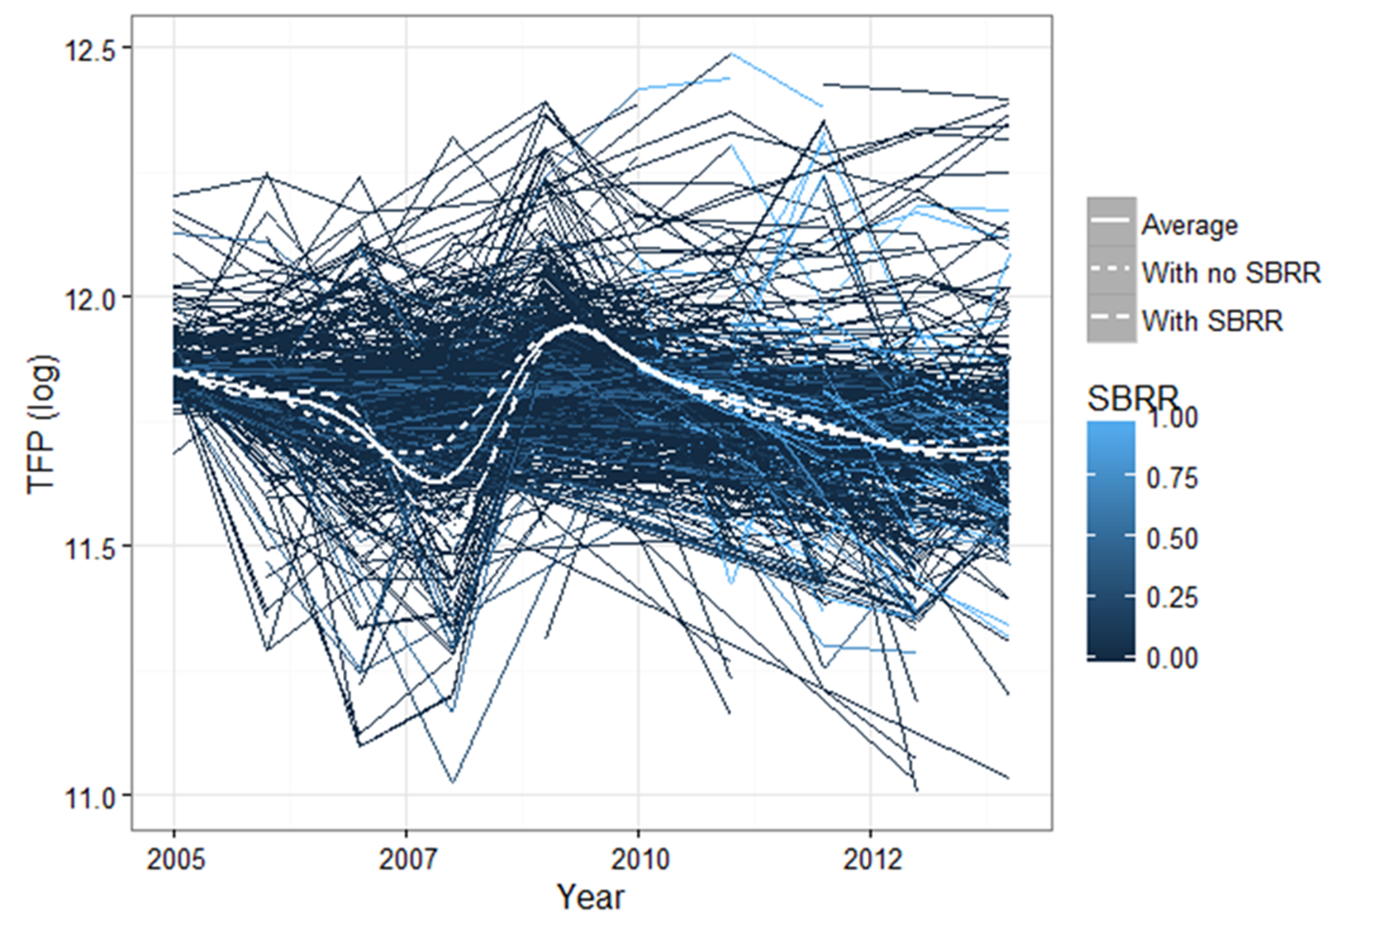
Productivity estimates as described in the method section. The white lines correspond to the annual averages of all firms. The white dotted line is the average SBRR recipients. The white dashed line is the average for non-recipients. The other lines are shaded by the proportionate level of SBRR. Where dark blue is 0 per cent and light blue is 100 per cent,
Source: ONS Data (matched sample), Author’s calculations.

Figure 2: Productivity Tree Groupings
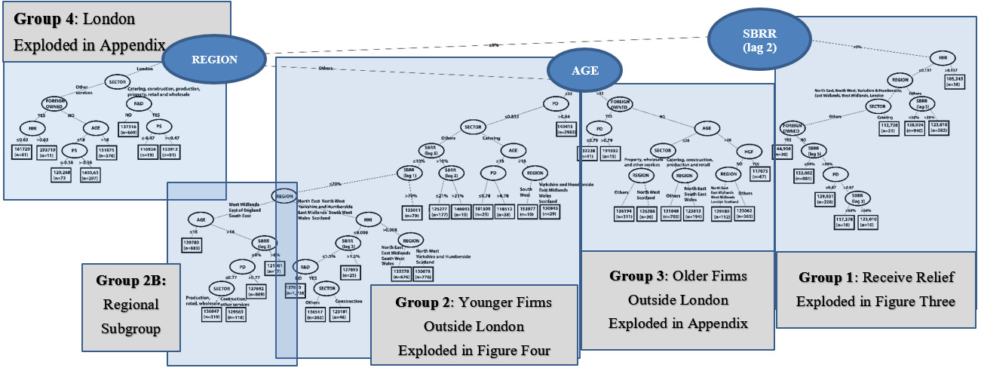
The decision tree algorithm identified four broad groups of firms which have increasingly homogeneous variation in the total factor productivity. The first grouping is on SBBR (Lag 2), indicated by the enlarged node. Those to the left receive no SBRR lagged by two years and those to the right receive SBRR lagged by two years. The next grouping is on region, to the left London and to the right all other regions considered in this study. We then also have a grouping on firm age.
From the blocks of sub-branches, we create groups for exploded presentation and detailed discussion. Group 1 is exploded in Figure 3 and Group Two is exploded in Figure 4. The other groups are in Appendix 5.
Source: ONS Data, Author’s Calculations.

Figure 3: Productivity Tree Extract Following Firms Receiving Two Year Lagged SBBR
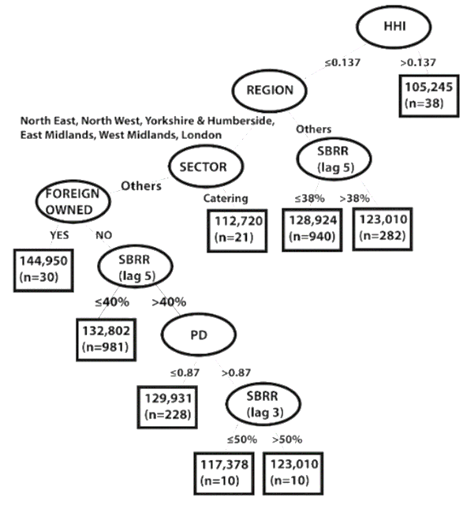
Productivity Tree. Extract of Group One. It follows firms receiving two year lagged SBBR.
Figures in the final nodes are the productivity, in terms of gross value added and n is a number of firm observations.
Source: ONS Data, Author’s Calculations.

Figure 4: Productivity Tree Extract of Younger Firms Not Receiving Two Year Lagged SBBR, Outside of London (Group Two)
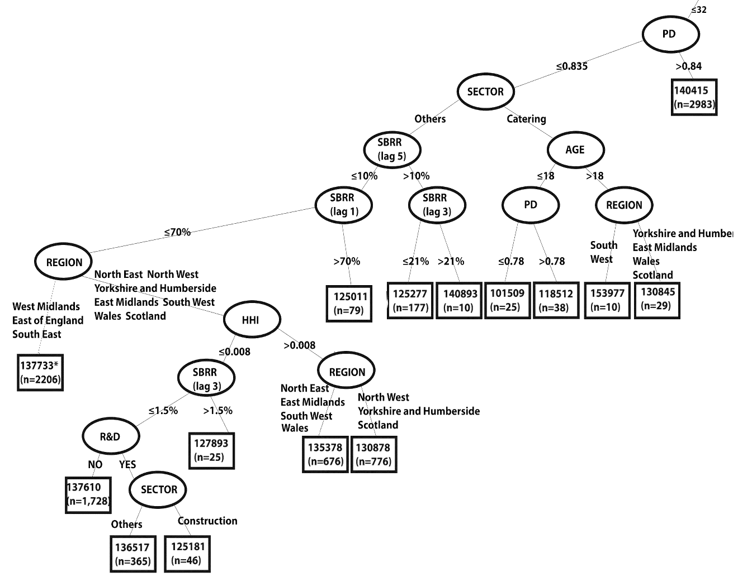
Productivity Tree. Extract of Group One. It follows firms that did not receive two year lagged SBBR and were outside of London. Figures in the final nodes are productivity, in terms of gross value added, and n, number of observations.
Note this is a truncated branch, not showing subsequent subgroup 2B for the regions West Midlands, East of England and South East England. This group does not subsequently group on SBRR. The final starred (*) node is a weighted average for the 2,206 observations in Group 2B.
Source: ONS Data, Author’s Calculations

Electronic Supplementary Material
Appendix 1: Deriving SBRR
SBRR in England
SBRR was derived in accordance with government publications because the Annual Respondents Database X only collects the BR each firm pays. As such, we calculate any SBRR received by calculating the firms underlying Rateable Value (RV).
$BR=RV×m×\left(1-SBRR\right)$, (7)
where BR is business rates paid, RV is rateable value and m is the annual multiplier.
Defining 1- SBRR as;
$1- SBRR=\left(1-{\left(max- \frac{RV-int}{\frac{int}{max}}\right)}_{}\right)=1-2×max+\frac{RV×max}{int}$, (8)
where max is a maximal relief available (50% or 100% depending on the period) and int is the range over which the relief is paid (either £5,000 or £6,000).
Combining both equations to extract the RV, we get:
${RV}^{2}+RV×\frac{int(1-2×max)}{max}-\frac{BR×int}{max×m}=0$ (9)
Given that maximal relief during 2005-2010 in England is equal to 0.5 (giving 1-2×max=0), the equation becomes relatively straightforward to estimate:
$RV= \sqrt{\frac{BR×int}{0.5×m}}$ (10)
By combining the equations (11) and (13), we can now solve for SBRR in England between 2005 and 2010 from observable parameters:
$SBRR=1-\frac{BR}{m×\sqrt{\frac{BR×int}{max×m}}}$ (11)
From 2010 the maximum relief was increased up to 1, so we now have to express another quadratic equation for this period:
$0={RV}^{2}+RV×\frac{int\left(1-2×max\right)}{max}-\frac{BR×int}{max×m}={RV}^{2}-RV×int-\frac{BR×int}{m}$ (12)
Combining the positive solution with the initial BR equation and solving for SBRR as a function of observable parameters, we get
$RV= \frac{int ∓ \sqrt{{int}^{2}+4×\frac{BR×int}{m}}}{2}$ (13)
$SBRR=1-\frac{2×BR}{m×\left(int+ \sqrt{{int}^{2}+4×\frac{BR×int}{m}}\right)}$ (14)

SBRR in Scotland and Wales
The SBRR for other years and nations of the UK are easier to estimate because reliefs were fixed for groups of rateable values. In Wales up to 2010 (after which it aligned with England), the reliefs were retrieved in a straight forward manner as illustrated in Table 2. Whilst, Scottish reliefs were much higher than in the rest of UK and were introduced in 2003 as provided in Table 3.
Table 2: SBRR in Wales before 2010
Ratable Value (RV) | Year
 | 2007 | 2008-2009
RV≤2,000 | 0.5 | 0.5
RV≤5,000 | 0.25 | 0.25
RV≤6,500 | 0 | 0.25
RV>5,000 | 0 | 0

Values are in numeric expression, e.g., 0.5 corresponds to 50%.
Source: Non-Domestic Rating (Small Business Relief) (Wales) Orders.

Table 3: SBRR in Scotland.
Ratable Value (RV) | Year
 | 2003 -2004 | 2005 - 2007 | 2008 | 2009 | 2010 -2014
0≤RV≤3,000 | 0.5 | 0.5 | 0.8 | 1 |  | 1
3,000< RV ≤3,500 | 0.4
3,500< RV ≤4,000 | 0.4 | 0.4 | 0.8 |  |  | 1
4,000< RV ≤4,500 | 0.3
4,500< RV ≤5,000 | 0.3 | 0.3 | 0.8 |  |  | 1
5,000< RV ≤5,750 | 0.2
5,750< RV ≤6,000 | 0.2 | 0.2 | 0.8 |  |  | 1
6,000< RV ≤7,000 | 0.1
7,000< RV ≤8,000 | 0.05 | 0.1 | 0.8 |  |  | 1
8,000< RV ≤10,000 | 0.05 | 0.05 | 0.4 | 0.5 |  | 1
10,00< RV ≤11,500 |  | 0.05
10,000< RV ≤12,000 | 0 | 0 | 0.2 | 0.25 |  | 0.5
12,000< RV ≤15,000 |  |  |  |  |  | 0.25
15,000< RV ≤18,000 | 0 | 0 | 0 |  |  | 0.25
18,000< RV | 0 | 0 |  |  |  | 0

Values are in a numeric expression, e.g., 0.5 corresponds to 50%.
Source: Non-Domestic Rate (Scotland) Orders.

Appendix 2
Table 4: Descriptive statistics of main variables (raw data)
Variable | N | Mean | St. Dev. | Pctl(25) | Median | Pctl(75)
Industry concentration (HHI) | 6230916 | 0.012 | 0.03 | 0.002 | 0.005 |  | 0.014
The Jacobian production diversity (PD) | 6230916 | 0.787 | 0.074 | 0.75 | 0.797 |  | 0.838
PS | 6229677 | 1.482 | 1.794 | 0.722 | 1.149 |  | 1.725
Employment | 6225925 | 14.154 | 149.276 | 1 | 3 |  | 10
Turnover (‘000 £) | 6225925 | 2624.307 | 174971.5 | 72 | 187 |  | 708
Business rate expense (‘000 £) | 574887 | 35.709 | 575.047 | 0 | 1.771 |  | 12.86
Gross value added (‘000 £) | 528763 | 2282.482 | 134916.8 | 34 | 157 |  | 909
Status | 6225887
Sector | 6230916
Region | 6230916
Immediate | 6230916
Ultimate foreign ownership | 6230916
Immediate foreign ownership | 6230916
Source: ONS Data, Author’s Calculations. For all variables count (N) is reported and for continues variables this is supplemented by mean, median, standard deviation (SD), 25th and 75th percentiles.
Source: ONS Data, Author’s Calculations.

Appendix 3: Model Diagnostics
The primary criticism of CART is related to overfitting (Cook and Goldman, 1984). To overcome this issue, we impose a minimum number of observations in each final node. This strategy was preferred instead of alternatives because of the disclosure controls imposed by the data owners limiting the minimum number of observations in outputs. Other options include building a model by using a training dataset and then estimating mean squared error with the hold-out data and cross-complexity pruning, estimating complexity factor to evaluate predictive capacity (James et al., 2013).
Another issue is the stability of the results (Briand et al., 2009). To test stability, Philipp et al. (2018) framework and implementation were followed. As candidate algorithms, we selected Conditional Inference Trees (Hothorn et al., 2006) that do not account for random effects and a more standard linear mixed model that accounts for random effects but assumes a more simplistic linear form. The default settings were used for all algorithms. The results are illustrated in Figure 5, which shows similarity values for all three algorithms. The REEM trees achieved the highest stability score for this dataset, with a median of 0.82.

Figure 5: Stability (1-total variation distance) of results generated by different implementations of estimations with matched data.
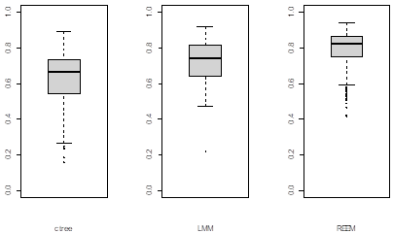
Source: ONS Data, Author’s Calculations.

To assess the accuracy, we use 10 fold validation, in which we compare the predictive capacity of our trees to other candidate algorithms. In addition to the previously used algorithms, we also include random forests known for its greater predictive accuracy. We base our strategy on Rabinowicz and Rosset’s (2020) assumptions that should be met for effective cross-validation with longitudinal data. We produce ten random subsamples where the same respondent firms are in both samples but at different times to preserve the distributional relation between the testing and training sets. For each subsample, we train the algorithms with an 80% train set and then use the remaining 20% to test the accuracy of predictions. The goal is to compare the accuracy of predictions of observations of the subjects, sampled at a random time-point from the same distribution. For the comparison, we use both Root Mean Squared Error (RMSE) and more reliable Mean Absolute Error (MAE).
The results from the k-fold validation are reported in Table 4. This table shows the means of RMSE and MAE of the four algorithms, supplemented by medians and SDs. The REEM tree achieved a relatively high accuracy when compared to alternative methods. RMSE estimates indicate that REEM tree achieved the highest accuracy, but that was not the case with MAE, which accounts for extreme outliers. Based on MAE, random forests slightly outperformed REEM tree.
.
Table 5: Accuracy measures (MAE and RMSE) generated by different implementations of estimations with matched data.
 | MAE |  |  | RMSE
 | Mean | Median | St. Dev. | Mean | Median | St. Dev.
RF | 11926.55 | 11940.23 | 523.38 | 28147.84 | 19632.10 | 12540.46
REEM tree | 12101.39 | 11974.63 | 627.33 | 23849.07 | 19027.20 | 10155.96
ctree | 12105.85 | 12014.93 | 528.29 | 28403.10 | 19867.47 | 12577.22
LMM | 12128.47 | 12090.07 | 459.22 | 28392.83 | 19807.62 | 12531.69
Source: ONS Data, Author’s Calculations.

Given that the random forest outperformed the REEM tree in terms of RMSE, we further explore the output from this algorithm. The random forests algorithm makes multiple decision trees in parallel, and the output is the maximum voting of all the outputs from each decision tree. Table 6 reports the importance scores from the impurity-based feature importance. It orders variables based on their importance and offers an importance score that allows for comparison with a higher importance score signalling greater contribution. We see that the algorithm identified current SBRR, SBRR lagged by two, three and four as highly influential, but in feature selection, Jacobian externalities, industry concentration (HHI) and region variables have greater importance scores. This is as expected given the relatively marginal value of SBRR as input to the overall productivity. Given that the REEM tree also primarily splits on these variables, we imply that it captured relationships from most of the influential variables.

Table 6: Random Forests Importance Scores
Variable | Importance score
PS | 2129435561322
Industry concentration (HHI) | 1739529428105
ID | 1649160154167
Age | 1062988368526
Year | 662769747910
Region | 581336712563
SBRR | 156688938575
High growth firm (HGF) dummy | 145599059814
SBRR lagged by 2 | 123988314100
SBRR lagged by3 | 106464998673
R&D | 90434107441
SBRR lagged by 4 | 89363912658
Ultimate foreign ownership | 42821004794
Immediate foreign ownership | 34903013715
Source: ONS Data, Author’s Calculations.

Appendix 4: Brief Introduction to Decision Trees
Decision trees, often referred to as recursive partitioning, is a tool that builds regression models in the shape of a tree structure, illustrating possible outcomes of different decisions based on a variety of parameters. The main advantages of these mechanisms are their ability to accommodate missing data, low sensitivity to outliers, and low impact of nonlinear relationships between parameters.
The tree algorithms are based on entropy, defined as a top-down partitioning of data into subsets that consist of homogenous data points. The decrease in entropy after the dataset is split on an attribute is also known as information gain, and the splits are based on which attributes generate the highest information gain. Entropy values are calculated for every parameter that is entered into the tree model and for each decision. The parameter with the highest information gain is selected. Then the process is repeated.
The decision trees are made of two components, leaves and nodes. The former is the outcome of the decision, whilst the latter is a decision test that examines a single variable and moves to another node based on the outcome.
As a simplified example, let the parent node be noted as $S$ and the left, $L$, and right, $R$, be sub-nodes as well as y be a response value in node $S$ and $\overline{y}$ is the average response values in node $S$. The Gini index of diversity or entropy could be used to reflect the impurity of a node, which defines the node splits where each split maximises the decrease in impurity. Let G be categories in the data, $π_{S}(g)$ be the proportion of the observations from the G^{th} category in node S and $n_{S}$ be the number of cases in node S. The Gini index is
$I_{S}=\sum_{g=1}^{G}{π_{s}\left(g\right)[1-π_{s}\left(g\right)]}$ (15)
Then, after splitting into $L$ and $R$, the decrease of heterogeneity of$S$ could be defined as $ΔI\left(S,L,R\right)=I_{S}-(I_{L}+I_{R})$. The chosen split for each node is the maximising $ΔI\left(S,L,R\right)$. This process is repeated until the largest possible tree is obtained and no more nodes can be split.
Conditional Inference trees are a non-parametric class of decision trees that uses a statistical theory to select variables instead of selecting the variable that maximises an information measure (information gain or Gini coefficient) and thereby removes the potential bias in CART or similar decision trees.

Appendix 5
Figure 6: Productivity Tree Extract of Older Firms Not Receiving Two Year Lagged SBBR, Outside of London (Group Three)
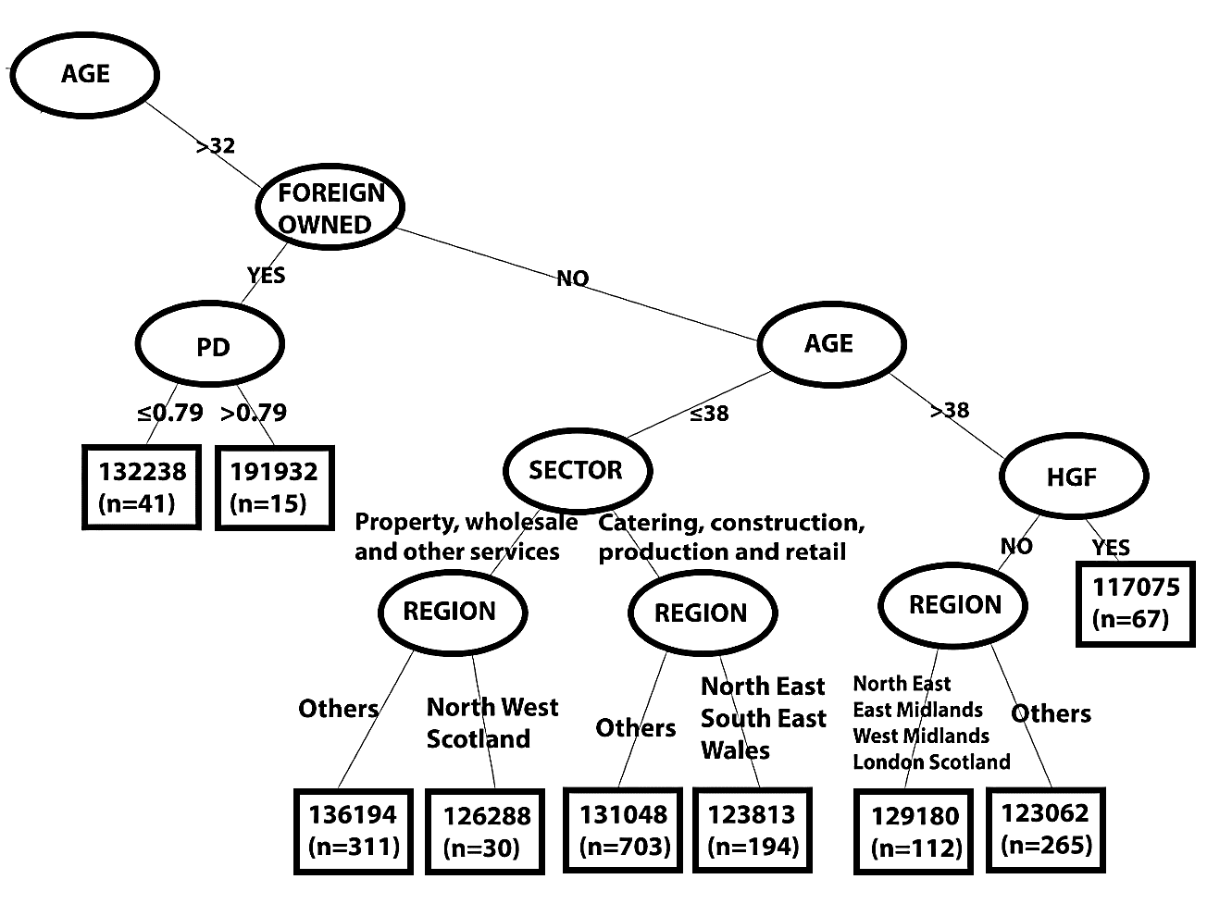
Productivity Tree. Extract of Group Two. It follows older firms that did not receive SBRR lagged by two year and were outside London.
Figures in the final nodes are productivity, in terms of gross value added, and n, number of observations.
Source: ONS Data, Author’s Calculations.

Figure 7: Productivity Tree Extract of Firms Not Receiving Two Year Lagged SBBR in London (Group Four)
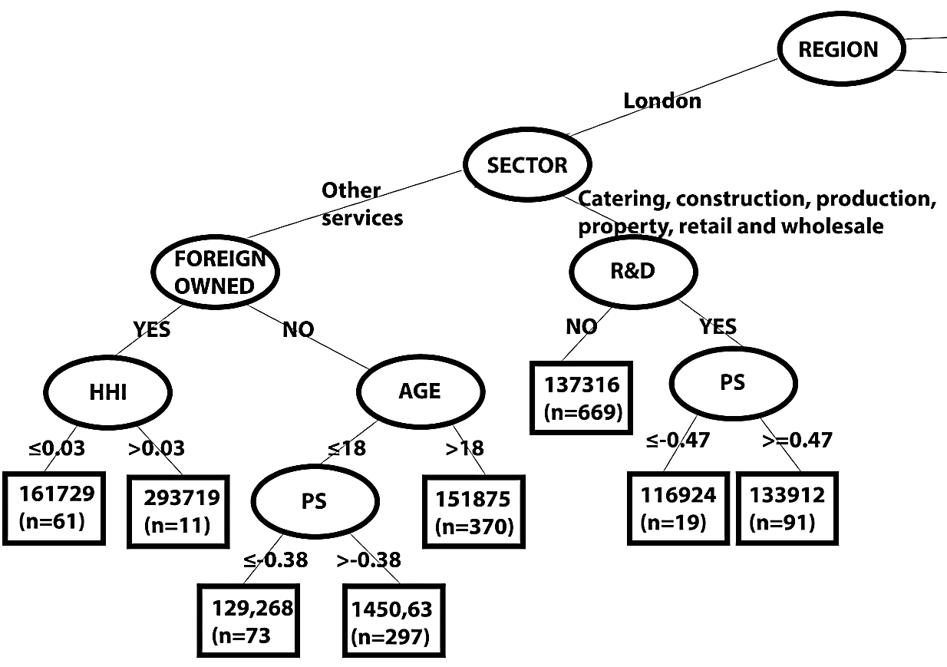
Productivity Tree. Extract of Group Four. It follows firms that did not receive two year lagged SBBR and were in London.
Figures in the final nodes are productivity, in terms of gross value added, and n, number of observations.
Source: ONS Data, Author’s Calculations.

We use Wooldridge’s (2009) one step GMM Total Factor Productivity estimator, which can control for simultaneity, selection and omitted price biases (Van Beveren, 2012) for our productivity estimates.
It is difficult to establish comparable metrics to investigate to what extent business rates burden businesses, but the burden is undoubtedly significant. This is particularly prominent amongst matched firms that did not receive SBRR and had to pay business rates (the matching process is described in subsection 3.2). The business rates to turnover ratio averaged 10% between 2000 and 2015. The business rates to employment expenses ratio averaged 21%, and business rates expense was, on average greater by a factor of 9 than the capital expenditure to acquire, upgrade, and maintain physical assets such as property, plants, buildings, technology, or equipment. Once we estimate these on raw data, the values change to 2%, 10% and 35, respectively. Note that for the raw data, the data is limited to entities that reported both units of measurement that is why does not necessarily correspond to figures in Appendix 2.
See Appendix 1 for a more detailed overview of SBRR across the nations.
Modelling heterogeneous firms operating in heterogenous locations were already problematic within the overall BR system (Duranton et al., 2011) but this is further amplified in the SBRR context, given the previously discussed issues of mistargeting.
Pay As You Earn is the taxation withholding mechanism whereby employers deduct taxation from employee income on behalf of the tax authorities.
There are nevertheless still missing observations, particularly for smaller firms. To estimate productivity, we used the Annual Respondents Database X capital stock maintained by ONS with more details available in the user guide, supplementary to Annual Respondents Database X (ONS, n.d.). In the same vein, before Coarsened Exact Matching, we used predictive mean matching, with the key variables of unique firm identifier, year, turnover, employment, region, sector and legal status that have almost no missing data from the Annual Respondents Database X or Business Structure Database sources. This enabled us to also include firms that may have missing observations for the particular year when matching was conducted.
Another alternative is instrumental variables that require strong instruments influencing specific variables, whilst we expect numerous interaction effects.
We report $L_{1}$ statistic on 2004 because the vast majority of SBRR were recipients from England and thus most of them were matched on 2004 data.
Note that following Duranton et al. (2011), the equation could be further extended to account for heterogeneous location effects. We could denote time-invariant effects for location $j$, with $γ_{j}$, and time-variant effect for that location, $θ_{jt}$. Then, the equation would become: $h\left(α_{it},Z_{it},f_{i}, γ_{j},θ_{jt}\right)$ but this would not change the reasoning and the location fixed effects would be captured by the establishment level estimates.
Scotland in 2003, England in 2005, Wales in 2007, with increase in relief in 2010
The endogenous growth models of Romer (1990) and the quality ladder models of Grossman and Helpman (1991) and Aghion and Howitt (1992) theorise that innovations drive long-term economic growth and aggregate productivity.
Agglomeration externalities, dating back to Marshall’s (1890) ’Industrial District-argument,’ are based on asset-sharing, such as the provision of specific goods and services by specialised suppliers and the creation of a local labour market pool sustained by a local concentration of productivity, which may influence production. Spillovers arise from knowledge sharing of firms in the same sector. Feldman and Audretsch (1999) and Paci and Usai (1999) suggested using the production structure specialisation index (PS) to measure Marshallian specialisation externalities.
We observe similar pattern further down the branch for the regions (i.e. Group 2B), West Midlands, East and South East of England that we do not show in Figure 4, for space reasons. 869 firms in these regions between 16 and 32 years old with a PD above 0.77 have productivity greater than that for the 437 firms in areas with lower PD, although the difference is only around 2.5 per cent.
The channels for this effect are diverse, from easier access to a wider selection of suppliers, secure demand or greater exposure to incremental changes which can be copied and adapted.
We also focus mainly on smaller firms and analyse much smaller areas that are tightly linked to a firm to better reflect their trading environments. Finally, instead of proportions, we use an inverse Gini to measure diversity and a measure of agglomeration, which places local conditions relative to the national context.

