Distributed Acoustic Sensing for the geotechnical assessment of offshore renewable developments
Introduction
Offshore geophysical assessment is often characterised by the rapid collection of sub bottom profile data using various acoustic sources. This approach is effective at profiling offshore sediments, but has the drawback of not determining their mechanical properties. The application of UMASW to determine geotechnical properties of offshore sediments has provided the developer with a tool to assess the geotechnical properties of the sub surface. This approach is time consuming and where weather dependency is a key factor in the progress of an offshore investigation program can result in a more sparse data coverage than would be ideal.
This paper discusses a recent technological addition to the field of offshore geotechnical investigation. Distributed Acoustic Sensing (DAS) utilises fibre optic cables as continuous sensing elements, measuring small strain imposed on the glass core by the transmission of acoustic energy along the sea bed / water interface (Trafford et al. 2021, Trafford et al. 2022a). The potential benefits of this over traditional sediment profiling methods is the rapid data acquisition over large scale arrays. As well as providing detailed information for the design of offshore foundations the potential to deploy extensive linear arrays make the proposed methodology ideal for the assessment of linear investigations such as transmission cable route options.
Smart Bay Site, Galway Bay
The Smart Bay test site was developed in Galway Bay in order to trial new technologies associated with tide and wave energy generation. The site is connected to a shore station located in Spiddal, County Galway via a c. 5km long power/communications cable including 2, 8 fibre loose tube fibre optic cables. The DAS system was configured to interrogate the c. 5km long cable using a 2m gauge length with 1m channel spacing, effectively creating over 5000 active channels spanning the road, pier and marine zones.

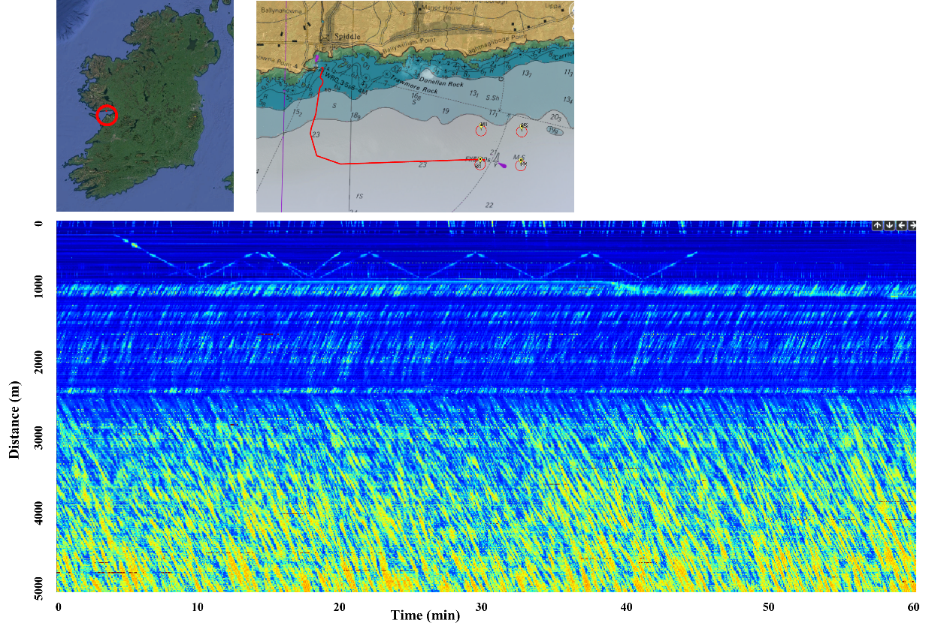
Main Road
Access Road/Pier
N-S marine section
E-W marine section

Figure 1 Smart Bay site location with fibre optic cable layout. 1 hour of DAS data showing different noise elements of terrestrial and ocean sections of cable.

Distributed Acoustic Sensing (DAS)
Distributed sensing works by transmitting a pulse of coherent optical laser signal through a single mode fibre optic cable and measuring the variations in the naturally backscattered light (Nickès & Ravet 2010) from microscopic variations in the glass core, due to strain changes. The phase of Rayleigh backscattered light along an optical fibre is well suited for monitoring dynamic strain changes, with a high spatial and temporal resolution. The application of this approach for measuring ground motion / seismic waves is called Distributed Acoustic Sensing (DAS). Current technologies are capable of resolving nano-strain induced by ground deformations from the interaction of acoustic waves with the fibre-optic cable (Jousset, et al. 2018, Masoudi, & Newson 2017, Trafford et al. 2022b)

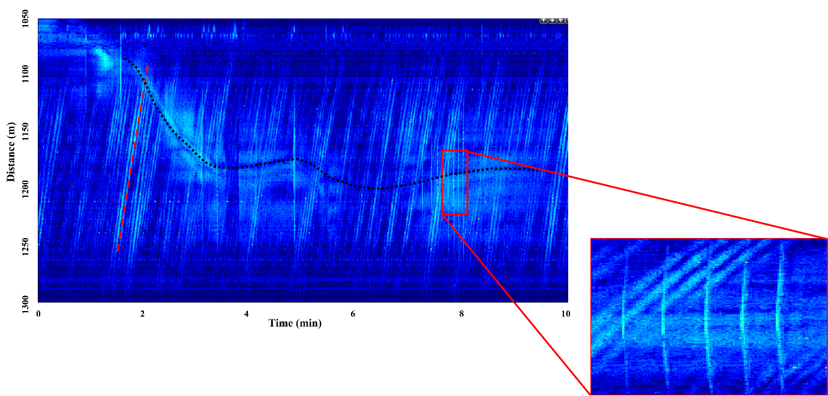

Figure 2 DAS data example showing noise from vessel (dashed black line), ocean wave orientation (red dashed line) and multiple shots from weight drop (inset)

Multichannel Analysis of Surface Waves (MASW)
MASW is a technique that involves measuring dispersive waves travelling through the subsurface and converting these into shear wave velocity (Vs) profiles. Park et al. (1999). The dispersive waveforms travel at different velocities / frequencies combinations controlled by the stiffness profile of the ground. Generated surface waves travel at velocities relating to the subsurface stiffness according to their individual wavelength. Dispersion images are created by converting the surface wave data to the phase velocity – frequency domain. The dispersion curves are picked from these images and inverted to 1D Vs profiles.
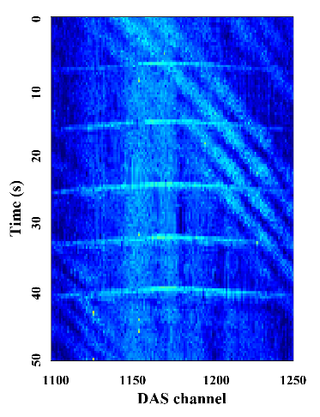
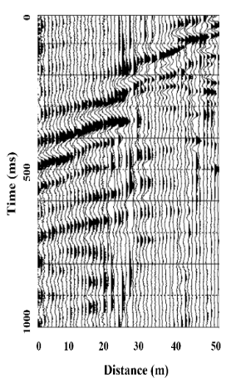
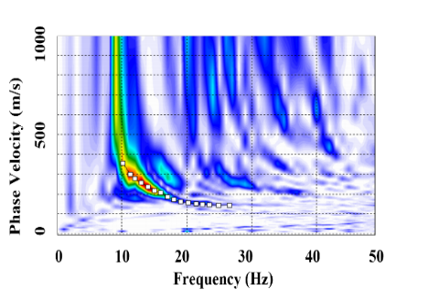
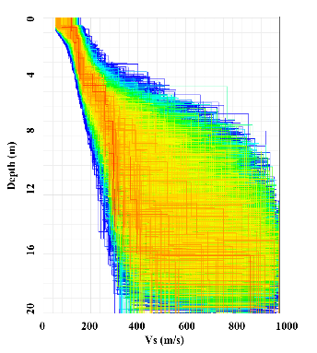

Figure 3 DAS data with 5 weight drop shots, extracted shot gather with processed dispersion image and inverted shear wave velocity model.
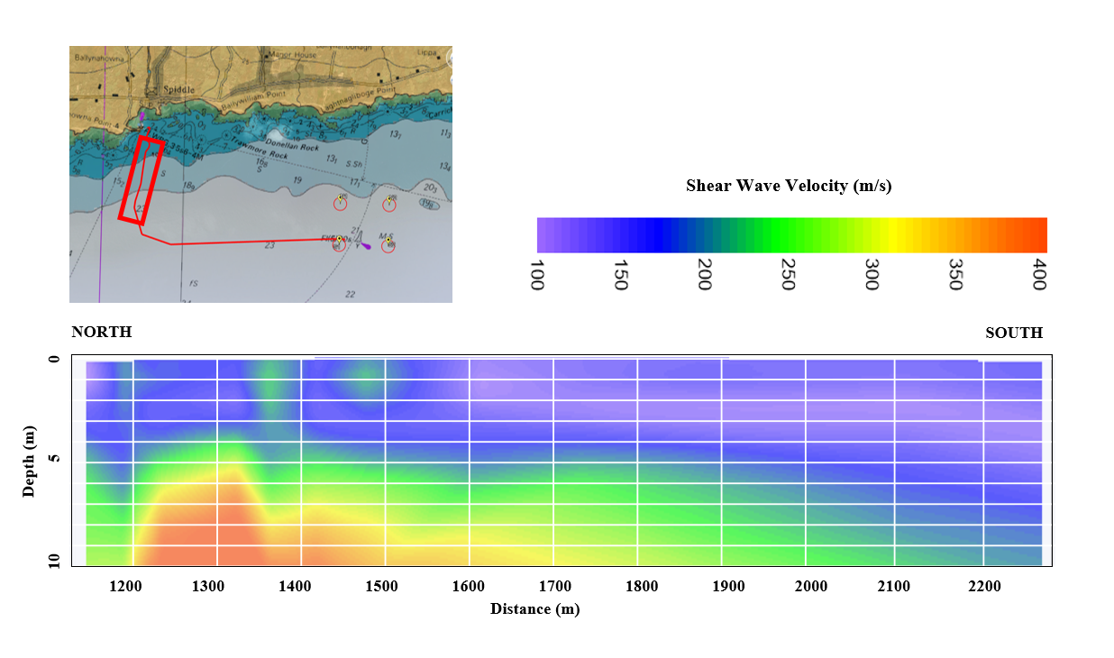
The data were analysed using both Surfseis and the Dinver software. Figure 3 shows the processing flow from shot gather to dispersion curve imaging to modelled Vs inversion. The analysis using the Monte Carlo method (Wathelet et al. 2004, 2008), has the benefit over the Surfseis inversion method (least squares approach) by giving an assessment of the level of uncertainty with depth (increasing wavelength).

Figure 4 2D Vs profile for N-S section of offshore cable showing increasing thickness of soft sediments with increasing distance offshore.

Ocean Waves
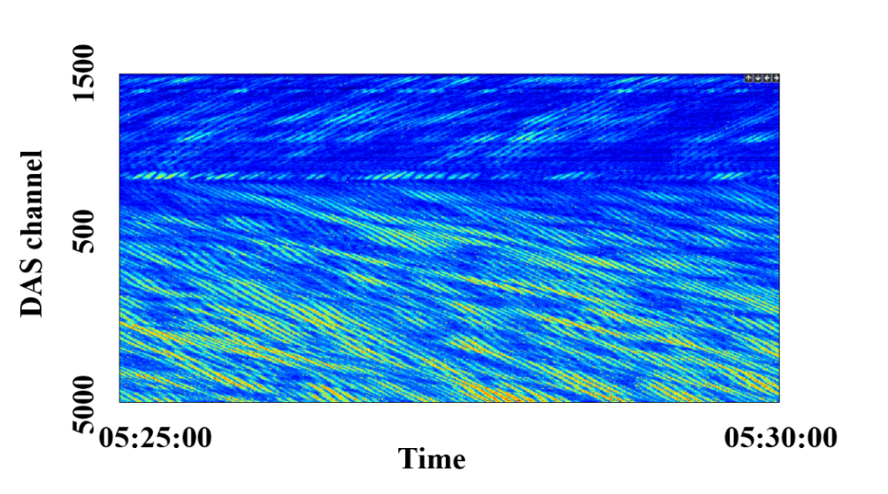
One area where DAS has been identified as having potential in offshore investigations is the detection of ocean waves through the pressure changes observed at the sea bed. These pressure changes from both wave and tide action are closely linked to the scour mechanisms taking place in many high energy marine environments.
N-S marine section
E-W marine section

Figure 5 5 minute long DAS record showing interaction of multiple ocean waves directions

Having the ability to determine the effect of wave and tide at the sea bed over long arrays would provide valuable information on the assessment of offshore infrastructure, particularly in the assessment of potential cable routes.

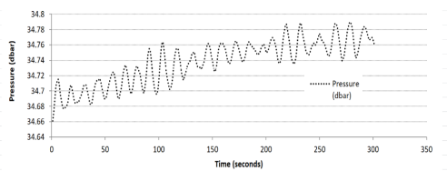

Figure 6 Example of absolute pressure data recorded using enduro data logger (Dundalk Bay)

Where perpendicular arrays are investigated, such as the Smart Bay cable, the true phase and group velocities of propagating ocean waves can be determined compared to the apparent velocity determination from linear arrays. Further work is required in order to determine whether the fibre response can be used to determine absolute pressure changes at the sea bed.

Conclusions
The study has shown that DAS is an effective approach to collecting both land and marine surface wave data and as such is an ideal method for the assessment of sites destined for the development of offshore renewables.

The real benefits of DAS for offshore investigations are in its ability to offer extensive sensor lengths from single cable deployments and the generation of detailed 2D shear wave profiles. The associated reduction in deployment and survey duration is particularly important when working in the marine environment due to potentially short and expensive weather windows.

The recent work also highlighted the effective use of low energy sources for the geotechnical assessment of sites with a significant reduction in the noise pollution and associated effects on marine mammals.

Acknowledgements
This project was being carried out by the Irish Centre of Research in Applied Geoscience (iCRAG) at UCD with funding from the Geological Survey of Ireland (GSI), Science Foundation Ireland (SFI), the European Regional Development Fund and Optasense Limited under Grant Number 13/RC/2092.

References
Nickès, M. & Ravet, F. Distributed fibre sensors: depth and sensitivity. Nat. Photonics 4, 431–432 (2010).
Masoudi, A. & Newson, T. P. High spatial resolution distributed optical fibre dynamic strain sensor with enhanced frequency and strain resolution. Optic Lett. 42, 290–293. (2017).
Jousset, P. et al. Dynamic strain determination using fibre-optic cables allows imaging of seismological and structural features, Nature Communications 9, 2509 (2018).
Park C.B., Miller D.M. & Xia J. Multichannel Analysis of surface waves. Geophysics 64, 3, 800–808 (1999).
Trafford, A., et al. (2021). The application of distributed acoustic sensing for shallow marine investigations an intertidal case study. EAGE NSG2021 27th European Meeting of Environmental and Engineering Geophysics. https://doi.org/10.3997/2214-4609.202120142
Trafford, A., et al. (2022a). Distributed acoustic sensing for active offshore shear wave profiling. Scientific Reports, 12, 9691 .
Trafford, A. et al. (2022b). An Assessment of Distributed Acoustic Sensing for Shallow Engineering Investigations EAGE NSG2022 28th European Meeting of Environmental and Engineering Geophysics, September, Belgrade, Serbia. https://doi.org/10.3997/2214-4609.202220118

