Children’s Ethno-National Flag Categories in Three Divided Societies

Jocelyn B. Dautel, Queen’s University Belfast

Edona Maloku, Rochester Institute of Technology Kosovo

Ana Tomovska Misoska, University American College Skopje

Laura K. Taylor, University College Dublin and Queen’s University, Belfast

Correspondence concerning this article should be addressed to Jocelyn Dautel, School of Psychology, Queen’s University Belfast, University Road, Belfast, BT6 9SG, United Kingdom. Email: jocelyn.dautel@qub.ac.uk

Acknowledgements: We would like to thank the many schools, parents, and children who participated in this research. The research was carried out as part of the Helping Kids! lab (helpingkidsqubblog.wordpress.com), with financial support from the School of Psychology Research Incentivisation Scheme (RIS) and the Department for the Economy (DfE) - Global Challenge Research Fund (GCRF) Award [DFEGCRF17-18/Taylor] and continuing support from GCRF-GIAA18-19/Taylor and British Psychological Society, Social Psychology Section, Pump-priming and Dissemination Fund Application. We also thank Risa Rylander for project management and Michal Fux and Amilcar Barreto for their helpful comments in the shaping of this paper. There are no conflicts of interest in the preparation or publication of this paper.

Abstract

Flags are conceptual representations that can prime nationalism and allegiance to one’s group. Investigating children’s understanding of conflict-related ethnic flags in divided societies sheds light on the development of national categories. We explored the development of children’s awareness of, and preferences for, ethnic flags in Northern Ireland, Kosovo, and the Republic of North Macedonia. Children displayed early categorization of, and ingroup preferences for, ethnic flags. By middle-childhood, children’s conflict-related social categories shaped systematic predictions about other’s group-based preferences for flags. Children of minority-status groups demonstrated more accurate flag categorization and were more likely to accurately infer others’ flag preferences. While most Balkan children preferred divided versus integrated ethnic symbols, children in the Albanian majority group in Kosovo demonstrated preferences for the new subordinate national flag. We discuss the implications of children’s ethno-national flag categories on developing conceptualizations of nationality and the potential for shared national symbols to promote peace.

Keywords: social cognition, nationality, flags, intergroup conflict

Children’s Ethno-National Flag Categories in Three Divided Societies
Flags are conceptual representations of group membership that can prime nationalism and allegiance to one’s group (Butz, 2009; Firth, 1973). Flags of rival groups in post-accord societies may fuel further divisions (Bryson & McCartney, 1994; Holmes & Cagle, 2000; Jarman, 1997; Morris, 2005). Yet, in settings of historic intergroup conflict, flags may also symbolize unity and peace. For instance, in Bolivia, the Wiphala flag holds dual status with the Bolivian flag; flown side by side, these flags symbolize unity with the indigenous minority population (Flesken, 2014). In Kosovo, the creation of a new flag after the break from Yugoslavia symbolized the formation of a new subordinate national identity—the Kosovar identity (Maloku, Derks, Van Laar, & Ellemers, 2016). Given these multiple meanings and representations, investigating children’s understanding of the symbolic content of flags representing conflict-related groups and national allegiances can shed light on early conceptions of nationality. Framed by Social Identity Development Theory (SIDT; Nesdale, 1999; 2004), we investigate the development of categorization of, and preferences for, ethnic flags in three post-accord societies: Northern Ireland (NI), the Republic of North Macedonia (RNM), and Kosovo.
NI, RNM, and Kosovo have each had a relatively recent period of intergroup violence sparked in part by contested national identities, resulting in two dominant ethno-national categories in each society. Here, ethno-national groups have a distinct ethnic heritage, culture, religion, and in the Balkans, also language. While all three societies have reached a formal peace agreement, intergroup tensions remain, and children are socialized in the history of intergroup conflict (Taylor & McKeown, 2019). For example, all three societies have divided education systems.
NI was formed with the partition of the island of Ireland in the early 1920s, resulting in a constitutional dispute over the sovereignty of the region. Now a part of the United Kingdom, Protestants and Catholics make up 48% and 45% of the resident NI population respectively (NI Census, 2011). Protestants, the historic majority status group, largely identify as British and/or Northern Irish, while Catholics, the historic minority status group, largely identify as Irish (ARK, 2019). The most recent period of intergroup violence known as the ‘Troubles’ (1968-1998) resulted from conflict over the authority of the region and the rights of Catholics. The region has been in relative peace, interspersed with bouts of tension, since the 1998 Good Friday Agreement.
RNM has a history of intergroup tension due to the rise of Albanian nationalism, traced back to the 1970’s in the former Yugoslavia. One major issue was the use of flags; the ethnic minority Albanians (25% of the population) preferred the Albanian ethnic flag (Figure 1). The ethnic majority group, Macedonians (64% of the population) viewed this nationalism and flagging as a sign of possible secession from the state. In 2001, violence erupted between Macedonians and Albanians, subsiding with constitutional changes implemented as part of the subsequent Ohrid Framework peace agreement granting more rights to Albanians (Reka, 2008). Macedonians viewed 2001 events as terrorism, while Albanians perceived the agreement as victory for Albanian human rights and national pride (Petroska-Beska & Najcevska, 2004; Serafimovska & Markovik, 2006). Distinct discourses of Macedonian and Albanian ethnic nationalism have led to polarization of the social space today (Atanasov, 2005; Trajkovski, 2005).
In Kosovo, a rise in Serbian nationalism following the succession of Slobodan Milosevic (1989–2004) and the breakup of Yugoslavia led to uprisings and armed conflict (1998-1999). The conflict was primarily between the Albanian ethnic majority (87% of the population) resisting oppression and seeking independence, and the Serb security forces (Serb ethnic minority make up about 8% of the population; European Centre for Minority Issues Kosovo, 2013). The 1999 Kumanovo Agreement set the stage for Kosovo’s declaration of independence from Serbia in 2008, which was celebrated by ethnic Albanians, but largely condemned by ethnic Serbs (Maloku, et al., 2016). Today, Europe’s newest country prides itself on being ‘newborn,’ and creating a ‘Kosovar identity’ to provide members of the two ethnic groups an overarching category that surpasses their ethnic sub-identification. The new national flag of the Republic of Kosovo was designed to resemble the flag of the European Union, also including a map of the country’s fragile borders, as well as six overarching white stars, each representing a formally recognized ethnic group in the country (Figure 2; see Maloku et al., 2016; Maloku, Kelmendi, & Vladisavljević, 2017; Maloku, Derks, Van Laar, & Ellemers, 2019 for more background on the post-independent identity-building process).
Learning about national categories can be quite complex, especially in societies such as NI, RMN, and Kosovo where overlap between nationality and ethnicity has been historically, or is currently, contested. Unlike other social categories (e.g. gender, race), nationality is often not a visibly identifiable social cue. Moreover, nations are an evolutionarily modern construct consisting of ‘imagined communities’ based on ethnic connections, both real and fabricated (Anderson, 1983). Nations, like ethnic groups, share myths of common ancestry (Connor 1994). The “formation of national identity is a dynamic, contentious, historical process of social construction” (Ting, 2008, p. 453), arising from shifting political demands of ethnic communities, such as requests for moderate forms of autonomy to the creation of a separate and sovereign states (Eriksen, 1993). National symbols can objectify the otherwise abstract political, social, and psychological construction of the nation (Butz, 2009; Firth, 1973). Indeed, for adults, flags are incredibly important for increasing, and sustaining, attention to national categories (Billig, 1995). Exposure to national flags can increase regard for flags, and subsequently, national identification (Kemmelmeier &Winter, 2008; Feschbach & Sakano, 1997; Schatz & Lavine, 2007). Thus, examining children’s awareness and preference for ethno-national flags has implications for their understanding of, and identification with, national categories.
Early work on children’s beliefs about national categories was based on stage theories of cognitive development, proposing that young children’s thinking about nationality was naïve (e.g. Piaget & Weil, 1951; Jahoda, 1963a). Such research proposed that cognitive limitations and lack of exposure to different national groups prevented young children from understanding civic relationships, for example, between nations and states or competing civic identities (e.g. that an individual who is Scottish is also by definition English; Jahoda, 1963a; see also Feeney, Dautel, Phillips, Leffers, & Coley, 2020, for an updated discussion of children’s theories of nationality). These conceptual errors are understandable given the complexity of nationality categories.
However, more recent work on the development of social cognition demonstrates that even young children hold systemic beliefs about abstract categories, such as nationality (Barrett, 2013; DeJesus, Hwang, Dautel & Kinzler, 2018; Feeney, et al., 2020; Hussak & Cimpian, 2019). Children demonstrate a remarkable ability to detect relevant and salient social information from their surroundings. By age 5, children identify their nationality and recognize their national flag (Barrett, 2013). Moreover, children integrate social information about an individual’s place of birth, language, and accent to make nationality judgments (Carrington & Short, 1995; DeJesus et al., 2018; Feeney et al., 2020). Particularly in societies in which social life is defined by ethnicity or nationality (Taylor, Dautel, & Rylander, 2020a), and divided between two significant subgroups (Brewer, 1999), children must understand the features associated with national categories to successfully navigate daily life.
Social Identity Development Theory (SIDT) provides a framework for investigating the development of ethno-national categories (Nesdale, 1999; 2004). SIDT outlines how children’s understanding and use of social categories is not only related to the development of cognitive abilities, but also to their social contexts (Nesdale, Maass, Durkin, & Griffiths, 2005). SIDT proposes four phases of ethnic categorization: (1) undifferentiated-- ethnic categories are not yet salient, (2) ethnic awareness-- children begin to attend to ethnic categories, (3) ethnic preference-- children develop a preference for the ethnic ingroup over the outgroup, and (4) ethnic prejudice- children demonstrate negative attitudes or behaviors towards the outgroup (Nesdale et al., 2005). Although SIDT predicts that ethnic awareness is foundational to the development of subsequent phases, children do not necessarily move through all phases. It is possible, for instance, to be aware of relevant ethno-national categories, and hold positive attitudes towards one’s ingroup, but not hold negative attitudes towards the outgroup (Bennett et al., 2004).
With a focus on effects of context, SIDT can be applied to understand the development of ethno-national categories that map onto salient conflict-related social groups. Tense intergroup relations or perceived threats to group status may shift the development of ethno-national categories from ethnic awareness to also include increased preferences for the ingroup and/or prejudice toward the outgroup (Oppenheimer, 2011). For instance, of children raised amid intergroup tensions in the Basque Country, those from Basque-speaking homes considered themselves ‘from Basque country’ while those from Spanish-speaking homes considered themselves to be ‘from Spain;’ here children also assigned positive and negative attributes to their perceived ingroup and outgroup respectively (Reizábal, Valencia, & Barrett, 2004). Similarly, in NI, children’s strength of national identity was positively correlated with positive attitudes towards the ingroup, but only Catholic (not Protestant) children’s national identification was correlated with negative attitudes toward the outgroup (Gallagher & Cairns, 2011). Thus, childhood is a critical period for social categorization as the developmental trajectory of ethnic awareness and group preference can shape later intergroup relations.
For ethno-national categories of an abstract nature and that cannot be easily visually distinguished, such as those discussed here, group symbols may be especially informative (Brewer, 1999). Indeed, children demonstrate early awareness of national symbols. Quantitative studies measuring European children’s awareness of a range of national and cultural symbols, find that children recognize national symbols (e.g. flags, anthems, historical icons), and that knowledge increases with age (Barrett, 2013; Jahoda, 1963b). In post-accord societies of NI and RNM, children categorized a range of conflict-related social and cultural group symbols (e.g. representing sports, foods, religious, geographical markers, and flags) by group labels (NI: Protestant/Catholic/British/Irish and RNM: Macedonian/Albanian; Taylor et al., 2020a; Tomovska Misoska, Taylor, Dautel & Rylander, 2020). In both societies, children were able to accurately categorize symbols related to both their ingroup and outgroup categories by the age of six, and awareness of conflict-related symbols increased with age. Furthermore, in NI, children categorized symbols more accurately by ethno-national labels (British/Irish) than ethno-religious labels (Protestant/Catholic), demonstrating the salience of national categories in this setting. Thus, in line with SIDT, children demonstrate awareness of ethno-national symbols and categories early in childhood.
Current Study
Because of the prevalence of flags as national emblems, and the importance of flags for objectifying and maintaining the salience of national categories (Billig, 1995; Butz, 2009), it is paramount to explore children’s reasoning about flags, specifically, in relation to conflict-related ethno-national categories (Oppenheimer, 2011). First, we aim to investigate the development of children’s categorization of, and preferences for, ethno-national flags across three post-accord societies. While children as young as five identify with their nationality, the degree of identification and subjective importance placed on national identity increases with age across early- to middle-childhood (Barrett, Wilson & Lyons, 2003). In line with these findings and with SIDT, we hypothesize that children’s awareness of, and preferences for, ethno-national flags will also emerge early and increase with age. Moreover, we employ two tasks to test children’s preferences, one asking children which flag they themselves prefer, and also, which flag they predict another fictitious child, labelled as an ingroup or outgroup member, would prefer. When reasoning about gender and race categories, for example, children first demonstrate first-person preferences, with third-person preferences coming in only once categories are robust enough to support such inferences (Shutts, Pemberton Roben, & Spelke, 2013). Including both measures of first-person and third-person preferences here allows us to explore further nuance in the development of ethno-national flag categories. We predict that reasoning about ethno-national flags will initially be employed for first-person preferences, then subsequently adapted for reasoning about other ingroup and outgroup members’ preferences.
Second, by investigating children’s reasoning about flags across three societies, we aim to explore both between- and within-society variation. Between societies, we predict that socio-political factors and the nature of intergroup relations will affect children’s ethno-national categories (Bar-Tal, 1997; Oppenheimer, 2011); children exposed to more recent periods of violence may develop ethno-national flag categories earlier and more robustly. To explore within-society variation based on group status, we include samples from the majority, as well as the conflict-related ethno-national minority (NI: Protestant/Catholic; RNM: Macedonian/Albanian; Kosovo: Albanian/Serbian). That is, although there may be other minority groups, the study focuses on the two ethno-national groups underpinning intergroup conflict. There is evidence that children living in the same geographical setting, but belonging to different ethno-national groups, differentially identify with their nationality (Barrett, 2002; Gallagher & Cairns, 2011; Reizábal, et al., 2004) and prefer different ethno-national symbols (Connolly, 2003; Moodie, 1980). For instance, a qualitative interview of children in NI found that Protestant children preferred the British Union Jack flag while Catholic children expressed preferences for the Irish tricolour flag (Connolly, 2003). We hypothesize majority and minority status children may demonstrate different levels of categorization of, and preferences for, ingroup versus outgroup ethno-national flags. Past research finds children in ethnic majorities exhibit stronger ingroup preferences than children in ethnic minorities (e.g. Griffiths & Nesdale, 2006), however less is known about differences by group status in post-accord societies.
Lastly, we aim to explore children’s preferences for flags symbolizing unity versus division. After conflict, flags may also be used as tools for building cohesion rather than continued division. Children’s understanding of the symbolic functions of flags shifts across development; not only symbolizing ‘us and them,’ children begin to understand flags as conventionally agreed symbols representing people sharing common allegiances and goals (Wienstein, 1957). Moreover, children view flags as social conventions that can be altered by consensus or shared agreement (Helwig & Prencipe, 1999). Thus, children’s developing ability to understand flags as shared symbols lends promise to generations born of peace being agents of change, consistent with the Developmental Peacebuilding Model (Taylor, 2020). Toward that end, in the Balkans we explore majority and minority group children’s preferences for ethno-national flags flown together or apart.
Method
Participants
Northern Ireland
Children were recruited through six schools, three state-controlled, de facto Protestant schools and three Catholic maintained schools. Based on exclusion criteria, ten participants born outside of the British Isles or Ireland and nine children belonging to other ethnic minorities were removed from analyses. The final sample included 291 5- to 10-year old children (51% male, M_{age} = 7.53, SD = 1.56). The sample was evenly split by background (49% Protestant, 51% Catholic).
Republic of North Macedonia
Children were recruited from two schools located in mixed municipalities. Both schools had two languages of instruction, Macedonian and Albanian, and children attended classes in one of those languages based on their ethnicity. One school was located in a town where Albanians are the local majority and the other school was located in a big city where Macedonians are the local majority. Fourteen participants were removed because they belonged to another ethnic minority. The final sample consisted of 192 6- to 10-year-old children (55% male, M_{age} = 8.38, SD = 1.40) and evenly split by ethnic background (45% Macedonian, 55% Albanian).
Kosovo
Albanian children were recruited through two majority-Albanian schools. Due to political tensions at the time of recruitment, some Serbian participants were recruited from two majority-Serbian schools (N=64), while others were recruited directly by the local RA and tested in their homes (N= 35). Eight participants were removed because they belonged to other ethnic minorities. The final sample included 220 6- to 10-year-old children (50% male, M_{age} = 8.07, SD = 1.31) and evenly split by background (54% Albanian, 46% Serbian).
Materials and Design
Flag images were presented as part of a larger study investigating children’s first- and third-person preferences, and categorization of, a variety of ethnic group symbols (see Taylor et al., 2020a; Tomovska Misoska et al., 2020; and Maloku, Derks, Van Laar, Ellemers, Taylor, & Dautel, under review for reports on children’s categorization of and preference for ethnic symbols in each society). Within the current study, children were presented with divided flag trials; this included paired images of flags from the dominant conflict-related national categories in each site (Figure 1). Children in the two Balkan sites (but not in NI) were also presented with an integrated flag trial to explore preferences for shared national symbols (Figure 2). In RNM, the integrated flag trial presented an image of participants’ ingroup flag only paired with an image of their ingroup and outgroup flags flown together. In Kosovo, the integrated flag trial presented an image of participants’ ingroup flag only paired with an image of their ingroup flag paired with the new national Republic of Kosovo flag. On all trials, the side of the screen each flag appeared on was randomized across children.
In the categorization question capturing ethno-national awareness, children were presented with the divided flag trial and asked to select which flag ‘belonged’ to a labelled category. NI children were randomly presented with one of four labels representing nationality or ethno-religious identity (“Which of these is British/Irish/ Protestant/Catholic). Balkan children were randomly presented one of two labels (Kosovo: “Which of these is Albanian/Serbian;” RNM: “Which of these is Macedonian/Albanian). Whether children were presented an ingroup or outgroup label was randomly assigned across children. Researchers assisted children in dragging and dropping the chosen flag into a labelled box. Reponses to this task were coded for accuracy of sorting images to the social label, whereby accurate sorting responses were coded 1, and inaccurate sorting responses were 0.
To explore children’s first-person preference we asked, “which one do you like better?” and children selected which of the two flags they preferred. Children were first presented with the divided flag trial; selection of an ingroup flag was coded 1 and selection of an outgroup flag was coded 0. Balkan children were then presented with the integrated flag trial; selection of an ingroup flag was coded 1 and selection of the integrated flags was coded 0.
To learn children’s third-person preference participants were introduced to a fictitious, gender-matched target child from their society, represented as a simple cartoon face, and asked about this other child’s preferences. Whether the fictitious child was labelled an ingroup or outgroup member was randomly assigned across children. For example, the researcher would read “This is a girl/boy from Kosovo. She/he is Albanian/Serbian.” Children in all sites were again presented with the divided flag trial. The researcher asked: “Which one does he/she like better?” Results were coded such that choosing the ingroup flag of the target character was coded 1, while choosing the outgroup flag of the target character was coded 0. Balkan children were then presented with the integrated flag trial and asked about the same target ingroup or outgroup character’s preference; selection of the target character’s ingroup flag flying alone was coded 1, and selection of the integrated flags was coded 0.
The order in which children were presented categorization, first-person and third-person questions was randomized across children. For the first-person preference and third-person preference questions, participants saw a randomly selected subset of ten pairs of images from the broader study of ethnic symbols, resulting in only approximately 50% of the total sample of participants viewing the divided flag trial for these questions. The order in which the flag trials appeared amongst other symbol pairs in the broader study was also randomized.
Procedure
All procedures were approved by the Ethics Committee at Author Identifying University. In schools, principals provided informed consent. All parents also provided informed consent and provided the demographic information for the child; children provided assent prior to participating by pointing at a happy face to opt in or a frown face to opt out. Research assistants (RAs) across sites were trained as part of the Author Identifying Lab. Children completed the study, one-on-one with a RA in a quiet area of their school or home. Testing sessions were delivered via Qualtrics on tablets and lasted approximately 15 minutes. RAs followed a script in the child’s native language (e.g., Serbian, Albanian, Macedonian, or English). Each task began with an introductory slide where the researcher provided a brief overview, reassured the participant that there were no right or wrong answers, and answered any questions before beginning. Throughout the session, children were rewarded with stickers, and at completion, received a certificate and a small prize. Preliminary analyses did not identify any significant differences in children’s responses across RAs.
Results
Divided Flag Trials
One sample t-tests were conducted to examine flag categorization and preferences against chance. Overall, children demonstrated accuracy in categorizing flags; on the categorization task, 85% children selected the accurate national label (t(700)= 63.75, p < .001). Children also demonstrated strong preferences for their ingroup versus outgroup flag; in the first-person preference question, 92% children reported liking their ingroup flag better (t(418)= 31.2, p< .001). On the third person preference question, 78% children reported a fictitious child would prefer their ingroup flag too (t(451)= 14.43, p< .001). A further series of one-sample t-tests, with Bonferroni corrections for multiple comparisons (p= .05/16= .003), revealed that in each site children demonstrated first-person preferences for ingroup flags by age 6 (Figure 3), accurate categorization of flags by age 6 in Kosovo and RNM, but not until age 7 in NI (Figure 4), and hypothesized third-person preferences by age 7 in Kosovo and RNM, but not until age 9 in NI (Figure 5).
Chi-square tests demonstrate that children were equally accurate in categorizing flags when presented with an ingroup or outgroup label across each setting. However, when predicting third-person preferences, participants’ choices were influenced by the group membership of the target character presented. Across settings, 87.8% of participants predicted a fictitious ingroup member would have an ingroup flag preference (e.g. a Catholic participant matched a Catholic character to the Irish Tricolor flag), while only 68.8% of participants predicted a fictitious outgroup member would have an outgroup flag preference (e.g. a Catholic participant matched a Protestant character to the British Union flag; X² (1)= 23.72, p< .001). In other words, children were more likely to predict ingroup members’ preferences in the hypothesized direction than outgroup members’ preferences.
Binary logistic regressions were conducted for each question type to explore the influence of children’s age, gender, group status, and research setting (two dummy variables: Kosovo = 1 and all else =0; RNM= 1 and all else = 0) on flag categorization and preferences. First, a logistic regression model testing whether age, gender, group status, and research setting would predict the likelihood that participants would accurately categorize a flag to a given label was significant (X² (5) = 163.71, p < .001), explaining 36.8% (Nagelkerke R²) of the variance in flag categorization and accurately classified 86.7% of cases (Table 1). According to the model, the log of the odds of a child accurately categorizing a flag was positively related to age. Females had 2.12 times higher odds of accurately categorizing flags than males. Children in RNM (97.9%) and Kosovo (94.1%) were more likely to categorize flags accurately than children in NI (70.3%). Whether children were minority or majority group status did not relate to their accuracy in flag categorization.
Next, a logistic regression model testing whether age, gender, group status, and research setting would predict the likelihood that participants would demonstrate first-person preferences for their ingroup flag was significant, X² (5) = 38.89, p < .001. The model explained 20.9% (Nagelkerke R²) of the variance in first-person flag preferences and correctly classified 92.1% of cases. Of the five predictor variables, four were statistically significant: age, group status, and RNM and Kosovo dummy variables (Table 1). Increasing age was associated with an increased likelihood of an ingroup flag preference. Children in the majority status group had 4.35 times higher odds of demonstrating an ingroup flag preference compared to children in the minority status group. Children in RNM (98.3%) and Kosovo (95.5%) were more likely to choose their ingroup flag than children in NI (83.7%). Children’s gender did not relate to their flag preference.
Lastly, a logistic regression model testing the effects of age, gender, group status, and research setting on the likelihood that participants would predict third-person flag preferences was statistically significant, X² (5) = 71.28, p < .001. The model explained 22.4% (Nagelkerke R²) of the variance in third-person flag preferences and accurately classified 79.2% of cases. Age and group status were statistically significant predictors of third-person flag preferences (Table 1) such that increasing age was associated with an increased likelihood of predicting another’s ingroup versus outgroup flag preference. Compared to children in the minority status group, children from the majority status group had 0.44 times lower odds of predicting another’s ingroup flag preference. Only 70.9% of children from the majority status group predicted another’s ingroup flag preference compared to 85.6% of children from the minority status group. Children in RNM (86.0%) and Kosovo (84.3%) were more likely to predict another’s ingroup flag preference than children in NI (64.7%). Children’s gender did not relate to their predictions of others’ ingroup flag preferences.
Integrated Flag Trials
RNM: Ingroup Flag Alone Versus Two Ethno-National Flags Flown Together
One sample t-tests were conducted to examine first and third-person preferences for an ingroup flag over integrated flags against chance. RNM children demonstrated first-person preferences for their ingroup flag flown alone versus the two ethnic flags flown together (M = .79, SD = .41, t(219)= 3.45, p = .001) and predicted another target character would hold preferences for their ingroup flag flown alone too (M = .80, SD = .40, t(188)= 10.51, p < .001). A binomial logistic regression model investigating influence of age, gender, and group status on RNM children’s first-person flag preference was only marginally significant (X² (3) = 7.29, p = .06), demonstrating a trend toward increased preference for the ingroup flag flown alone with age (Table 2). However, a binomial logistic regression investigating the effects of age, gender, and group status on the likelihood that participants would predict another child’s preference for their ingroup flag flown alone versus two flags flown together was statistically significant, X² (3) = 14.70, p = .002. The model explained 11.9% (Nagelkerke R²) of the variance in others’ flag preferences and correctly classified 80.4% of cases. Of the three predictor variables, only age was statistically significant (Table 2). Increasing age was associated with an increased likelihood of predicting another’s ingroup flag only preference versus integrated ingroup and outgroup flags. Children’s gender nor group status related to their predictions of others’ flag preferences.
Kosovo: Ingroup Flag Alone Versus Ingroup Flag Together with National Kosovar Flag
In Kosovo, a one-sample t-test conducted to examine children’s first-person preferences for their ingroup flag flown alone, versus their ingroup flag flown together with the national Kosovar flag, did not differ from chance (M = .52, SD= .50, t(219)=.67, p = .50). However, children’s first-person preferences varied by group status (X² (1) = 130.69, p < .001). Children in the Albanian, majority-status group preferred the image of the Albanian flag flown together with the Kosovo national flag over the Albanian flag flown alone (M= .17, SD= .38, t(118)= -9.64, p< .001). However, children in the Serbian minority status group preferred the Serbian flag flown alone versus the Serbian flag flown together with the Kosovo national flag (M= .94, SD= .24, t(100)= 18.64, p < .001). A binomial logistic regression investigating the effects of age, gender, and group status on the likelihood that participants would prefer their ingroup flag flown alone versus two flags flown together was statistically significant, X² (3) = 156.11, p < .001. The model explained 67.8% (Nagelkerke R²) of the variance in others’ flag preferences and correctly classified 88.2% of cases. The model confirmed the findings above by group status, and additionally found that with age, children demonstrated a decreased preference for the ingroup flag flown alone (Table 3). Children’s gender was not related to their integrated flag preferences.
When asked about third-person preference, again, overall, children’s predictions of others’ preferences for integrated flags did not differ from chance (M = .55, SD = .50, t(219)=1.62 , p= .11). But, children’s third-person preferences differed by group status (X²(1) = 71.17, p < .001). On the one hand, children from the Albanian majority-status group believed a target character would prefer an ethno-national ingroup flag flown together with the Kosovar national flag over an ethno-national ingroup flag flown alone (M= .29, SD= .46, t(118)= -4.91, p< .001), regardless of whether the target character was labelled as an Albanian ingroup or Serbian outgroup member. On the other hand, children from the Serbian minority-status group believed a target character would prefer an ethno-national ingroup flag flown alone versus an ethno-national ingroup flag flown together with the Kosovar national flag (M= .86, SD= .35, t(100)= 10.46, p< .001), regardless of whether the target character was labelled as an Albanian outgroup or Serbian ingroup member. A binomial logistic regression modelling the influence of age, gender, and group status on children’s third-person integrated flag preferences (Table 3; X² (3) = 77.61, p < .001, Nagelkerke R² = .40), confirmed these differences by group status, but neither age nor gender were significant predictors.
Discussion
Across three post-accord generations of children born after the height of conflict, we demonstrate that the symbolic nature of children’s national categories is rooted in group-based cognition. Overall, children displayed early awareness of, and ingroup preferences for, ethno-national flags. In addition, by at least middle-childhood, children’s ethno-national social categories shaped systematic predictions about others’ group-based preferences for flags. Children’s group-based cognition was stronger in the Balkan countries, where history of conflict is more recent and perhaps more salient, than in NI. Children from majority groups demonstrated stronger ingroup flag preferences, while children from minority groups demonstrated more accurate flag categorization, and were more likely to infer others’ flag preferences in the hypothesized direction. Given the option of divided or integrated flags, most children preferred division. However, children from the majority group in Kosovo demonstrated a preference for the new, supra-ethnic national flag flown together with their ingroup ethno-national flag. We discuss theoretical implications for children’s development of national categories, and practical implications for the potential of symbols to unite divided nations.
Development of Ethno-National Flag Categories
In line with Social Identity Development Theory (SIDT, Nesdale, 1999; 2004), children demonstrated early awareness of, and preferences for, ethno-national flags; both increase with age. Adding to the literature on children’s developing awareness of ethnic and national symbols (Barrett, 2013; Connolly, 2003; Taylor et al., 2020a; Tomovska Misoska et al., 2020), flags are meaningful symbols for young children, representing abstract and largely invisible ethno-national categories. Yet, while SIDT predicts that ethnic awareness emerges first, followed by ethnic preference (Nesdale, 1999), this developmental pattern was not clear with ethno-national flags. For example, children in the Balkans accurately categorized ethno-national flags and demonstrated first-person flag preferences at age six, the age in which children enter primary school. In NI, children’s first-person preferences were present by age six, but accurate categorization appeared at age seven. It is possible that in settings of intergroup tensions where ethno-national emblems are particularly salient, ingroup preferences emerge early for familiar symbols, in line with, or followed by knowledge of category labels. To further investigate the developmental patterns of awareness of, and preference for, ethno-national symbols, studies of younger children across societies with and without historic intergroup conflict is necessary.
Our study design allowed for further investigation of the robustness of children’s ethno-national categories across development by probing third-person preferences, in which children predicted another’s flag preference. While first-person preferences emerged by age six, third-person preferences for the ingroup ethno-national flag emerged by age seven in the Balkans, and by age nine in NI. Like children’s reasoning about gender and race categories (Shutts, et al., 2013), here we find that reasoning about ethno-national flags is initially employed for first-person preferences. Third-person preferences may emerge only once categories are robust enough to support such inferences. Moreover, despite children being equally accurate at categorizing ingroup and outgroup ethno-national flags, children’s third-person preferences were influenced by whether the target character was an ingroup or an outgroup member. Children were more likely to predict an ingroup target would prefer an ingroup flag compared to predicting an outgroup target would prefer an outgroup flag (e.g. a Catholic participant was more likely to predict another Catholic child would prefer the Irish tricolor flag than they were to predict a Protestant child would prefer the British Union flag). The nuance in children’s third-person preferences may be due to the development of tangential socio-cognitive processes, such as perspective-taking skills, which are also affected by intergroup cognition. For instance, young children tend to use more mental state words (e.g. want, know) when describing ingroup versus outgroup actions (McLoughlin & Over, 2017), and Turkish adolescents were more accurate at inferring mental states of Turkish ingroup members than Syrian outgroup members (Gönültaş, Selçuk. Slaughter, Hunter & Ruffman, 2019). Alternatively, differences in third-person flag preferences based on group membership of the target may also have resulted from children selecting their own ingroup flag more often, regardless of how the target character was labelled. Future research should investigate tangentially developing social and cognitive skills in relation to the development of third-person preferences.
Between- and Within-Society Variation in Ethno-National Flag Categories
As predicted, there was both between-and within-society variation in children’s ethno-national flag categories and preferences. Children in the Balkans were more likely to accurately categorize ethno-national flags and were more likely to demonstrate first- and third-person preferences for the ingroup flag, compared to children in NI. This may be due to differences in the recency of intergroup conflict between Balkan societies and NI. Such differences in children’s ethnic awareness and ingroup identification based on competition or intergroup conflict may result in the development of outgroup prejudice (Nesdale, et al., 2005; Oppenheimer, 2011). Further study of children’s social motivations in post-accord societies are warranted, given the implications for later intergroup relations.
Moreover, consistent differences in ethno-national flag categorization and preferences were found based on children’s majority versus minority group status within all three societies. Consistent with past research finding stronger ingroup preferences among children belonging to racial and ethnic majority groups (e.g. Aboud, 1988; Griffiths & Nesdale, 2006), children in ethno-national majority-status groups were more likely to demonstrate first-person ingroup flag preferences compared to children in minority-status groups. Again, in line with SIDT, threats to majority group status in such contexts of historic ethno-national conflict may motivate stronger ingroup preferences, with potential consequences for outgroup prejudice (Nesdale et al., 2005; Oppenheimer, 2011). However, children in minority-status groups across all three post-accord societies were more likely to accurately categorize ethno-national flags and more likely to accurately infer third-person flag preferences. The greater robustness in minority-status children’s ethno-national categories may result from motivations to attend to meaningful group symbols in order to successfully and safely navigate complex social environments. Parents of children in ethnic minorities may be more likely to engage in ethnic socialization and preparation for bias (Hughes et al., 2006). Future research should explore influences of different social motivations between- and within-societies on the development of ethno-national categories and preferences, which in turn have implications for conceptions of nationality and peacebuilding.
Children’s Preferences for Divided versus Integrated Flags
Lastly, explorations of divided versus integrated flag preferences in the Balkans provide insight into the potential of symbols for building united nations. In RNM, children preferred divided versus integrated ethno-national symbols, and expected another would prefer divided symbols too. Both first-and third-person preferences for division increased with age. In Kosovo, children in the Serbian minority group also preferred their ingroup ethno-national flag flown alone. However, children in the Albanian majority group preferred the new, supra-ethnic Kosovo national flag flown together with their ingroup flag. Interestingly, in Kosovo, children expected other’s preferences would match their own preferences regardless of ethnic background, such that Albanian children predicted either another Albanian or Serbian child would also prefer an ethno-national ingroup flag (i.e. Albanian) flown together with the Kosovo national flag, while Serbian children predicted another Albanian or Serbian child would prefer an ethno-national ingroup (i.e. Serbian) flag flown alone. In Kosovo, children’s differing preferences for the new Republic of Kosovo flag by ethno-national background are in line with findings with children’s and adults’ ethnic and national identification. In recent work (Maloku, et al., under review), the Albanian children developed a preference for the Kosovar identity with age, while for Serb children this was not the case. Similarly, Albanian adults in Kosovo report identification with both the ethnic Albanian identity and the national Kosovar identity to a similar degree, while Serbs identify highly with their Serbian ethnicity, but not the national Kosovar identity (Maloku et al., 2016). Yet, across groups, children in Kosovo demonstrated a decreased preference for an ethno-national flag flown alone with age. Thus, there is potential for children born in generations of peace to identify with uniting national symbols across development, and in turn, these children may be more open to unfreezing conflict dynamics (Taylor et al., 2014; Taylor, Štambuk, Čorkalo Biruški, & O’Driscoll, 2020b). Future research might investigate factors that predict preferences for uniting national symbols, with an eye towards inclusive practices for minority-status groups.
Ethnic and Civic Conceptions of Nationality
Taken together, these findings add to our theoretical understanding of children’s conceptualization of nationality. In contexts of historic intergroup conflict, children are aware of, and identify with, flags relating to ethno-national group membership. In some cases, children’s ethno-national flag preferences differ from the official national flag. For instance, in NI and RNM, where the official ‘national’ flag aligns with the historic ethnic majority group (e.g. the only official flag of NI is that of the United Kingdom), children demonstrate awareness of both the national flag and the other conflict-related ethno-national flag. Yet, early flag preferences differed across children in the same society, and children from minority-status groups demonstrated preferences for the flag of their ethno-national ingroup, over the official symbol of their ‘nation.’ Future research may explore children’s reasoning about other national symbols, such as passports (e.g. citizens in Northern Ireland can opt for an Irish or United Kingdom passport as a result of the peace accord).
Political science and sociology literature differentiate between two conceptions of nationality: ethnic and civic (Smith, 2001). Under an ethnic theory of nationality, national category membership is derived from descent and common ancestry, resulting in a focus on native ethnic traditions and symbols. Alternatively, under a civic theory of nationality, national category membership is derived through legal definitions of citizenship, and measured by commitment to the nation’s institutions, which may change based on consensus. In post-accord regions, children’s preference for ingroup ethno-national flags points towards an early ethnic conception of nationality, with import placed on their native ethnic symbols. This is consistent with evidence that children may initially conceptualize national category membership as biologically inherited (Davoodi, Soley, Harris & Blake, 2019; Hussak & Cimpian, 2019) and believe that it is not possible to hold more than one civic identity (e.g. Northern Irish and British; Jahoda, 1963a). While these beliefs tend to decline with age (Feeney et al., 2020; Jahoda, 1963a; Hussak & Cimpian, 2019), an early ethnic construal of nationality might give rise to greater identification with ingroup ethno-national symbols.
Yet, there is further evidence that even young children evidence both ethnic and civic conceptions of nationality (Feeney et al., 2020), at least for national categories without history of conflict. In NI, four- to eleven-year-old children presented with hypothetical vignettes about an immigrant child whose parents were Polish but who grew up in NI, and provided with varied information about the immigrant child’s place of birth (Poland versus NI) and accent (Polish versus Northern Irish). Children were asked the nationality of the immigrant child. Across vignettes, children’s modal response was ‘both Polish and Northern Irish,’ suggesting that children do not have a strict ethnic nor a strict civic theory of nationality. Rather children’s conceptions of national categories can be characterized by elements of both types of theories (Feeney et al., 2020). Further research is necessary on children’s ethnic and civic conceptions of nationality in divided societies, including both newcomer nationalities as well as ethno-national categories relevant to the historic divide (e.g., Gallagher & Cairns, 2011). As suggested here, children in societies characterized by a salient, dichotomous social division may hold stronger ethnic theories of nationality. However, Albanian children in Kosovo held preferences for images integrating national and ethnic flags, suggesting the potential for the amalgamation of civic and ethnic conceptions of nationality in childhood. Using flags as conventionally agreed symbols of a common social identity (e.g. Maloku et al., 2016; McKeown, 2014) and to represent people sharing common allegiances and goals (Wienstein, 1957) may foster civic versus ethnic conceptions of nationality, which has been found to moderate the link between ingroup identification and outgroup prejudice (Pehrson, Vignoles & Brown, 2009).
Conclusion
We demonstrate children’s understanding of, and preference for, ethno-national flags across three post-accord societies. Children evidenced systematic reasoning about ethno-national categories despite the complexity of abstract national categories, especially in societies where nationality and national borders are historically contested. In line with SIDT, children’s ethno-national flag awareness and ingroup preference increased with age. Contextual factors such as socio-political context and group status influenced children’s ethno-national categories and preferences. When presented with integrated versus divided ethno-national symbols, most children preferred division. Such group-based national cognition in children aligns with ethnic construals of nationality, which has potential implications for intergroup relations. Future research should investigate factors that promote unifying national symbols, while also protecting the rights of minority groups (e.g. Maloku et al., 2016; McKeown, 2014), among future generations in divided societies.

References
Aboud, F. E. (1988). Children and prejudice. Oxford: Basil Blackwell Inc.
Anderson, B. (1983). Imagined Communities: Reflections on the Origin and Spread of Nationalism. London: Verso.
ARK. Northern Ireland Life and Times Survey. (2019). ARK www.ark.ac.uk/nilt, June 2020.
Atanasov, P. (2005). Macedonian multicultural model: Class and ethnicity as factors of mobilization. In I. Dodovski (Ed.), Multiculturalism in Macedonia: An emerging model (pp. 55-66). Skopje: Open Society Institute Macedonia.
Barrett, M. (2002). Children’s views of Britain and Britishness in 2001 [Keynote address]. Annual Conference of the Developmental Psychology Section of the British Psychological Society, University of Sussex. http://epubs.surrey.ac.uk/1644/1/fulltext.pdf
Barrett, M. (2013). Children's knowledge, beliefs and feelings about nations and national groups. Psychology Press.
Barrett, M., Wilson, H., & Lyons, E. (2003). The development of national in‐group bias: English children's attributions of characteristics to English, American and German people. British Journal of Developmental Psychology, 21(2), 193-220.
Bar-Tal, D. (1997). Formation and change of ethnic and national stereotypes: An integrative model. International Journal of Intercultural Relations, 21(4), 491-523.
Bennett, M., Barrett, M., Karakozov, R., Kipiani, G., Lyons, E., Pavlenko, V., & Riazanova, T. (2004). Young children's evaluations of the ingroup and of outgroups: A multi‐national study. Social development, 13(1), 124-141.
Billig, M. (1995). Banal nationalism. London: Sage Publications.
Brewer, M. (1999). The Psychology of Prejudice: Ingroup Love and Outgroup Hate? Journal of Social Issues, 55(3), 429-444. https://doi.org10.1111/0022-4537.00126
Bryson, L. & McCartney, C. (1994). Clashing symbols? A report on the use of flags, anthems and other national symbols in Northern Ireland. Institute of Irish Studies, The Queen's University of Belfast.
Butz, D. A. (2009) National symbols as agents of psychological and social change. Political Psychology, 30(5). https://doi.org/10.1111/j.1467-9221.2009.00725.x
Carrington, B. & Short, G. (1995). What makes a person British? Children’s conceptions of their national culture and identity. Educational Studies, 21(2), 217-238. https://doi.org/10.1080/0305569950210206
Connolly, P. (2003). The development of young children’s ethnic identities. In C. Vincent (Eds.), Social Justice, Education and Identity (165-182). Routledge.
Davoodi, T., Soley, G., Harris, P. L., & Blake, P. R. (2020). Essentialization of social categories across development in two cultures. Child development, 91(1), 289-306.
DeJesus, J., Hwang, H., Dautel J. B., & Kinzler, D. (2018). “American = English Speaker” before “American = White”: The development of children’s reasoning about nationality. Child Development, 89(5). https://doi.org/10.1111/cdev.12845
Eriksen, Thomas H. 1993. Ethnicity & Nationalism: Anthropological Perspectives. London: Pluto Press.
European Centre for Minority Issues Kosovo. (2013, December 9). Communities in Kosovo: A guidebook for professionals working with communities in Kosovo. http://www.ecmikosovo.org/ uploads/ECMIKosovoDec2013Guidebookfor- ProfessionalsENG.pdf
Feeney, A., Dautel, J. D., Phillips, K., Leffers, J., & Coley, J. (2020). The development of essentialist, ethnic and civic intuitions about national categories. Advances in Child Development and Behavior, 59, 95-131.
Feschbach, S., & Sakano, N. (1997). The structure and correlates of attitudes toward one’s nation in samples of United States and Japanese college students: A comparative study. In D. Bar-Tal & E. Staub (Eds.), Patriotism in the lives of individuals and nations (pp. 91–107). Chicago: Nelson-Hall.
Firth, R. (1973). Symbols: Public and private. Ithaca, NY: Cornell University Press.
Flesken, A. (2014). On the link between ethnic politics and identification: Lessons from Bolivia. Ethnopolitics, 13(2), 159-180.
Gallagher, E. & Cairns, E. (2011) National identity and in-group/out-group attitudes: Catholic and Protestant children in Northern Ireland. European Journal of Developmental Psychology, 8(1), 58-73. DOI: 10.1080/17405629.2010.533977
Gönültaş, S., Selçuk, B., Slaughter, V., Hunter, J.A., & Ruffman, T. (2019). The capricious nature of theory of mind: Does mental state understanding depend on the characteristics of the target? Child Development, 91(2), 280-298. 10.1111/cdev.13223
Griffiths, J. A., & Nesdale, D. (2006). In-group and out-group attitudes of ethnic majority and minority children. International Journal of Intercultural Relations, 30(6), 735-749.
Helwig, C. C., & Prencipe, A. (1999). Children’s judgements of flags and flag-burning. Child Development, 70(1), 132-143. https://doi.org/10.1111/1467-8624.00010
Holmes, R., & Cagle, M. C. (2000). The great debate: White support for and Black opposition to the Confederate Battle Flag. In J. M. Martinez, W. D. Richardson, & R. McNinch-Su (Eds.), Confederate symbols in the contemporary South (pp. 281–302). Gainesville: University Press of Florida.
Hughes, D., Rodriguez, J., Smith, E. P., Johnson, D. J., Stevenson, H. C., & Spicer, P. (2006). Parents’ ethnic–racial socialization practices: A review of research and directions for future study. Developmental Psychology, 42, 747–770.
Hussak, L. J., & Cimpian, A. (2019). “It feels like it’s in your body”: How children in the United States think about nationality. Journal of Experimental Psychology: General, 148(7), 1153.
Jahoda, G. (1963a). The development of children's ideas about country and nationality, Part I: The conceptual framework. British Journal of Educational Psychology, 33, 47-60. doi:10.1111/j.2044-8279.1963.tb00562.x
Jahoda, G. (1963b). The development of children's ideas about country and nationality, Part II: National symbols and themes. British Journal of Educational Psychology, 33, 143-153.
Jarman, N. (1997). Material Conflicts: Parades and Visual Displays in Northern Ireland. Oxford: Routledge.
Kemmelmeier, M., &Winter, D. G. (2008). Sowing patriotism, but reaping nationalism? Consequences of exposure to the American flag. Political Psychology, 29, 859–879.
Kosovo Agency of Statistics (2012). REKOS 2011 Population Census Data. Retrieved from http://askdata.rks-gov.net/PXWeb/pxweb/en/askdata/?rxid = 0b4e087e-8b00-47ba-b7cf1ea158040712/
Maloku E., Derks B., Van Laar C., Ellemers N. (2016). Building National Identity in Newborn Kosovo: Challenges of Integrating National Identity with Ethnic Identity Among Kosovar Albanians and Kosovar Serbs. In: McKeown S., Haji R., Ferguson N. (eds) Understanding Peace and Conflict Through Social Identity Theory. Peace Psychology Book Series. Springer, Cham. https://doi.org/10.1007/978-3-319-29869-6_16
Maloku, E., Derks, B., Van Laar, C., & Ellemers, N. (2019). Stimulating interethnic contact in Kosovo: The role of social identity complexity and distinctiveness threat. Group Processes & Intergroup Relations, 22(7), 1039–1058. https://doi.org/10.1177/1368430218808884
Maloku, E., Derks, B., Van Laar, C., Ellemers, N., Taylor, L., & Dautel, J (2020). How children learn social categorization in a divided society: Group preferences and willingness to be close to outgroup peers (manuscript under review).
Maloku, E., Kelmendi, K., & Vladisavljević, M. (2017). Who is this new we? Similarities and differences of ethnic, religious, and national identity among the Albanian majority and the Serb minority in post-conflict Kosovo. In F. Pratto, I. Žeželj, E. Maloku, V. Turjačanin, & M. Branković (Eds.), Shaping social identities after violent conflict: Youth in the Western Balkans (pp. 113-133). New York, NY: Palgrave Macmillan. https:// doi.org/10.1007/978-3-319-62021-3_2
McKeown, S. (2014). Perceptions of a superordinate identity in Northern Ireland. Peace and Conflict: Journal of Peace Psychology, 20(4), 505–515. https://doi.org/10.1037/pac0000051
McLoughlin, N., & Over, H. (2017). Young children are more likely to spontaneously attribute mental states to members of their own group. Psychological Science, 28(10), 1503-1509.
Moodie, M. A. (1980). The development of national identity in white South African schoolchildren. Journal of Social Psychology, 111(2), 169.
Morris, E. (2005). Our own devices: National symbols and political conflict in twentieth-century Ireland. Dublin: Irish Academic Press.
Nesdale, D. (1999). Social identity and ethnic prejudice in children. In P. Martin & W. Noble (Eds.), Psychology and Society, (pp. 92-110). Brisbane: Australian Academic Press.
Nesdale, D. (2004). Social identity processes and children’s ethnic prejudice. In M. Bennett & F.S. Sani (Eds.), The Development of the Social Self (pp. 219-245). New York, NY, US: Psychology Press. https://doi.org/10.4324/9780203391099_chapter_8
Nesdale, E., Maass, A., Durkin, K., & Griffiths, J. (2005). Group norms, threat, and children’s racial prejudice. Child Development 76(3). https://doi.org/10.1111/j.1467-8624.2005.00869.x
Office for National Statistics; National Records of Scotland; Northern Ireland Statistics and Research Agency (2016): 2011 Census aggregate data. UK Data Service (Edition: June 2016). http://dx.doi.org/10.5257/census/aggregate-2011-1
Oppenheimer, L. (2011) Comparative analyses: Are there discernable patterns in the development of and relationships among national identification and in-group/out-group attitudes?, European Journal of Developmental Psychology, 8(1), 116-132, DOI: 10.1080/17405629.2010.534277
Pehrson, S., Vignoles, V., & Brown, R. (2009). National identification and anti-immigrant prejudice: Individual and contextual effects of national definitions. Social Psychology Quarterly, 72, 24–38.
Petroska-Beska, V., & Najcevska, M. (2004). Macedonia: Understanding history, preventing future conflict. Retrieved from: https://www.usip.org/publications/2004/02/macedonia-understanding-history-preventing-future-conflict.
Piaget, J., & Weil, A. (1951). The development in children of the idea of the homeland and of relations with other countries. International Social Science Bulletin 3, 561-578.
Reizábal, L., Valencia, J., & Barrett, M. (2004). National identifications and attitudes to national ingroups and outgroups amongst children living in the Basque Country. Infant and Child Development: An International Journal of Research and Practice, 13(1), 1-20.
Reka, A. (2008) The Ohrid agreement: the travails of inter-ethnic relations in Macedonia. Human Rights Review, 9(1), 55–69. https://doi.org10.1007/s12142-007-0029-z.pdf
Schatz, R. T., & Lavine, H. (2007). Waving the flag: National symbolism, social identity, and political engagement. Political Psychology, 28, 329–355.
Serafimovska, E., & Markovik, M. (2006). Perception of historic events which happened on the territory of Republic of Macedonia during 2001. Macedonia after the Framework Agreement (pp. 34-43). Skopje: Open Society Insitute Macedonia.
Shutts, K., Pemberton Roben, C. K., & Spelke, E. (2013). Children’s use of social categories in thinking about people and social relationships. Journal of Cognition and Development 14(1), 35-62. https://doi.org/10.1080/15248372.2011.638686
Smith, A. (2001). Nationalism: Theory, ideology, history. Cambridge, MA: Polity Press.
Taylor, L.K. (2020). The developmental peacebuilding model (DPM) of children’s prosocial behaviours in settings of intergroup conflict. Child Development Perspectives, 14(3). https://doi.org/10.1111/cdep.12377
Taylor, L. K., Dautel, J.B., & Rylander, R. (2020a). Symbols and labels: Children’s awareness of social categories in a divided society. Journal of Community Psychology.
Taylor, L. K., & McKeown, S. (2019). Does violence beget violence? The role of family ethnic socialization and intergroup bias among youth in a setting of protracted intergroup conflict. International Journal of Behavioral Development, 43(5), 403-408.
Taylor, L.K., Merrilees, C.E., Goeke-Morey, M.C., Shirlow, P., Cairns, E., & Cummings, E.M. (2014). Political violence and adolescent outgroup attitudes and prosocial behaviors: Implications for positive intergroup relations. Social Development, 23(4), 840-859.
Taylor, L. K., Štambuk, M., Čorkalo Biruški, D., & O’Driscoll, D. (2020b). Transgenerational transmission of collective victimhood through a developmental intergroup framework: The lasting power of group narratives of suffering. In J. Vollhardt (Ed.), The Social Psychology of Collective Victimhood (pp. 37-55). United Kingdom: Oxford University Press.
Ting, H. (2008). Social construction of nation—A theoretical exploration. Nationalism and Ethnic Politics 14(3), 453-482. https://doi.org/10.1080/13537110802301418
Tomovska Misoska, A., Taylor, L.K., Dautel, J.B. & Rylander, R. (2020). Children’s understanding of ethnic group symbols: Piloting an instrument in the Republic of North Macedonia. Peace and Conflict: Journal of Peace Psychology, 26(1), 82–87.
Trajkovski, I. (2005). Nationalisms and multiculturalism in Macedonia: Situation and perspectives. In I. Dodovski (Ed.), Multiculturalism in Macedonia: An emerging model (pp. 5-13). Skopje: Foundation Open Society Institute Macedonia.
Weinstein, E. A. (1957). Development of the concept of flag and the sense of national identity. Development 28(2), 167-174. https://doi.org/10.2307/1125879

Table 1. Binomial Logistic Regression Models Predicting Likelihood of Ethno-National Flag Categorization or Preferences based on Age, Gender, Group Status and Research Setting

 |  | B | SE | Wald | df | p | Odds Ratio | 95% CI for Odds Ratio
 |  |  |  |  |  |  |  | Lower | Upper
Accurate Flag Categorization¹ | Age | .61 | .09 | 42.24 | 1 | < .001 | 1.85 | 1.53 | 2.22
 | Gender (Female = 1, Male = 0) | .75 | .26 | 8.64 | 1 | .003 | 2.12 | 1.28 | 3.50
 | Group Status (Maj=1, Min=0) | -.37 | .26 | 2.03 | 1 | .155 | .69 | .42 | 1.15
 | Kosovo dummy (Kosovo= 1) | 1.83 | .33 | 30.11 | 1 | < .001 | 6.20 | 3.23 | 11.91
 | RNM dummy (RNM= 1) | 2.73 | .53 | 26.30 | 1 | < .001 | 15.40 | 5.42 | 43.77
 | Constant | -3.75 | .73 | 26.42 | 1 | < .001 | .024
First-Person Preference for Ingroup Flag² | Age | 0.39 | .15 | 6.67 | 1 | .010 | 1.48 | 1.10 | 1.98
 | Gender (Female = 1, Male = 0) | -.16 | .39 | .17 | 1 | .677 | .85 | .39 | 1.84
 | Group Status (Maj=1, Min=0) | 1.47 | .44 | 10.92 | 1 | .001 | 4.35 | 1.82 | 10.39
 | Kosovo dummy (Kosovo= 1) | 1.16 | .46 | 6.27 | 1 | .012 | 3.20 | 1.29 | 7.96
 | RNM dummy (RNM= 1) | 2.29 | .76 | 9.08 | 1 | .003 | 9.92 | 2.23 | 44.12
 | Constant | -1.73 | 1.13 | 2.32 | 1 | .127 | 0.18
Third-Person Preference for Ingroup Flag³ | Age | .46 | .09 | 28.33 | 1 | < .001 | 1.60 | 1.35 | 1.90
 | Gender (Female = 1, Male = 0) | .114 | .25 | .21 | 1 | .649 | 1.12 | 0.69 | 1.83
 | Group Status (Maj=1, Min=0) | -.81 | .26 | 9.56 | 1 | < .001 | 0.44 | 0.27 | 0.74
 | Kosovo dummy (Kosovo= 1) | 1.05 | .29 | 13.13 | 1 | < .001 | 2.84 | 1.62 | 5.0
 | RNM dummy (RNM= 1) | .91 | .33 | 7.52 |  | .006 | 2.49 | 1.30 | 4.77
 | Constant | -2.52 | .70 | 12.95 | 1 | < .001 | 0.08
¹ Flag Categorization: Model χ² (5) = 163.71, p < 0.001, Nagelkerke R² = 0.37
² First-Person Preference: Model χ² (5) = 38.89, p < 0.001, Nagelkerke R² = 0.21
³ Third-Person Preference: Model χ² (5) = 71.28, p < 0.001, Nagelkerke R² = 0.22

Table 2. Binomial Logistic Regression Models Predicting Likelihood of Integrated Flag Preferences in the Republic of North Macedonia based on Age, Gender and Group Status

 | First-Person Preference for Ingroup Flag over Integration of Flags¹ |  |  |  |  |  |  |  | Third-Person Preference for Ingroup Flag over Integration of Flags²
 | B | SE | Wald | df | p | Odds Ratio | 95% CI for Odds Ratio |  | B | SE | Wald | df | p | Odds Ratio | 95% CI for Odds Ratio
 |  |  |  |  |  |  | Lower | Upper |  |  |  |  |  |  | Lower | Upper
Age | .25 | .13 | 3.56 | 1 | .059 | 1.28 | .99 | 1.66 | .44 | .14 | 9.78 | 1 | .002 | 1.55 | 1.18 | 2.03
Gender (Female = 1, Male = 0) | .61 | .39 | 2.50 | 1 | .114 | 1.84 | .86 | 3.94 | .09 | .40 | .05 | 1 | .831 | 1.09 | .50 | 2.37
Group Status (Maj = 1, Min = 0) | .08 | .38 | 0.04 | 1 | .833 | 1.08 | .52 | 2.26 | -.71 | .39 | 3.23 | 1 | .072 | .49 | .23 | 1.07
Constant | -1.00 | 1.10 | 0.84 | 1 | .360 | .37 |  |  | -1.82 | 1.13 | 2.58 | 1 | .108 | .16
¹ First-Person Preference: Model χ² (3) = 7.29, p = .06, Nagelkerke R² = 0.06
² Third-Person Preference: Model χ² (3) = 14.70, p = 0.002, Nagelkerke R² = 0.12

Table 3. Binomial Logistic Regression Models Predicting Likelihood of Integrated Flag Preferences in Kosovo based on Age, Gender and Group Status

 | First-Person Preference for Ingroup Flag over Integration of Flags¹ |  |  |  |  |  |  |  | Third-Person Preference for Ingroup Flag over Integration of Flags²
 | B | SE | Wald | df | p | Odds Ratio | 95% CI for Odds Ratio |  | B | SE | Wald | df | p | Odds Ratio | 95% CI for Odds Ratio
 |  |  |  |  |  |  | Lower | Upper |  |  |  |  |  |  | Lower | Upper
Age | -.39 | .19 | 4.47 | 1 | .034 | .68 | .47 | .97 | .08 | .13 | .40 | 1 | .529 | 1.09 | .84 | 1.41
Gender (Female = 1, Male = 0) | .12 | .44 | 0.07 | 1 | .786 | 1.13 | .48 | 2.65 | .14 | .34 | .18 | 1 | .674 | 1.15 | .59 | 2.24
Group Status (Maj = 1, Min = 0) | -4.84 | .58 | 70.68 | 1 | .008 | .008 | .00 | .02 | -2.64 | .36 | 53.06 | 1 | .000 | .07 | .04 | .15
Constant | 6.11 | 1.68 | 13.22 | 1 | .000 | 451.59 |  |  | 1.05 | 1.13 | .86 | 1 | .355 | 2.85
¹ First-Person Preference: Model χ² (3) = 156.11, p < .001, Nagelkerke R² = 0.68
² Third-Person Preference: Model χ² (3) = 77.61, p < .001, Nagelkerke R² = 0.40

Figure 1. Divided Flag Trial Stimuli by Research Setting

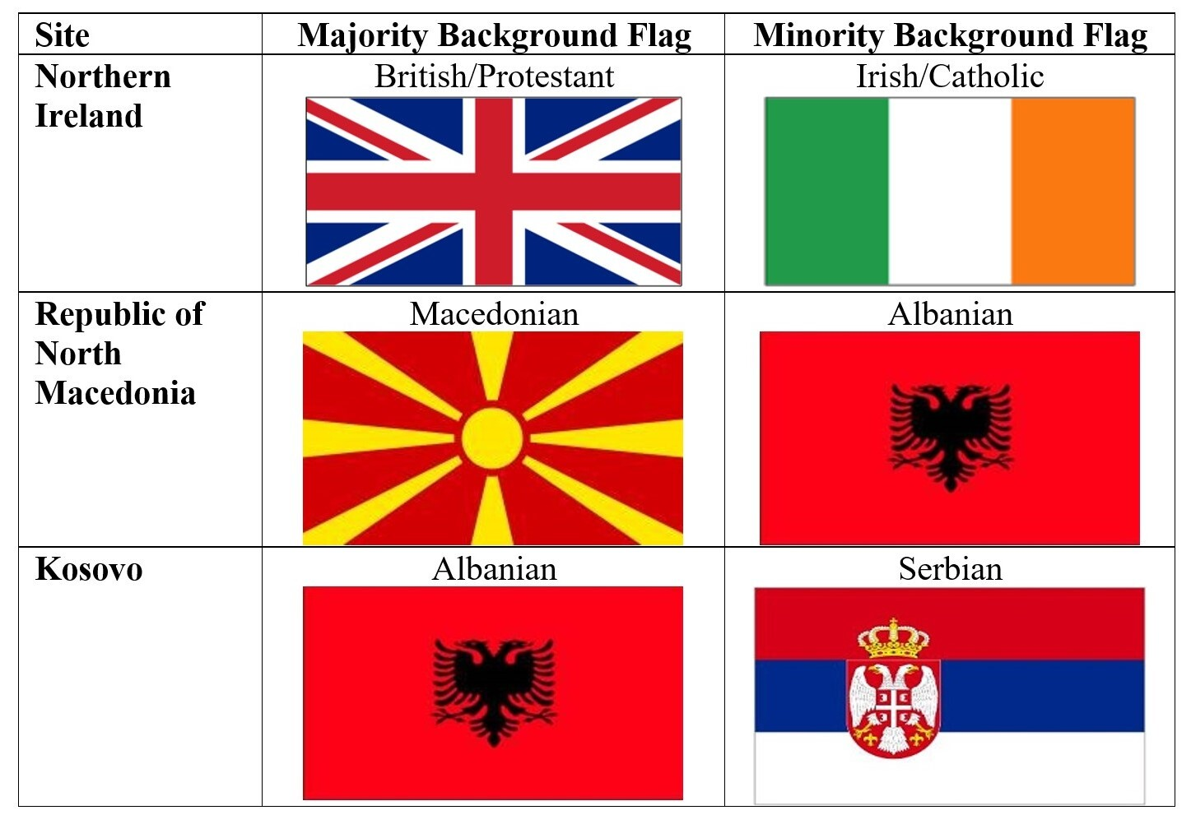
Figure 2. Integrated Flag Trial Stimuli by Research Setting and Child Ethnicity

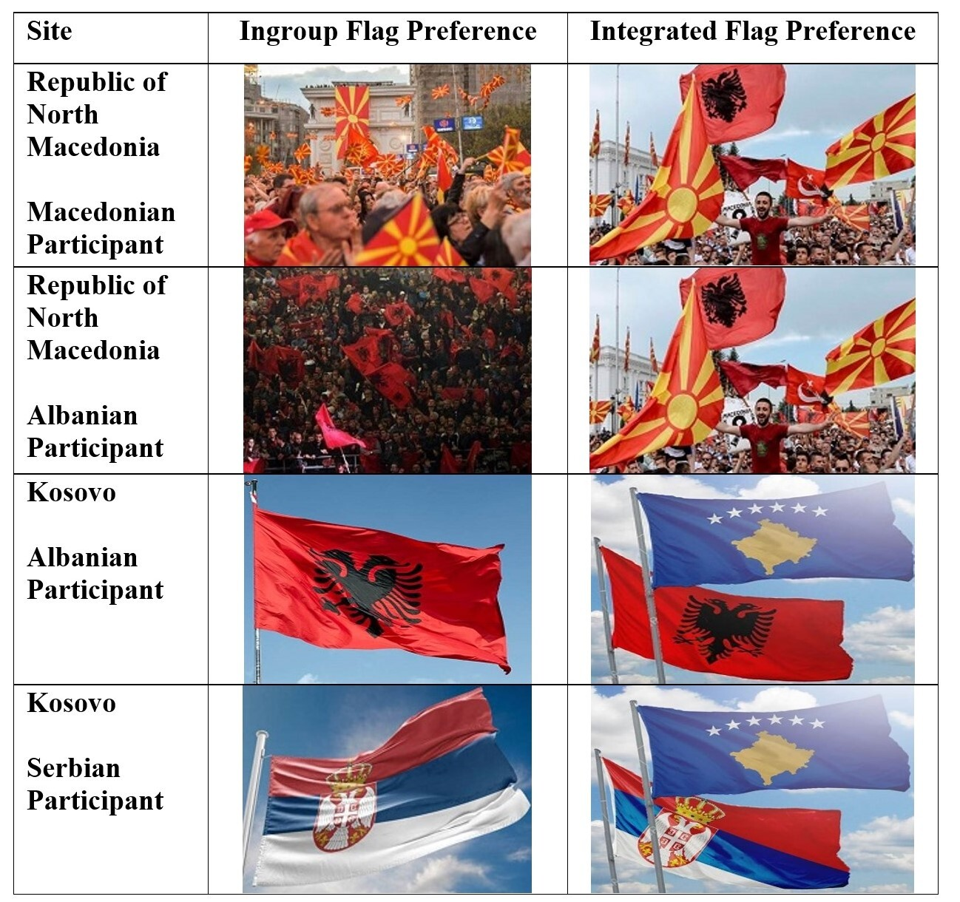
Figure 3. Children’s first-person ethno-national flag preferences by age and research setting

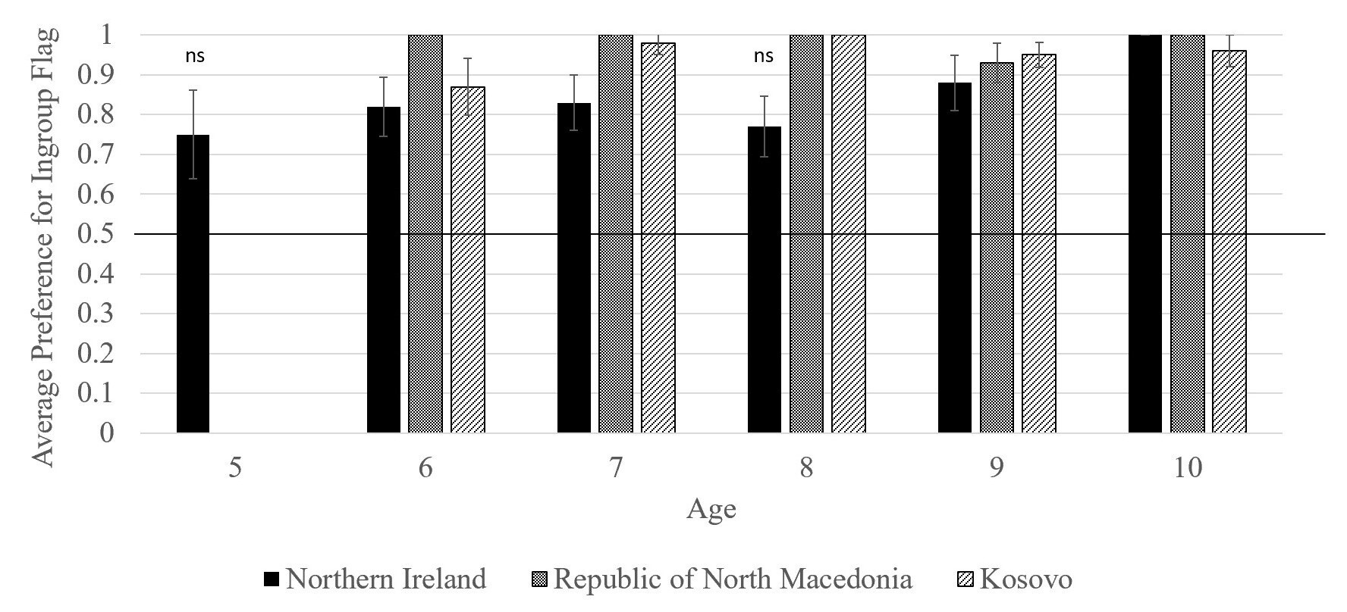
Note. ‘ns’ refers to non-significant one-sample t-tests examining preference for own group flag (1) over outgroup flag (0) against chance (M=0.5) after Bonferroni corrections for multiple comparisons (p= .05/16= .003). All other bars are significant against chance.
*Data for 5yos in Kosovo and RNM not available

Figure 4. Children’s categorization of ethno-national flag to category label by age and research setting

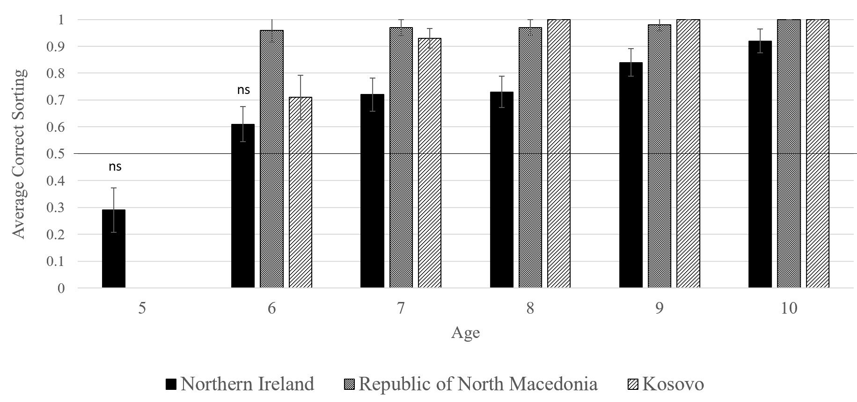

Note. ‘ns’ refers to non-significant one-sample t-tests examining children’s accurate pairing of ethno-national flag to category label (1) over inaccurate pairing ethno-national flag to category label (0) against chance (M= 0.5) after Bonferroni corrections for multiple comparisons (p= .05/16= .003). All other bars are significant against chance.
*Data for 5yos in Kosovo and RNM not available

Figure 5. Children’s third-person ethno-national flag preferences by age and research setting

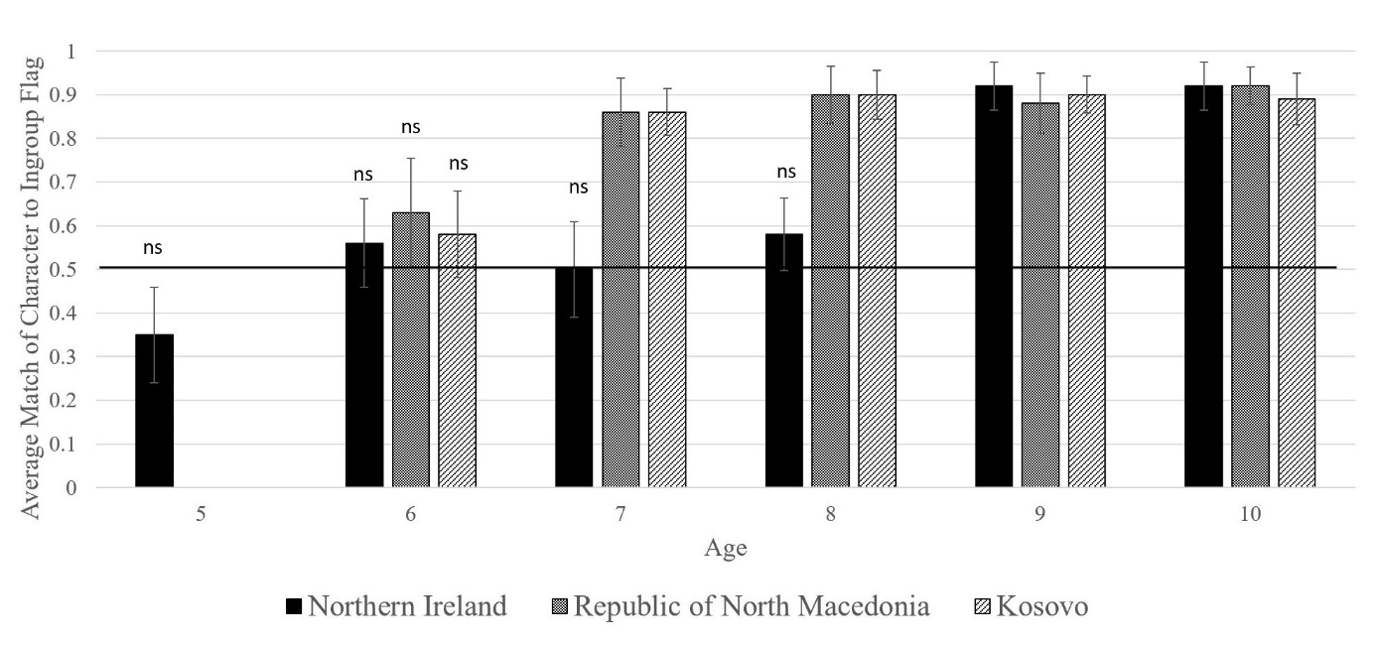
Note. ‘ns’ refers to non-significant one-sample t-tests examining children’s predictions that a labelled target character will prefer their own ingroup flag (1) over outgroup flag (0) against chance (M= 0.5) after Bonferroni corrections for multiple comparisons (p= .05/16= .003). All other bars are significant against chance.
*Data for 5-year-olds in Kosovo and RNM not available

Population statistics are highly sensitive in the Kosovo context and should be taken with caution. Ethnic group percentages used in this paper are those from the European Center for Minority Issues - Kosovo (ECMI Kosovo, 2013). These data combine estimates from the last Population Census (2011), which was partly boycotted by ethnic Serbs, and other relevant election sources to present more accurate estimates of the Serb population in the country.

