Supporting Information
Ordered surface structuring of spherical colloids with binary nanoparticle superlattices
Fabian Meder*^{,1,†,‡}, Steffi S. Thomas^{1,‡}, Tobias Bollhorst², Kenneth A. Dawson^{1,}*
¹Centre for BioNano Interactions, University College Dublin, School of Chemistry and Chemical Biology, Belfield, Dublin 4, Ireland
²Advanced Ceramics, University of Bremen, Department of Production Engineering, Bremen, Germany

Supplementary experimental details
Materials:
Gold(III) chloride (AuCl₃, ≥99.99%), sodium borohydride (NaBH₄¸ 99.99%), Dodecyldimethylammonium bromide (DDAB, 98%), 1-dodecane thiol (≥98%), palladium(II) chloride (PdCl₂, 99.999%), sodium dodecyl sulfate (SDS, ≥99.0%), dextran from Leuconostoc spp. (~6000 g/mol), tetrachloroethylene (anhydrous, ≥99%), toluene (anhydrous, 99.8%), hexane (≥99%), and ethanol (≥99.8%) were obtained from Sigma Aldrich, Ireland.
Synthesis of Au and Pd NPs:
Au and Pd NPs were synthesized as reported by Shevchenko et al.^{[15]} In short, for the synthesis of 5.0 nm Au NPs, 34 mg of AuCl₃ were added to 92.5 mg of DDAB in a 20 mL glass vial. For 2.4 nm Pd NPs, 23.7 mg PdCl₂ and 157mg DDAB were used in a separate glass vial. Then, 10 mL toluene was added and the mixture was bath sonicated for 5 min. Under magnetic stirring, 40 µL of an aqueous 9.4 M NaBH₄ solution was added dropwise and stirred for further 20 min, followed by addition of 0.8 mL of 1-dodecanethiol and further stirred for 5 min. Then the solution was refluxed under nitrogen at 110˚C for 30 min. Subsequently, the reaction was allowed to cool down to room temperature, 10 mL ethanol was added, and the solution was transferred to glass centrifugation vials. The solution was centrifuged at 4000 rcf for 3 min and the supernatant was discarded. The NP pellet was dispersed in a few drops of toluene by bath sonication followed by addition of 20 mL ethanol. This washing procedure was repeated two more times and after the final spin down, the pellet was redispersed in hexane (~6 mL) by the aid of bath sonication (5 min). Then a size-selective precipitation was performed to isolate a NP fraction with homogenous size. To the redispersed NPs, approximately 1 mL of ethanol was added dropwise under stirring and the solution turned slightly turbid. The solution was centrifuged at 4000 rcf for 5 min and the supernatant was collected in another centrifugation tube and the pellet was redispersed in 2 – 3 mL hexane (fraction 1). To the collected supernatant 1 mL of ethanol was added with stirring, the solution turned turbid, and the solution was centrifuged again at 4000 rcf for 5-10 min. The supernatant was transferred to another vial and the pellet was redispersed in hexane (fraction 2). TEM images of the different fractions were recorded to verify their monodispersity and fractions with < 10% standard deviation of the mean particle size were used for the experiments (usually fraction 1 for Pd NPs and fraction 2 for Au NPs). The concentration of the Au and Pd NPs were obtained by determination of the dry weight of a known volume of the NPs in triplicates using an analytical balance. The NP number concentrations were calculated assuming spherical particles, a density of 19.3 g/cm³ for Au and 11.9 g/cm³ for Pd, respectively and subtracting about 30% of the measured weight which is attributed to the dodecane surface coating (confirmed by determining the weight loss during pyrolysis of the dodecane layer in thermal gravimetric analysis (data not shown) and also reported in previous studies^{[15]}).
Synthesis of SiO₂ core particles:
Amorphous SiO₂ were synthesized using the Stöber process as reported earlier^{[35]} and washed three times with ethanol and subsequently refluxed for 12 h in octadecanol after evaporation of the ethanol at 100 °C for 1 h to esterify the surface silanol groups with the corresponding alcohol.^{[37]} The octadecane coated particles were washed 3 times in chloroform by repeated centrifugation using glass centrifuge tubes (20 min, 4000 rcf) and finally redispersed in hexane. The particle concentration was determined by measuring the dry weight of a known volume of the particles in triplicates using an analytical balance and transferred into particle number concentrations assuming spherical particles, a density of 2.1 g/cm³ for SiO₂. The SiO₂ particles were diluted into tetrachloroethylene to a concentration of 48 µg/mL for all experiments.
Transmission Electron Microscopy:
Ten µL of the particle suspensions were dropcasted on a lacey-formvar (carbon stabilized) coated copper specimen holder (300 mesh, Ted Pella, Inc., U.K.) and dried at room temperature. The sample was analyzed using a FEI Tecnai G2 20 twin microscope (FEI, Inc., The Netherlands) operating at an accelerating voltage of 200 kV. HAADF STEM imaging and EDX analysis was performed on a FEI Titan 80-300 (FEI, Inc., The Netherlands) operating at 300 kV. To check if the two subunits assemble into binary lattices on a planar surface, carbon-coated copper specimen holders (300 mesh, Ted Pella, Inc., U.K.) were initially dipped in toluene and the excess of toluene was removed by wiping on to a filter paper. The specimen holder was then placed at the bottom of a 2 mL glass vial at which was kept at an angle of 45˚. Au and Pd NPs were mixed in a certain ratio (e.g. 1:16 by number) and diluted in TCE and 20 µL were added on the TEM specimen holder. The vial was transferred to a vacuum centrifuge and kept at an angle of 45˚ and dried at 45 ˚C for 5 h. All distance analysis on the images has been done manually using the image analysis software ImageJ 1.47v.
Differential Centrifugal Sedimentation (DCS):
DCS was carried out using a CPS disc centrifuge DC24000 (CPS Instruments Inc., U.K.) in which an 8-24 w/w% sucrose gradient in water was applied. All measurements were carried out at centrifugal speed of 18,000 rpm. Before each measurement, a calibration was performed using a poly (vinyl chloride) (PVC) particle standard (size 0.483 µm, Analytik Ltd., U.K.) followed by the analysis of 0.1 mL of each sample.
Dynamic Light Scattering (DLS) and electrophoretic light scattering:
DLS measurements were carried on a Malvern Nanosizer ZS Series (Malvern, Ireland) at a temperature of 25 °C. The particles were diluted by adding 50 µL of the NPs to 950 µL of solvent in a glass cuvette. The Au-Pd NPs coated SiO₂ particles in water were analyzed undiluted. Electrophoretic mobility measurements were done using a dip cell (Malvern, Ireland). Reported results are an average of at least four individual measurements with 10-15 accumulations per run.
UV – Vis Spectroscopy:
UV – Vis spectra were recorded on a Varian Cary 6000i spectrophotometer (Agilent Technologies, Ireland) using a quartz cuvette with a path length of 1 cm. The spectra were corrected by running initially a baseline with the respective solvent the particles are dispersed in.

Supporting data
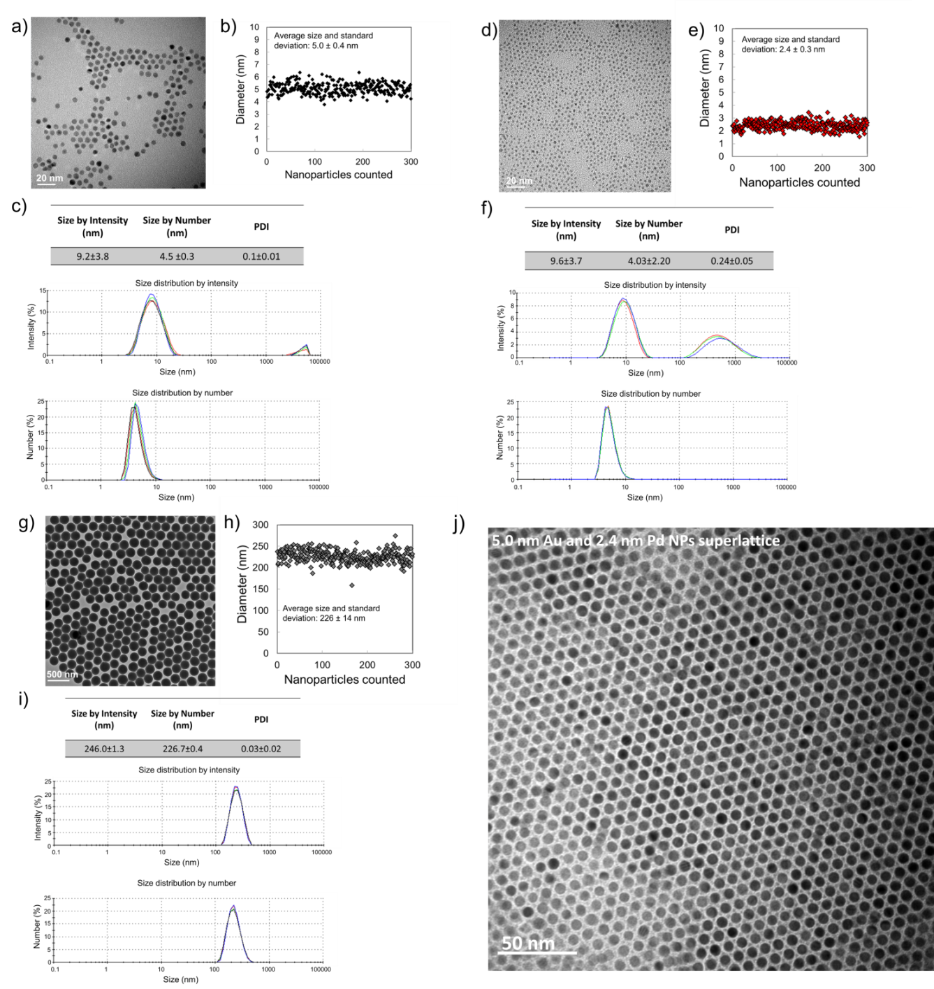
Figure S1. Characterization of Au, Pd NPs and SiO₂ particles used as building blocks for three dimensional assembly. (A, D, and G) TEM images of Au, Pd, and SiO₂ particles, respectively. (B, E, and H) Plots showing particle diameter measurements for 300 particles from TEM images and average and standard deviation of the measured diameter of Au, Pd, and SiO₂ NPs, respectively. Au and Pd NPs are coated with C₁₂ hydrocarbon chain layers with extended chain length of 1.52 nm.^{[27]} The inferred core plus coating diameter is thus about ~8.0 nm for Au@C₁₂ and ~5.4 nm for Pd@C₁₂. The SiO₂ particles are C₁₈–coated which have an extended chain length 2.27 nm, extrapolated from molecular modeling data given in Ref. ^{[27]}. (C, F, and I) DLS analysis of Au, Pd, and SiO₂ NPs, respectively, showing average diameters and standard deviations as well as intensity and number distribution graphs for 4 measurements of each sample. (J) TEM image of a binary superlattice formed by the self-assembly of 5 nm Au and 2.4 nm Pd NPs during evaporation of a drop-casted mixture of the NPs (number ratio of Au NPs to Pd NPs ~1:16) in tetrachloroethylene on a planar carbon-formvar film of a TEM specimen holder.
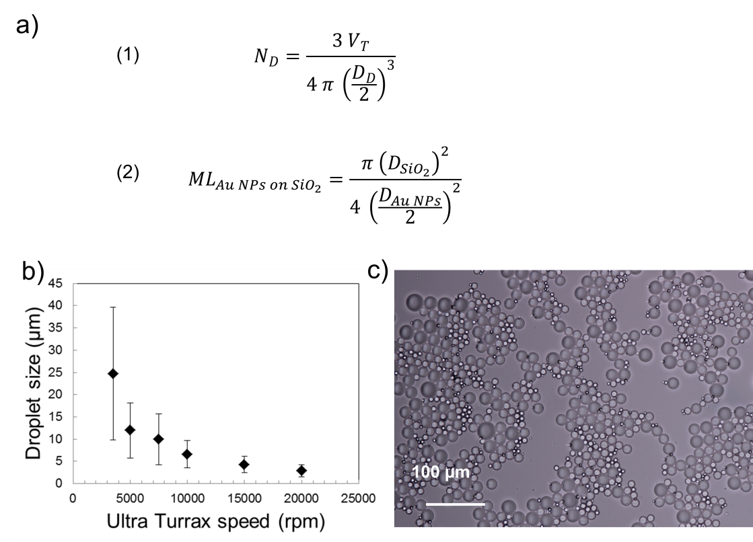
Figure S2. Theoretical design and characterization of mini-emulsions. (A) Formula 1: Calculation of the droplet number $N_{D}$ in the emulsion with a total volume of the oil phase $V_{T}$ and the average droplet diameter $D_{D}$. To statistically encapsulate a single SiO₂ particle in a single droplet, the SiO₂ number concentrations in the oil phase were adjusted in a 1 to 1 ratio to N_{D}. $D_{D}$ can be varied by the parameters of the emulsion preparation. Formula 2: Calculation of a theoretical monolayer (ML) of Au NPs with average diameter $D_{Au NPs}$ on a single SiO₂ particle with average diameter $D_{{SiO}_{2}}$ assuming square circle packing with a packing density of $\frac{π}{4}$. The Au NP concentration in the emulsion was adjusted to about 2 ML and the ratio of Pd NPs was varied. (B) Characterization of emulsion of TCE (containing dispersed Au NPs, Pd NPs, and SiO₂ particles) in water supplemented with SDS and dextran. Emulsion droplet size as function of rotational speed of the homogenizer (Ultra-Turrax). Data points represent average and standard deviations obtained from >100 droplet size measurements per data point acquired by analyzing light microscopy images of the emulsions. (c) Light microscope image of the emulsions obtained at 5000 rpm resulting in an average droplet size of 11.9±6.2 µm used for the assemblies of Au and Pd NPs on SiO₂.
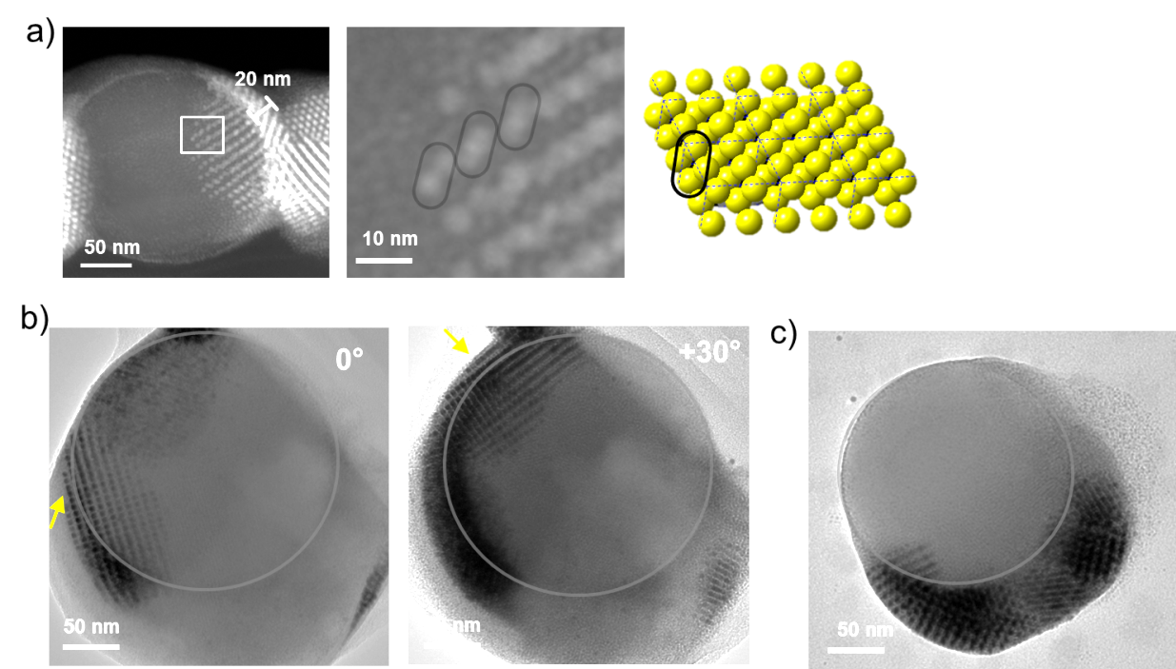
Figure S3. Selection of TEM images highlighting the variety in the thickness of Au-Pd NPs superlattice coatings on SiO₂. a) The assembly shown in the HAADF-STEM image (left image) and the zoom into the area marked by the white square (right image) suggest a coating consisting of two Au planes in z direction (interstitial Pd NPs are not visual due to their lower contrast over SiO₂). The white scale bar at the edge of the particle indicates a thickness of about 20 nm corresponding to about 2 Au Pd NP lattice layers considering an average spacing of about 8.9±0.9 nm. This is confirmed in the zoom-in panel that shows Au NPs in a typical double layer stacking as depicted in the illustration of an Au-Pd NP AB₁₃-type lattice on the right (Pd particles are not displayed in illustration for clarity). b) TEM images of two Au-Pd NPs superlattice patches on the surface of a SiO₂ particle in two different tilting angles (the grey, semi-transparent line was added to highlight the edge of the core particle). The yellow arrow points to locations in which the Au Pd NP lattice coating is one or maximal two Au NP layers thick and sits on the particle surface in distances that correspond to the alkane ligand length of Au NPs and the SiO₂ (C₁₂ ligand + C₁₈ ligand ≈ 4 nm). This corresponds well with the amount of Au NPs that were added in a ratio to the SiO₂ particles which is limited to generate two monolayers (see Methods). c) During the complex assembly in the evaporating emulsion droplets and all involved interparticle interactions as outlined in the discussion, it may, however, in addition come to local inhomogeneity of the Au and Pd NPs concentration which leads to locally thicker binary superlattices as shown in in the TEM image (the grey, semi-transparent line was added to highlight the edge of the core particle).

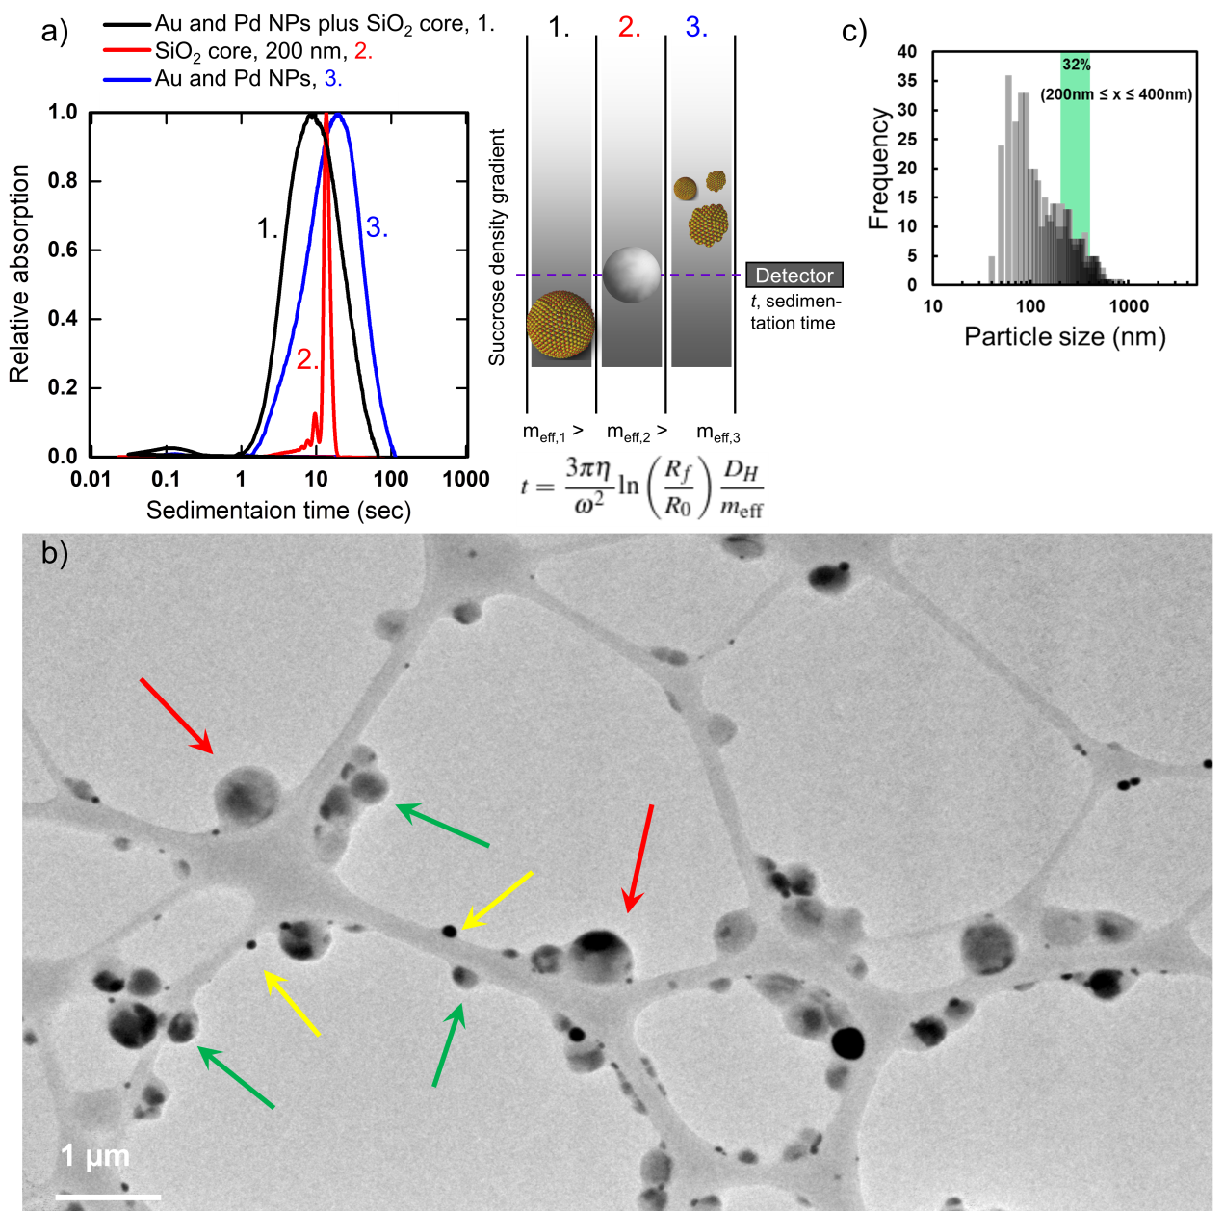
Figure S4. Differential centrifugal sedimentation and TEM overview analysis of the assemblies. (A) DCS analysis of (1.) SiO₂ particles with self-assembled binary Au-Pd NPs superlattice coating, (2.) unmodified SiO₂ particles, and (3.) sample containing assembled Au and Pd NPs following the assembly procedure of (1.) but without adding SiO₂ core. The DCS analysis was performed in an 8-24 wt% sucrose-in-water density gradient. The graph (left) displays the sedimentation time in the density gradient applied in a rotating disc versus the relative absorption when the particles pass a 405 nm laser installed at a fixed length from the sample injection point. The illustration (right) shows the measurement principle and suggests the behavior of the different samples. The given formula (which is derived from a combination of the centrifugal force and Stoke’ law^{[38]}) shows that the sedimentation time t is a function of η, the viscosity of the medium, ω, the angular velocity of the centrifuge, R_{f} and R₀, the final and initial distance from the axis of rotation, D_{H}, the hydrodynamic diameter of the particle, and m_{eff}, the effective mass of the particle. It is expected that the effective mass of a SiO₂ particle increases when Au or Pd NPs adhere on the surface and accompanied with a slight increase of the diameter (compare DLS measurements of bare SiO₂ (~246±1 nm), Figure S1 and SiO₂ with Au and Pd surface coating (318±88 nm), Figure S7). Due to the high density but rather small volume (density Au, 19.3 g/cm³ and Pd, 11.9 g/cm³, respectively on SiO₂, density 2.1 g/cm³), the effective mass is increased lowering the sedimentation time. Accordingly, peak sedimentation time is decreased for SiO₂ particles with Au and Pd NPs coating (1.) compared to bare SiO₂ particles (2.). As a control, we also analyzed samples prepared by the assembly of Au and Pd NPs using the same procedure but without SiO₂ particles (3.) and peak sedimentation times were larger than for (1.) and (2.) suggesting a lower effective mass and size (due to irregular shapes and smaller Au Pd NP supraparticles confirmed by TEM). The peak broadening of sample (1.) compared to (2.) towards lower sedimentation times suggests byproducts (e.g. uncoated SiO₂, or Au-Pd NP clusters due the intrinsic size distributions of the volume elements for confinement/emulsion droplets, respectively) leading to a certain degree of heterogeneity of the samples which is also observed in TEM. (B) TEM overview image of SiO₂ particles with self-assembled binary Au-Pd NPs superlattice coating (green arrows) showing that also smaller clusters without SiO₂ core (yellow arrows) and larger complexes (red arrows, with more than one SiO₂ core or only Au and Pd) form and coexist in the final sample. There particles appear in different grey scales related to the composition of the assemblies. The main factor leading to significant darker contrast is the presence of Au NPs and the thickness of the Au NP-containing layers. Pd NPs and SiO₂ cannot be differentiated from each other in the low magnification of the overview image, we refer to the high resolution images in Figure 2. The grey network structure is the lacey carbon grid. The DCS analysis suggests that these can be separated by further size selection steps using density gradient centrifugation. (C) Histogram of particle size analysis by TEM of SiO₂ particles with self-assembled binary Au-Pd NPs superlattice coating suggests that about 32 % of the particles are in the regime of 200 nm ≤ x ≤ 400 nm, which is the expected regime of Au-Pd NP coated SiO₂ cores considering a 226 ± 15 nm core plus additional superlattice coating (500 particles have been analyzed to obtain the histogram).
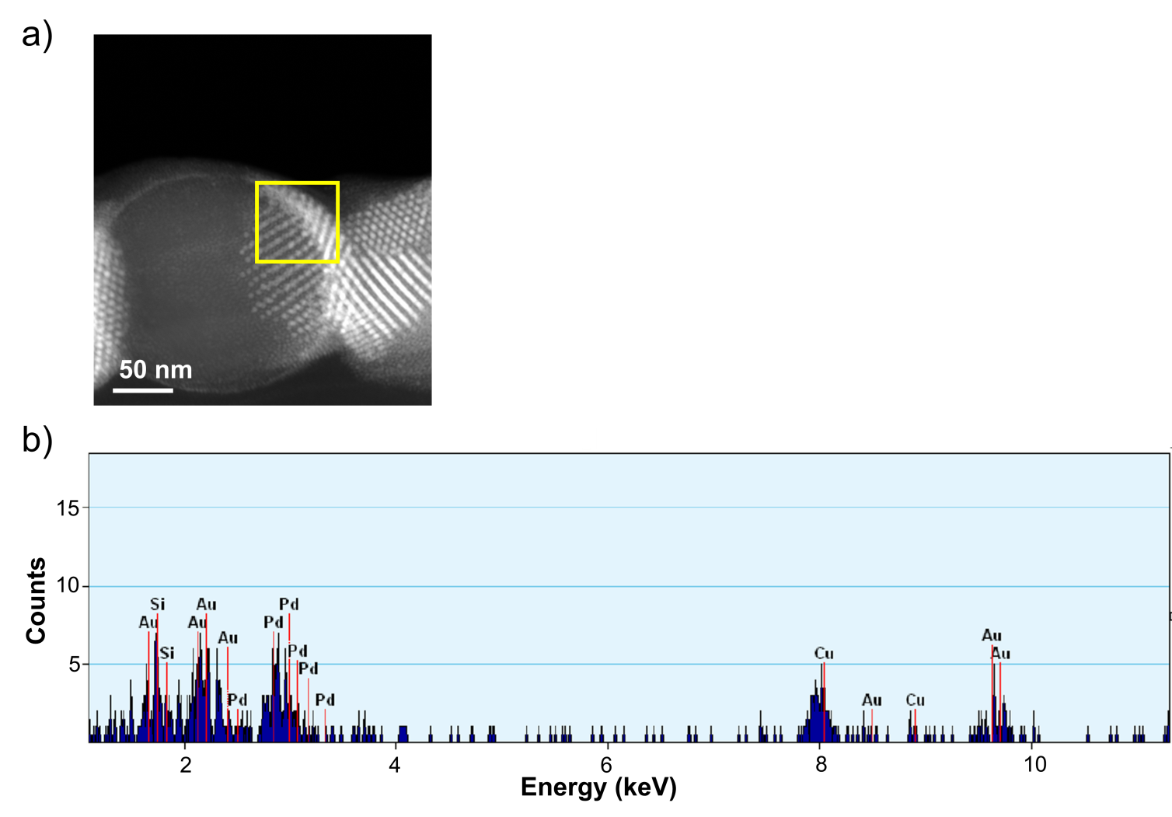
Figure S5. Energy-dispersive X-ray (EDX) spectroscopy. (A) HAADF-STEM image of binary Au-Pd NPs superlattice self-assembled on a SiO₂ particle. The yellow square marks the area which was analyzed by EDX spectroscopy. (B) EDX spectroscopy of the yellow marked area of the particle shown in a) confirming the presence of Si, Au, and Pd expectedly representing the SiO₂ core and Au and Pd NP surface layer.
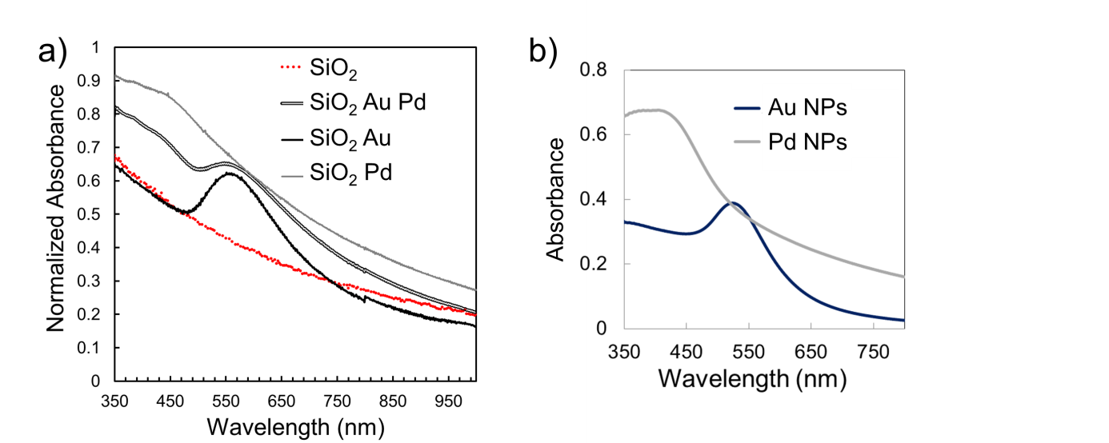
Figure S6. Plasmonic properties of assemblies. (A) UV-Vis spectroscopy of bare SiO₂ particles and SiO₂ particles with mixed and single Au and Pd NP surface coatings in water. Particles containing Au NPs show absorption at ~560 nm which is slightly shifted from the characteristic plasmon resonance of Au NPs (~530 nm, see b) likely due to plasmon coupling on the surface of the SiO₂ cores. The SiO₂ particles coated with Pd NPs show increased absorption at 440 nm also slightly red-shifted absorbance of the intrinsic properties of Pd particles (~420 nm, see b). The particles with binary Au and Pd NP surface coatings show absorption at both 530 and 440 nm wavelengths representing the binary surface composition and confirming that the surface composition can be qualitatively derived from the spectra. (B) UV-Vis spectroscopy of Au and Pd NPs in tetrachloroethylene showing the specific plasmon resonance peaks of Au NPs at about 530 nm and of Pd NPs at about 420 nm.

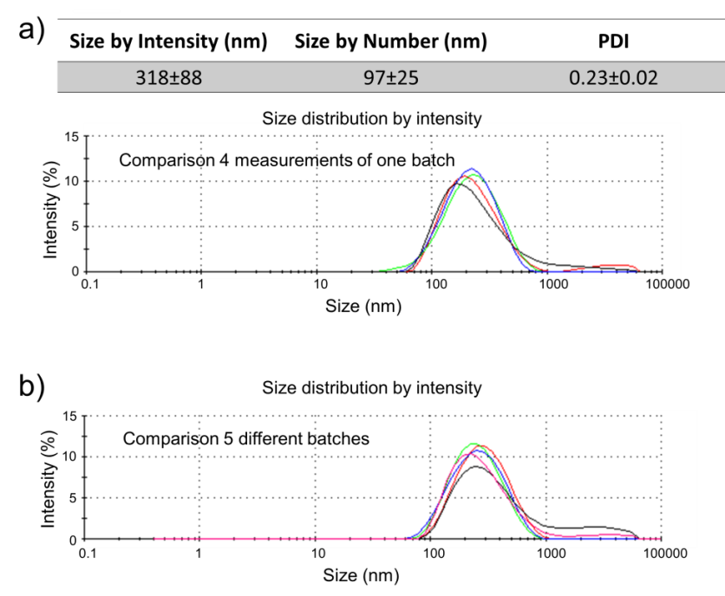
Figure S7. Size analysis of SiO₂ particles with binary Au-Pd NP superlattice coatings by DLS. (A) Intensity and number mean average and standard deviation and a graph showing the intensity size distributions obtained from 4 measurements of the same sample. (B) shows the reproducible size distribution when comparing 5 different batches independently synthesized using the same parameters (number ratio Au to Pd NPs is 1 to 16).

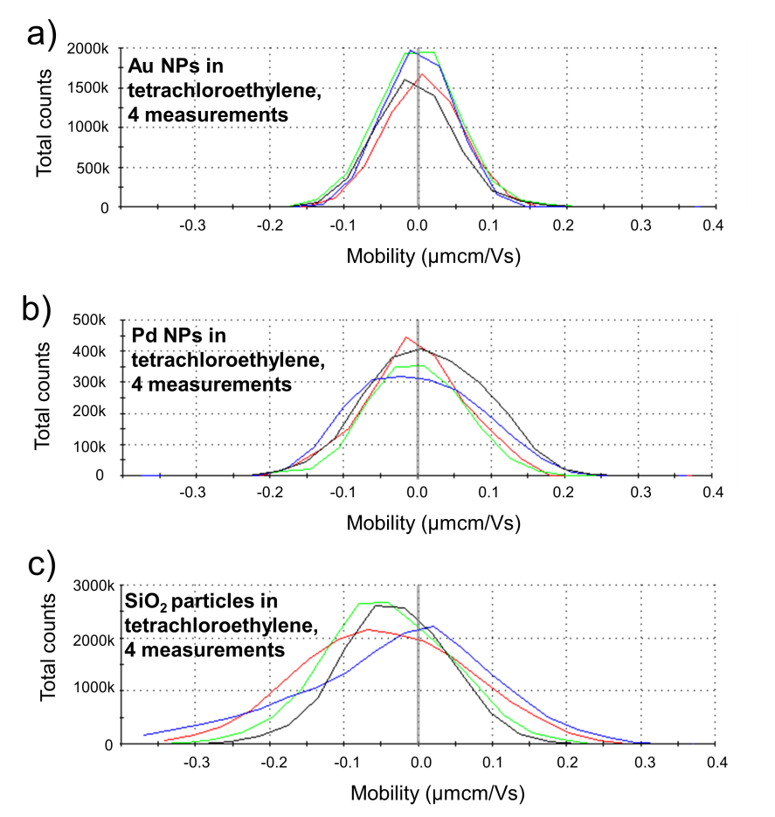
Figure S8. Electrophoretic mobility of Au, Pd, and SiO₂ NPs. Distributions of electrophoretic mobility of (A) 5 nm Au NPs (dodecane-coating), (B) 2.4 nm Pd NPs (dodecane-coating), and (C) 230 nm SiO₂ particles (octadecyl-coating) dispersed in tetrachloroethylene obtained by electrophoretic light scattering. The distribution curves of four single measurements per sample are shown. It was reported previously that opposite charges due to impurities with charged surfactants (or by controlled addition of the charged surfactants) impart a specific affinity of the NPs even in non-polar solvents and stabilize a binary lattice formation (by coulomb interactions) while destabilizing single-component superlattices.^{[15]} Here, our Au and Pd NPs show neutral characteristics (expectedly due to excessive purification procedures after synthesis) while SiO₂ particles acquire a negative surface charge (as suggested previously in non-polar solvents^{[39]}). We thus assume that coulomb interactions play in our system a minor role in the assembly of Au and Pd NPs into the AB₁₃-type superlattices and suggest that dispersion interactions are a main driving force (as further proposed in models by Ben-Simon et al.^{[32]}) but Coulomb interactions could influence the interaction of the SiO₂ particles with the emulsion droplet surface bearing negatively charged SDS molecules at the outer surface. In addition, adding certain amounts of charged surfactants could be a tool to modify superlattice configurations^{[15]} and to direct the particles onto the SiO₂ surface.
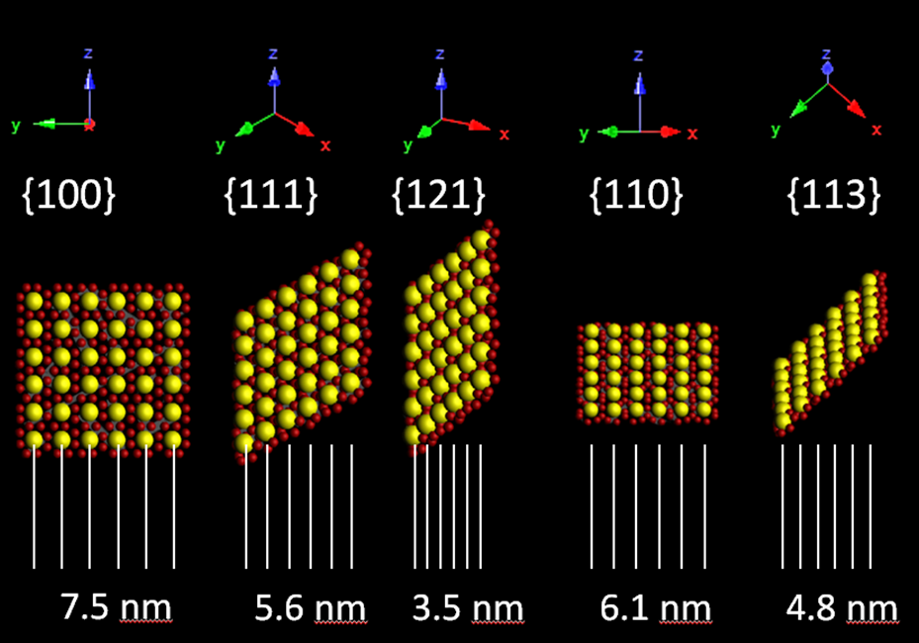
Figure S9. Illustration of the {100} plane of an AB₁₃ lattice at different tilting perspectives and its impact on the measured Au NP line spacing. In a 2D image, the tilting perspective leads to a reduction of the measured lattice spacing when the lattice is tilted in respect to the {100} plane. This effect may account for the observation of smaller Au NPs line spacing (peak 1. in the TEM image analysis depicted in Figure 3a in the manuscript).

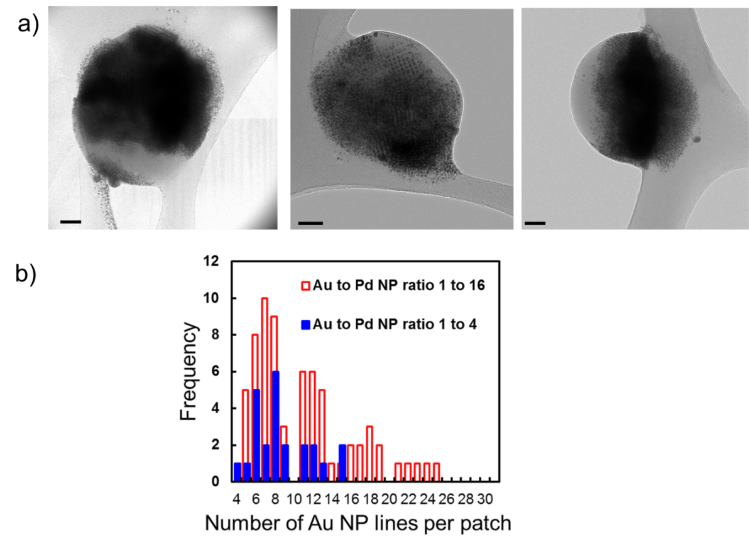
Figure S10. Formation of Au Pd NP superlattices on SiO₂ cores with increased Au NP concentration. (A) TEM images and (B) analysis of Au NP lines per binary Au Pd superlattice patch of a sample obtained by increasing the Au NP concentration 4 times and maintaining Pd NP concentration so that a number ratio 4 Au NPs to 16 Pd NPs, respectively 1 Au NP to 4 Pd NPs was obtained, scale bars are 50 nm. 63 patches on 25 particles were measured for assemblies synthesized with an Au to Pd NP ratio of 1 to 16 and 20 patches on 9 particles for assemblies synthesized with an Au to Pd NP ratio of 1 to 4.

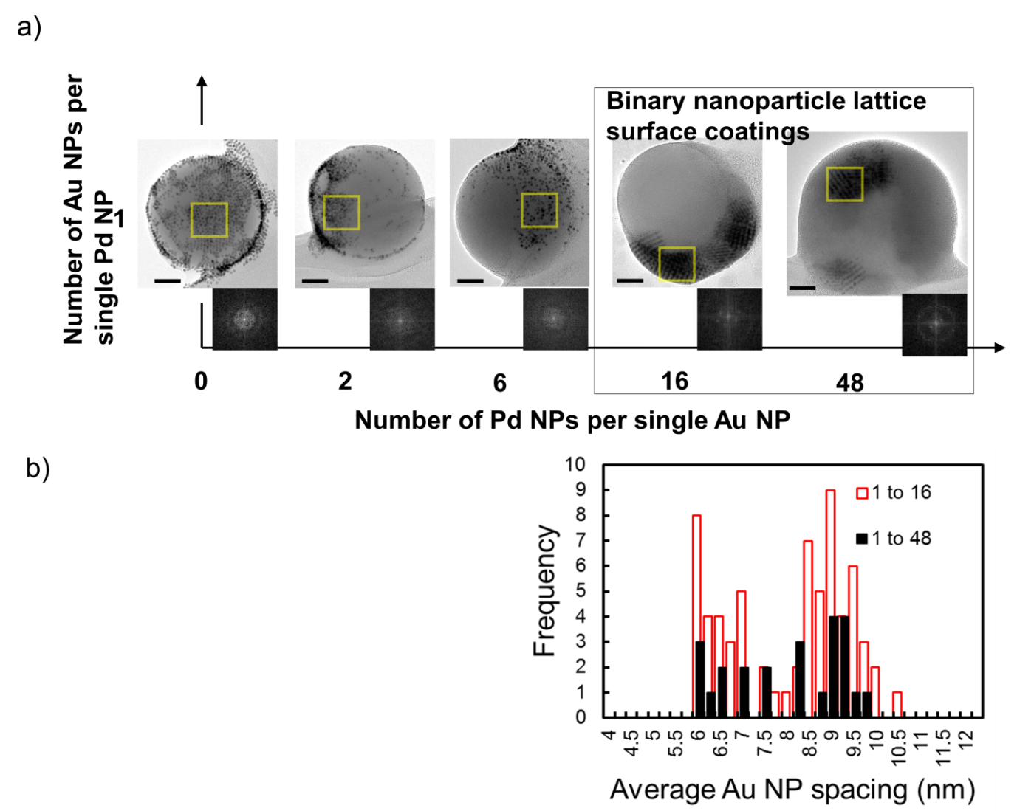
Figure S11. Varying the stoichiometric ratio of Au and Pd NPs during assembly on SiO₂ core particles. (A) TEM images and fast Fourier transformation (FFT) of areas marked in yellow of SiO₂ particles coated with varying ratios of Au and Pd NPs, scale bars 50 nm. The particle number ratios 1 to 16 and 1 to 48 of Au NPs to Pd NPs lead to binary surface lattices while for other samples no binary lattice structures could be observed confirming that a certain ratio is required to form stable binary crystals. (B) Comparison of average Au NP spacing in lattices of patches obtained from coating SiO₂ particles with Au and Pd NPs in ratio 1 to 16, and 1 to 48, respectively. 63 patches on 25 particles were measured for assemblies synthesized with an Au to Pd NP ratio of 1 to 16 and 23 patches on 12 particles for assemblies synthesized with an Au to Pd NP ratio of 1 to 4.

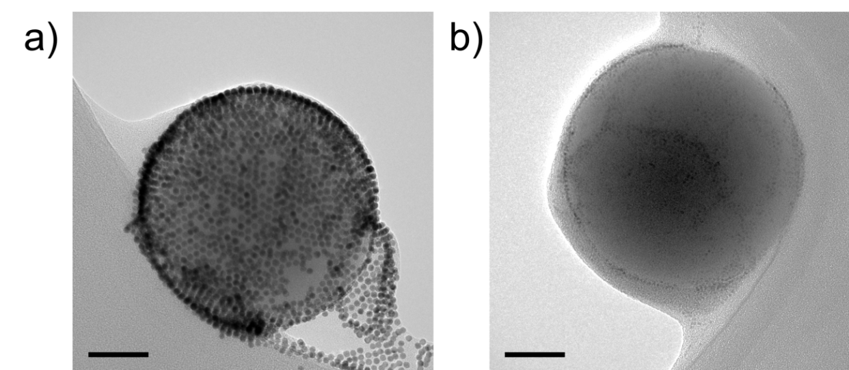
Figure S12. TEM images of SiO₂ particles coated exclusively with Au or Pd NPs. (A) Au NP coating and (B) Pd NP coating using the same assembly procedure as for binary coatings, scale bars 50 nm, images are representative for the sample. Large crystalline lattice structures could not be observed as obtained for particles synthesized with binary mixtures of Au and Pd NPs.

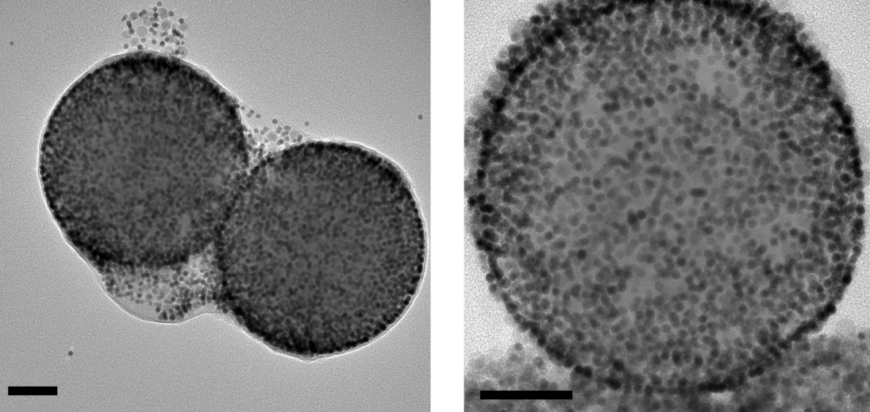
Figure S13. Varying the hydrocarbon chain length on the surface of the SiO₂ core before Au and Pd NP assembly. TEM images of SiO₂ particles coated with a C₈ hydrocarbon chain did not show superlattice patches which suggests, that the longer C₁₈ chain (images of assemblies in Figure 2) improves particle packing and stabilizes superlattice formation.

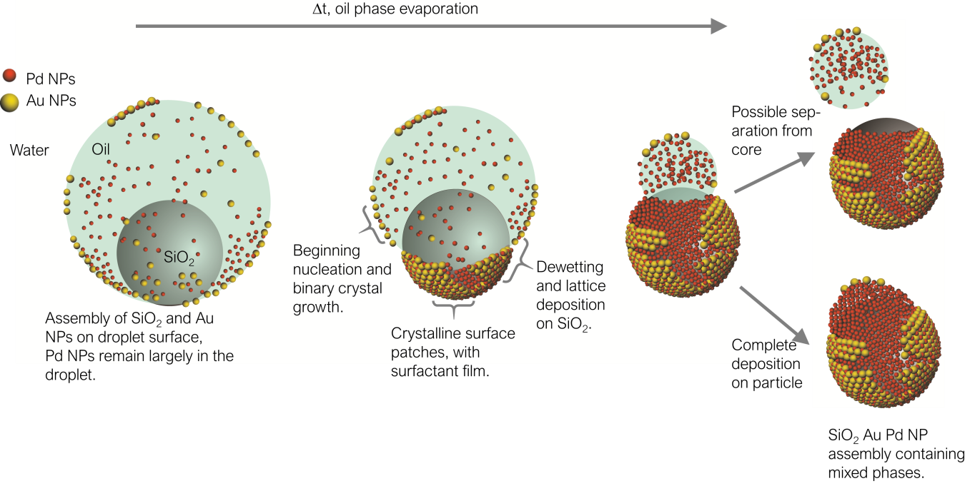
Figure S14: Illustration of the potential assembly mechanism as further described in the discussion.

Movies S1 to S3
TEM tomography series of images of three individual SiO₂ particles coated with binary Au Pd NP superlattices in a 1:16 ratio recorded at different tilting angles.

