CIRP Manufacturing Systems Conference 2019
An Application of 3D Model Reconstruction and Augmented Reality for Real-Time Monitoring of Additive Manufacturing
Ammar Malikª*, Hugo Lhachemiª, Joern Ploennigs^{b}, Amadou Ba^{b}, Robert Shortenª
ªElectrical and Electronic Engineering, University College Dublin, Dublin, Ireland
^{b}Ireland Research Lab, IBM, Dublin, Ireland
* Corresponding author. E-mail address: ammar.malik@ucdconnect.ie
Abstract
This paper presents a novel scan-based method for the real-time monitoring of additive manufacturing processes. Most traditional scanning techniques used for generating 3D models capture the only outer shape of the object after completion of the printing process. The method proposed in this paper differs as it relies on a layer-by-layer scanning of the 3D object directly during the printing process. This strategy has been successfully implemented with a fused filament 3D printer (PRUSA i3 MK3). Furthermore, in order to offer an increased interaction between the obtained 3D model and the user, a virtual environment has been developed for the augmented reality glasses HoloLens. The novelty of this method lies in the layer-by-layer 3D model reconstruction of both the outer shape and the inner layers of the printed part. It enables the user, directly during the printing process, to view and detect potential defects, not only at the surface but also in the inner layers of the printed object. Therefore, it can provide detailed information about the build quality and can be used as the basis of a decision-making tool.

© 2019 The Authors. Published by Elsevier Ltd. This is an open access article under the CC BY-NC-ND license (http://creativecommons.org/licenses/by-nc-nd/3.0/)
Peer-review under responsibility of the scientific committee of the 52nd CIRP Conference on Manufacturing Systems.
Keywords: Additive Manufacturing; Augmented Reality; Real-Time 3D Model Reconstruction; Real-Time Monitoring.

- Introduction
Additive manufacturing (AM), also known as 3D printing, refers to the various processes of adding together materials to create three-dimensional objects based on 3D model files under computer control. Originally used for fast prototyping [1-2], AM has emerged as a disruptive technology poised to deeply transform manufacturing [3]. However, despite its huge potential, AM still does not meet the standards of conventional manufacturing. In particular, it suffers from low productivity rates, poor quality and repeatability of manufacture, uncertain properties of the manufactured parts, etc. [4]. These limitations are some of the reasons that prevent the widespread adoption of AM technologies with stringent process requirements (such as aerospace [5] and biomedical industries [6]). The essential cause of these problems is the inherent difficulty to model, monitor, and control the underlying AM process [4]. Many parameters, such as process parameters (heat source, trajectory generation, etc.), ambient parameters (temperature or humidity), and intrinsic properties of the employed materials, have a strong impact on the quality of the final product [7]. Any uncertainty in even one of these parameters might result in defects. For instance, due to the off-line generation and optimization of the printing trajectories, the accuracy of the geometry may not reach the required level for a given application, and because of the layer-based printing process, inhomogeneities can appear, yielding problems in the mechanical properties [8].
It is widely recognized that the development of adequate monitoring methods combined with efficient decision-making tools is a key step toward the widespread adoption of AM technologies in industrial sectors presenting stringent requirements [9]. Recent years have seen many applications in which augmented reality is used to enhance 3D printing technology. This paper presents a novel scan-based method for the real-time monitoring of AM processes using 3D model reconstruction and Augmented Reality (AR). The principal difference between our work and that of other authors is that image processing, and component models are used to realize a layer-by-layer reconstruction of the printed part. It consists of a 3D model reconstruction of the printed part based on images taken layer-by-layer during the printing process. The resulting 3D model can be used either for the monitoring of the printing process or the detection of internal defects of the final printed object. In order to improve the interaction between the user and the resulting 3D model, an AR environment has been developed for the mixed-reality glasses HoloLens. Note that in this paper, AR is used as a technology brick to allow the user to interact with the 3D model, either to visualize the full part or to perform layer-by-layer interrogation of the final printed part.

The remainder of the paper is organized as follows. Related works are presented in Section 2. An overview of our experimental equipment is given in Section 3. The proposed methodology is detailed in Section 4 and obtained results for a case study are related in Section 5. Finally, concluding remarks are provided in Section 6.
- Related works
Geometry reconstruction is a well-studied area of research in computer graphics and vision. In the past, the 3D geometries have been reconstructed using passive cameras [10,11], active sensors [12], online images [13] or from unordered 3D points to generate watertight surfaces [14]. Traditional 3D model reconstruction techniques can be generally classified as photogrammetry and 3D scanning. In Photogrammetry (or Structure from Motion [15]), the three-dimensional coordinates of surface points of a 3D printed object are estimated using pictures taken from different angles. In non-contact active 3D scanning, the scanner estimates the surface points of the object by detecting the reflection of radiation or light emitted by the scanner towards the object. The emitted radiations could be infra-red, ultrasound or X-ray. This scanning technique either use time of flight [16] or triangulation method [17] to estimate surface points of the object. Both photogrammetry and 3D scanning either require multiple cameras/scanners to be installed or a single camera/scanner to be moved around the object to acquire images/data from different angles. The 3D surface points generated from these images/data also contain surface points of the environment around the object, and hence a manual removal (3D cropping) of these surface points is required to retain surface points of the object only. These techniques capture only the surface information of the object and do not provide any information about the internal condition of the product.
Augmented Reality (AR) is a human-computer interaction tool that augments computer-generated perceptual information on the real-world environment. Extensive research is being carried out to design and implement integrated AR-assisted manufacturing systems to achieve reduced cost and improved quality. For example, in the automotive industry, the 3D models of car interiors have been overlaid on real body mock-up cars during the initial phases of development using AR [18]. Similarly, a gesture-based AR design environment, GARDE, has been developed [19]. In which, using gestures, the designer can visualize, design and make modifications in a 3D model in an AR environment. AR in manufacturing has been mainly focused on the design phase of the manufacturing process [20,21,22]. However, AR can also play a significant role in the improvement of process monitoring. For instance, it was proposed in [23] to bridge the gap between digital and physical works by projecting the 3D model directly on top of the currently printed part in the printer workspace. In this context, the user can control both the displayed 3D model and the printer actuations toward an integrated design. The idea of superimposing the 3D model to the currently printed part was also developed in [24] as a comparison tool for fast prototyping. An automatic image comparison procedure was developed for the detection of the printing failures by comparing a picture of the part being printed and the original 3D model.
Proposed system: The 3D reconstruction technique proposed in this paper requires only one camera mounted on the top of the build plate; thus, avoiding the need for multiple static cameras or moving a single camera around the object. Also, the proposed scanning technique suggests an automated cropping of the background from the acquired images, thus generating a 3D model of the object only. Since the proposed technique reconstructs the 3D model layer by layer, it can be used for real-time monitoring of the build to detect the defects on the surface as well as within the object. Finally, we use AR to monitor the process of 3D printing using the reconstructed 3D model of a part.
- System overview
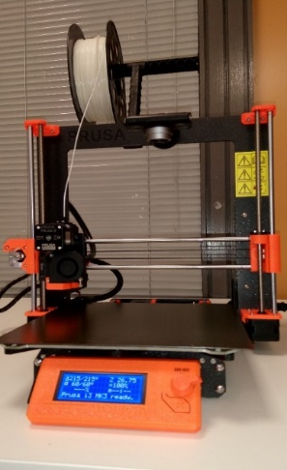
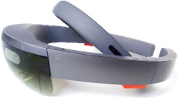
The setup of the system used to test the proposed technique is shown in Fig. 1. It includes a Fused Filament Fabrication (FFF) technology based, Prusa i3 MK3, 3D printer with 13 Mega Pixels camera mounted at its gantry and HoloLens. The camera lens has been oriented parallel to the printer’s print bed to acquire top view image of each printed layer. An app has also been developed in Unity Platform which enables the user to interact with the digital model in a mixed reality environment using HoloLens.
b
a
Camera
Print Bed
Filament Extruder
Fig. 1. (a) Camera Mounted on 3D Printer; (b) HoloLens

- Methodology
This section presents the methodology for layer-by-layer reconstruction of the 3D model of the printed product and development of the app to interact with the digital model for real-time monitoring of the build process using HoloLens.
  - Image acquisition and processing
To acquire images after the deposition of each layer, the extruder and print bed must be positioned in such a way that the work is in front of the camera. Therefore, the G-code has been modified by adding the following command before the commands for the next layer (i.e., before the change in z-coordinate).

G1 X0 Y200;

This returns the extruder to the left and pushes the build plate forward so that top view is clearly visible by the camera after deposition of each layer. The camera-acquired images are then processed in MATLAB to generate the 3D model. Since the image acquired after deposition of each layer also contains information about the previous layers (and/or about the print bed) therefore, the image must be processed to extract the information concerning the current layer.
    - Segregation of the Current Layer

During the acquisition of the top view image, depth information is lost. Therefore, it is difficult to differentiate between the current layer-area and the previous layer-area. One possible solution to this problem is to use color-based image segmentation. Since the majority of the layers in a 3D printed product are of the same color therefore, we need some other strategy for segregation. One such strategy, as proposed in this paper, is to use the information about the current layer through the G-code of the 3D model being used for printing. The idea is to use the image obtained by the G-code simulator of the current layer as a mask, and then to keep the information from the camera acquired image which lies under the area delineated by this mask. Then, we assign the color black to the area which does not lie under the mask. This image, containing information about the current layer, is termed as the processed image in the remainder of the paper, and we refer to the overall technique as automated cropping. Since the camera-acquired image and the image acquired from G-Code simulator are from different sources, we need to align both images before using the image acquired from the G-Code simulator as a mask.
    - Image Registration
To use the image acquired from G-Code simulator as mask, the mask must be aligned with the camera-acquired image to overcome issues such as image rotation, scale, and skew. This problem of aligning multiple scenes into a single integrated image is solved by image registration. Image registration is an image processing technique usually used to align satellite images or medical images captured with different imaging sources, such as Magnetic resonance imaging (MRI) and SPECT. In image registration, one of the images (referred to as the moving or source image) is spatially transformed to align with the other image (referred to as the target, fixed or sensed image). In our particular case, we have set mask as a moving image, and the camera-acquired image as a target image. While image registration algorithms can be intensity-based or feature-based, we have used MATLAB’s inbuilt function ‘imregister’ for intensity-based automatic image registration to align the images. In intensity-based registration, the misaligned image (moving image) is spatially transformed to align with the target image by comparing intensity patterns in images [25].
  - 3D Model Reconstruction
The reconstruction of the 3D model involves converting the processed image to a 3D file format. A 3D file format is used for storing information concerning the 3D models. The common 3D file formats used for 3D printing are STL, OBJ, PLY, AMF, 3MF, and FBX. Since HoloLens supports OBJ and FBX 3D model file formats, therefore, we have used OBJ file format to estimate the geometry of the 3D model from processed images.
    - 3D model surface encoding
The processed image is converted into a binary image. The area of the pixels of the previous layers is assigned a black color, whereas the current layer area is assigned a gray color. These pixel values are then used as depth values to convert 2D processed image to 3D image. Fig. 2 (a) shows an example of a down-sampled triangular estimation of a processed 2D image and Fig. 2 (b) shows 3D geometry estimation from the processed image. The processed binary image is then converted to OBJ file to encode the geometry of the current layer based on the processed image. In this encoding technique, the binary processed image is covered with the mesh of non-overlapping triangles. The pixels of the binary processed image are assigned as vertices of these triangles. The row number and column number of the image pixels are assigned as x and y coordinates whereas pixel values are assigned as z-coordinates of the vertices of these triangles. Since we do not want the triangles lying on the previous layer to be encoded in the OBJ file of the current layer therefore, we use a condition to encode only the triangles having non-zero z-coordinates.

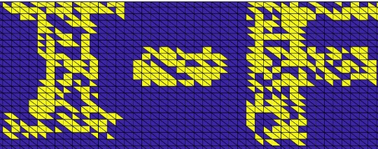
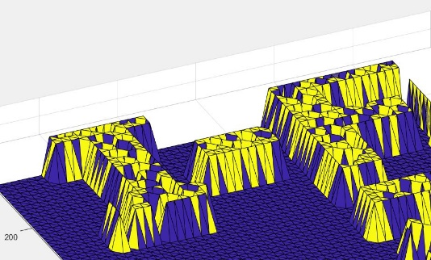
Fig. 1. (a) Triangle mesh over Processed 2D image; (b) Estimated 3D Geometry from Processed Image
a
b

  - Interaction with the reconstructed model via HoloLens
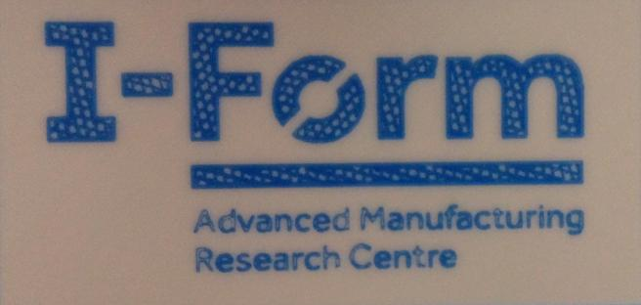
The Microsoft HoloLens is a holographic computer, enabling the user to interact with holograms in a mixed reality environment. An application has been developed in Unity Platform which allows the user to interact with 3D models using HoloLens. The user can move and rotate to inspect the reconstructed model of each layer using hand gestures. Two voice commands, expand model and reset model, have also been added. The expand model command shows the digital model layer-by-layer and let the user inspect each layer using hand gestures whereas reset model command reconstructs and joins all the layers back together.
a
b
c
d
Fig. 4. Camera acquired images after deposition of (a) Layer 1; (b) Layer 2; (c) Layer 3; (d) Layer 4.
Defect
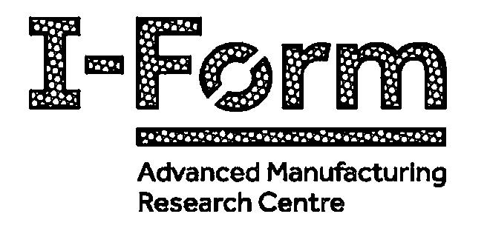
- Results
Fig. 5. Layer 2 Image acquired from G-Code Simulator
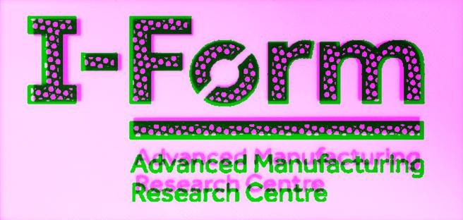
The methodology described in Section 4 has been tested on a 3D printed object shown in Fig. 3. Although the printed object consists of 35 layers, for illustration purposes, we assume this object consists only the of 4 layers shown in Fig. 4. The 3D model of this product has been designed to contain a hidden I-Form logo in the second layer and an intentional defect in the third layer.
Fig. 6. Misalignment between camera acquired and G-Code Simulator acquired images.

Fig. 3. 3D Printed Object.

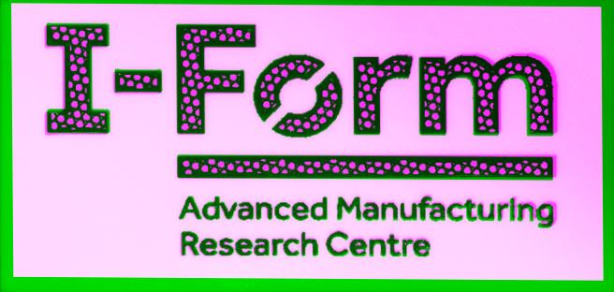
Fig. 7. (a) Aligned Images; (b) Mask Image after alignment.
a
b

  - Current Layer area Segregation
Fig. 4 (b) shows the camera-acquired image after deposition of layer 2. The white area in Fig. 4 (b) is layer 1, whereas the blue area is layer 2. The mask (image obtained from G-Code Simulator) to segregate layer 2 area from layer 1 area in Fig. 4 (b) is shown in Fig. 5. The misalignment between the camera acquired image (Fig. 4 (b)) and G-Code simulator acquired image (Fig. 5) is shown in Fig. 6. To use the layer 2 image from G-code simulator as a mask, we need to align Fig. 5 with Fig. 4 (b). Fig. 7 (a) shows the result of alignment using Image registration. The segregated area of the layer 2 obtained after applying the aligned mask (Fig. 7 (b)) is shown in Fig. 8.
  - 3D Model Reconstruction
After extraction of the layer 2 area from camera acquired image (Fig. 4 (b)), the current layer (Layer 2) geometry is encoded in the OBJ file. The generated OBJ file for the current layer viewed in 3D builder app is shown in Fig. 9. This process is repeated after deposition of each layer to generate OBJ file for each layer and these files are then merged in the developed app.
  - Interaction with the reconstructed 3D model
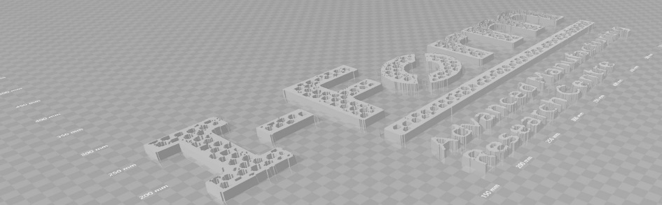
Fig. 10 shows the reconstructed 3D Model of the four layers viewed through HoloLens. The defect occurred during the deposition of the third layer can be seen in Fig. 10. Hence, using the proposed scanning technique, the user can visualize the hidden I-Form logo in the second layer as well as the defect in the third layer.
Fig. 9. Generated OBJ file for layer 2.
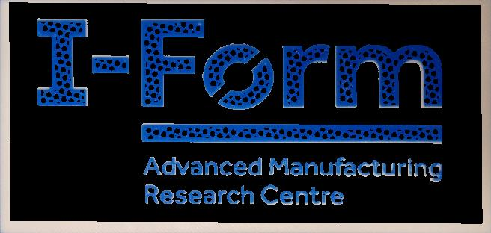
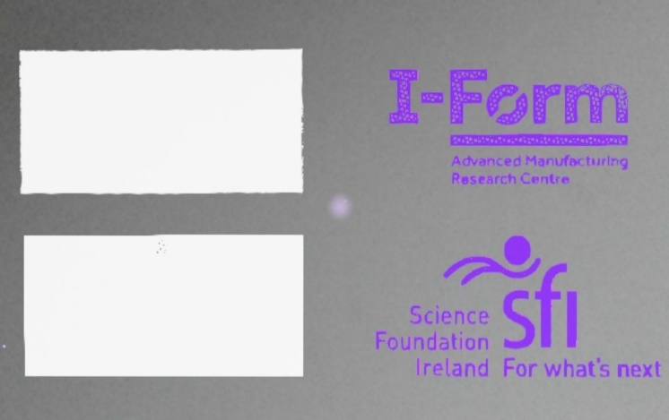
Fig. 8. Segregated Layer 2 (Processed) Image.
Defect
Fig. 10. Reconstructed 3D Model of the layers viewed through HoloLens.
Layer 1
Layer 2
Layer 3
Layer 4
- Concluding remarks
In this research, a novel scan-based method to reconstruct the 3D model of the product during the manufacturing process has been proposed and tested. The proposed method updates the 3D model of the work in progress, layer after layer, hence enabling real-time monitoring of the process. The proposed scanning technique also allows the user to inspect the build quality of the product by visualizing the reconstructed 3D model in a mixed reality environment using HoloLens. The app developed for HoloLens also allows the user to interact with the digital model using hand gestures and voice commands. Thus, the proposed scanning technique not only speeds up the iterative process development by enabling real-time monitoring but also provides detailed information about the build quality. The proposed scanning technique has the potential to facilitate the development of a decision support system using techniques from machine learning. This decision support system will not only be responsible for real-time defect detection but will also provide support for the operator’s decision-making capabilities in order to mitigate the occurred defects. This approach will be the direction of future work.
Acknowledgments
This publication has emanated from research supported in part by a research grant from Science Foundation Ireland (SFI) under grant number 16/RC/3872 and is co-funded under the European Regional Development Fund and by I-Form industry partners.
References
[1] Ramakers R, Anderson F, Grossman T, Fitzmaurice G. Retrofab: A design tool for retrofitting physical interfaces using actuators, sensors and 3d printing. In Proceedings of the 2016 CHI Conference on Human Factors in Computing Systems 2016 May 7 (pp. 409-419). ACM.
[2] Mueller S, Im S, Gurevich S, Teibrich A, Pfisterer L, Guimbretière F, Baudisch P. WirePrint: 3D printed previews for fast prototyping. InProceedings of the 27th annual ACM symposium on User interface software and technology 2014 Oct 5 (pp. 273-280). ACM.
[3] Cotteleer M, Joyce J. 3D opportunity: Additive manufacturing paths to performance, innovation, and growth. Deloitte Review. 2014 Jan 17;14:5-19.
[4] Tapia G, Elwany A. A review on process monitoring and control in metal-based additive manufacturing. Journal of Manufacturing Science and Engineering. 2014 Dec 1;136(6):060801.
[5] Uriondo A, Esperon-Miguez M, Perinpanayagam S. The present and future of additive manufacturing in the aerospace sector: A review of important aspects. Proceedings of the Institution of Mechanical Engineers, Part G: Journal of Aerospace Engineering. 2015 Sep;229(11):2132-47.
[6] Gu DD, Meiners W, Wissenbach K, Poprawe R. Laser additive manufacturing of metallic components: materials, processes and mechanisms. International materials reviews. 2012 May 1;57(3):133-64.
[7] Zeng K, Pal D, Stucker B. A review of thermal analysis methods in laser sintering and selective laser melting. In Proceedings of Solid Freeform Fabrication Symposium Austin, TX 2012 Aug 6 (Vol. 60, pp. 796-814).
[8] Abeykoon C, Martin PJ, Li K, Kelly AL. Dynamic modelling of die melt temperature profile in polymer extrusion: Effects of process settings, screw geometry and material. Applied Mathematical Modelling. 2014 Feb 15;38(4):1224-36.
[9] Oropallo W, Piegl LA. Ten challenges in 3D printing. Engineering with Computers. 2016 Jan 1;32(1):135-48.
[10] Hartley, Richard, and Andrew Zisserman. "Multiple view geometry in computer vision." Robotica 23.2 (2005): 271-272.
[11] Merrell P, Akbarzadeh A, Wang L, Mordohai P, Frahm JM, Yang R, Nistér D, Pollefeys M. Real-time visibility-based fusion of depth maps. In2007 IEEE 11th International Conference on Computer Vision 2007 Oct 14 (pp. 1-8). IEEE.
[12] Levoy M, Pulli K, Curless B, Rusinkiewicz S, Koller D, Pereira L, Ginzton M, Anderson S, Davis J, Ginsberg J, Shade J. The digital Michelangelo project: 3D scanning of large statues. InProceedings of the 27th annual conference on Computer graphics and interactive techniques 2000 Jul 1 (pp. 131-144). ACM Press/Addison-Wesley Publishing Co..
[13] Frahm JM, Fite-Georgel P, Gallup D, Johnson T, Raguram R, Wu C, Jen YH, Dunn E, Clipp B, Lazebnik S, Pollefeys M. Building rome on a cloudless day. In European Conference on Computer Vision 2010 Sep 5 (pp. 368-381). Springer, Berlin, Heidelberg.
[14] Kazhdan M, Hoppe H. Screened poisson surface reconstruction. ACM Transactions on Graphics (ToG). 2013 Jun 1;32(3):29.
[15]Schonberger JL, Frahm JM. Structure-from-motion revisited. InProceedings of the IEEE Conference on Computer Vision and Pattern Recognition 2016 (pp. 4104-4113).
[16] Cui Y, Schuon S, Chan D, Thrun S, Theobalt C. 3D shape scanning with a time-of-flight camera. In s2010 IEEE Computer Society Conference on Computer Vision and Pattern Recognition 2010 Jun 13 (pp. 1173-1180). IEEE.
[17] Chow J, Ang K, Lichti D, Teskey W. Performance analysis of a low-cost triangulation-based 3D camera: Microsoft Kinect system. InInt. Soc. for Photogrammetry and Remote Sensing Congress (ISPRS) 2012 Aug 25 (Vol. 39, p. B5).
[18] Fründ J, Gausemeier J, Matysczok C, Radkowski R. Using augmented reality technology to support the automobile development. InInternational Conference on Computer Supported Cooperative Work in Design 2004 May 26 (pp. 289-298). Springer, Berlin, Heidelberg.
[19] Ng LX, Oon SW, Ong SK, Nee AY. GARDE: a gesture-based augmented reality design evaluation system. International Journal on Interactive Design and Manufacturing (IJIDeM). 2011 Jun 1;5(2):85.
[20] Ong S, Pang Y, Nee AY. Augmented reality aided assembly design and planning. CIRP annals. 2007 Jan 1;56(1):49-52.
[21] Pang Y, Nee AY, Khim Ong S, Yuan M, Youcef-Toumi K. Assembly feature design in an augmented reality environment. Assembly Automation. 2006 Jan 1;26(1):34-43.
[22] Shen Y, Ong SK, Nee AY. Augmented reality for collaborative product design and development. Design Studies. 2010 Mar 1;31(2):118-45.
[23] Yamaoka J, Kakehi Y. MiragePrinter: interactive fabrication on a 3D printer with a mid-air display. In ACM SIGGRAPH 2016 Studio 2016 Jul 24 (p. 6). ACM.
[24] Ceruti A, Liverani A, Bombardi T. Augmented vision and interactive monitoring in 3D printing process. International Journal on Interactive Design and Manufacturing (IJIDeM). 2017 May 1;11(2):385-95.
[25] Oliveira FP, Tavares JM. Medical image registration: a review. Computer methods in biomechanics and biomedical engineering. 2014 Jan 25;17(2):73-93.

https://www.microsoft.com/en-us/hololens

