Consumer knowledge and attitudes towards microalgae as food: The case of Spain
Lafarga, Tomás ª; Rodríguez-Bermúdez, Ruth ^{b}; Morillas-España, Ainoa ª; Villaró, Silvia ^{c}; García-Vaquero, Marco ^{d}; Morán, Lara ^{e}; Sánchez-Zurano, Ana ª; González-López, Cynthia Victoria ª; Acién-Fernández, Francisco Gabriel ª
ª Department of Chemical Engineering, University of Almería, Almería, Spain
^{b} Department of Anatomy, Animal Production and Clinical Veterinary Science, University of Santiago de Compostela, Lugo, Spain
^{c} Department of Food Technology, University of Lleida, Lleida, Spain
^{d} School of Agriculture and Food Science, University College Dublin, Dublin, Ireland
^{e} Department of Pharmacy and Food Science, University of the Basque Country, Alava, Spain

Highlights
- A total of 3084 Spanish consumers over 18 years old were considered in the study.
- Average Spanish consumers do not know what microalgae are.
- Consumers consider microalgae as sustainable, nutritious, and safe.
- Main reasons for low consumption are lack of knowledge and lack of habit.
- Increasing consumers' knowledge could increase market shares of microalgae.

Keywords: Spirulina, Chlorella, Functional foods, Purchase intention, Questionnaire.

Abstract
Spanish consumers' knowledge and attitudes towards microalgae as food were assessed using a specific questionnaire - a total of 3084 Spanish consumers over 18 years old were considered in the current study. Overall, the questionnaire revealed that there is a huge lack of knowledge on basic aspects of microalgae, especially within the youngest respondents (18–24 years old) and for those aged over 65 years old. Approximately 85% of all respondents scored the statement “There is a big lack of information about microalgae” with either 4 or 5 (using a 5-point hedonic scale), demonstrating that microalgae and their potential applications are unknown to the majority of the Spanish population. Spanish consumers consider microalgae as: (i) sustainable and environmentally friendly, (ii) nutritious and healthy, and (iii) safe, which is of key importance for food products. The main reasons that were given for not consuming microalgae were lack of information available on the product and lack of consuming habit. The current study also demonstrated that increasing consumer's knowledge on microalgae has the potential to increase consumer choice and market shares of microalgae-enriched products. Results reported herein could be extrapolated to other European countries, although perception and attitudes towards food can vary depending on cultural considerations.

1. Introduction
Microalgae biotechnology has experienced an impressive growth over the last couple of decades in parallel with novel large-scale production facilities [1]. Microalgae are gaining increased significance in the context of the European bioeconomy, as these microscopic organisms can be used as sources of biomolecules that could serve as feedstock for energy and other valuable products with applications in agriculture, wastewater treatment, and cosmetic or pharmaceutic industries [2]. However, current production costs limit microalgae biomass applications to high-value markets, mainly for the production of foods (including functional foods) and nutritional supplements or nutraceuticals.

Microalgae are rich in high quality proteins, polyunsaturated fatty acids (PUFAs) including docosahexaenoic acid (DHA) and eicosapentaenoic acid (EPA), and bioactive molecules with health promoting properties such as phycocyanin, lutein, or astaxanthin [3]. Due to the high content of nutrients and health-promoting compounds, microalgae have been evaluated in several scientific publications as innovative ingredients for the formulation of functional baked products [4,5], beverages [6,7], pasta [8,9], and other foodstuffs [10,11]. Although the number of microalgae containing food products launched into the market is increasing every year, microalgae products are not yet a common food ingredient, at least in Western cultures [12]. Previous reports suggested that the strong (generally green) colour of microalgae together with their powdery consistency and their “marine” taste and odour limit their incorporation into food products [13]. Moreover, the current low microalgae production capacities make microalgae biomass not realistically available for the food industry, which operates at higher orders of magnitude [1]. A third reason could be the lack of knowledge that consumers have about microalgae and the health promoting properties attributed to their consumption. Consumers do not have access to reliable scientific publications, and their knowledge about microalgae depends on internet searches that generally do not provide evidence for given health claims or link microalgae with biodiesel production, aquaculture, and wastewater treatment.

Functional foods are one of the top trends in the food industry. These are sold at higher prices and allow larger profit margins than conventional foods. Although the acceptance of a functional food is far from being unconditional, one of the main conditions for acceptance of a functional food is the trustworthiness of its health claim [14]. Do consumers trust (or even know) the health benefits attributed to the consumption of microalgae? It is not known. Spirulina is the most cultivated and known microalgae [15]. Do consumers know what Spirulina is, or how it is produced? Information on consumers' perception of and knowledge about microalgae is lacking. The characterisation of consumer perception of and attitudes towards microalgae as food will be important to enable the development of marketing policies and promote the production and consumption of this valuable resource.

The aim of the current paper was to fill these gaps in knowledge by determining the knowledge that consumers have about microalgae: what they are, how they are produced, or the health benefits attributed to their consumption, among other issues. Moreover, the current paper also assessed the willingness of consumers to buy (and pay more for) microalgae containing products and determine the main reasons that make them buy or reject microalgae containing foods. Although this paper is limited to Spanish consumers, it provides clear evidence of the most relevant factors influencing acceptance by the consumers.

2. Materials and methods
2.1. Questionnaire
A specific questionnaire was designed for this study. The questionnaire included 36 close-ended questions. Coded options were provided as responses and consumers were asked to choose the option that best reflected their opinion or behavioural pattern [16]. Briefly, questions were divided into four sections: (i) personal data, (ii) general knowledge about microalgae, (iii) microalgae consumption as food, and (iv) purchase intention of microalgae containing foods.

Personal data included gender, age group, educational level, province and region of residence, number of family members, and frequency of shopping relative to other members of the family. The questionnaire was anonymous.

General questions about microalgae included if they heard about microalgae, if they heard about Spirulina or Chlorella, and if they know what they are or how they are produced, among other issues. Specific questions about microalgae as food included if they have ever eaten microalgae or microalgae derived ingredients, if they would be willing to eat them in the future, and a number of statements that had to be scored using a 10-point hedonic scale from 1 (totally disagree) to 10 (totally agree) and were used to identify the main reasons to accept or reject food products containing microalgae.

Finally, consumers were asked if they would purchase microalgae for food and what extra price they would pay for the product in comparison to the same product without microalgae. Then, consumers were asked to read a short paragraph about microalgae that explained what they are, how they are produced, their impact on the environment, and their nutritional value (among other issues) and were asked to answer once again if they would purchase microalgae for food and what extra price they would pay for the product – see Supplementary Material 1.

2.2. Data collection
The questionnaire was distributed online using social media sites namely LinkedIn, Twitter, Instagram, and Facebook by several Spanish universities, research institutes, associations, foundations, and by microalgae and food producers. Sociodemographic sample characteristics are given as Supplementary Material 2. A total of 3084 Spanish consumers over 18 years old were considered in the current study. The questionnaire was distributed in all the regions and provinces of Spain: most of the respondents (56.9%) resided in Andalusia, Catalonia, or the Community of Madrid, which are the most populated regions of Spain representing 18.3, 16.7, 14.5% of the total Spanish population. Responses were received within March and May 2020.

2.3. Statistical analysis
Data were analysed using SPSS v.24 (NY, USA). All variables were analysed by cross-tabulation and differences were considered significant at p < 0.05 using the Chi-square test.

3. Results and discussion
3.1. General knowledge about microalgae
The first question about microalgae was: Have you heard the term microalgae, at least once? Responses are described in Table 1. Briefly, the percentage of consumers who answered “Yes” was higher within the age groups 25–34 and 35–44 years old (25–44 years old), which was statistically higher than that of respondents aged 18–24 and 65 or higher (p < 0.001). Over 90 and 80% of respondents with a Doctorate or Master Degree heard the term microalgae at least once, against 53.8% of respondents with no regulated studies who never heard about microalgae (p < 0.001). Moreover, approximately 80% of consumers who affirmed that they like exotic flavours answered “Yes” (p < 0.001), probably caused by their higher predisposition to or interest in uncommon foods. Consumers were asked a second question on general knowledge about microalgae: Do you know what they are? Overall, more than 50% of all respondents did not know what microalgae are (or were not sure). Results are shown in Table 1, and more detailed information provided as Supplementary Material 3. The responses “No” and “I am not sure” were especially frequent in consumers within the age group 18–24 years old (p < 0.001) and in consumers with no regulated studies or with secondary or advanced level secondary education (p < 0.001). In contrast, consumers with a Doctorate Degree, which are only a small share of the Spanish population, were the only group that affirmed (80.4% of affirmative responses) knowing what microalgae are.

In terms of production, a third question was asked: Do you know how microalgae are produced? Approximately 80% of the respondents answered either “No” (48.2%) or “I am not sure” (29.0%) (Table 1). Again, this value was especially high for consumers aged 18–24 years old and also for those over 65 years old (p < 0.001). Approximately 99% of respondents with no formal education and 85% of respondents with secondary education degrees did not know how microalgae are produced, and only respondents with a Doctorate Degree affirmed knowing microalgae production strategies (57.8% of affirmative responses).

Table 1. Basic knowledge of microalgae.
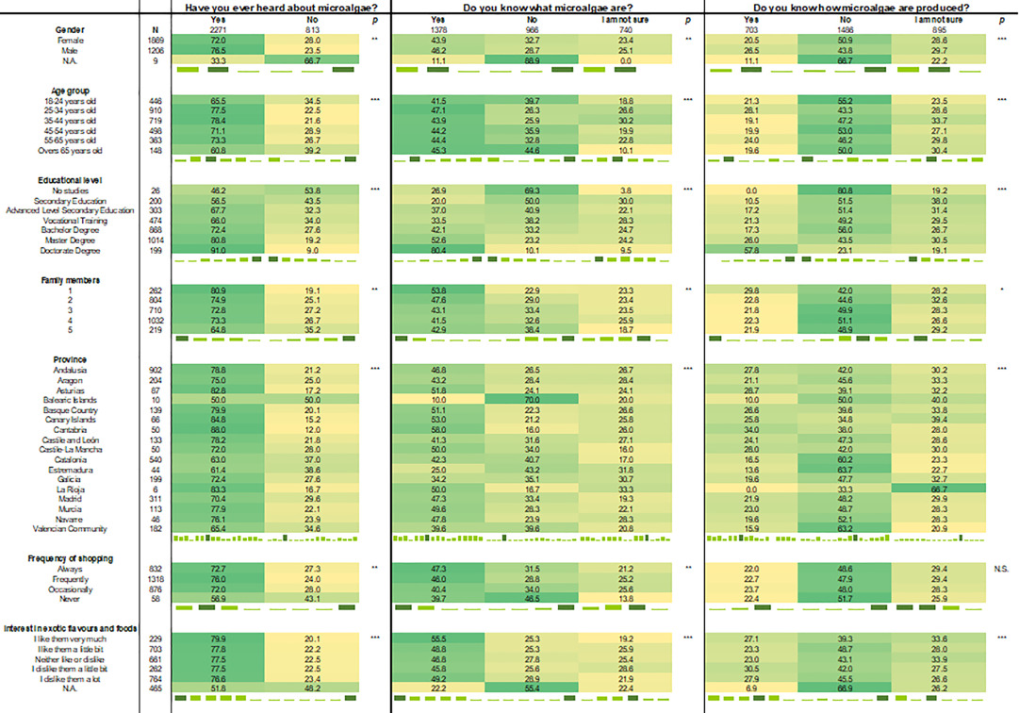
N: Number of samples; N.A.: Not answered; N.S.: Not significant. * p < 0.05; ** p < 0.01; *** p < 0.0001.

In addition, despite the many applications of microalgae, which range from biodiesel production [17] or wastewater treatment [18] to production of high value chemicals [19], the aim of the current paper was to assess the attitude of consumers towards microalgae when used as food. As highlighted previously the value of microalgae as food resides in the wide variety of health promoting compounds that microalgae synthesise. These include, but are not limited to PUFAs, proteins/enzymes, sterols, carotenoids, vitamins, and minerals [20]. Therefore, a fourth question on basic knowledge on microalgae, in this case focusing on microalgae used as food, was: Do you know the health benefits of consuming microalgae? Most of the respondents (72.2%) either did not know or were not sure about the potential benefits of consuming microalgae (Table 1). Approximately 50% of respondents did not know or were not sure about what microalgae are. Only 51.8% of consumers with a Doctorate Degree affirmed knowing the health benefits of consuming microalgae, which was the group that affirmed having the highest knowledge (p < 0.001).

Overall, results demonstrated that knowledge on the basic aspects of microalgae, namely what they are, how they are produced, and their potential application as food is lacking. This lack of knowledge on the basic aspects of microalgae is especially high for the youngest respondents (18–24 years old) and for those aged over 65 years old. Moreover, the educational level was the most significant factor affecting general knowledge on microalgae. Only respondents with a Doctorate Degree, who represent the 0.8% of the Spanish population, affirmed having knowledge on basic aspects of microalgae. However, only 57.8% affirmed knowing how they are produced and 51.8% know the health benefits associated to their consumption.

The number of microalgae strains that can be incorporated into foods is limited. In the EU, microalgae must be commercialised under the Novel Food Regulation (EU) 2015/2283, which defines a novel food as a food that has not been consumed to any significant degree in the EU before 15 May 1997 [15]. Because of their long history of use, the access to the market of Spirulina and Chlorella is not subjected to this regulation and are the most common for food applications. Spirulina is a trade name given to describe mainly two species of cyanobacteria (microalgae): Arthrospira platensis and Arthrospira maxima. Spirulina is the most cultivated microalga worldwide – over 30% of microalgal biomass production is from Spirulina [21] and is the most commonly consumed microalgae in Europe and America. In turn, Chlorella is more common in Asia. Most of the microalgae containing food products commercialised in Spain contain the words “Spirulina” and/or “Chlorella” in their label instead of “microalgae”. For this reason, in the current study, consumers were asked: Have you heard about Spirulina or Chlorella? Answers to this question demonstrated that the majority of consumers heard the terms Spirulina or Chlorella. Indeed, a 25.2% of the respondents affirmed hearing at least once about both and 37.8% affirmed hearing only about Spirulina (Fig. 1). This demonstrates that the terms “Spirulina” and “Chlorella” are almost as common in Spain as the term “microalgae”. Affirmative responses were especially high for females, as 69.9% of female respondents heard speaking about one or both strains while only 54.5% of men did.

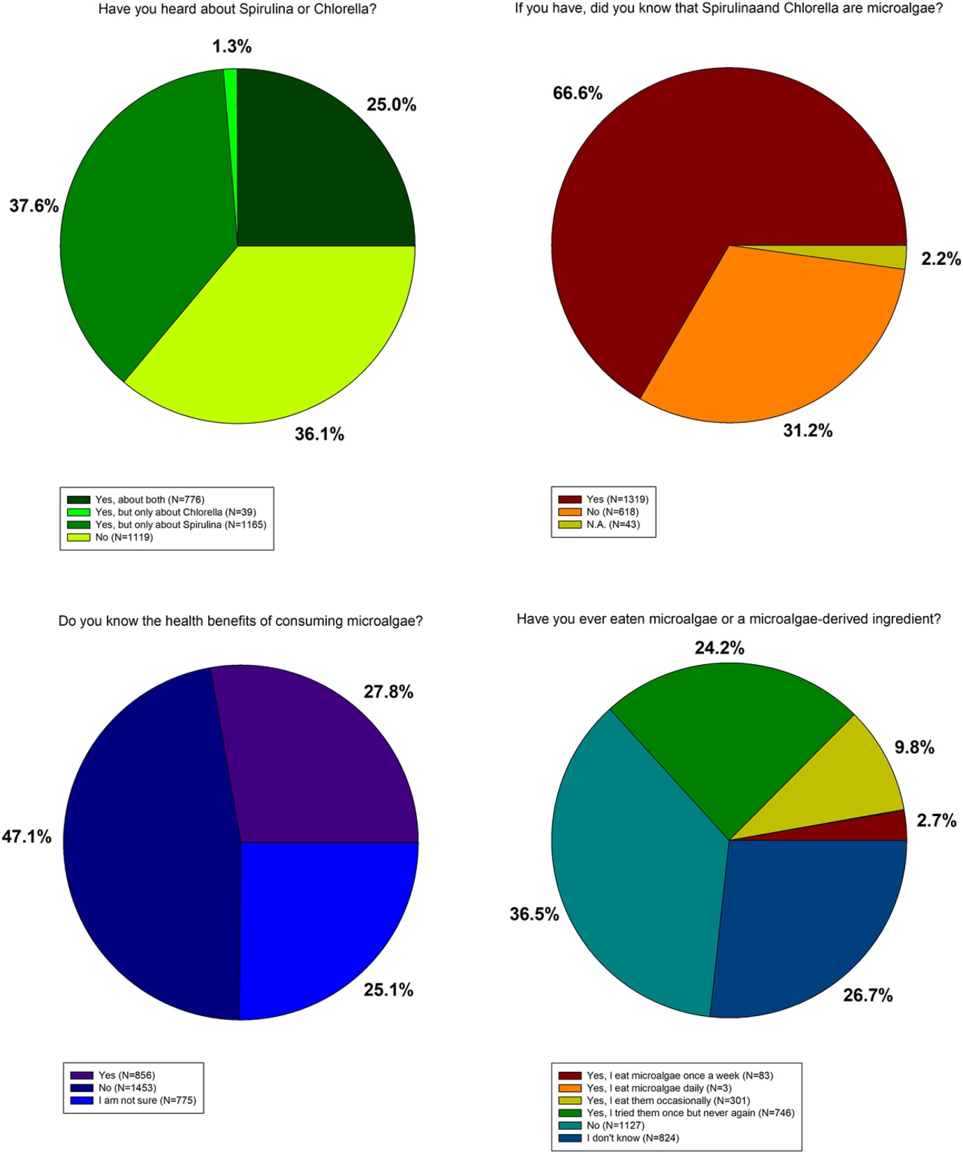
Fig. 1. Consumption of microalgae: Spirulina and Chlorella.

Those consumers who heard the terms Spirulina or Chlorella were asked a second question: Did you know that Spirulina and Chlorella are microalgae? Reponses demonstrated that two thirds (66.6%) of the respondents knew that Spirulina and Chlorella were microalgae. This value was especially high for those consumers with a Doctorate Degree and for those aged 25–44 years old (p < 0.001) – see Supplementary Material 3.

3.2. Microalgae consumption as food
The first question regarding consumption of microalgae was: Have you ever eaten microalgae or a microalgae-derived ingredient? Briefly, 36.7% of responses were “Yes”, 36.5% were “No”, and the remaining 26.7% of respondents did not know whether they had consumed microalgae or not (see Supplementary Material 3). Consumers who have never consumed microalgae were more frequent within the those aged over 65 years old (62.1%) and within those with no regulated studies (61.6%). Moreover, a relatively high number of consumers who dislike exotic flavours and foods never ate microalgae (41.7%) when compared to those who do like exotic flavours (25.8%). For those who answered “Yes”, the majority (71.0%) said that they consumed microalgae just once, while 28.7% consume them occasionally and only 0.2% consumed microalgae on a regular basis. Based on the results reported herein, only 9.7 and 0.1% of the Spanish consumers consume microalgae occasionally or regularly, respectively.

To better understand the low consumption of this valuable resource, a number of questions were further formulated. In the first place, consumers were asked: If you have never consumed microalgae, or you have but you have stopped consuming them, would you be interested in consuming them in the future? Approximately 30% of responses were affirmative, while almost half of the total responses were “I am not sure”. This suggests that although the current consumption level is very low, consumers are likely to consume this valuable resource in the future. Consumers that do not consume microalgae but would be willing to consume microalgae in the future were more common within those that like exotic flavours and foods (51.2%), those who live alone (37.4%), and those aged 18–34 years old (34.5%). This information is relevant for the development of marketing policies and to promote the consumption of microalgae biomass (or compounds derived thereof).

In the current survey, consumers were asked to give the reasons for consuming microalgae and to assess them using a 10-point hedonic scale. The three most common answers suggest that Spanish consumers consider microalgae as: (i) sustainable and environmentally friendly, (ii) nutritious and healthy, and (iii) safe (Fig. 2). This is of key importance as sustainability, health promoting properties, and safety are key (and essential) for the present and future of the food industry. Microalgae are indeed sustainable and nutritious. As highlighted in previous sections, microalgae are a rich source of a wide variety of health promoting properties. The statement “Microalgae are nutritious and healthy” was positively scored by the consumers, with 75.8% of all responses ranging between 7 and 10 (using a 10-point hedonic scale). Results demonstrate that microalgae are considered as a healthy option by most of the Spanish consumers. This could be caused by the perception of green foods as healthy [22], although this would need to be assessed in future studies. When asked for more specific aspects of the nutritional value of microalgae, results demonstrated a lack of knowledge. For example, the composition of microalgae varies depending on several factors. There are important differences in the major macromolecular molecules across different phyla and between different growth stages [23]. Some microalgae such as Spirulina are naturally rich in protein [15] and their commercial success comes (in part) from their high protein content. When asked about the protein content of microalgae, responses reflected that most of the consumers did not know that microalgae are a potential protein source: over 60% of the consumers who assessed the statement “Microalgae are rich in protein” scored it from 1 to 7 (using a 10-point hedonic scale). In terms of sustainability, 75.7% of all responses scored the statement “Microalgae are sustainable and good from the environment” from 7 to 10 (using a 10-point hedonic scale) (Fig. 2). Probably, the green colour of (the majority of) microalgae led consumers to consider them as an environmentally friendly product, as it is known that green colour echoes positive environmental connotations [24,25]. This is not just due to of their green colour, several reports highlight the sustainability of microalgae production, especially when coupled to wastewater treatment process and absorption of carbon dioxide produced in industrial facilities [26,27].

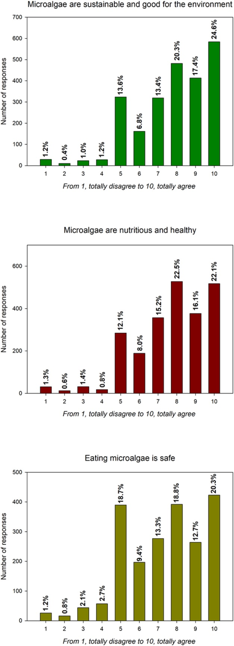
Fig. 2. Main reasons given by consumers for consuming microalgae and microalgae-derived ingredients. Assessed using a 10-point hedonic scale.

Moreover, consumers were asked to assess the main causes limiting consumption of microalgae. Results were surprising, as consumers did not negatively score taste or aroma, which have been suggested as negatively affecting the incorporation of microalgae in the past [13]. One reason could be the very low number of microalgae introduced into commercial products, which is generally under 1%. In turn, the intense green colour of microalgae was negatively scored: 52.3% of responses negatively scored the statement “Their colour is too intense” from 7 to 10 (using a 10-point hedonic scale). The intense colour of microalgae is a drawback. For this reason, previous reports aimed at masking the green colour of microalgae-containing foods by using, for example, chocolate [28] or by incorporating microalgae biomass into naturally green products such as broccoli soup [7]. The most common reasons given by Spanish consumers for not consuming microalgae are shown in Fig. 3. Consumers highlighted that they did not know where to buy microalgae and that they were not used to consuming them. Although algae (macroalgae) have been traditionally consumed in some regions of Spain, mainly in the North-West coast, the majority of Spanish consumers are not used to consume algae. Moreover, although the number of food products containing microalgae launched into the market is increasing every year [12], the amount and variety of products currently commercially available in Spain is still very low. Finally, it is important to highlight the scores given to the statement “There is a big lack of information about microalgae”, which are summarised in Fig. 4. Approximately 85% of all the respondents scored this statement with either 4 or 5 (using a 5-point hedonic scale), which supports the idea that microalgae and their potential applications are unknown to the majority of the Spanish population. Consumer knowledge about microalgae is likely to be similar in other European countries.

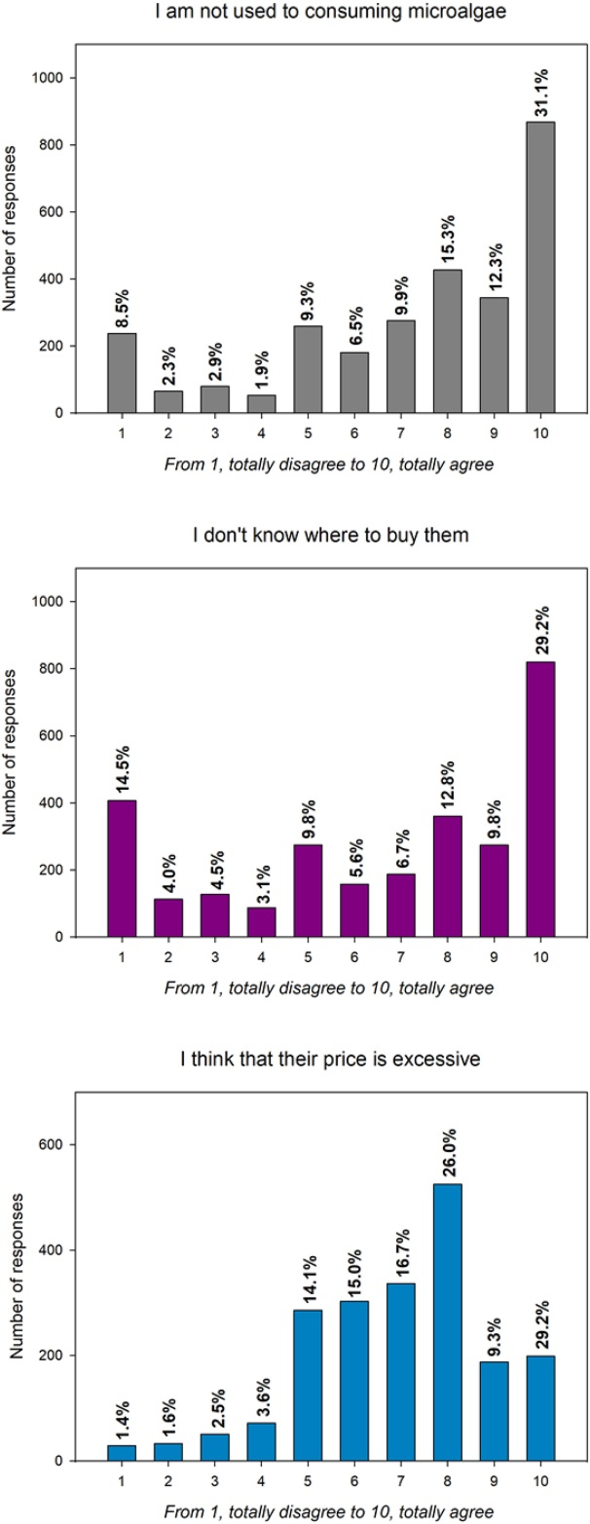
Fig. 3. Main reasons given by consumers for not consuming microalgae and microalgae-derived ingredients. Assessed using a 10-point hedonic scale.

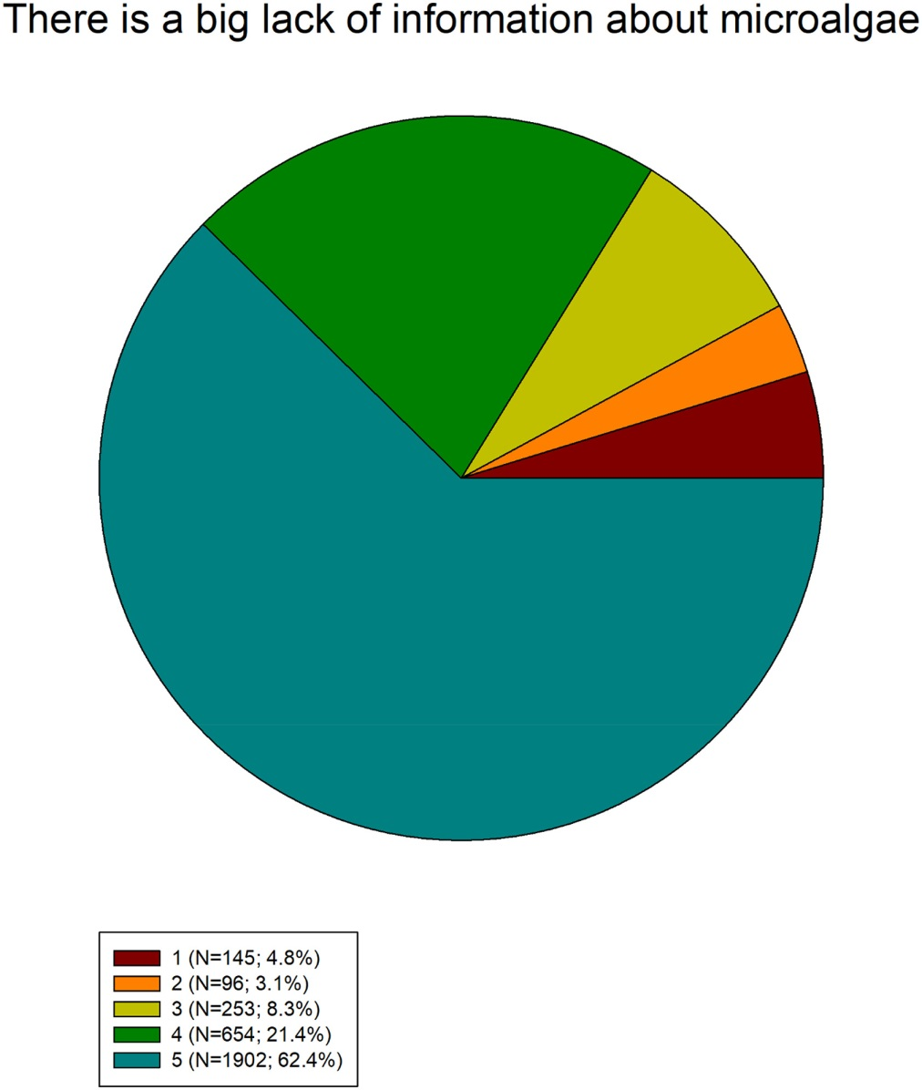
Fig. 4. Assessment of the statement There is a big lack of information about microalgae using a 5-point hedonic scale.
3.3. Purchase intention of microalgae-containing foods
The current study assessed the effect of knowing the environmental impact of microalgae production and the health benefits associated to their consumption on both, purchase intention and the amount of money that consumers would be willing to pay for a microalgae-enriched product. For this reason, consumers were asked two questions: (i) Would you eat microalgae? and (ii) What extra price would you pay for a microalgae containing product? These questions were asked twice, before and after reading a text which summarises some of the positive aspects of microalgae production and consumption (shown in Materials and Methods section). Briefly, before reading the text, only 42.7% of all respondents stated that would eat microalgae while 53.5% were not sure (Fig. 5). After reading the text, 84.5% of all respondents would be willing to eat microalgae-containing foods while only 1.4% said that would not consume them. Knowing that microalgae contains health promoting compounds, and that their production is controlled and sustainable, doubled the number of affirmative responses, demonstrating the importance of increasing awareness about microalgae to facilitate their consumption and commercialisation. Increasing consumer's knowledge on microalgae has the potential to increase consumer choice and market shares of microalgae enriched products. Previous reports suggested that nudging strategies as well as strategies to reduce unfamiliarity are worthy options to increase the preference for meat substitutes formulated using microalgae [29].

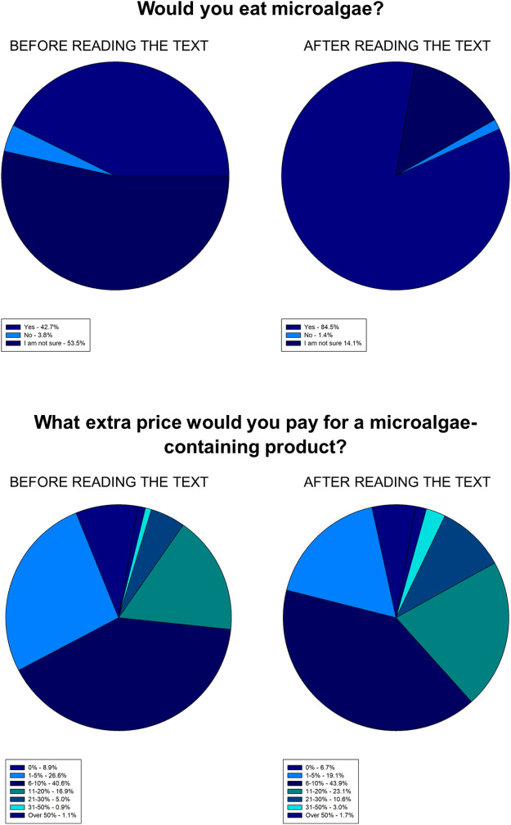
Fig. 5. Effect of knowledge on basic aspects of microalgae biotechnology on purchase intention of microalgae-containing foods.

Moreover, when asked about the extra price that they would pay for a microalgae-containing product, before reading the text, 8.9% of the consumers stated that they would not pay an extra price while approximately 40% of them would be willing to pay an extra 6–10% for the product. After reading the text, the trend was similar, most of the consumers would be willing to pay an extra 6–10% for a microalgae-containing product, although the number of consumers that would pay an extra 21–30% or 31–50% was doubled and tripled, respectively (Fig. 5). Knowledge on the health benefits of a given product and on the environmental impact of its production can affect not only the purchase and consumption intention but also the amount of extra money that consumers would be willing to pay. In a previous study, the preference and willingness of French, German, and Dutch consumers to purchase microalgae-based meat substitutes was affected by knowledge on the health benefits of microalgae [29]. Similar results were reported by García-Segovia et al. [30], who assessed consumer perception and acceptability of an innovative microalgae-based breadstick and concluded that consumers would accept if the microalgae containing product had a higher price as it was considered as healthier.

Consumers purchase behaviour and attitudes towards a functional product depends on several factors such as the nature of the carrier product, the type of health claim associated to such product, the functional ingredient incorporated into the food, and a combination of all of these factors [31]. Moreover, certain food matrices aid in the retention of bioactivity during processing and digestion [32]. Thus, selection of a suitable delivery vehicle for health promoting properties and the use of mild processing technologies is of key importance. For example, bread has been suggested as ideally suited for the delivery of bioactive molecules [5,33]. Furthermore, in Japan, for example, functional foods are considered a distinct class of product and the importance of their health promoting activity often exceeds the importance of their sensory attributes [34]. However, Western cultures have a different attitude towards functional foods and acceptance of food is more conditional, especially with respect to taste [34]. Taste expectation and experiences were shown to be critical factors when selecting functional foods in numerous studies [35,36]. Overall, microalgae containing foods are well accepted by consumers [5,7,30,37,38]. In addition, as suggested previously, the amount of microalgae incorporated into most products is very low and does not generally affect flavour.

In order to aid the development of microalgae enriched products, consumers were asked one last question: In what food group(s) would you prefer to introduce microalgae as an ingredient? The most common responses were “Baked products” followed by “Sauces and seasonings”, “Beverages”, and “Pasta” (Table 2). Baked products such as bread were the preferred option for all the studied age groups (except for those aged over 65 years old, who preferred sauces and seasonings) and educational levels (except for those with no regulated studies who preferred pasta). Results are in line with currently available microalgae containing products, which are mainly pasta, beverages, and baked products such as bread or biscuits [12]. In addition, results are consistent with those reported by Grahl et al. [39], who evaluated consumers' (from France, Germany, and the Netherlands) willingness to try three foods containing Spirulina and concluded that Spirulina-filled pasta was the preferred product when compared with sushi and jerky. To the best of our knowledge, there are no studies on consumer attitudes towards microalgae as food in other countries, except for a limited number of publications on microalgae as food supplements or focused on a specific microalga enriched product or products [29,39,40]. Thus, results obtained in the current study cannot yet be compared with those of other countries, although Grahl et al. [39] recently concluded that, in their study, country differences in acceptance of three microalgae-enriched products could be neglected. We believe that results reported herein could be extrapolated to other European countries, although perception and attitudes towards can vary depending on cultural considerations [16].

Table 2. Preferred food groups to incorporate microalgae.
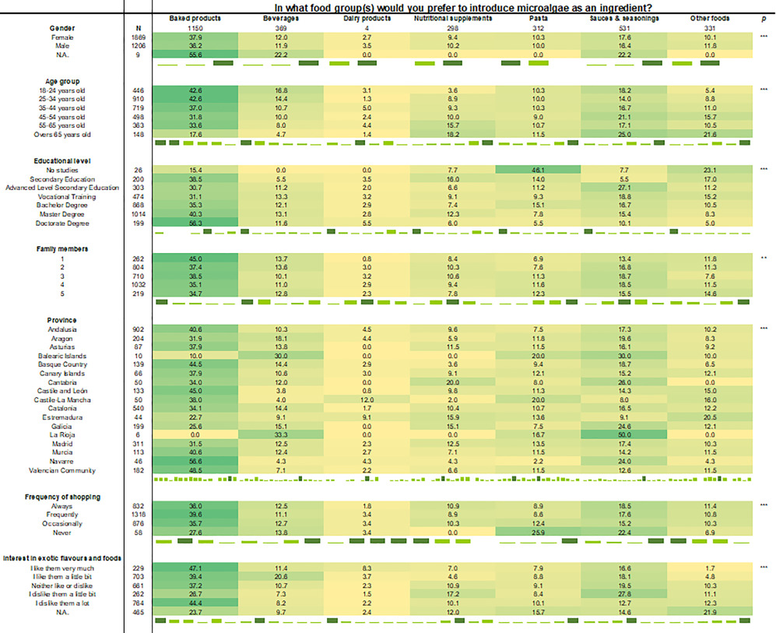
N: Number of samples; N.A.: Not answered; N.S.: Not significant. * p < 0.05; ** p < 0.01; *** p < 0.0001.

4. Conclusions
The knowledge on basic aspects of microalgae is lacking, namely; what they are, how they are produced, and their potential application as food. Age group and educational level were the most significant factors affecting general knowledge on microalgae. A positive finding was that Spanish consumers consider microalgae as sustainable, environmentally friendly, healthy, and safe, which are vital for success when commercialising a food ingredient. The main reasons given for not consuming microalgae were lack of information on the product and lack of consuming habit as algae are not common ingredients in Spanish culinary preparations. When asked about the ideal food matrix for incorporating microalgae, baked products such as bread was the preferred option for most of the respondents, followed by pasta. Efforts are required by microalgae and food processors to increase consumer knowledge about microalgae, as this has potential to increase consumer choice and market shares of microalgae-enriched products.

Acknowledgements
This research forms part of the SUSPROT project funded by the BBVA foundation under the Leonardo Grant for Researchers and Cultural Creators, the SABANA project of the European Union's Horizon 2020 Research and Innovation Programme (grant # 727874), and the AL4BIO Project, funded by the Spanish Ministry of Science, Innovation, and Universities (RTI2018-099495-A-C22). T. Lafarga thanks the Juan de la Cierva Incorporación programme, funded by the Spanish Ministry of Science, Innovation, and Universities (IJC2018-035287-I).

References
[1] J.A. Garrido-Cardenas, F. Manzano-Agugliaro, F.G. Acien-Fernandez, E. Molina-Grima Microalgae research worldwide Algal Res., 35 (2018), pp. 50-60, 10.1016/j.algal.2018.08.005
[2]K.W. Chew, J.Y. Yap, P.L. Show, N.H. Suan, J.C. Juan, T.C. Ling, D.J. Lee, J.S. Chang Microalgae biorefinery: high value products perspectives Bioresour. Technol., 229 (2017), pp. 53-62, 10.1016/j.biortech.2017.01.006
[3] T. Lafarga Cultured microalgae and compounds derived thereof for food applications: strain selection and cultivation, drying, and processing strategies Food Rev. Int., 36 (2020), pp. 559-583, 10.1080/87559129.2019.1655572
[4] C. Graça, P. Fradinho, I. Sousa, A. Raymundo Impact of Chlorella vulgaris on the rheology of wheat flour dough and bread texture LWT - Food Sci. Technol., 89 (2018), pp. 466-474, 10.1016/j.lwt.2017.11.024
[5] T. Lafarga, E. Mayre, G. Echeverria, I. Viñas, S. Villaró, F.G. Acién-Fernández, M. Castellari, I. Aguiló-Aguayo Potential of the microalgae Nannochloropsis and Tetraselmis for being used as innovative ingredients in baked goods LWT – Food Sci. Technol., 115 (2019), p. 108439, 10.1016/j.lwt.2019.108439
[6] P.R. Los, D.R.S. Simões, R. de S. Leone, B.C. Bolanho, T. Cardoso, E.D.G. Danesi Viability of peach palm by-product, Spirulina platensis, and spinach for the enrichment of dehydrated soup Pesqui. Agropecuária Bras., 53 (2018), pp. 1259-1267, 10.1590/s0100-204x2018001100008
[7] T. Lafarga, F.G. Acién-Fernández, M. Castellari, S. Villaró, G. Bobo, I. Aguiló-Aguayo Effect of microalgae incorporation on the physicochemical, nutritional, and sensorial properties of an innovative broccoli soup LWT – Food Sci. Technol., 111 (2019), pp. 167-174, 10.1016/j.lwt.2019.05.037
[8] E. Rodríguez De Marco, M.E. Steffolani, C.S. Martínez, A.E. León Effects of spirulina biomass on the technological and nutritional quality of bread wheat pasta LWT - Food Sci. Technol., 58 (2014), pp. 102-108, 10.1016/j.lwt.2014.02.054
[9] M. Fradique, A.P. Batista, M.C. Nunes, L. Gouveia, N.M. Bandarra, A. Raymundo Isochrysis galbana and Diacronema vlkianum biomass incorporation in pasta products as PUFA’s source LWT - Food Sci. Technol., 50 (2013), pp. 312-319, 10.1016/j.lwt.2012.05.006
[10] R.C. Robertson, M.R. Gracia Mateo, M.N. O’Grady, F. Guihéneuf, D.B. Stengel, R.P. Ross, G.F. Fitzgerald, J.P. Kerry, C. Stanton An assessment of the techno-functional and sensory properties of yoghurt fortified with a lipid extract from the microalga Pavlova lutheri Innov. Food Sci. Emerg. Technol., 37 (2016), pp. 237-246, 10.1016/j.ifset.2016.03.017
[11] B.F. Lucas, M.G. de Morais, T.D. Santos, J.A.V. Costa Spirulina for snack enrichment: nutritional, physical and sensory evaluations LWT - Food Sci. Technol., 90 (2018), pp. 270-276, 10.1016/j.lwt.2017.12.032
[12] T. Lafarga Effect of microalgal biomass incorporation into foods: nutritional and sensorial attributes of the end products Algal Res., 41 (2019), p. 101566, 10.1016/j.algal.2019.101566
[13] T.L. Chacón-Lee, G.E. González-Mariño Microalgae for “healthy” foods-possibilities and challenges Compr. Rev. Food Sci. Food Saf., 9 (2010), pp. 655-675, 10.1111/j.1541-4337.2010.00132.x
[14] I. Siró, E. Kápolna, B. Kápolna, A. Lugasi Functional food. Product development, marketing and consumer acceptance—a review Appetite, 51 (2008), pp. 456-467, 10.1016/j.appet.2008.05.060
[15] T. Lafarga, J.M. Fernández-Sevilla, C. González-López, F.G. Acién-Fernández Spirulina for the food and functional food industries Food Res. Int., 137 (2020), p. 109356, 10.1016/j.foodres.2020.109356
[16] R. Rodríguez-Bermúdez, M. Miranda, I. Orjales, M.J. Ginzo-Villamayor, W. Al-Soufi, M. López-Alonso Consumers’ perception of and attitudes towards organic food in Galicia (northern Spain) Int. J. Consum. Stud., 44 (2020), pp. 206-219, 10.1111/ijcs.12557
[17] S. Jazzar, J. Quesada-Medina, P. Olivares-Carrillo, M.N. Marzouki, F.G. Acién-Fernández, J.M. Fernández-Sevilla, E. Molina-Grima, I. Smaali A whole biodiesel conversion process combining isolation, cultivation and in situ supercritical methanol transesterification of native microalgae Bioresour. Technol., 190 (2015), pp. 281-288, 10.1016/j.biortech.2015.04.097
[18] A. Sánchez Zurano, J.A. Garrido Cárdenas, C. Gómez Serrano, M. Morales Amaral, F.G. Acién-Fernández, J.M. Fernández Sevilla, E. Molina Grima Year-long assessment of a pilot-scale thin-layer reactor for microalgae wastewater treatment. Variation in the microalgae-bacteria consortium and the impact of environmental conditions Algal Res., 50 (2020), 10.1016/j.algal.2020.101983101983
[19] Y.K. Chang, P.L. Show, J.C.W. Lan, J.C. Tsai, C.R. Huang Isolation of C-phycocyanin from Spirulina platensis microalga using ionic liquid based aqueous two-phase system Bioresour. Technol., 270 (2018), pp. 320-327, 10.1016/j.biortech.2018.07.138
[20] M.F. De Jesus Raposo, R.M.S.C. De Morais, A.M.M.B. De Morais Health applications of bioactive compounds from marine microalgae Life Sci., 93 (2013), pp. 479-486, 10.1016/j.lfs.2013.08.002
[21] J.A.V. Costa, B.C.B. Freitas, G.M. Rosa, L. Moraes, M.G. Morais, B.G. Mitchell Operational and economic aspects of Spirulina-based biorefinery Bioresour. Technol., 292 (2019), p. 121946, 10.1016/j.biortech.2019.121946
[22] J.P. Schuldt Does green mean healthy? Nutrition label color affects perceptions of healthfulness Health Commun., 28 (2013), pp. 814-821, 10.1080/10410236.2012.725270
[23] Z.V. Finkel, M.J. Follows, J.D. Liefer, C.M. Brown, I. Benner, A.J. Irwin Phylogenetic diversity in the macromolecular composition of microalgae PLoS One, 11 (2016), Article e0155977, 10.1371/journal.pone.0155977
[24] Z. O’ConnorLogo colour and differentiation: A new application of environmental colour mapping Color. Res. Appl., 36 (2011), pp. 55-60, 10.1002/col.20594
[25] A. Sundar, J.J. Kellaris How logo colors influence Shoppers’ judgments of retailer ethicality: the mediating role of perceived eco-friendliness J. Bus. Ethics, 146 (2017), pp. 685-701, 10.1007/s10551-015-2918-4
[26] T.M. Mata, A.M. Mendes, N.S. Caetano, A.A. Martins Sustainability and economic evaluation of microalgae grown in brewery wastewater Bioresour. Technol., 168 (2014), pp. 151-158, 10.1016/j.biortech.2014.04.091
[27] L. Moreno-Garcia, K. Adjallé, S. Barnabé, G.S.V. Raghavan Microalgae biomass production for a biorefinery system: recent advances and the way towards sustainability Renew. Sust. Energ. Rev., 76 (2017), pp. 493-506, 10.1016/j.rser.2017.03.024
[28] S.A.A. Hlaing, M.B. Sadiq, A.K. Anal Enhanced yield of Scenedesmus obliquus biomacromolecules through medium optimization and development of microalgae based functional chocolate J. Food Sci. Technol., 57 (2020), pp. 1090-1099, 10.1007/s13197-019-04144-3
[29] R. Weinrich, O. Elshiewy Preference and willingness to pay for meat substitutes based on micro-algae Appetite., 142 (2019), p. 104353, 10.1016/j.appet.2019.104353
[30] P. García-Segovia, V. García Alcaraz, A. Tárrega, J. Martínez-Monzó Consumer perception and acceptability of microalgae based breadstick Food Sci. Technol. Int., 26 (2020), pp. 493-502, 10.1177/1082013220906235
[31] J.M. Wills, S. Storcksdieck Genannt Bonsmann, M. Kolka, K.G. Grunert, European consumers and health claims: attitudes, understanding and purchasing behaviour, Proc. Nutr. Soc. 71 (2012) 229–236, doi:https://doi.org/10.1017/s0029665112000043.
[32] T. Lafarga, C. Álvarez, M. Hayes Bioactive peptides derived from bovine and porcine co-products: A review J. Food Biochem., 41 (2017), Article e12418, 10.1111/jfbc.12418
[33] T. Lafarga, E. Gallagher, R.E. Aluko, M.A.E. Auty, M. Hayes Addition of an enzymatic hydrolysate of bovine globulins to bread and determination of hypotensive effects in spontaneously hypertensive rats J. Agric. Food Chem., 64 (2016), pp. 1741-1750, 10.1021/acs.jafc.5b06078
[34] S. Grasso, N.P. Brunton, J.G. Lyng, F. Lalor, F.J. Monahan Healthy processed meat products - regulatory, reformulation and consumer challenges Trends Food Sci. Technol., 39 (2014), pp. 4-17, 10.1016/j.tifs.2014.06.006
[35] H. Tuorila, A.V. Cardello Consumer responses to an off-flavor in juice in the presence of specific health claims Food Qual. Prefer., 13 (2002), pp. 561-569, 10.1016/S0950-3293(01)00076-3
[36] L.C. Gilbert The functional food trend: What’s next and what Americans think about eggs J. Am. Coll. Nutr., 19 (2000), pp. 507S-512S, 10.1080/07315724.2000.10718973
[37] N. Castillejo, G.B. Martínez-Hernández, V. Goffi, P.A. Gómez, E. Aguayo, F. Artés, F. Artés-Hernández Natural vitamin B12 and fucose supplementation of green smoothies with edible algae and related quality changes during their shelf life J. Sci. Food Agric., 98 (2018), pp. 2411-2421, 10.1002/jsfa.8733
[38] Ḿonica Fradique, A.P. Batista, M.C. Nunes, L. Gouveia, N.M. Bandarra, A. Raymundo Incorporation of Chlorella vulgaris and Spirulina maxima biomass in pasta products. Part 1: Preparation and evaluation J. Sci. Food Agric., 90 (2010), pp. 1656-1664, 10.1002/jsfa.3999
[39] S. Grahl, M. Strack, R. Weinrich, D. Mörlein Consumer-oriented product development: the conceptualization of novel food products based on Spirulina (Arthrospira platensis) and resulting consumer expectations J. Food Qual., 2018 (2018), Article ID1919482, 10.1155/2018/1919482
[40] P. Rzymski, M. Jaśkiewicz Microalgal food supplements from the perspective of polish consumers: patterns of use, adverse events, and beneficial effects J. Appl. Phycol., 29 (2017), pp. 1841-1850, 10.1007/s10811-017-1079-5

