Impact of impending sustainability legislation on manufacturing SMEs
Owen Humphreys and Denis Dowling

Under the Irish Government Sectoral Emissions Ceilings announced last year, the manufacturing sector will have to achieve a 35% reduction in emissions by 2030, compared to the level of emissions in 2018. Manufacturing along with broader industrial processing accounts for approximately 13% of Ireland’s greenhouse gas emissions [1]. While a range of companies such as Intel, Diageo, Janssen and Boston Scientific have already pledged to significantly reduce their carbon emissions [2], many companies do not have the resources or internal technical expertise to make this transition to sustainability. This is particularly the case for SMEs, which account for 49% of Irish industrial sector employment. Overall within the EU however, it is reported that SMEs are the source of 64% of total industrial pollution and account for 60-70% of the total industrial waste [3].

Carbon Taxes
Going forward, companies who do not significantly reduce their emissions will increasingly be at a competitive disadvantage. One reason for this is the increased cost associated with the introduction of carbon taxes. The carbon tax rate for Ireland has increased from €21.60 tCO₂e in 2020, to €48.50 tCO₂e this year [4]. Ireland’s carbon tax rate is in the medium range when compared with countries in northern and eastern Europe as shown in Figure 1. A recent paper from the journal Nature, provided an assessment of the social cost of carbon dioxide, based on estimates of the monetised value of the damages to society, caused by a metric tonne of CO₂ emissions [5]. This study concluded that the true cost of carbon emissions should be €178 tCO₂e, based on estimates derived from a combination of the latest climate models, along with the greater scientific understanding of how changes in climate are likely to affect human wellbeing. In providing this estimation however, the authors highlighted that this cost per ton did not take into account the impact of climate change on biodiversity, labour productivity, conflict, and migration. These factors were likely to further increase the costs to society for each additional ton of carbon emitted, thus strengthening the need for more stringent climate mitigation policies. In the next decade there is likely to be further significant increases to the carbon tax rate and companies should act now to reduce their emissions and associated costs.
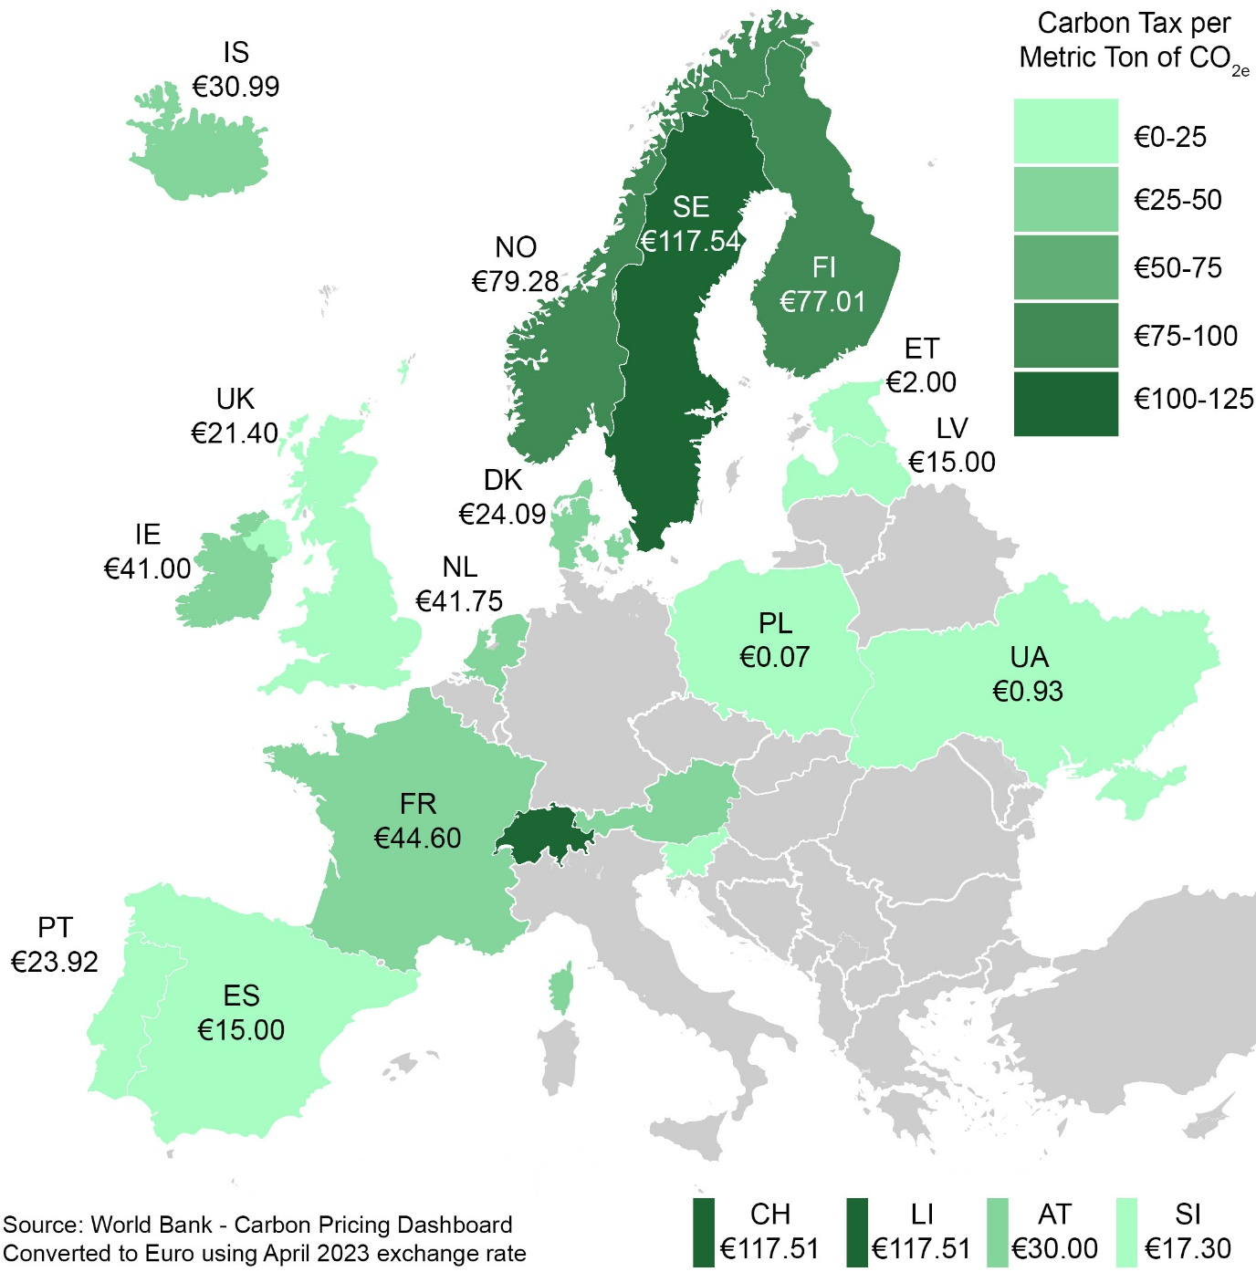
Figure 1 Map of 2022 carbon taxes in Europe, as of 1st April 2022

EU Taxonomy and Emission Trading Scheme
The EU Taxonomy provides a framework for identifying and promoting environmentally sustainable financial products, while the EU emission trading scheme (ETS) provides a market-based mechanism for reducing greenhouse gas emissions. Together, these two policies help to align manufacturing along with other industry sectors, with the EU's climate and environmental objectives. A further objective is to promote the development of financially sustainable products that contribute to the transition to a low-carbon and circular economy.
The EU Taxonomy sets out clear and objective criteria for determining which economic activities are considered environmentally sustainable, while the EU ETS sets a cap on the amount of greenhouse gases that can be emitted by certain sectors of the economy.
On 18th April 2023 the EU parliament voted to adopt significant reforms to the ETS. The free allowances of greenhouse gas (GHG) emissions for companies will be phased out from 2026 until 2034. A new ETS II will be created which will put a price on GHG emissions from fuel used in road transport and buildings, starting in 2027. The maritime sector will also be included in the ETS for the first time, and free allowances for aviation will be phased out by 2026. Manufacturers will therefore face increased transportation costs, they therefore need to consider investments in low carbon technologies and optimising the weight and packaging of their products for shipping.
The parliament have also adopted a new Carbon Border Adjustment Mechanism, which will affect certain high emission goods listed in the ETS such as steel, cement, and aluminium. The importers of these goods will have to pay the difference in carbon price between the country of origin and the price defined in the EU ETS. The impact of this legislation will be that EU companies will no longer have an incentive to outsource GHG emissions to countries that do not charge a carbon tax. It will result in EU manufacturers becoming more cost competitive in the EU market and incentivise non-EU manufacturers to reduce their emissions.

Sustainability Reporting
In addition to carbon taxes, a further issue impacting on SMEs is the need to comply with new environmental legislation. An example is the EU Corporate Sustainability Reporting Directive (CSRD) for which companies will have to apply the new rules for the first time in financial year 2024 [6]. Amongst the reasons for this legislation is to help to address greenwashing. The European Commission highlighted this as a growing problem by performing a review of company websites, they found that 42% of sustainability claims made by European companies were falsified or deceptive in nature and hence in breach of EU law [23]. Under CSRD, larger companies employing more than 250 staff and with a turnover of over €40 million will have to report their environmental, social, and governance (ESG) data. Companies will need to calculate and report the total direct and indirect greenhouse gas emissions of their products and services, and the company data will have to be independently audited. While not targeted at SMEs directly, in order for the larger companies to report on their Scope 3 emissions, they will require emission data from their supply chain, including from SME suppliers. Large companies will of-course favour suppliers who have the ability to calculate and report the emissions from their products and services.
It will be critically important for SMEs to be able to provide environmental data in order to stay competitive. The European Commission’s, Annual Report on European SMEs has highlighted however that smaller enterprises are far less likely to audit or monitor their own CO₂ emissions and those of their supply chain [8]. This difference is more pronounced the smaller the SME. Part of the reason for this is the level of investment required to reduce CO₂ emissions, along with the auditing or monitoring of these emissions. The Annual Report on European SMEs highlighted that there are a range of factors explaining these differences, including access to finance and uncertainty about regulation and taxes.

Sustainable Finance
It is widely recognised that access to finance is critically important for companies to make the green transition. In order to address this need, sustainable finance is a rapidly growing field. This growth is driven by increasing demand from investors, regulators, consumer trends, and government legislation for more sustainable and responsible financial products and services. Investors who specialise in sustainable finance take environmental, social and governance (ESG) issues into account for their financial decision-making. Investors use ESG rating agencies to provide them with the information needed to make more informed investment decisions and align their investment strategies with the U.N. Sustainable Development Goals and responsible investment principles.
The sustainability finance market grew to $1.6 trillion in 2022, of which $600 billion was driven by sustainability-linked loans (SLL) [9]. SLLs incentivise companies’ sustainability performance by linking the loan's pricing or other loan terms to the borrower's progress in achieving specific ESG targets. For example, the loan's interest rate may be adjusted based on the borrower's progress in reducing their greenhouse gas emissions, or the loan's maturity may be extended if the borrower meets certain water management targets. SLLs are designed to provide borrowers with an incentive to improve their ESG performance and to encourage lenders to support sustainable projects and activities. They are also intended to provide a mechanism for lenders to manage environmental and social risks and to promote sustainable practices among their borrowers. SLLs are becoming increasingly popular as a way for companies to finance sustainable projects and activities, and for lenders to support the transition to a low-carbon and sustainable economy. SLLs are also an opportunity for companies to demonstrate their commitment to sustainability and to attract investment from environmentally and socially conscious investors. The terms and conditions of SLLs may vary depending on the lender and borrower, but they are based on a set of pre-agreed sustainability performance targets and corresponding incentives or penalties. These can be related to environmental and/or social performance, and can be linked to different ESG metrics, such as emissions reductions, energy efficiency, water management, or human rights.
In a 2022 analysis of 870 European SLLs equating to over €250 billion of debt, environmental KPIs accounted for six of the top ten most common KPIs further demonstrating the prioritisation of environmental issues in ESG [6].
SME Sustainability Reporting Barriers and Supports
SMEs are at a disadvantage in accessing funding from the sustainability finance market. Amongst the reasons for this is that they are not generally legally required to report ESG data, and often do not have the resources or expertise to self-report this data to rating agency platforms. As a result, SMEs who are not prepared for this new sustainability focused business landscape and are thus likely to find it increasingly difficult to attract investment.
A number of local, national, and international initiatives have been developed to help SMEs become net zero by 2050. The EU-funded Sustainable Transition to the Agile and Green Economy (STAGE) project is an example of such a trans-European development project. The I-Form Centre at University College Dublin is a member of the STAGE project consortium, which provides free innovation and sustainability assessments to thousands of SMEs and creates roadmaps with action steps to help them to achieve their sustainability goals. SMEs can receive bespoke training in sustainable technologies and sustainability reporting. Funding will be provided to the most promising SMEs to engage with sustainability advisors, who will support the implementation of their transition plan. The STAGE project will help the SMEs become more investment ready, assisting them to access sustainability finance options. Visit www.stagepartners.eu for more information.

[1] E. P. Agency, ‘Latest emissions data’. https://www.epa.ie/our-services/monitoring--assessment/climate-change/ghg/latest-emissions-data/ (accessed Mar. 15, 2023).
[2] ‘Ireland: 43 companies sign low carbon pledge to cut emissions’, World Business Council for Sustainable Development (WBCSD). https://www.wbcsd.org/Overview/Global-Network/News/43-companies-sign-low-carbon-pledge-to-cut-emissions (accessed Mar. 15, 2023).
[3] S. Mitchell, P. O’Dowd, and A. Dimache, ‘The issue of waste in European manufacturing SMEs’, Oct. 2011, Accessed: Nov. 11, 2022. [Online]. Available: https://research.thea.ie/handle/20.500.12065/329
[4] Citizensinformation.ie, ‘Carbon tax’. https://www.citizensinformation.ie/en/money_and_tax/tax/motor_carbon_other_taxes/carbon_tax.html (accessed Mar. 15, 2023).
[5] K. Rennert et al., ‘Comprehensive evidence implies a higher social cost of CO2’, Nature, vol. 610, no. 7933, Art. no. 7933, Oct. 2022, doi: 10.1038/s41586-022-05224-9.
[6] ‘Corporate sustainability reporting’. https://finance.ec.europa.eu/capital-markets-union-and-financial-markets/company-reporting-and-auditing/company-reporting/corporate-sustainability-reporting_en (accessed Mar. 15, 2023).
[7] ‘Global sweep finds 40% of firms’ green claims could be misleading’, GOV.UK. https://www.gov.uk/government/news/global-sweep-finds-40-of-firms-green-claims-could-be-misleading (accessed Nov. 11, 2022).
[8] P. Muller, R. Ladher, and J. Boothe, ‘European Commission - SMEs and environmental sustainability: SME Performance Review 2021/2022’. https://single-market-economy.ec.europa.eu/smes/sme-strategy/sme-performance-review_en (accessed Nov. 15, 2022).
[9] PricewaterhouseCoopers, ‘Financing sustainable growth: An emerging opportunity’, PwC. https://www.pwc.co.uk/services/business-restructuring/insights/financing-sustainable-growth-emerging-opportunity.html (accessed Jan. 21, 2023).

