Modeling the effects of ecosystem changes on seagrass wrack valorization: merging system dynamics with life cycle assessment
Charlene Vance ^{ab*}, Matia Mainardis ^{c}, Francesca Magnolo ^{d}, Joseph Sweeney ª, Fionnuala Murphy ^{ab}
ª School of Biosystems and Food Engineering, University College Dublin (UCD), Belfield, Dublin 4, Ireland
^{b} BiOrbic Bioeconomy SFI Research Centre, University College Dublin, Belfield, Dublin 4, Ireland
^{c} Polytechnic Department of Engineering and Architecture (DPIA), University of Udine, Via del Cotonificio 108, 33100, Udine, Italy
^{d} Department of Agricultural Economics, Faculty of Bioscience Engineering, Ghent University, Coupure Links 653, 9000, Gent, Belgium

* Corresponding author: charlene.vance@ucd.ie.

Abstract
Seagrass meadows, while recognized as essential ecosystem service providers, are degrading worldwide. This has a profound impact on the environment but also on socioeconomic systems which hope to utilize beach-cast seagrass (wrack) as a bioresource. This study integrates system dynamics (SD) thinking with life cycle assessment (LCA) and life cycle costing (LCC) to understand how a degraded ecosystem feedbacks into the circular bioeconomy. An SD model was created to assess the impacts of seagrass meadow changes on wrack production and on ecosystem services accounting, considering an Italian case study of wrack deposited on a beach. Environmental and economic impacts of wrack valorization through anaerobic digestion (AD) were then determined through LCA and LCC. Finally, an extended LCC combined the results of the SD model, LCA, and LCC to demonstrate the cost of seagrass meadow degradation and the value of restoration. The results confirmed complexities in stakeholder perspective within the waste-to-resource framework. For the AD operator, meadow restoration would increase the profits from wrack valorization (23.10 €/ton), while for the municipality, meadow degradation would reduce the high costs associated with management (104.29-140.00 €/ton). When also considering the impacts on the environment and local community, valuation of ecosystem services and cost of restoration were influential. Meadow restoration with wrack valorization was the most favorable option if the natural capital of the seagrass meadows was valued appropriately (>0.065 €/m²) and direct costs of restoration could be kept relatively low (<1,179 €/ha). Overall, the model resulted in a total net present cost of -3.161,462.40 € for the baseline scenario, -1,488,277.28 € for the scenario of wrack valorization, and -1,231,325.12 € for the scenario of wrack valorization and meadow restoration.

Keywords: system dynamics thinking, life cycle assessment, life cycle costing, resource management, anaerobic digestion, ecosystem services

1. Introduction
Seagrasses are flowering aquatic plants found in meadows within coastal waters off every continent except Antarctica (Reynolds, 2018). Despite providing several vital ecosystem services including carbon sequestration (Duarte et al., 2013), coastal protection (Christianen et al., 2013), and providing food and habitat for numerous fish and invertebrate species (Unsworth et al., 2019b), seagrass meadows are degrading worldwide. Global seagrass habitat rates of decline have been estimated at 7% per year since 1990 (Waycott et al., 2009). While natural events such as disease and storms can cause localized seagrass decline, seagrass meadow degradation is mostly influenced by anthropogenic factors such as climate change, eutrophication, and physical disturbances (Githaiga et al., 2019; Orth et al., 2006). The degradation or removal of seagrass meadows has been shown to negatively impact fauna (McCloskey and Unsworth, 2015), carbon storage (Githaiga et al., 2019) and sediment stability/water quality (Daby, 2003).

Accordingly, the importance of the conservation and restoration of seagrass meadows is apparent. In the EU, the health of seagrass meadows is emphasized through initiatives such as the Water Framework Directive and Marine Strategy Framework Directive (Marbà et al., 2013). In Italy, successful restoration of seagrass meadows has been achieved through projects such as SERESTO (Habitat 1150* (Coastal lagoon) recovery by SEagrass RESTOration). However, the costs of seagrass restoration are significant. 1,563,898 € was spent on the SERESTO project (Life: SEagrass RESTOration, 2018), translating to about 651 €/ha restored site area. Bayraktarov et al. (2016) found the average cost of seagrass restoration to be much higher, at approximately 317,000 €/ha when including only capital costs and 518,000 €/ha when also accounting for operating costs.

To prove the benefits of conservation and restoration efforts despite their high costs, it is important that seagrass meadows be properly valued. A key challenge identified in seagrass conservation is a limited societal recognition of their importance (Unsworth et al., 2019a). While it is ethically controversial to put a price on the environment (Beder, 1996), in a society where decisions are made based on economic metrics, the value of natural resources should be measured in monetary terms to ensure their protection (Vassallo et al., 2013). This is demonstrated through the concept of natural capital accounting, where natural capital is defined as all natural assets that provide benefits to humankind (United Nations, 2021; United Nations Statistics Division, 1996). To assess natural capital, it is useful to associate the changes in stocks to changes in a provided ecosystem service with a direct monetary value (Balmford et al., 2008).

In the beach ecosystem, seagrass necromass, or dead biomass shed by the flowering plant, contributes to washed up organic material, known as beach wrack (Michaud et al., 2019). This wrack accumulates to form banquettes, which are essential to protecting beaches from erosion (Boudouresque et al., 2016). On the other hand, beach wrack is shown to emit greenhouse gases (GHGs) such as CO₂ and CH₄ as it decomposes (Liu et al., 2019; Misson et al., 2021), with estimated global levels of carbon emissions between 1.31-19.04 Tg C/year (Liu et al., 2019). Without human intervention, the wrack ultimately is either used as a source of food and shelter by intertidal fauna (Michaud et al., 2019) or washes back to the sea where it is reintroduced into the shallow water ecosystem as a nutrient source (Prasad et al., 2019).

Due to the visual impact and foul odor associated with decomposing beach wrack, touristic communities often remove the wrack during summer months (Corraini et al., 2018). While common practice is to dispose of the wrack as waste in a landfill, recent studies have shown improvements in environmental and economic sustainability when the wrack is utilized as a resource for bioenergy generation via anaerobic digestion (AD) or compost production (Mainardis et al., 2021b). Such activity could be considered as contributing to the circular bioeconomy (European Commission, 2018). Indeed, waste valorization is a key strategy of the European Union’s Circular Economy Action Plan (European Commission, 2020). However, complexities arise in the paradigm shift from waste-to-resource and its effects on decision-making and sustainable business models. For example, if considering the common practice where wrack is landfilled and assuming the ecosystem services provided by the seagrass meadows are not properly valued, seagrass meadow degradation could be considered a benefit to the municipality, as less wrack will be produced and thus less “waste” created. On the other hand, if the wrack is to be valorized as a source of bioenergy or compost, the business model of the processor would rely on the preservation and health of the seagrass meadows for a sustainable supply of wrack.

Such conflicting perspectives are important to address. To understand complex socio-ecological systems, system dynamics (SD) can be a useful tool. System dynamics uses a network of state variables (stocks) and rate of change equations (flows) to represent complex relationships among elements which could include feedback loops and non-linear interactions (Elsawah et al., 2017). Once the relationships within a system are understood, life cycle assessment (LCA) and life cycle costing (LCC) methodologies can be used to quantify and assess the economic and environmental impacts of the system over its full life cycle (UNEP/SETAC Life Cycle Initiative, 2011). Finally, economic and environmental considerations can be integrated into a single assessment methodology by performing an extended LCC, which converts environmental or social impacts into external costs and incorporates them into the LCC (Rebitzer and Hunkeler, 2003).

This study explores the effects of ecosystem changes on wrack management, evaluating impacts through an SD and extended LCC model. The case study considers the regional context of a touristic beach in northeast Italy. An SD model is created to represent the seagrass meadow and beach ecosystems, exploring the effects of ecosystem degradation and restoration on ecosystem services and the amount of wrack available to be valorized. The environmental and economic impacts of wrack valorization are captured through LCA and LCC, respectively. Finally, the SD model is used to produce a time dynamic LCA and LCC, which is fed into the extended LCC model. This research is one of the first of its kind to combine system dynamics modelling, LCA, and LCC within one thorough assessment method. By doing so, this work demonstrates the complexities of achieving environmental and economic sustainability within the circular bioeconomy framework. Particularly, the work demonstrates how SD can be used to model the effects of ecosystem degradation and restoration efforts on bioresource utilization and management for different stakeholders.

2. Materials and methods
2.1. Case study background
The case study considers wrack which is deposited on a 1.6 km beach in the Grado municipality of northeast Italy (45° 40′ N; 13° 24′ E), as shown in Figure 1. The current management method is to send the collected wrack to a landfill in Slovenia, approximately 199 km from the beach. Wrack is collected from the beach only during the tourist season (from April to October); wrack accumulation in the winter protects the shore from erosion and storms. The total volume collected per day is therefore larger (approx. 15 truckloads) at the start of the tourist season, due to the accumulation during the winter months. After the initial load, the volume collected decreases to 1 truckload per day for the rest of the collection period. It is important to note that when wrack is collected, a significant amount of inorganic material (primarily sand) is also collected. This amount can vary significantly depending on the collection method (Hansen and Kjaer, 2020). For the considered case study, the material collected is approximately 50% sand, 36% seagrass, 8% macroalgae, and 6% wood (Mainardis et al., 2021b). Regarding species, 45% of the seagrass collected is Cymodocea nodosa, 38.4% is Zostera marina, and 16.2% is Zostera noltii (Misson et al., 2020).

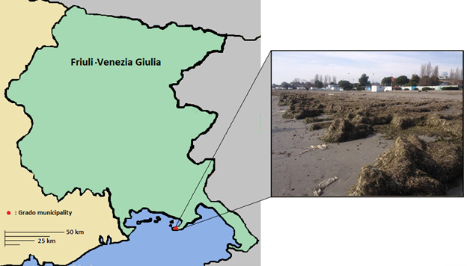
Figure 1: Location of Grado municipality in the Friuli-Venezia Giulia region of Italy and photo of beach wrack accumulation.

Due to the high economic and environmental impacts associated with the current landfilling practice, there is significant interest by the municipality in valorizing the wrack. However, since 2004, roughly 234 tons less material has been collected each year from the case study beach. This indicates that wrack as a local bioresource is finite and thus unsustainable. Assuming a direct correlation between the amount of wrack collected to the size and health of the seagrass meadow (Cucco et al., 2020), this also indicates that by the year 2027 the seagrass meadow from which the wrack originates could be entirely depleted. The stakeholder groups identified in this case study are the municipal government of Grado, the local community in Grado, and, in the case of valorization, the receiver of the exported seagrass wrack. The receiver considered in this study is a local wastewater treatment plant (WWTP) which could use the material in their anaerobic digestion (AD) facility. For the municipality and WWTP operator, impacts are observed through payments for services such as wrack collection, beach replenishment and AD operations. For the local community, impacts are related to the environmental damages from both seagrass meadow degradation and wrack management (Figure 2).

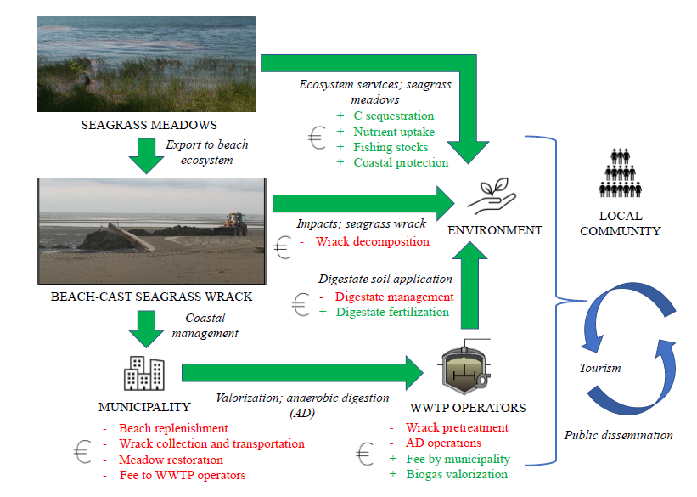
Figure 2: Schematic of relevant stakeholders and interactions in the context of seagrass meadows and wrack management.

2.2. System dynamics (SD) model
To understand the role of seagrass meadows on beach wrack as a resource, a system dynamics (SD) model was created. The first step was to determine which stocks, flows and variables to include in the model, and to define their relationship to one another. Once all items were defined, the system dynamics could then be simulated. The software used for the modeling and simulation was Insight Maker (Fortmann-Roe, 2014). The simulation time chosen for this model was 6 years, whereas the time step was 1 month. Thus, the simulation included 72 time steps. A detailed explanation of the system dynamics modeling is provided in the Supplementary Material.

Two simulation scenarios were defined. The first scenario assumed that the seagrass meadows were degrading at a constant rate, while the second scenario assumed that ecological restoration would be implemented, resulting in a recovery of the seagrass meadows. On other words, the two simulation scenarios were defined to show the different impact of no intervention (business-as-usual) and intervention (ecological restoration). The SD model was built in two stages; in the first stage, primary and secondary data were used to model changes to the seagrass meadow and produced wrack due to meadow degradation and restoration. In the second stage, the model was expanded to quantify the changes to ecosystem services caused by changes to the seagrass meadows and produced wrack. The following subsections detail the assumptions and limitations considered for each stage.

2.2.1. Modeling seagrass meadow degradation and restoration
Seagrass meadow decline can be caused by multiple anthropogenic sources including climate change, introduction of invasive species, eutrophication, land erosion, dredging, seining, boat mooring and anchoring (Githaiga et al., 2019; Orth et al., 2006; Waycott et al., 2009). Natural seagrass cycles also contribute to relevant variations. The causes are thus very complex and the rate at which decline occurs is influenced by many factors. To reduce the complexities of the model, the causes of seagrass meadow decline were not modelled. Instead, an assumption was made that the seagrass meadow was degrading at a linear rate, corresponding to the rate of decline in collected wrack found at the case study area.

It should be noted that even in the case of complete seagrass meadow degradation, there would still be contribution of macroalgae, wood, and other organic materials to the wrack. In fact, it could be possible that the wrack from macroalgae would increase, as many species of macroalgae have been known to outcompete seagrasses for light and nutrients, and thus could thrive in their absence (Ceccherelli and Campo, 2002; Thomsen et al., 2012). However, this was not considered within the scope of the study. Instead, macroalgae and wood were assumed to remain at the current percentage (14% of total material; 39% of organic material) and reduce at the same rate as the seagrass wrack.

An important aspect of the modeling was how to determine the size of the seagrass meadow area. As no study has been conducted which links specific seagrass meadows to the wrack collected on the Grado beach, a relationship between the size of the seagrass meadow area and the collected wrack needed to be assumed. The equivalent seagrass meadow size was calculated based on the seagrass wrack deposited and average annual change in biomass by species:
$$\frac{M_{wrack}}{m_{avg loss}*E}=A_{meadow}$$
(1)
Where $M_{wrack}$ is the seagrass wrack deposited per year (kg/year), $m_{avg loss}$ is the average biomass production by the seagrass meadow (kg/km²/year), E is the percentage of biomass exported to the beach ecosystem (%), and $A_{meadow}$ is the equivalent seagrass meadow area (km²). The percentage of biomass exported was assumed to be 15% (Duarte and Krause-Jensen, 2017), and the average biomass production was estimated per species and weighted by the percentage of that species in the seagrass wrack composition (Table A1, Appendix). The initial seagrass meadow area was found by running the simulation to produce 2,055 tons of collected material in the first 12 months, corresponding to the amount of material collected from the case study area in 2020. The initial seagrass meadow area was thus calculated to be 14.5 km².

For the scenario of ecological restoration, the decision to perform restoration was immediate (time = 0). However, it was assumed that it would take some time (2 years) to carry out preliminary activities such as research, development, and preparation of the restoration project. After the planning period, the municipality would begin their restoration, where it was assumed that the restoration project would achieve a recovery of 25% of the site area per year, and thus 100% of the area after 4 years. This is comparable to the SeRESTO project, where they were able to achieve an increase of seagrass meadows in the Venice lagoon covering an average of 69% of the restoration sites after 3 years (Life: SEagrass RESTOration, 2018). Again, a linear rate was assumed for restoration. It was assumed that the site area of the restoration effort would be equal to the seagrass meadow lost to degradation after two years (4.83 km²) and thus the rate of recovery after the planning period would be 1.21 km²/year.

2.2.2. Valuing seagrass meadow ecosystem services
As previously mentioned, seagrass meadows provide several vital ecosystem services (Christianen et al., 2013; Duarte et al., 2013; Duarte and Krause-Jensen, 2017; McCloskey and Unsworth, 2015; Unsworth et al., 2019b). When the meadow experiences changes, it therefore affects: 1) the fishing industry, 2) coastal protection, 3) carbon and nutrient uptake. To account for their value, the system dynamics model was expanded to include the accounting of each ecosystem service and its translation to monetary value. Quantification and valuation of ecosystem services was based on literature and is described below:

1) Fishing industry
According to Jackson et al. (2015), the estimated worth of seagrass meadows to Mediterranean fish landings is 190 million €/year. The Mediterranean has an estimated extension of 46,854 ha of seagrass meadows (de los Santos et al., 2019). Thus, the average value of seagrass meadows attributed to fishing was 4,055 €/ha.

2) Coastal protection
According to Githaiga et al. (2019), a degraded seagrass meadow causes reduction in coast elevation of 23.4 mm/year. Assuming a beach area of 1.6 km², this would result in a need for beach replenishment amount of 37,440 m³/year. Beach nourishment projects were found to cost anywhere from 1-50 €/m³ (Rosendahl Appelquist and Halsnæs, 2015); thus, the cost of coastal erosion due to seagrass meadow degradation was set at 20 €/m³.

3) Carbon stocks and nutrient uptake
Seagrass meadows are well established sources of carbon sequestration, as they accumulate carbon within their sediments. Furthermore, seagrass exported from the meadows can contribute to an additional 30% of total carbon storage through burial in both shelf and deep-sea sediments (Duarte and Krause-Jensen, 2017). When seagrass meadows are lost, studies have cited losses of carbon of 4.75-25.7 tons C/ha (Githaiga et al., 2019; Thorhaug et al., 2017). For this study, a carbon flux of 21 tons C/ha seagrass meadow gained or lost was assumed, inclusive of carbon stored in shelf and deep-sea sediments from exported seagrass (estimated at 6 tons C/ha, or 30% of total carbon stored). The current price for carbon in the EU is 50 €/ton (Buli et al., 2021); thus, the value of seagrass carbon sequestration was set at 50 €/ton.
In addition to carbon, seagrasses uptake nutrients during their growth, with leaves containing nitrogen and phosphorus concentrations of 1.0-3.0% and 0.05-0.20% dry weight, respectively (Alcoverro et al., 2000). The value of nutrient uptake is equated to the cost of N and P removal in wastewater treatment (Ottaviani, 2020). Depending on the technology, the cost of N removal can widely vary from 0.37-14.79 €/kg (Vineyard et al., 2020) while the cost of P removal can range from 143-404 €/kg (Jiang et al., 2005). For this study the value of nutrient removal was set on the conservative end at 0.5 €/kg N and 150 €/kg P.

2.3. LCA and LCC
To quantify the impacts of wrack valorization, LCA and LCC methodologies were applied. The following sections discuss the LCA modeling through its defined stages as outlined in the LCA standards (European Commission, 2010): goal and scope definition, life cycle inventory (LCI), and life cycle impact assessment (LCIA). In this study, the LCA and LCC were conducted in parallel, both for data consistency (Bierer et al., 2015) and to avoid double counting of impacts (Neugebauer et al., 2016). The LCC was thus integrated into the standardized framework parallel to the LCI stage.

2.3.1. Goal and scope
The goal of the LCA and LCC was to assess the impacts of beach wrack valorization, where the availability of wrack changes over time. The valorization of wrack was compared to the current wrack management strategy of landfilling (baseline scenario), as explained in Section 2.1. As discussed earlier, when wrack is collected, the collected material includes a significant amount of sand. Thus, the functional unit for the LCA and LCC was 1 ton of collected wrack and sand (referred to as collected material).

The valorization considered was the production of electricity, heat and digestate from biogas produced by anaerobic digestion (AD). The collected material was assumed to be sent to an existing digester located at a wastewater treatment plant (WWTP) 22 km from the beach. The material was pre-treated (washed and ground) and then co-digested with municipal sludge. However, co-digestion was not assumed to have any effects on biogas yield and composition from wrack AD, hence the scope of the LCA was limited to the impacts of the addition of wrack and not to the existing AD system. The produced biogas was assumed to be combusted in a combined heat and power (CHP) unit, while the digestate was centrifuged, stored and then spread on local farmland as a replacement for inorganic fertilizer. A portion of the produced heat was assumed to be used internally, while the remaining heat was wasted, as is typical in Italian biogas plants (Italian Composting and Biogas Association, 2017). As such, the only final product was electricity, which was assumed to replace electricity from the Italian electricity grid. The system boundary of the LCA and LCC can be seen in Figure 3.

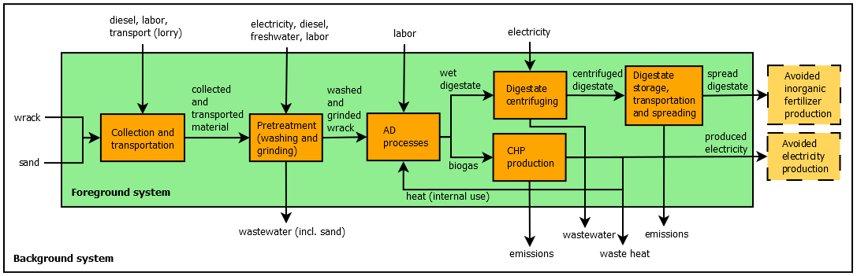
Figure 3: System boundaries of AD scenario (production of electricity, heat and digestate from wrack AD).

2.3.2. LCI
The LCI was built considering several process steps: material collection and transportation, pre-treatment, wrack AD, biogas CHP, and digestate management. Primary data was taken from the Grado municipality and two local WWTPs, and secondary data was acquired from previous works (Mainardis et al., 2021a, 2021b) and from literature (Angelidaki et al., 2017; Gimzauskaite et al., 2020; Lijó et al., 2014). Background data, such as the Italian electricity mix, transport, diesel, wastewater treatment and landfilling were taken from the Ecoinvent database (Wernet et al., 2016). The LCA modeling and simulation was done using Simapro software (Pre Consultants, Amersfoot, Netherlands).

As a waste stream, no environmental burden was allocated to the deposited wrack (Ahlgren et al., 2015). The collected sand was considered as an input from nature (PRé et al., 2016). Inventory objects associated with the collection and transportation of the material to the WWTP were assumed from previous work (Mainardis et al., 2021b). Two pre-treatments were assumed in the study: washing and grinding. The main objective of the washing pretreatment was to separate the sand from the collected material, leaving only the digestible wrack (Angelidaki et al., 2017). The sandy water was then treated as nontoxic wastewater. The main objective of the grinding pretreatment was to reduce the size of the wrack, as reduced particle sizes allow for better digestion (Kawai et al., 2012). It was assumed that the WWTP had a grinder/chopper available for use; thus, no impacts were assigned for capital equipment. Furthermore, no impact was assumed for the use of equipment/machinery related to AD and CHP, as they have negligible contribution to overall environmental impact (Henriksson et al., 2012).

Figure 4 displays the mass and energy balance for the wrack valorization scenario. The biogas and biomethane potential of the wrack were determined from experimental studies (Misson et al., 2020), while the electrical and thermal efficiency were estimated from data obtained from the WWTP (Mainardis, Buttazzoni, et al., 2021). Gaseous emissions from biogas combustion were then assumed as in previous work by Mainardis, Magnolo et al. (2021). The digestate storage and spreading was modelled from Lijo et al. (2014) and assumed to be used as a substitute for inorganic fertilizers, based on the levels of N and P found in the digestate composition of digested wrack. Finally, the heavy metal content for each digestate was retrieved from previous works (Misson et al., 2020) and considered as emissions to the soil. Further details on the LCI data and sources can be found in Tables S1-3 (Supplementary Material).
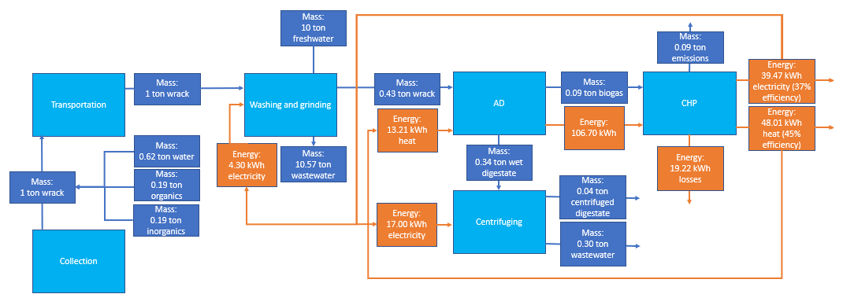
Figure 4: Mass and energy balance for AD scenario.

2.3.3. LCC
Economic assessment is dependent on the stakeholder; for example, while the municipality might want to pay a low gate fee for disposal of the wrack, the WWTP will want a higher fee to improve profit potential. Thus, costing was differentiated by stakeholder (the municipality and WWTP). The LCC included both costs (negative monetary value) and revenues (positive monetary value). The LCC used primary data for wrack and sand collection and transportation from the municipality. Compared to landfilling, the cost of collection in the AD scenario was assumed to be the same. The transport costs were calculated based on previous work (Mainardis et al., 2021b) considering an average Slovenian landfill gate fee of 11 €/ton (Aleksic, 2013). For the AD scenario, a gate fee of 50 €/ton was assumed. This value was assumed as it still resulted in savings to the municipality (compared to the cost of transporting to the landfill) while also being high enough to cover the costs of washing and grinding and provide an additional revenue for the WWTP. Additional costs associated with the washing and grinding pretreatment and the AD processes included the purchase of diesel, electricity, and freshwater, as well as the cost of labor and wastewater treatment. Revenue to the WWTP included the gate fee and the electricity produced by the addition of wrack (91.80 kWh/ton wrack wet weight), where electricity generated was assumed to qualify for the all-inclusive feed-in tariff (AIFT) scheme, with a selling price of 0.22 €/kWh (Carlini et al., 2017). Diesel was assumed to have a price of 1.49 €/L (Statistica Research Department, 2021). Electricity purchased was assumed to have a price of 0.15 €/kWh (Cottes et al., 2020). The water price was assumed at 1.41 €/m³ (Meran et al., 2021). Labor was estimated at a rate of 7 €/h (Carlini et al., 2017). Wastewater was assumed to be discharged to a non-sensitive area, with transport and treatment cost of 0.20 €/m³ (Hernandez-Sancho et al., 2015). Finally, a cost of 100 €/ton digestate was assumed for transportation and spreading of digestate from primary data.

2.3.4. LCIA
Midpoint categories considered in the LCA were abiotic depletion of fossil fuels (ADP), 100-year global warming potential (GWP100a), human toxicity (HT), marine aquatic ecotoxicity, photochemical oxidation (POx), acidification, fine particulate matter formation (PM), freshwater eutrophication, and marine eutrophication. For ADP, GWP100a, HT, POx, and acidification, the LCIA method used was CML-IA baseline V3.06 (University of Leiden, Leiden, Netherlands). For PM, marine aquatic ecotoxicity, freshwater eutrophication, and marine eutrophication, the LCIA method used was the ReCiPe midpoint 2016 – Hierarchical perspective (Huijbregts et al., 2016). For the LCC, the indicator was always monetary (€/ton).

2.4. Dynamic LCA and LCC
As both LCA and LCC results were calculated per ton collected wrack, by integrating with the results of the SD model, the impacts over time could be calculated. During the winter months, it was assumed that the only impact from the system was the environmental impact of the GHGs (kg CO₂ equivalent) emitted during the wrack decomposition on the beach, which was estimated at 1.5% of the total material deposited per month (Liu et al., 2019). During the summer months, economic and environmental impacts derived from wrack management were evaluated per ton collected material in the static LCA and LCC. Additionally, in the summer months the collection of wrack resulted in significant amounts of sand being removed from the beach. This contributed to an additional volume of sand needed during beach replenishment, which was calculated assuming a sand density of 1,600 kg/m³ (Baboo, 2019). By integrating the static LCA and LCC with the SD model, dynamic results were produced, capturing both the effects of resource seasonal variation as well as the effects of a gradual change in resource availability over the defined lifetime. This was demonstrated for monthly GHG emissions considering the AD scenario.

2.5. Extended LCC
An extended LCC includes the costs calculated through a conventional LCC but also includes ‘indirect costs’, which are costs indirectly incurred as a consequence of an economic action, and ‘external costs’, which are monetized representations of social and environmental costs (Rebitzer and Hunkeler, 2003). Similar to a conventional LCC, an extended LCC includes negative monetary values related to costs or damages and positive monetary values related to benefits or revenues. The costs considered in this study are displayed in Table 1.

In addition to the stakeholders included in the LCC (the municipality and WWTP), the extended LCC included an additional stakeholder of community/environment. To translate environmental impacts from an LCA into monetized costs, several methods have been established (Arendt et al., 2020). The choice of method is dependent on the geographical scope, inclusion and prioritization of impact categories, and cost perspectives. For this study, the extended LCC used established weighing factors from Ecovalue 2012 (Finnveden et al., 2013), which give a value in Swedish Krona (SEK) for 9 impact categories. To convert to 2021 Euro, an exchange rate of 8.7 SEK to Euro was assumed (ExchangeRates.org.uk, 2021) and the inflation rate from 2012-2021 was assumed to be 11.01% (Alioth LLC, 2021). It should be noted that in LCA, environmental impacts (‘costs’) are given a positive value and benefits (‘savings’) are given a negative value. Thus, the monetary weighting also included a reversal of positive and negative signs from the LCA results to match the signs used in the LCC.

The extended LCC considered impacts of wrack management captured by the static LCA and LCC as well as two impacts captured by the SD model: emissions from wrack decomposition on the beach and loss of sand due to wrack collection. Therefore, both needed to be translated to monetary costs. The cost of emissions from decomposition was calculated using the Ecovalue 2012 factors for GWP translated to 2021 Euros (363.65 €/ton CO₂ equivalent) and allocated as an external cost to the community/environment. The cost of sand removal was allocated to the municipality and used the same values as the cost of coastal erosion discussed in Section 2.2.2 (20 €/m³ sand). Finally, the extended LCC included the impacts of changes to the seagrass meadow ecosystem, either through degradation assumed at current rates or restoration from interventive efforts. The natural capital of the seagrass meadows was estimated through its ecosystem services quantified by the SD model (Section 2.2.2). For the scenario of restoration, the cost was assumed to be 651 €/ha, corresponding to the cost per ha of successfully restored site achieved in the Life SeRESTO project (Life: SEagrass RESTOration, 2018). The total cost was incurred at the initial decision to perform a restoration (time = 0).

Table 1: Costs included in the extended LCC, differentiated by stakeholder.
Stakeholder | Cost | Direct/indirect | Source
Municipality | Seagrass meadow restoration | Direct | SD
Municipality | Wrack management | Direct | LCC
Municipality | Beach replenishment from sand removal | Indirect | SD
WWTP | Wrack valorization | Direct | LCC
Community/ environment (external costs) | Ecosystem services: carbon sequestration | Indirect | SD
Community/ environment (external costs) | Ecosystem services: nutrient uptake | Indirect | SD
Community/ environment (external costs) | Ecosystem services: fishing stocks | Indirect | SD
Community/ environment (external costs) | Ecosystem services: coastal protection | Indirect | SD
Community/ environment (external costs) | Seagrass wrack decomposition | Indirect | SD
Community/ environment (external costs) | Wrack management | Indirect | LCA

For calculating the overall impacts over the considered time period, the monetary flows for each stakeholder were accounted for and discounted according to the net present value (NPV) method (Žižlavský, 2014), which uses the following equation:
$$NPV= \sum_{t=0}^{n}{\frac{{NCF}_{t}}{{(1+r)}^{t}}}$$
(2)
where net cash flow (NCF, €/year) is the annual cash flow, n is the number of years of operation, t is the year and r is the discount rate (%). A discount rate of 10% was used.

2.6. Sensitivity and uncertainty analyses
As many variables are used in this study with varying degrees of uncertainty, sensitivity analyses were conducted. Sand content is a significant factor in wrack management, as with current collection methods it can contribute up to 76.8% of the total collected material (Hansen and Kjaer, 2020). The COASTAL Biogas project has experimented with different collection methods to reduce the sand content, managing to collect wrack with a sand content as low as 23% dry volume (Gimzauskaite et al., 2020). Thus, a sensitivity analysis was conducted to find the impact of reduced sand collection on the system, varying sand content in the collected material from 25-75%. Regarding the cost of seagrass meadow restoration, while the assumed capital cost was taken based on a recently completed restoration project in the region (Life: SEagrass RESTOration, 2018), this is a relatively low cost compared to other restoration projects (Bayraktarov et al., 2016). Thus, a sensitivity analysis was performed, where the cost of restoration was increased from 300,000-3,000,000 €. Furthermore, restoration projects are not always successful, with Bayraktarov et al. (2016) finding a median survival rate of 38% for seagrass ecosystem restoration projects. Some studies also question the speed and long-term effectiveness of restoration efforts (Beheshti et al., 2022). Thus, the restoration rate was varied from 25-100% recovery within 4 years, corresponding to a restoration rate of 0.36-1.21 km²/year. Finally, many assumptions were made in the valuation of ecosystem services. Such calculations are dependent on spatial and temporal factors and can thus vary significantly (ten Brink et al., 2015). Thus, a sensitivity analysis was conducted to understand how changing the value of seagrass meadow ecosystem services would affect the analysis. The value was varied from 0-0.16 €/m², where 0.08 €/m² was the initial estimate.

3. Results
3.1. SD model: Influence of degradation and restoration on stocks, flows, and ecosystem services
Figure 5 shows the influence of ecosystem degradation and restoration on the seagrass meadow and material collected. The assumption of degradation resulted in a linear reduction of seagrass meadow area from 14.5 km² to 0 km², gradually increasing the damage costs related to the loss of ecosystem services up to -1,328,933.93 € in month 72. This value does not include the time value of money, which is considered later in the extended LCC through the use of a discounting rate. The assumption of restoration resulted in a recovery of seagrass meadow area from 9.67 km² in month 24 back to its original 14.5 km² in month 72. The costs reflected this recovery, reaching peak damage cost of -442,978.08 € (excluding discounting) in month 24 and then rebounding to 0 € in month 72.

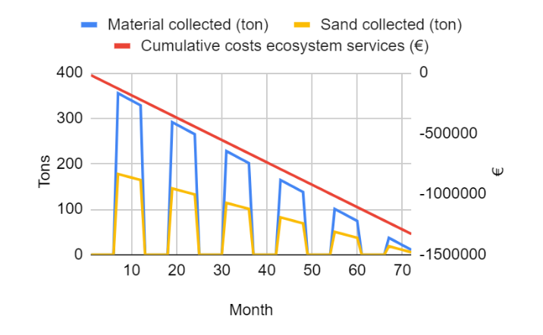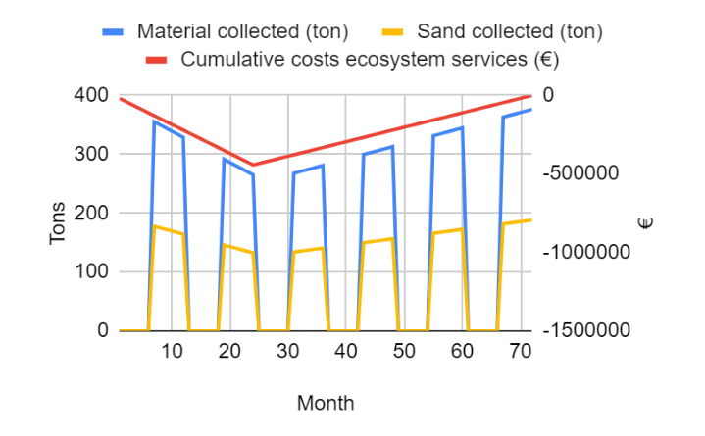
(a) (b)
Figure 5: Influence of (a) seagrass meadow degradation and (b) restoration on seagrass meadow area, cumulative costs relating to loss of ecosystem services, and amount of wrack/sand collected.

3.2. LCA and LCC: environmental and economic impacts of wrack valorization
Figure 6 displays the relative environmental impacts of the AD scenario, normalized against the landfilling scenario. It is clear that the AD scenario has a lower environmental impact in all impact categories compared to the landfilling scenario. For freshwater and marine eutrophication, the measured impact of the AD scenario is negative; this is due to the displacement of fossil-based electricity and fertilizers by the AD products of bio-based electricity and digestate. Table A2 (Appendix) displays the LCIA results of the landfilling and AD scenarios per ton collected material, and the conversion to monetary value as defined in Section 2.5. Considering the monetary weights applied, global warming has the highest impact for both scenarios, followed by abiotic depletion, freshwater eutrophication, and human toxicity for the landfilling scenario and human toxicity, abiotic depletion and marine aquatic ecotoxicity for the AD scenario. For the landfilling scenario, the environmental impacts are mainly derived from the processes of landfilling and feedstock transport, while for the AD scenario the environmental impacts are mainly derived from biogas combustion, wastewater treatment, diesel usage, and feedstock transport to the AD plant.
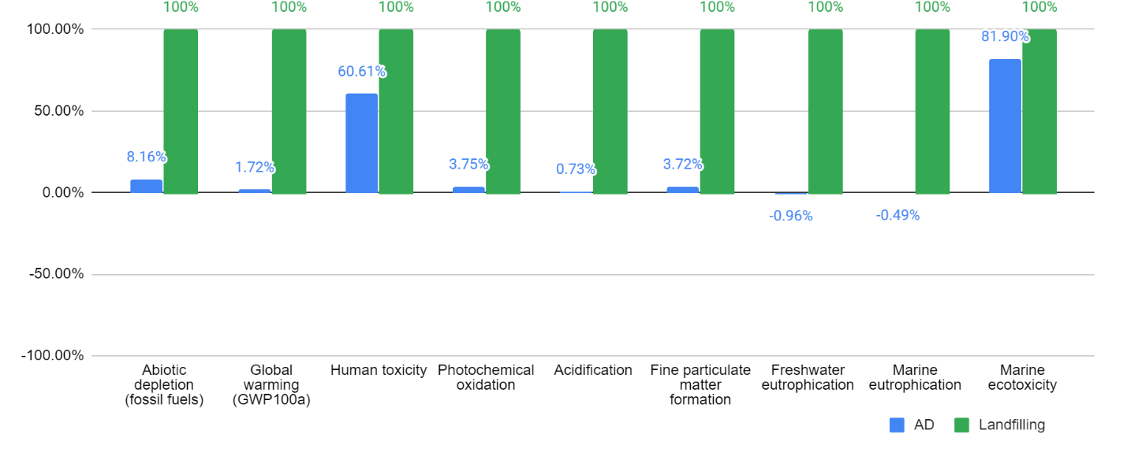
Figure 6: LCIA results of AD and landfilling scenario, where the impacts are normalized against the baseline (landfilling scenario).

Table A3 (Appendix) shows the results from the LCC of wrack management per ton collected material, considering the baseline and alternative scenario and the stakeholders of the municipality and WWTP. Due to the high costs associated with the pretreatment of wrack and operation of the AD and CHP plant, a high gate fee of 50 €/ton was established to result in some profit margin (23.10 €/ton) for the WWTP. Despite this high fee, the significantly shorter distance between the beach and WWTP compared to the baseline scenario of landfilling in Slovenia also meant that the transportation costs were significantly reduced. Thus, the municipality could still save money in this scenario (35.71 €/ton) compared to the baseline scenario.

Figure 7 displays the dynamic LCA results considering the monthly GHG emissions in the AD scenario. The emissions from the AD of wrack in the tourist season are higher than the emissions from the decomposition of wrack on the beach in off-season. While one might assume that the emissions from the wrack decomposing on the beach would be similar or even greater than the emissions of electricity production from AD (Liu et al., 2019), two considerations are important. First, when wrack is deposited on the beach, only part of it decomposes, as a portion returns to the sea (Boudouresque et al., 2016) and another portion is consumed by intertidal animals (Michaud et al., 2019). Second, in addition to the emissions from biogas combustion, in the AD scenario the wrack must also be transported and processed, which further contributes to GHG emissions due to diesel combustion and fossil-based electricity consumption. The assumption of seagrass meadow degradation leads to a reduction in GHG emissions from wrack management over time; however, this does not consider the loss of carbon sequestration due to the loss of seagrass meadows, nor the fact that the AD scenario still results in significantly less GHG emissions compared to the current management scenario. Thus, while the dynamic LCA demonstrates the time variations considered in this study, it is an incomplete picture and emphasizes the importance of the extended LCC performed in the following section.
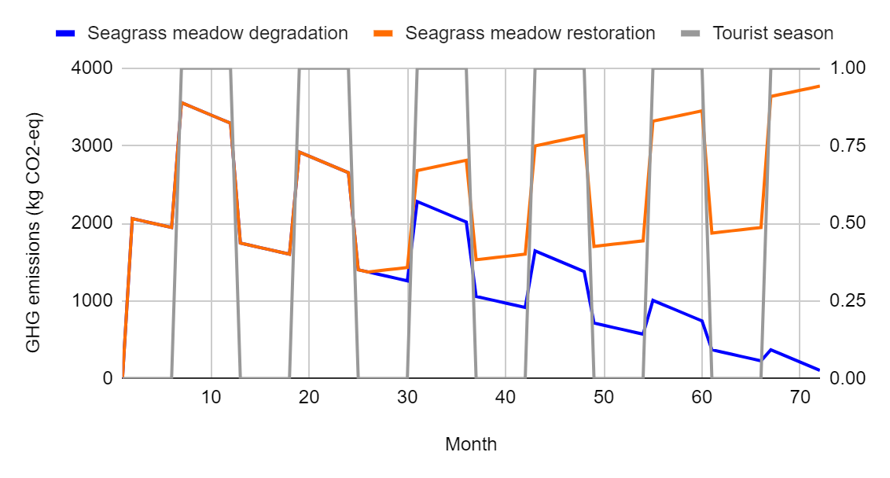
Figure 7: Monthly GHG emissions (kg CO₂ eq) emitted in AD scenario. In tourist season (=1.00), wrack is collected and transported to the WWTP for AD. Contributions to GHG emissions include collection, transport, pretreatment, AD and CHP operations, and digestate management. In non-tourist season (=0.00), wrack remains on beach, emitting GHGs from decomposition.

3.3. Extended LCC: Comparing wrack management scenarios
Table 2 and Figure 8 show the NPV of direct and indirect costs for each stakeholder. If only costs to the municipality are considered, seagrass meadow degradation results in the best economic performance. As described earlier, if only the cost of wrack management is considered, the municipality is financially incentivized to allow degradation to produce less wrack. For the WWTP, the most optimal scenario is seagrass meadow restoration. This is also clear, as restoration would provide more wrack, generating more revenue through its valorization. When considering the indirect costs to the community and environment, seagrass meadow degradation results in significant costs based on the loss of ecosystem services. Second, while the future restoration of the meadow can reverse the degradation and loss of ecosystem services, it does not fully make up the cost of current meadow degradation, due to the time value of money (discount rate) used in the NPV calculations. Additionally, as restoration of the meadows would result in an increase in wrack produced and collected, external environmental costs associated with wrack management would also increase. Nonetheless, regardless of degradation or restoration of seagrass meadows, valorization via AD results in significantly lower environmental impacts compared to landfilling. Including all direct and indirect costs, it was determined that the restoration scenario is the best performing scenario, even accounting for the significant cost associated with seagrass meadow restoration.

Table 2: NPV of direct and indirect costs (euro-equivalent) for each scenario.
Stakeholder | Cost | Scenario
Stakeholder | Cost | Degradation, no valorization (landfilling) | Degradation, valorization (AD) | Restoration, valorization (AD)
Municipality | Seagrass meadow restoration | N/A | N/A | -314,650.00
Municipality | Wrack management | -733,489.22 | -546,378.38 | -860,200.76
Municipality | Sand removal | -32,745.05 | -32,745.05 | -51,552.77
Municipality | Total | -766,234.27 | -579,123.44 | -1,226,403.51
WWTP | Wrack valorization | N/A | +121,000.76 | +190,499.76
WWTP | Total | 0.00 | +121,000.76 | +190,499.76
External (Community and environment) | Seagrass meadow ecosystem services | -964,642.28 | -964,642.28 | -94,282.59
External (Community and environment) | Seagrass wrack decomposition | -11,229.70 | -11,229.70 | -15,677.92
External (Community and environment) | Wrack management | -1,419,356.14 | -54,282.62 | -85,460.84
External (Community and environment) | Total | -2,395,228.12 | -1,030,154.60 | -195,421.35
Total direct and indirect costs: |  | -3,161,462.40 | -1,488,277.28 | -1,231,325.12

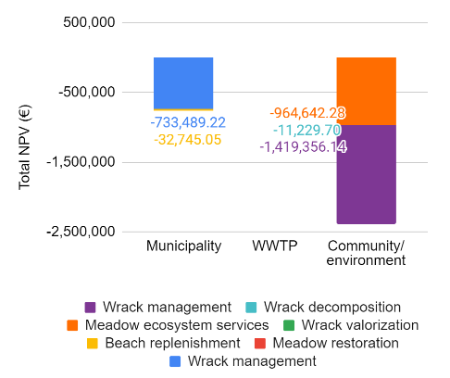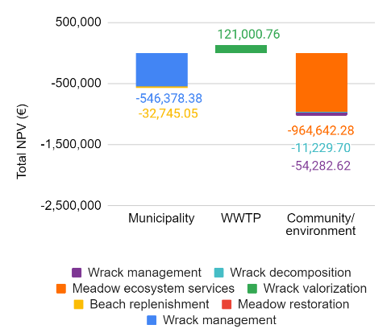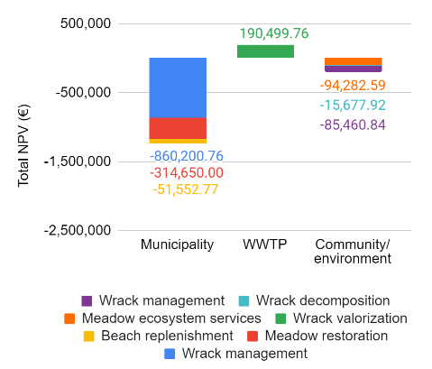
- (b) (c)
Figure 8: NPV of direct and indirect costs (euro-equivalent) for (a) degradation without valorization (b) degradation with valorization via AD and (c) restoration with valorization via AD.

3.4. Sensitivity analyses
Four variables were varied in the sensitivity analyses: sand collected, cost of restoration, restoration rate, and value of ecosystem services. The amount of sand collected was varied from 25% to 75%. Reduction of sand content increased the percentage of wrack in the collected material, which increased the revenue of the WWTP by increasing the electricity production per ton of collected material. However, it also resulted in higher processing costs per collected material. For example, while less wastewater was produced from washing collected material with lower contents of sand, more energy was needed to grind the wrack, centrifuge the digestate, and transport the digestate per ton of material. Thus, reducing sand content from 75% to 25% only minimally increased the profit of the WWTP from 22.33 €/ton to 23.86 €/ton, respectively (Table A4, Appendix). However, by reducing the total amount of material collected by the municipality (wrack produced per year remained unchanged from the previously defined scenarios), direct costs such as landfill and WWTP transportation and gate fees were reduced. Additionally, indirect and external costs associated with the unnecessary removal of sand were also reduced (Figure A1, Appendix). Next, the cost of restoration was varied from 300,000-3,000,000 € (Figure A2, Appendix). It was found that at a restoration cost of over 570,000 € (NPV), or approximately 1,179 €/ha restored site area, it became preferable to allow degradation with wrack valorization than to perform restoration with wrack valorization. At a cost of approximately 2,250,000 €, or 4,655 €/ha restored site area, even the baseline scenario of landfilling without any valorization became preferable to performing restoration with wrack valorization. When the rate of restoration was varied, a restoration rate of 30% recovery resulted in a total NPV of -1,364,698.72 € whereas the original rate of 100% recovery resulted in a total NPV of -1,231,325.12 € (Figure A3, Appendix). This demonstrates that while higher rates of restoration increased the amount of wrack produced which augmented the direct costs for the municipality, it also resulted in higher revenue for the WWTP and, most critically, lower external costs due to higher amounts of ecosystem services retained. Finally, the value of ecosystem services was varied from 0.00 €/m² up to 0.16 €/m² (Figure A4, Appendix). Restoration was only the most favorable scenario when the ecosystem services were valued at over 0.065 €/m²; if the seagrass meadow's ecosystem services were valued below that, it became more favorable to allow degradation. These two sensitivity analyses show that restoration is only favorable when restoration costs are kept low and ecosystem services are valued highly.

4. Discussion
In this study, the SD model was used both to quantify the services provided by the seagrass meadow ecosystem and to simulate the effects of degradation and restoration on seagrass wrack management. The extended LCC was able to capture several direct, indirect and external costs which affected the municipality, WWTP and local community. This section will first discuss the implications of the study on the stakeholder groups, providing suggestions for management options. The discussion will then continue by addressing the limitations of the model and suggesting improvements for future work.

For all stakeholder groups, there is the possibility for significant improvements in technology, processing, and life cycle management which could reduce both economic and environmental impacts. One process improvement which was explored in this study was the reduction of sand content in the collected material, which reduced costs for all stakeholders but especially for the municipality. The municipality could therefore investigate new methods or technologies for wrack collection, as suggested in the COASTAL Biogas project (Gimzauskaite et al., 2020). However, new methods could be more energy-intensive or require more labor, which would reduce their attractiveness both economically and environmentally. For example, new beach cleaning equipment has a high capital cost of anywhere from 10,000-90,000 € (H Barber & Sons, 2021). Such trade-offs should thus be explored. For the WWTP, significant costs are involved in washing and grinding the wrack and centrifuging the digestate. The WWTP could investigate possible alternative processes, or whether this processing could be further optimized. In addition, the use of excess heat could improve system sustainability; the WWTP could find local industrial or community partners interesting in acquiring process heat (Dave et al., 2013). Another technological option to consider could be conversion of wrack to biochar, which could both reduce emissions related to the decomposition of wrack and increase atmospheric carbon sequestration by using biochar as a soil amendment (Macreadie et al., 2017).

While many values in this study were estimated from external sources, they can provide significant insight to stakeholders. For example, it is known that the municipality pays for beach replenishment approximately every 5 years, and that the last beach replenishment costed 600,000.00 €. However, it is not known whether the need for beach replenishment is tied mostly to the removal of sand from the beach during wrack collection or due to erosion from the degradation of the local seagrass meadows. Assuming the need for beach replenishment is only tied to sand losses from wrack management (625 m³/year), the beach replenishment costs would correspond to 192 €/m³, which would be a very high cost. However, if the need for beach replenishment is also tied to coastal erosion and the estimated erosion due to seagrass meadow degradation from this study is considered (37,440 m³/year), the beach replenishment costs would correspond to a cost of 3.15 €/m³. According to secondary sources (Rosendahl Appelquist & Halsnæs, 2015) this is a more realistic rate, showing that the coastal erosion values used in this study were also realistic and that the primary driver for beach replenishment costs is seagrass meadow degradation and not the removal of wrack from the beach. Thus, for the municipality to reduce their costs with regards to beach replenishment, it is imperative that they focus on restoration of seagrass meadows.

Additional considerations which were not considered in this study could help strengthen future works. For the environment and local community, the valuation of ecosystem services is the most critical point. A wide variation in the natural capital of seagrass meadows was found in literature, ranging from 2.44 €/m² to 327 €/m² (ten Brink et al., 2015). The valuation of seagrass meadow ecosystem services in this paper was therefore very conservative at 0.092 €/m². One significant limitation of the study is the lack of quantification of ecosystem services provided by the wrack. Wrack contributes to the ecosystem by providing shelter and food for several species on the coast (Dugan et al., 2003). However, no studies have yet to quantify the costs and benefits correlated to these ecosystem services in monetary terms. Thus, additional studies are suggested to help provide this data. Another external cost which was not included in this study was the impact of seagrass ecosystem changes on tourism. Some natural capital assessments for seagrass meadows have included tourism revenue through activities such as diving and ecotourism (Junta de Andalusia, 2014), where the value of tourism was the most significant contribution to the valuation of ecosystem services. However, while certain types of tourism can benefit from the ecosystem services provided by seagrass meadows, other tourists may be negatively affected by the sight and smell of the produced seagrass wrack (Corraini et al., 2018). Thus, as pointed out in a previous study (Mainardis, Magnolo et al., 2021), the impact on tourism is not easily quantifiable. To understand the costs and benefits of the seagrass meadows and generated wrack on the different types of tourists and local community, a deeper socioeconomic investigation is needed. For example, willingness-to-pay studies could be used to better monetize the value of ecosystem services as perceived by the local community (Winden et al., 2014), and Multi-criteria Decision Analysis (MCDA) could be used to understand the relative importance of factors despite a lack of quantitative information (Goulart Coelho et al., 2017), while stakeholder mapping could help better understand how different groups perceive and are affected by wrack and meadow management (Berg et al., 2018). To enhance the social perception of ecosystem values provided by seagrass meadows, dedicated communication campaigns could be programmed in the future, to extend the applicability of ecological solutions without inducing economic costs connected to tourism.

Several assumptions were made for this study which, while necessary to simplify the model, could be further explored in future work. First, the case study considered the co-digestion of seagrass wrack and sewage sludge at a local WWTP, where it was assumed that the WWTP would prioritize using all the seagrass wrack delivered in summer months. However, it is possible that all the delivered seagrass wrack would not be used immediately, and thus would need to be stored. In this case, ensiling is highly recommended as a low cost and low energy preservation method (Gimzauskaite et al., 2020). The effects of ensiling on the variable supply of marine feedstocks could be explored in future works. A reduction in CH₄ potential from stocked material could be hypothesized, due to the ongoing degradation process (Kreuger et al., 2011; Li et al., 2017). While this study demonstrated benefits of wrack valorization through co-digestion with municipal sludge, the majority of Italian biogas plants are on-farm, utilizing energy crops and agricultural residues as feedstocks (Benato and Macor, 2019). At the moment, biogas plants processing agricultural and agro-industrial waste are not likely to take this material, as it is not currently considered as an accepted feedstock for bioenergy production (Ministero delle politiche agricole alimentari e forestali, 2016), despite its acceptance as a feedstock for bio-based fertilizer (Ministero dell’Ambiente e della Tutela del Territorio e del Mare, 2019). Thus, until the regulations are made clearer, there is a missed opportunity to valorize the seagrass wrack through AD, which is the more environmentally sustainable option compared to landfilling or even composting (Mainardis et al., 2021b). A paradigm shift from waste-to-resource must be performed at all levels to efficiently exploit the energy and nutrient contents embedded in seagrass wrack. Finally, this work considered seagrass restoration through a human interventive approach (physical implantation). However, natural recovery of seagrass meadows is also possible through the improvement of general ecosystem quality such as through reduction in eutrophication and disturbances caused by human activity (de los Santos et al., 2019). Studies have shown the positive effects of utilizing digestate fertilizer on reducing marine eutrophication (Cappelli et al., 2015; Seghetta et al., 2016). Thus, it is possible that the effects of utilizing the seagrass wrack as a resource would contribute to better ecosystem quality, reducing the necessity for physical restoration efforts. While it was not within the scope of this work, in future studies it would be beneficial to model the feedback loops which influence the health of the seagrass meadow and the effects of ecological restoration of the beach ecosystem.

5. Conclusion
This study demonstrates how system dynamics modeling can be integrated with LCA methodologies to understand how ecosystem health can affect bioresource availability, and how bioresource availability can affect the sustainability of bio-based systems. It was found that wrack valorization was more economically and environmentally sustainable (NPV of -1,488,277.28 €) compared to the current management method of landfilling (NPV of -3,161,462.40 €). When comparing the scenarios of seagrass meadow degradation or restoration, degradation was preferrable for the municipality due to the high costs associated with wrack collection and transport (104.29-140.00 €/ton collected material), while restoration was preferrable for the WWTP to increase their revenues (23.10 €/ton collected material). When considering the natural capital of the seagrass meadows, the sensitivity analyses showed that restoration was the preferred scenario (NPV of -1,231,325.12 €) when restoration costs were low (651 €/ha) and seagrass ecosystem services were valued highly (0.092 €/ha). This combined approach, which includes system dynamics modeling, LCA and LCC, can be applied to other relevant case-studies where seagrass degradation is observed to properly assess and compare alternative management options as well as to determine the value and impacts of seagrass restoration. Finally, future research could consider technological and process improvements, feedback loops from management and externalities on the ecological system, economic impacts related to tourism, and additional ecosystem services provided by the wrack.

Acknowledgements: This research was supported by the European Union’s Horizon 2020 research and innovation programme AgRefine under the Marie Skłodowska-Curie grant agreement No 860477.

References
Ahlgren, S., Björklund, A., Ekman, A., Karlsson, H., Berlin, J., Börjesson, P., Ekvall, T., Finnveden, G., Janssen, M., Strid, I., 2015. Review of methodological choices in LCA of biorefinery systems - key issues and recommendations. Biofuels, Bioproducts and Biorefining 9. https://doi.org/10.1002/bbb.1563
Alcoverro, T., Manzanera, M., Romero, J., 2000. Nutrient mass balance of the seagrass Posidonia oceanica:the importance of nutrient retranslocation. Marine Ecology Progress Series 194, 13–21. https://doi.org/10.3354/meps194013
Aleksic, D., 2013. Municipal waste management in Slovenia.
Alioth LLC, 2021. CPI Inflation Calculator [WWW Document]. URL https://www.in2013dollars.com/europe/inflation/2012?endYear=2021&amount=100
Angelidaki, I., Karakashev, D., Alvarado-Morales, M., 2017. Anaerobic Co-digestion of Cast Seaweed and Organic Residues: Final report prepared in framework of Energinet.dk project no. 2013- 1-12097.
Arendt, R., Bachmann, T.M., Motoshita, M., Bach, V., Finkbeiner, M., 2020. Comparison of different monetization methods in LCA: A review. Sustainability (Switzerland). https://doi.org/10.3390/su122410493
Baboo, P., 2019. Re: How we can determine the dry sand density? [WWW Document]. URL https://www.researchgate.net/post/How_we_can_determine_the_dry_sand_density
Balmford, A., Rodrigues, A.S.L., Walpole, M., ten Brink, P., Kettunen, M., Braat, L., de Groot, R., 2008. The Economics of Biodiversity and Ecosystems: Scoping the Science. Cambridge, UK.
Bayraktarov, E., Saunders, M.I., Abdullah, S., Mills, M., Beher, J., Possingham, H.P., Mumby, P.J., Lovelock, C.E., 2016. The cost and feasibility of marine coastal restoration. Ecological Applications 26, 1055–1074. https://doi.org/10.1890/15-1077
Beder, S., 1996. Valuing the Environment. Engineering World 12–14.
Beheshti, K.M., Williams, S.L., Boyer, K.E., Endris, C., Clemons, A., Grimes, T., Wasson, K., Hughes, B.B., 2022. Rapid enhancement of multiple ecosystem services following the restoration of a coastal foundation species. Ecological Applications 32. https://doi.org/10.1002/eap.2466
Benato, A., Macor, A., 2019. Italian biogas plants: Trend, subsidies, cost, biogas composition and engine emissions. Energies (Basel) 12. https://doi.org/10.3390/en12060979
Berg, S., Cloutier, L.M., Bröring, S., 2018. Collective stakeholder representations and perceptions of drivers of novel biomass-based value chains. Journal of Cleaner Production 200, 231–241. https://doi.org/10.1016/j.jclepro.2018.07.304
Bierer, A., Götze, U., Meynerts, L., Sygulla, R., 2015. Integrating life cycle costing and life cycle assessment using extended material flow cost accounting. Journal of Cleaner Production 108, 1289–1301. https://doi.org/10.1016/j.jclepro.2014.08.036
Boudouresque, C.F., Pergent, G., Pergent-Martini, C., Ruitton, S., Thibaut, T., Verlaque, M., 2016. The necromass of the Posidonia oceanica seagrass meadow: fate, role, ecosystem services and vulnerability. Hydrobiologia. https://doi.org/10.1007/s10750-015-2333-y
Buli, N., Abnett, K., Twidale, S., 2021. EU carbon price hits record 50 euros per tonne on route to climate target. Reuters.
Cappelli, A., Gigli, E., Romagnoli, F., Simoni, S., Blumberga, D., Palerno, M., Guerriero, E., 2015. Co-digestion of Macroalgae for Biogas Production: An LCA-based Environmental Evaluation, in: Energy Procedia. Elsevier Ltd, pp. 3–10. https://doi.org/10.1016/j.egypro.2015.06.002
Carlini, M., Mosconi, E., Castellucci, S., Villarini, M., Colantoni, A., 2017. An Economical Evaluation of Anaerobic Digestion Plants Fed with Organic Agro-Industrial Waste. Energies (Basel) 10, 1165. https://doi.org/10.3390/en10081165
Ceccherelli, G., Campo, D., 2002. Different Effects of Caulerpa racemosa on Two Co-occurring Seagrasses in the Mediterranean. Botanica Marina 45, 71–76. https://doi.org/10.1515/BOT.2002.009
Christianen, M.J.A., van Belzen, J., Herman, P.M.J., van Katwijk, M.M., Lamers, L.P.M., van Leent, P.J.M., Bouma, T.J., 2013. Low-Canopy Seagrass Beds Still Provide Important Coastal Protection Services. PLoS ONE 8. https://doi.org/10.1371/journal.pone.0062413
Communication from the Commission to the European Parliament, the C. the E.E. and S.C. and the C. of the R., 2020. A new Circular Economy Action Plan: For a cleaner and more competitive Europe.
Corraini, N.R., de Souza de Lima, A., Bonetti, J., Rangel-Buitrago, N., 2018. Troubles in the paradise: Litter and its scenic impact on the North Santa Catarina island beaches, Brazil. Marine Pollution Bulletin 131, 572–579. https://doi.org/10.1016/j.marpolbul.2018.04.061
Cottes, M., Mainardis, M., Goi, D., Simeoni, P., 2020. Demand-Response Application in Wastewater Treatment Plants Using Compressed Air Storage System: A Modelling Approach. Energies (Basel) 13, 4780. https://doi.org/10.3390/en13184780
Cucco, A., Quattrocchi, G., Brambilla, W., Navone, A., Panzalis, P., Simeone, S., 2020. The Management of the Beach-Cast Seagrass Wracks—A Numerical Modelling Approach. Journal of Marine Science and Engineering 8, 873. https://doi.org/10.3390/jmse8110873
Curiel, D., Bellato, A., Rismondo, A., Marzocchi, M., 1996. Sexual reproduction of Zostera noltii Hornemann in the lagoon of Venice (Italy, north Adriatic). Aquatic Botany 52, 313–318. https://doi.org/10.1016/0304-3770(95)00507-2
Curiel, D., Rismondo, A., Scarton, F., Marzocchi, M., 1997. Flowering of Zostera marina in the lagoon of Venice (North Adriatic, Italy). Botanica Marina 40, 101–105. https://doi.org/10.1515/botm.1997.40.1-6.101
Daby, D., 2003. Effects of seagrass bed removal for tourism purposes in a Mauritian bay. Environmental Pollution 125, 313–324. https://doi.org/10.1016/S0269-7491(03)00125-8
Dave, A., Huang, Y., Rezvani, S., McIlveen-Wright, D., Novaes, M., Hewitt, N., 2013. Techno-economic assessment of biofuel development by anaerobic digestion of European marine cold-water seaweeds. Bioresource Technology 135, 120–127. https://doi.org/10.1016/j.biortech.2013.01.005
de los Santos, C.B., Krause-Jensen, D., Alcoverro, T., Marbà, N., Duarte, C.M., van Katwijk, M.M., Pérez, M., Romero, J., Sánchez-Lizaso, J.L., Roca, G., Jankowska, E., Pérez-Lloréns, J.L., Fournier, J., Montefalcone, M., Pergent, G., Ruiz, J.M., Cabaço, S., Cook, K., Wilkes, R.J., Moy, F.E., Trayter, G.M.R., Arañó, X.S., de Jong, D.J., Fernández-Torquemada, Y., Auby, I., Vergara, J.J., Santos, R., 2019. Recent trend reversal for declining European seagrass meadows. Nature Communications 10. https://doi.org/10.1038/s41467-019-11340-4
Duarte, C., Sand-Jensen, K., 1990. Seagrass colonization: biomass development and shoot demography in Cymodocea nodosa patches. Marine Ecology Progress Series 67, 97–103. https://doi.org/10.3354/meps067097
Duarte, C.M., Kennedy, H., Marbà, N., Hendriks, I., 2013. Assessing the capacity of seagrass meadows for carbon burial: Current limitations and future strategies. Ocean and Coastal Management 83, 32–38. https://doi.org/10.1016/j.ocecoaman.2011.09.001
Duarte, C.M., Krause-Jensen, D., 2017. Export from seagrass meadows contributes to marine carbon sequestration. Front Mar Sci. https://doi.org/10.3389/fmars.2017.00013
Dugan, J.E., Hubbard, D.M., McCrary, M.D., Pierson, M.O., 2003. The response of macrofauna communities and shorebirds to macrophyte wrack subsidies on exposed sandy beaches of southern California. Estuarine, Coastal and Shelf Science 58, 25–40. https://doi.org/10.1016/S0272-7714(03)00045-3
Elsawah, S., Pierce, S.A., Hamilton, S.H., van Delden, H., Haase, D., Elmahdi, A., Jakeman, A.J., 2017. An overview of the system dynamics process for integrated modelling of socio-ecological systems: Lessons on good modelling practice from five case studies. Environmental Modelling & Software 93, 127–145. https://doi.org/10.1016/j.envsoft.2017.03.001
European Commission, 2018. Bioeconomy: the European way to use our natural resources. Action plan 2018. Luxembourg. https://doi.org/10.2777/79401
ExchangeRates.org.uk, 2021. Euro to Swedish Krona Spot Exchange Rates for 2012 [WWW Document]. URL https://www.exchangerates.org.uk/EUR-SEK-spot-exchange-rates-history-2012.html#:~:text=Average%20exchange%20rate%20in%202012%3A%208.7059%20SEK.
Finnveden, G., Hakansson, C., Noring, M., 2013. A new set of valuation factors for LCA and LCC based on damage costs, in: 6th International Conference on Life Cycle Management. Gothenburg, Sweden.
Fortmann-Roe, S., 2014. Insight Maker: A general-purpose tool for web-based modeling &amp; simulation. Simulation Modelling Practice and Theory 47, 28–45. https://doi.org/10.1016/j.simpat.2014.03.013
Gimzauskaite, D., Suopys, A., Tamosiunas, A., 2020. A report on operating biogas facilities utilising anaerobic digestion of cast seaweed. Deliverable 3.2.
Githaiga, M.N., Frouws, A.M., Kairo, J.G., Huxham, M., 2019. Seagrass removal leads to rapid changes in Fauna and loss of carbon. Frontiers in Ecology and Evolution 7. https://doi.org/10.3389/fevo.2019.00062
Goulart Coelho, L.M., Lange, L.C., Coelho, H.M., 2017. Multi-criteria decision making to support waste management: A critical review of current practices and methods. Waste Management & Research: The Journal for a Sustainable Circular Economy 35, 3–28. https://doi.org/10.1177/0734242X16664024
H Barber & Sons, 2021. Beach Cleaner FAQ: Answers to Frequently Asked Questions [WWW Document]. URL http://www.beachcleaner.com/beach-cleaner-faq.html
Hansen, M.D., Kjaer, T., 2020. A report on beach cleaning and pre-treatment of seaweed. Deliverable 4.1.
Henriksson, P.J.G., Guinée, J.B., Kleijn, R., de Snoo, G.R., 2012. Life cycle assessment of aquaculture systems—a review of methodologies. The International Journal of Life Cycle Assessment 17. https://doi.org/10.1007/s11367-011-0369-4
Hernandez-Sancho, F., Lamizana-Diallo, B., Mateo-Sagasta, J., Qadir, M., 2015. Economic Valuation of Wastewater - The cost of action and the cost of no action.
Italian Composting and Biogas Association, 2017. Annual Report on Biowaste Recycling. Rome.
Jiang, F., Beck, M.B., Cummings, R.G., Rowles, K., Russell, D., 2005. Estimation of costs of phosphorus removal in wastewater treatment facilities: Adaptation of existing facilities.
Junta de Andalusia, 2014. Conservación de las praderas de Posidonia oceanica en el Mediterráneo andaluz. Análisis económico y social de las aguas en las que habitan dichas praderas: coste que entraña su degradación. PROYECTO LIFE09 NAT/ES/000534. Agosto 2014.
Kawai, M., Izumi, K., Norio, N., Niwa, C., Matsuyama, T., Toda, T., 2012. The Effect of Particle Size Reduction on Biodegradability in Anaerobic Digestion of a Seaweed, Sargassum Nigrifolium, in: Proceedings of the 5th Asian Particle Technology Symposium. Research Publishing Services, Singapore, pp. 157–158. https://doi.org/10.3850/978-981-07-2518-1_313
Kreuger, E., Nges, I., Björnsson, L., 2011. Ensiling of crops for biogas production: effects on methane yield and total solids determination. Biotechnology for Biofuels 4, 44. https://doi.org/10.1186/1754-6834-4-44
Li, C., Strömberg, S., Liu, G., Nges, I.A., Liu, J., 2017. Assessment of regional biomass as co-substrate in the anaerobic digestion of chicken manure: Impact of co-digestion with chicken processing waste, seagrass and Miscanthus. Biochemical Engineering Journal 118, 1–10. https://doi.org/10.1016/j.bej.2016.11.008
Life: SEagrass RESTOration, 2018. LAYMANʼS REPORT LIFE12 NAT/IT/000331. “Habitat 1150* (Coastal lagoon) recovery by SEagrass RESTOration. A new strategic approach to meet HD & WFD objectives.”
Lijó, L., González-García, S., Bacenetti, J., Fiala, M., Feijoo, G., Lema, J.M., Moreira, M.T., 2014. Life cycle assessment of electricity production in italy from anaerobic co-digestion of pig slurry and energy crops. Renewable Energy 68, 625–635. https://doi.org/10.1016/j.renene.2014.03.005
Liu, S., Trevathan-Tackett, S.M., Ewers Lewis, C.J., Ollivier, Q.R., Jiang, Z., Huang, X., Macreadie, P.I., 2019. Beach-cast seagrass wrack contributes substantially to global greenhouse gas emissions. Journal of Environmental Management 231, 329–335. https://doi.org/10.1016/j.jenvman.2018.10.047
Macreadie, P.I., Trevathan-Tackett, S.M., Baldock, J.A., Kelleway, J.J., 2017. Converting beach-cast seagrass wrack into biochar: A climate-friendly solution to a coastal problem. Science of The Total Environment 574, 90–94. https://doi.org/10.1016/j.scitotenv.2016.09.021
Mainardis, M., Buttazzoni, M., Gievers, F., Vance, C., Magnolo, F., Murphy, F., Goi, D., 2021a. Life cycle assessment of sewage sludge pretreatment for biogas production: From laboratory tests to full-scale applicability. Journal of Cleaner Production 322, 129056. https://doi.org/10.1016/J.JCLEPRO.2021.129056
Mainardis, M., Magnolo, F., Ferrara, C., Vance, C., Misson, G., de Feo, G., Speelman, S., Murphy, F., Goi, D., 2021b. Alternative seagrass wrack management practices in the circular bioeconomy framework: A life cycle assessment approach. Science of the Total Environment 798. https://doi.org/10.1016/j.scitotenv.2021.149283
Marbà, N., Krause-Jensen, D., Alcoverro, T., Birk, S., Pedersen, A., Neto, J.M., Orfanidis, S., Garmendia, J.M., Muxika, I., Borja, A., Dencheva, K., Duarte, C.M., 2013. Diversity of European seagrass indicators: patterns within and across regions. Hydrobiologia 704, 265–278. https://doi.org/10.1007/s10750-012-1403-7
McCloskey, R.M., Unsworth, R.K.F., 2015. Decreasing seagrass density negatively influences associated fauna. PeerJ 2015. https://doi.org/10.7717/peerj.1053
Meran, G., Siehlow, M., von Hirschhausen, C., 2021. Water Tariffs. pp. 123–184. https://doi.org/10.1007/978-3-030-48485-9_4
Michaud, K.M., Emery, K.A., Dugan, J.E., Hubbard, D.M., Miller, R.J., 2019. Wrack resource use by intertidal consumers on sandy beaches. Estuarine, Coastal and Shelf Science 221, 66–71. https://doi.org/10.1016/j.ecss.2019.03.014
Ministero dell’Ambiente e della Tutela del Territorio e del Mare, 2019. Oggetto: gestione degli accumuli di Posidonia oceanica spiaggiati.
Ministero delle politiche agricole alimentari e forestali, 2016. Criteri e norme tecniche generali per la disciplina regionale dell’utilizzazione agronomica degli effluenti di allevamento e delle acque reflue, nonché per la produzione e l’utilizzazione agronomica del digestato. Gazz. Office, Italy.
Misson, G., Mainardis, M., Incerti, G., Goi, D., Peressotti, A., 2020. Preliminary evaluation of potential methane production from anaerobic digestion of beach-cast seagrass wrack: The case study of high-adriatic coast. Journal of Cleaner Production 254. https://doi.org/10.1016/j.jclepro.2020.120131
Misson, G., Mainardis, M., Marroni, F., Peressotti, A., Goi, D., 2021. Environmental methane emissions from seagrass wrack and evaluation of salinity effect on microbial community composition. Journal of Cleaner Production 285. https://doi.org/10.1016/j.jclepro.2020.125426
Neugebauer, S., Forin, S., Finkbeiner, M., 2016. From life cycle costing to economic life cycle assessment-introducing an economic impact pathway. Sustainability (Switzerland) 8, 1–23. https://doi.org/10.3390/su8050428
Olesen, B., Sand-Jensen, K., 1994. Biomass-density patterns in the temperate seagrass Zostera marina. Marine Ecology Progress Series 109, 283–291. https://doi.org/10.3354/meps109283
Orth, R.J., Carruthers, T.J.B., Dennison, W.C., Duarte, C.M., Fourqurean, J.W., Heck Jr., K.L., Hughes, A.R., Kendrick, G.A., Kenworthy, W.J., Olyarnik, S., Short, F.T., Waycott, M., Williams, S.L., 2006. A global crisis for seagrass ecosystems. BioScience 56, 986–996. https://doi.org/10.1641/0006-3568(2006)56[987:AGCFSE]2.0.CO;2
Ottaviani, D., 2020. Economic valuation of ecosystem services provided by deep-sea sponges. FAO, Rome. https://doi.org/10.4060/cb2331en
Pergent-Martini, C., Pasqualini, V., Ferrat, L., Pergent, G., Fernandez, C., 2005. Seasonal dynamics of Zostera noltii Hornem. in two Mediterranean lagoons. Hydrobiologia 543, 233–243. https://doi.org/10.1007/s10750-004-7454-7
Prasad, M.H.K., Ganguly, D., Paneerselvam, A., Ramesh, R., Purvaja, R., 2019. Seagrass litter decomposition: an additional nutrient source to shallow coastal waters. Environmental Monitoring and Assessment 191. https://doi.org/10.1007/s10661-018-7127-z
PRé, Goedkoop, M., Oele, M., Vieira, M., Leijting, J., Ponsioen, T., Meijer, E., 2016. SimaPro Tutorial.
Rebitzer, G., Hunkeler, D., 2003. Life cycle costing in LCM: ambitions, opportunities, and limitations. The International Journal of Life Cycle Assessment 8. https://doi.org/10.1007/BF02978913
Reynolds, P.L., 2018. Seagrass and seagrass beds [WWW Document]. Smithsonian.
Rismondo, A., Curiel, D., Marzocchi, M., Scattolin, M., 1997. Seasonal pattern of Cymodocea nodosa biomass and production in the lagoon of Venice. Aquatic Botany 58, 55–64. https://doi.org/10.1016/S0304-3770(96)01116-3
Rosendahl Appelquist, L., Halsnæs, K., 2015. The Coastal Hazard Wheel system for coastal multi-hazard assessment & management in a changing climate. Journal of Coastal Conservation 19, 157–179. https://doi.org/10.1007/s11852-015-0379-7
Seghetta, M., Hou, X., Bastianoni, S., Bjerre, A.B., Thomsen, M., 2016. Life cycle assessment of macroalgal biorefinery for the production of ethanol, proteins and fertilizers – A step towards a regenerative bioeconomy. Journal of Cleaner Production 137, 1158–1169. https://doi.org/10.1016/j.jclepro.2016.07.195
Statistica Research Department, 2021. Prices of diesel fuel in Italy 2000 to 2021 [WWW Document]. Statistica. URL https://www.statista.com/statistics/603718/diesel-fuel-prices-italy/
ten Brink, P., Mutafoglu, K., Newman, S., Kettunen, M., Russi, D., 2015. Measuring the benefits of marine protected areas in the context of EU’s Natura 2000 network-scoping the methodology.
Thomsen, M.S., Wernberg, T., Engelen, A.H., Tuya, F., Vanderklift, M.A., Holmer, M., McGlathery, K.J., Arenas, F., Kotta, J., Silliman, B.R., 2012. A meta-analysis of seaweed impacts on seagrasses: Generalities and knowledge gaps. PLoS ONE. https://doi.org/10.1371/journal.pone.0028595
Thorhaug, A., Poulos, H.M., López-Portillo, J., Ku, T.C.W., Berlyn, G.P., 2017. Seagrass blue carbon dynamics in the Gulf of Mexico: Stocks, losses from anthropogenic disturbance, and gains through seagrass restoration. Science of the Total Environment 605–606, 626–636. https://doi.org/10.1016/j.scitotenv.2017.06.189
UNEP/SETAC Life Cycle Initiative, 2011. Towards a Life Cycle Sustainability Assessment: Making informed choices on products. UNEP/SETAC Life Cycle Initiative.
United Nations, 2021. System of Environmental-Economic Accounting - Ecosystem Accounting (SEEA EA). White cover publication, pre-edited text subject to official editing.
United Nations Statistics Division, 1996. Glossary of Environment Statistics. United Nations.
Unsworth, R.K.F., McKenzie, L.J., Collier, C.J., Cullen-Unsworth, L.C., Duarte, C.M., Eklöf, J.S., Jarvis, J.C., Jones, B.L., Nordlund, L.M., 2019a. Global challenges for seagrass conservation. Ambio 48, 801–815. https://doi.org/10.1007/s13280-018-1115-y
Unsworth, R.K.F., Nordlund, L.M., Cullen-Unsworth, L.C., 2019b. Seagrass meadows support global fisheries production. Conservation Letters 12. https://doi.org/10.1111/conl.12566
Vassallo, P., Paoli, C., Rovere, A., Montefalcone, M., Morri, C., Bianchi, C.N., 2013. The value of the seagrass Posidonia oceanica: A natural capital assessment. Marine Pollution Bulletin 75, 157–167. https://doi.org/10.1016/j.marpolbul.2013.07.044
Vineyard, D., Hicks, A., Karthikeyan, K.G., Barak, P., 2020. Economic analysis of electrodialysis, denitrification, and anammox for nitrogen removal in municipal wastewater treatment. Journal of Cleaner Production 262, 121145. https://doi.org/10.1016/j.jclepro.2020.121145
Waycott, M., Duarte, C.M., Carruthers, T.J.B., Orth, R.J., Dennison, W.C., Olyarnik, S., Calladine, A., Fourqurean, J.W., Heck, K.L., Hughes, A.R., Kendrick, G.A., Kenworthy, W.J., Short, F.T., Williams, S.L., 2009. Accelerating loss of seagrasses across the globe threatens coastal ecosystems. PNAS 106, 12377–12381. https://doi.org/10.1073pnas.0905620106
Wernet, G., Bauer, C., Steubing, B., Reinhard, J., Moreno-Ruiz, E., Weidema, B., 2016. The ecoinvent database version 3 (part I): overview and methodology. The International Journal of Life Cycle Assessment 21, 1218–1230. https://doi.org/10.1007/s11367-016-1087-8
Winden, M., Cruze, N., Haab, T., Bakshi, B., 2014. Integrating life-cycle assessment and choice analysis for alternative fuel valuation. Ecological Economics 102, 83–93. https://doi.org/10.1016/j.ecolecon.2014.03.008
Žižlavský, O., 2014. Net Present Value Approach: Method for Economic Assessment of Innovation Projects. Procedia - Social and Behavioral Sciences 156, 506–512. https://doi.org/10.1016/J.SBSPRO.2014.11.230

- Appendix
Table A1: Total seasonal biomass measured in seagrass meadows from literature and weighted according to wrack composition identified in case study.
Sources | Species | Total biomass, g (dry)/m² |  |  |  | Annual change, g (dry)/m²/a | % wrack composition | Weighted change, g (dry)/m²/a
Sources | Species | Winter | Spring | Summer | Fall | Annual change, g (dry)/m²/a | % wrack composition | Weighted change, g (dry)/m²/a
(Duarte and Sand-Jensen, 1990; Rismondo et al., 1997) | Cymodocea nodosa | 600 | 470 | 1,750 | 900 | 1,280 | 51.2% | 655.36
(Curiel et al., 1997; Olesen and Sand-Jensen, 1994) | Zostera marina | 100 | 250 | 350 | 100 | 250 | 28.6% | 71.5
(Curiel et al., 1996; Pergent-Martini et al., 2005) | Nanozostera noltii | 175 | 165 | 280 | 125 | 155 | 20.2% | 31.31
 |  |  |  |  |  |  | Total: | 758.17

Table A2: Comparison of LCIA results per ton of collected material and the conversion to monetary costs per ton of collected material for use in the extended LCC.
Scenarios | Landfill |  |  | AD
Impact category | Unit | Environmental Impact | Monetized Cost (€) | Unit | Environmental Impact | Monetized Cost (€)
Abiotic depletion (fossil fuels) | MJ | 1,582.67 | -24.23 | MJ | 129.09 | -1.98
Global warming (GWP100a) | kg CO₂ eq | 581.35 | -211.41 | kg CO₂ eq | 10.01 | -3.64
Human toxicity | kg 1,4-DB eq | 14.60 | -5.24 | kg 1,4-DB eq | 8.85 | -3.17
Marine aquatic ecotoxicity | kg 1,4-DB eq | 1.20 | -1.84 | kg 1,4-DB eq | 0.99 | -1.51
Photochemical oxidation | kg C₂H₄ eq | 0.12 | -0.40 | kg C₂H₄ eq | 0.0044 | -0.015
Acidification | kg SO₂ eq | 0.43 | -1.65 | kg SO₂ eq | 0.0031 | -0.012
Fine particulate matter formation | kg PM2.5 eq | 0.11 | -3.94 | kg PM2.5 eq | 0.0042 | -0.15
Freshwater eutrophication | kg P eq | 0.13 | -10.88 | kg P eq | -0.0012 | 0.11
Marine eutrophication | kg N eq | 0.12 | -1.40 | kg N eq | -0.00060 | 0.0068

Table A3: Internal direct costs per ton collected material.
Management scenario | Stakeholder | Process | Cost or revenue (€/ton collected material)
Landfill | Municipality | Wrack collection | -45.00
Landfill | Municipality | Transportation to landfill | -84.00
Landfill | Municipality | Gate fee to landfill | -11.00
Landfill | Total for municipality |  | -140.00
AD | Municipality | Wrack collection | -45.00
AD | Municipality | Transportation to WWTP | -9.29
AD | Municipality | Gate fee to WWTP | -50.00
AD | Total for municipality |  | -104.29
AD | WWTP | Gate fee | +50.00
AD | WWTP | Wrack pre-treatment: washing and grinding | -23.89
AD | WWTP | AD direct operation, maintenance and financing costs | -7.66
AD | WWTP | Digestate transport to agricultural sites and use | -4.08
AD | WWTP | CHP electricity produced from biogas | +8.73
AD | Total for WWTP |  | 23.10

Table A4: Sensitivity analysis of sand content on LCC for WWTP.
 | Specific cost (€/ton collected material)
Sand content | 25% | 50% | 75%
Revenue wrack treatment | 50.00 | 50.00 | 50.00
Pre-treatment: washing and grinding | -24.17 | -23.89 | -23.61
Direct operation and maintenance, plant financing and extraordinary operating costs | -8.94 | -7.66 | -6.39
Digestate transport to agricultural sites and use | -6.12 | -4.08 | -2.04
Revenue electricity production | 13.09 | 8.73 | 4.36
Total | 23.86 | 23.10 | 22.33

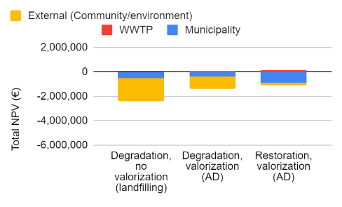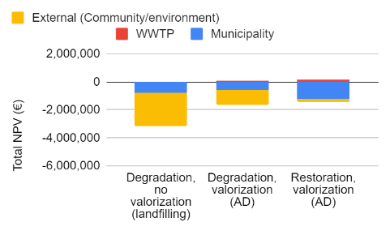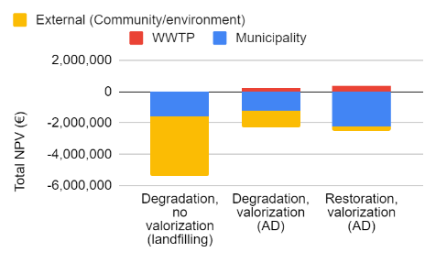
(a) (b) (c)
Figure A1: Sensitivity analysis of sand content as (a) 25% of collected material (b) 50% of collected material and (c) 75% of collected material on extended LCC for individual stakeholders.

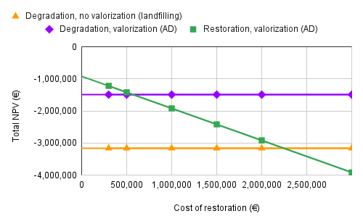
Figure A2: Sensitivity analysis of cost of restoration on extended LCC for all stakeholders.

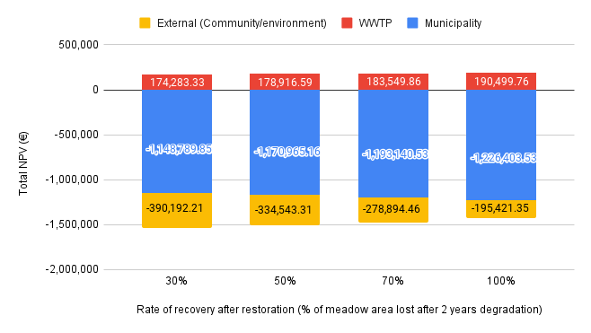
Figure A3: Sensitivity analysis of restoration rate on extended LCC for individual stakeholders.
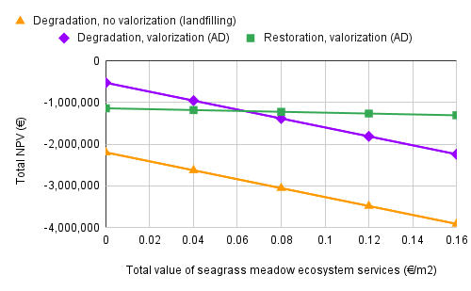
Figure A4: Sensitivity analysis of cost of ecosystem services on extended LCC for all stakeholders.

