Partnering Locally to Monitor Changes Towards the Achievement of SDGs
Ainhoa González^{1*}, Shane Mc Guinness², Enda Murphy², Grainne Kelliher³, Lyn Hagin-Meade³
¹ School of Geography, University College Dublin, Ireland
² School of Architecture, Planning and Environmental Policy, University College Dublin, Ireland
³ Dundrum 2030 Community Group, Airfield Estate, Ireland
*Corresponding author: ainhoa.gonzalez@ucd.ie
Abstract
Sustainable Development Goals (SDGs) are commonly reported nationally but often implemented locally. The common lack of knowledge about changes or monitoring mechanisms at the local level affects the accuracy of national and global reporting. In this context, local multi-stakeholder partnerships offer two critical opportunities: 1) to raise awareness and understanding of sustainability and thus drive implementation efforts through its incorporation into day-to-day actions and activities; and 2) to examine and comprehend how existing and emerging community/individual initiatives contribute to the achievement of the SDGs. This chapter describes the process of developing and establishing a multi-stakeholder partnership in Dundrum, Ireland. It describes the partnership-building mechanisms and efforts, particularly in the context of limited opportunities for face-to-face interaction, and the various roles and tiered responsibilities within the partnership. It then discusses the observed advantages (e.g. increased awareness, shared responsibilities, and opportunities for boosting local SDG implementation and data gathering efforts) and limitations (e.g. the pandemic, digital-literacy and lack of funding support) of the partnership, before making recommendations for future similar collaborations. Ongoing communication has been vital in creating the partnership and maintaining its activity. Information and Communication Technology (ICT) is central to this, facilitating multiple ways of disseminating, gathering and exchanging information. Nevertheless, in-person interactions between associated individuals and future collaborators, hindered in this case by the circumstances of the Covid-19 pandemic, would possibly help to solidify relationships and connections, and thus contribute to sustaining future partnership activity.
Keywords: Partnerships-building mechanisms, community, sustainability, Information and Communication Technology.

8.1 Introduction
The United Nations (UN) has stressed that although the implementation of the Sustainable Development Goals (SDGs) is officially the responsibility of national governments, the responsibility for the implementation must be shared among all domains of society - the state, the market and civil society – if their objectives are to be achieved. In other words, such is the scale of the challenge and nature of the transformation required that a whole-of-society approach is imperative for SDG implementation and achievement. Indeed, the UN Deputy Secretary General Amina Mohammed has specifically noted that a successful sustainable development agenda requires partnerships between a wide range of stakeholders including governments, the private sector, and civil society (Mohammed, 2018). These inclusive partnerships are built upon sustainability principles and values, a shared vision, and shared goals that place people and the planet at the centre of decision-making. Moreover, there is a clear recognition that such partnerships are needed at a range of geographic scales including at the global, regional, national, and local levels (Murphy et al., 2021).
Partnerships of various types for sustainable development initiatives and related capacity building have been increasing since the 1990s (Gabay and Ilcan, 2017). In particular, the 2030 Agenda emphasizes the need to strengthen global partnerships and multi-stakeholder partnerships (MSPs) across sectors by leveraging synergies between goals and related targets and emphasizing the urgency of transformative action. Global partnerships are typically led by governments with a focus on international co-operation while MSPs are voluntary arrangements that are seen as key enablers for achieving the Goals at a wider range of spatial scales including nationally, regionally and locally (Eweje et al., 2021). In this regard, the current chapter is primarily concerned with local MSPs given their role and potential for ‘bottom-up’ achievement of the SDGs.
Many SDG partnerships are established at the local scale targeting community level sustainability initiatives that contribute to achieving the wider SDG agenda. As noted in Chapter 2, local level partnerships for the SDGs tend to be large or smaller tri-sector partnerships, public-private partnerships and/or civil society-business partnerships. These partnerships can involve a wide variety of partners, including local governments, universities, schools, sports clubs, chambers of commerce, non-governmental organizations, small businesses, larger companies, and citizen groups (Escher and Brzustewicz, 2020; Ordonez-Ponce et al., 2021). In addition, empirical studies in the academic literature have noted that partnerships can offer a wide range of partner, partnership and societal benefits which can be realised at the local level (see Murphy et al., 2021). For example, Shulla et al. (2020) have noted the importance of local level SDG partnerships for stimulating community-based citizen science initiatives and related data gathering, while Wuebben et al. (2020) have outlined how alliances between citizen science initiatives and energy communities have the potential to contribute to related SDG implementation.
SDGs are global and commonly reported nationally; yet sustainable actions are often local, and yet there is a lack of knowledge about changes or monitoring mechanisms at this level thus affecting the accuracy of national and global reporting. For example, although greenhouse gas (GHG) emissions are measured at a national scale with increasing accuracy, the ability to capture the extensive suite of actions conducted at local scales towards reductions in GHGs (e.g. building energy retrofitting, community energy planning) is absent. This has the effect of discounting the perceived relevance of these measures and misses the opportunity to encourage similar groups to follow-suit. This remains a data centralisation, reporting and interoperability issue, and represents a broader lack of recognition of the importance of these activities regardless of issues around cohesion. Moreover, ongoing transformations at an individual basis on sustainability and sustainable development, and resulting attitudinal changes in society are particularly important in driving change towards the achievement of SDGs. Yet, there is also a general lack of knowledge around local collaborative efforts towards SDG targets, as well as on the contribution that the amalgamation of small changes at community and household levels is making (Shulla et al., 2020).
Within this context, local multi-stakeholder partnerships offer two critical opportunities: 1) to raise awareness and understanding of sustainability and thus drive implementation efforts through its incorporation into day-to-day actions and activities; and 2) to examine and comprehend (through collaborative exploration and/or citizen science, for example) how existing and emerging community/individual initiatives contribute to the achievement of the SDGs. This chapter describes the process of developing and establishing a multi-stakeholder partnership in Dundrum, a neighbourhood of Dublin, Ireland. The underlying aim of the chapter is to explore the importance of local level partnerships as a mechanism to co-create knowledge, foster sustainability, and monitor progress towards a sustainable future.

8.2 The Case Study
Dundrum is located in the Dún Laoghaire – Rathdown administrative area of the larger county of Dublin, on the east coast of Ireland. The townland has a long history, with settlement dating back to the 8th century. Today, the population of Dundrum’s five Electoral Divisions is just over 23,500 inhabitants, representing an 8% increase in the years 2011-2016 (CSO, 2017). A wide range of socio-economic and demographic backgrounds are represented in this catchment, although average incomes are higher than that of other regions in Dublin and exceed those of the national average. Despite having experienced significant building development in the last decade and having ill-defined boundaries in a wider suburban setting, the community exhibits strong social cohesion. Existing advocacy groups play an important role in engaging with local government, planning authorities and commercial interests, for example through the ‘Imagine Dundrum’ and the ‘Dundrum 2030’ initiatives.
In the current partnership, Dundrum 2030 are a keystone community body. This collective is wholly voluntary and was established in 2019 with a core vision of ensuring that “Dundrum will be a vibrant community sharing a new set of global values that govern our economic, social and environmental behaviours to the benefit of future generations and we will have a strong civic pride in our local contribution to those goals” (Dundrum 2030, 2022). To achieve this, a key target is the establishment of a Community Sustainability Framework which allows shared targets to be set, sectoral networks to be strengthened and an SDG reporting tool to monitor progress to be developed. Dundrum 2030 are also members of the Dún Laoghaire – Rathdown Public Participation Network (PPN). PPNs allow local authorities to connect with community groups around the country, providing the opportunity for community and local expertise to enter the decision-making process.
Dundrum 2030 mirrors similar efforts in a limited number of towns across Ireland, such as the Dingle 2030 initiative, and the Cloughjordan eco-village, both of which have endeavoured to stimulate community engagement towards achieving the SDGs by 2030. However, to date, no community efforts are underway to accurately quantify progress on local SDG implementation or to monitor key indicators at a local level. As such, establishing a co-created method of measuring SDG progress in Dundrum provides an excellent demonstrator case for application at a national level, as well as a good practice example of applied MSPs.
8.3 Developing A Local Multi-Stakeholder Partnership
The partnership (Figure 8.1) involved multiple sectors of society, including academics, researchers, businesses and residents, and their interactions expanded over time. Figure 8.1 captures the various tiers of expanding engagement (e.g. the core team at the nucleus as the driving force, stakeholders in the periphery - engaging at key points) and responsibilities (e.g. SDG ambassadors’ role in ‘recruiting’ additional partners through individual contacts.
The partnership originated out of a conversation between one of the directors on the Dundrum 2030 community group, and an academic at the School of Geography, University College Dublin (UCD). Dundrum 2030 were seeking a way to understand how local changes in the urban environment and community-led initiatives contribute towards achieving a more sustainable future. In that conversation, synergies between academic and social efforts became apparent, and it was agreed to jointly explore a systematic and geographic approach to measuring SDG-related indicator values locally.
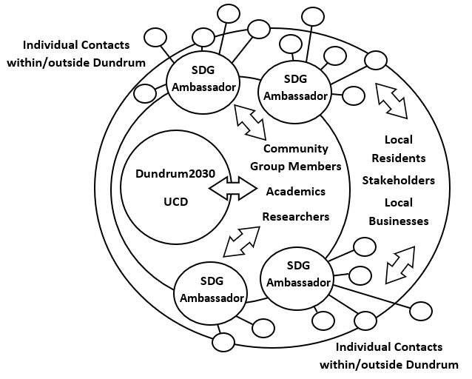
Figure 8.1 Structure of the community partnership (the arrows aim to illustrate the interlinkages in communication across all individuals/groups involved in the partnership); the circles illustrated the expanding tiers of engagement through the establishment of the partnership).

This dyad partnership rapidly grew into a multi-disciplinary project team. Various Dundrum 2030 community members and UCD academics with a range of relevant expertise (e.g. sustainable development, SDG indicators, environmental policy, community engagement, spatial analytics) came together out of research and/or personal interest and prepared a successful funding proposal. The proposal was co-designed to deliver a context-specific and tangible approach to the needs of the community. It provided a mechanism to progress the idea of social engagement for delivering and monitoring local sustainability activities, and thus progress towards achieving the SDGs. Funded by the Earth Institute at UCD, the project had two main goals: 1) to build the capacity of the Dundrum 2030 community group to monitor progress towards sustainability; and 2) to co-create an indicator-led monitoring toolkit and associated interactive dashboard for communities. These goals included three main underlying intentions: a) the co-definition of a UN-aligned indicator set that links to current local initiatives; b) capacity building in the areas of indicator data gathering/recording and interpretation; and c) the co-creation of a user-friendly dashboard as a framework for monitoring change. The co-creation of the dashboard itself was to provide a systematic and spatially-specific means for data gathering, analysis and visualisation; with the overall aim of developing a means by which local data can facilitate, influence and feed into national sustainability reporting mechanisms as currently undertaken by the Government of Ireland (see: https://irelandsdg.geohive.ie).
Three Dundrum residents and four academics comprised the project team and were soon joined by two postgraduate research students examining transitions towards sustainable transport and household energy provision. The project team set to actively engage with local community groups (e.g. residents associations, non-profit organisations) and businesses from the outset and thus nurture and develop the community partnership. Although in-person community events/workshop had been planned, these were not possible because of the Covid-related social distancing measures. To transcend this, alternative communication channels were established (section 3.1.). Information on the project circulated from inception, and an online workshop was delivered four months into the project to further disseminate local efforts and invite community representatives (i.e. residents, local businesses) to have their say. The workshop contributed to the prioritisation of SDGs, as well as to the preliminary identification of existing initiatives/activities fostering sustainability. Twenty-eight initiatives were initially identified in the Dundrum area during the workshop, and this list expanded as additional information was provided by the local community. The sustainability initiatives/activities have been captured in a digital interactive map embedded in the dashboard, which can be found on the Dundrum 2030 website (https://dundrumtwentythirty.com). Users can click on each initiative to unveil details of its main objectives, its related SDGs and obtain contact details of individuals involved in specific projects. The identified initiatives and the interactive map formed the basis for the co-creation of a community SDG dashboard.
The selection of priority SDGs and of UN-aligned SDG indicators for reporting and monitoring in the current iteration of the project was undertaken in close consultation with the local community, and was informed by the ongoing initiatives/activities in the locality. The selection was then refined taking into consideration spatial data availability; it was not possible to include in the dashboard some of the indicators considered relevant by the community due to the current absence of data/information to populate these. Similarly, although some desired indicators had data at national level, the resolution did not extend to the local level thus failing to capture the detail required to monitor progress locally. However, residents volunteered to support the indicator data gathering process; for example, by installing domestic air quality and traffic monitoring sensors at their homes, and answering online surveys. These facilitate the inclusion of additional indicators as data become available. Community members also reviewed the content and functionality of the dashboard, providing valuable feedback that helped improve its usability (e.g. data querying functions, visibility of layers, etc.).
To maintain ongoing communication with the community, follow-up emails were sent, and a newsletter was circulated on project progress. To further expand and strengthen the partnership, an ‘SDG ambassador’ role was developed (Section 8.3.2) to create local champions for each target SDG. Community representatives were invited to take this role and become active members of the Dundrum 2030 Community Group. They took on the responsibility of acting as links with community volunteers, helping to bring additional partners by actively engaging with their network of residents and with individuals participating in the various project events. They also endeavour to raise awareness on sustainability, foster engagement in ongoing initiatives and launch new ones (e.g. one of the ambassadors is, a result of her involvement in the community partnership, championing the development of various initiatives including a stumpery club and foraging-walking groups). The ambassadors chaired participative sessions at the second online community workshop where they discussed with residents existing and future initiatives of their related SDGs and encouraged them to get involved in data gathering efforts. They met in-person with the core team (i.e. Dundrum 2030 and UCD academics) to debrief on the workshop’s outcomes, exchange their proactive approaches to maintaining ongoing communication with interested residents, and further discuss the next steps for data gathering, collection and management. At this meeting, it was agreed that the ambassadors would report back to the project team on a quarterly basis. The gathered data contributes to updating the inventory of initiatives/activities and to populating the SDG indicators in the dashboard. The periodic reporting windows also serve to maintain communication within the MSP and reflect on what has been achieved and what needs to be done to continue fostering awareness and monitor progress towards the achievement of the SDGs. This partially addresses one of the key goals of the project: the co-production of a monitoring and reporting mechanism, building the capacity of volunteers along the way, to ensure progress beyond the life of the funded research period.
To nurture and eventually create a robust multi-stakeholder and multi-layered partnership, several communication and engagement approaches were used, and inter-linked roles created to structure inputs and responsibilities. These are further described, and examined in terms of advantages and limitations, in the following subsections.
8.3.1 Partnership Building Mechanisms and Efforts
The engagement between community representatives and researchers has been regular and progressive in building the MSP. The seven core project partners have co-produced research strategy documents, communication plans and progress reports. The communication plan, central to building the partnership, has been significantly influenced by Covid-19 pandemic restrictions. It has required continuous revisions to adapt the communication means to changing social interaction limitations. Information and Communication Technology (ICT) has been central to facilitating the creation and extension of the partnership in the context of the pandemic. In the absence of planned face-to-face meetings and workshops, the communication plan was co-designed to embrace multiple ICT methods (Table 8.1) and thus ensure wider dissemination and inclusivity (i.e. to reach out to different parts of the community and engage with different groups and audiences).
ICT Method | Users/Target audience | Application
Email exchange | Project team, SDG ambassadors, local community | Main means of communication between the core group; e-list to announce workshops and project progress.
Online meetings (Zoom) | Project team, SDG ambassadors | Partnership group meetings.
Online workshops (Zoom) | Project team, SDG ambassadors, local community | Community workshops.
e-Newsletter | Local community | Announce project progress and launch of the SDG dashboard.
Dundrum 2030 website | Local and wider communities | Dissemination of project and broader activities of the community group.
SDG Dashboard | Local and wider communities, research institutions and government departments | Community awareness through geographic visualisation of SDG indicator status and change (i.e. progress towards SDG achievement)

Table 8.1 Information and Communication Technology (ITC) methods used in building and developing the local partnership.

As it is common, email was the main means of communication between the core personnel in the Dundrum 2030 community group, UCD academics and researchers. An e-list was also created at project inception including community group members, local businesses, resident associations, etc. This e-list was then used to announce the workshops, communicate project progress, disseminate surveys (supporting research on local energy use and transition towards sustainable means of transport) and circulate the newsletters.
Meetings between project team members were held regularly, using Zoom, to discuss and prepare the communication strategy, organise the workshops, co-design the dashboard, etc. Several online meetings were also held with the ambassadors, including one-to-one meetings between the project lead and each of the ambassadors to clarify questions around the role and discuss ideas for the second workshop. Zoom was also used to facilitate the two online community workshops. One workshop was held in March 2021 (four months into the project) and one in November 2021 (a month from the project completion date). The workshops were designed around specific purposes:
  - The first workshop aimed at providing an opportunity for the local community to actively engage in the project by ‘having their say’. It involved 80 participants (130 registered; 61% attendance). The workshop included short presentations by community partners and academic researchers on the project’s goals and objectives and, more importantly, on local sustainability progress and challenges. It then provided an open platform for participants to share their knowledge and ideas. To aid in semi-structured discussion and inputs, Padlet collaboration software was used (Figure 8.2). Participants were prompted to discuss ongoing initiatives around each of the SDGs and to identify additional initiatives/activities they would like to foster or see implemented in the community, inputting them in the Padlet template. This helped compile an inventory of SDG-related initiatives in the community and gauge perceptions and ideas for future actions that could guide the Dundrum 2030 Community Group’s efforts. In particular, this platform facilitated effective participants’ interaction and input and, ultimately, allowed greater engagement at a time when face-to-face interaction was not possible, while also aiding in ‘digital democratisation’ towards achieving the SDGs. As this partnership progresses and options for social mixing re-emerge, caution will be required to retain the engagement of community members less willing/able to meet in person.
  - The second workshop started with the official launch of the ‘Community SDG Dashboard’, inviting participants to review and comment on its functionality and usability. It then focused on expanding the core partnership by facilitating interactions between the SDG ambassadors and the wider community. It included breakout groups with the 11 participants (45 registered, 24% attendance), where each ambassador, supported by a project team member, facilitated discussions around a specific goal. The purpose of these breakout groups was to raise awareness around the current status of SDG indicators and associated targets, and entice individuals to volunteer and participate in data gathering activities.
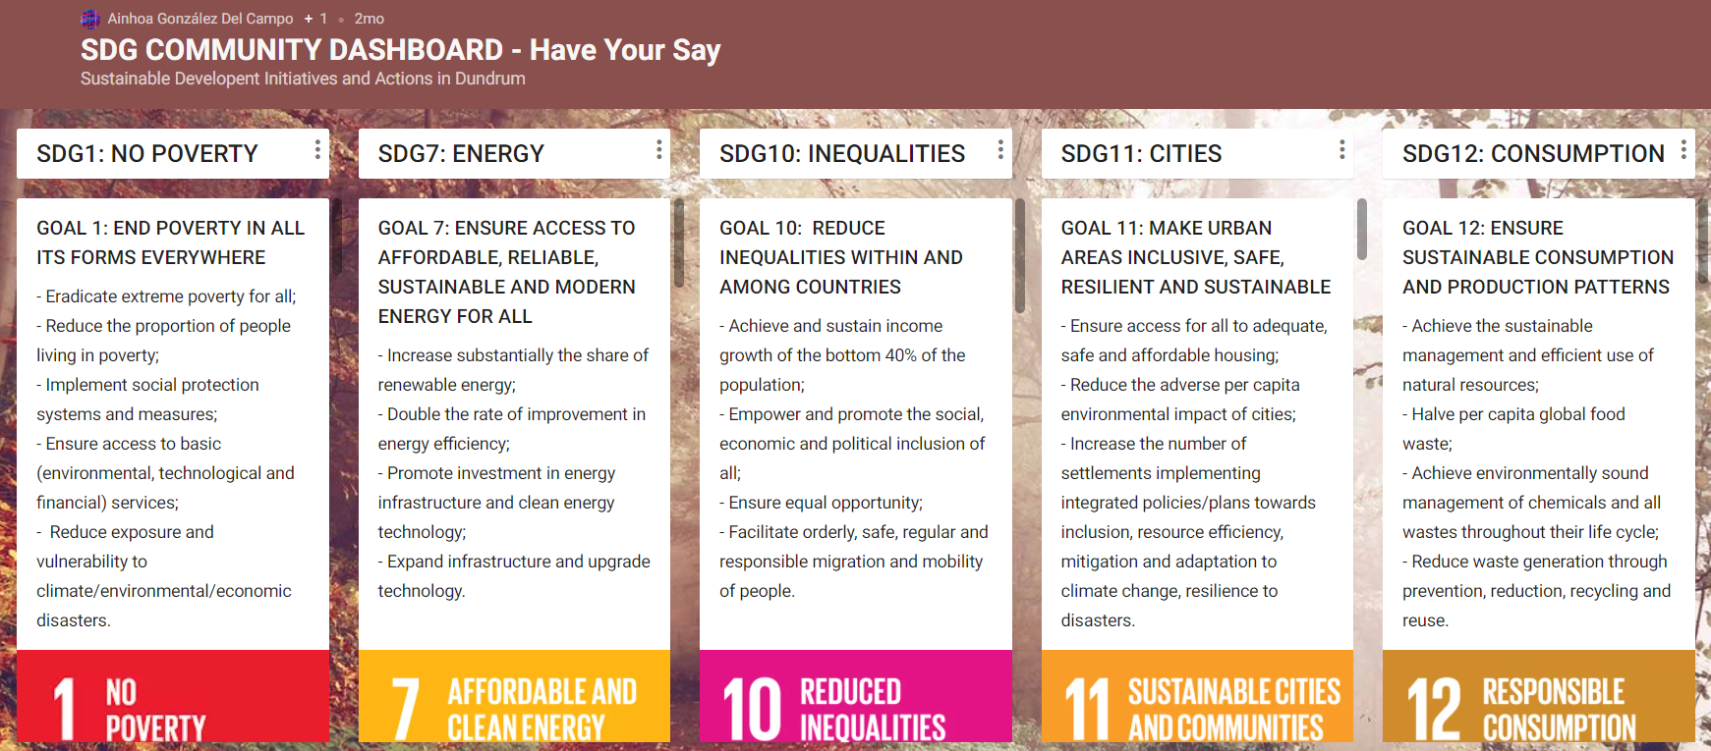
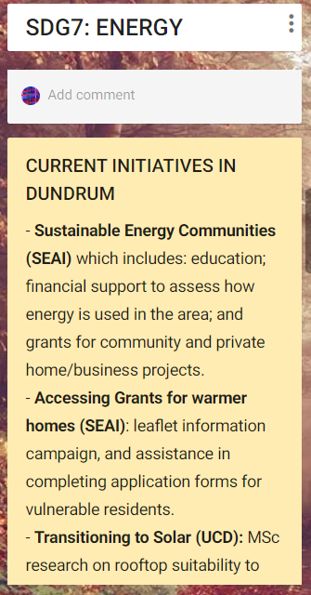
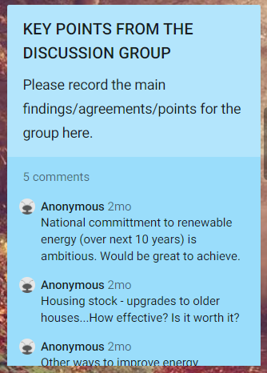
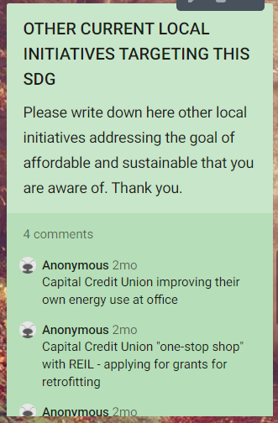
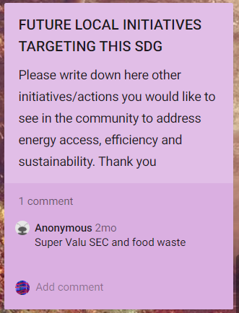
Example of inputs by workshop participants.

Figure 8.2. Structure of the Padlet template used in the first community workshop (top), and example of participants’ inputs (bottom).
Two e-newsletters were prepared and circulated to the wider community in Dundrum, and more broadly across Dublin, including local newspapers. The first one focused on project progress and the second one announced the launch of the dashboard (Figure 8.3). The newsletters aimed at maintaining ongoing communication within the partnerships, particularly with local residents and businesses. Their supplementary dissemination through the local newspapers helped address digital literacy barriers.
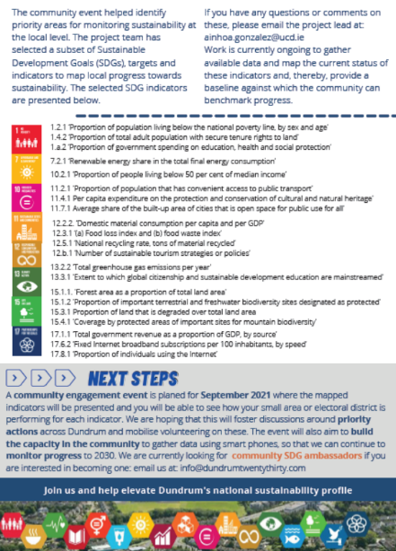
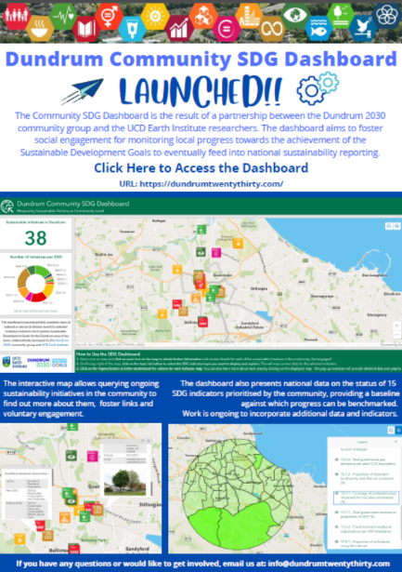
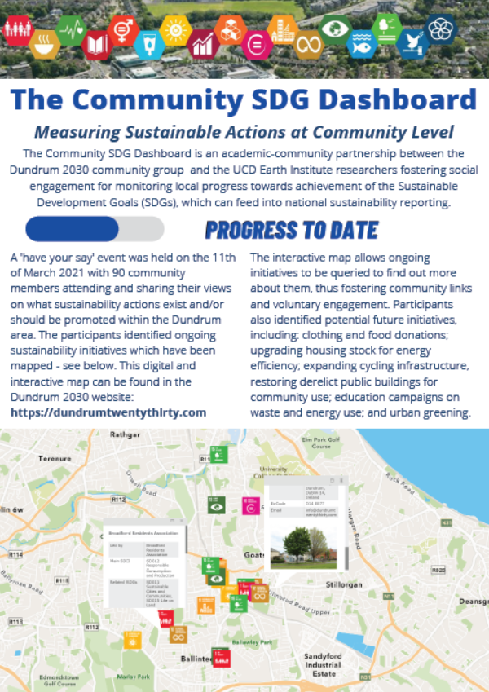
Figure 8.3 First newsletter on project progress (two images to the left), and second newsletter announcing the launch of the ‘Community SDG Dashboard’ (right).
The main wider communication channels include the Dundrum 2030 Community Group’s website (https://dundrumtwentythirty.com), where the project’ goals, progress and outputs have been published, and the SDG Dashboard. The ultimate aim of the project was to co-create a dashboard that captures community initiatives/activities that contribute towards the achievement of the SDGs, and that maps changes on UN-aligned SDG indicator values to monitor progress (Figure 8.4). The dashboard serves as a means of communication to anyone interested in sustainability at the local level but, more importantly, it helps raise awareness about local sustainability initiatives/activities encouraging involvement, and allows understanding and tracking change on SDG indicators. It has the potential, once geographical coverage can be guaranteed, to inform national reporting.
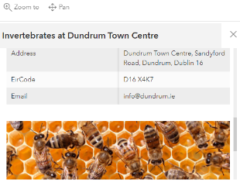
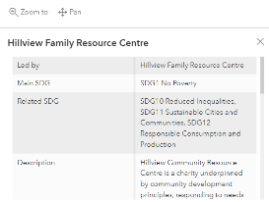
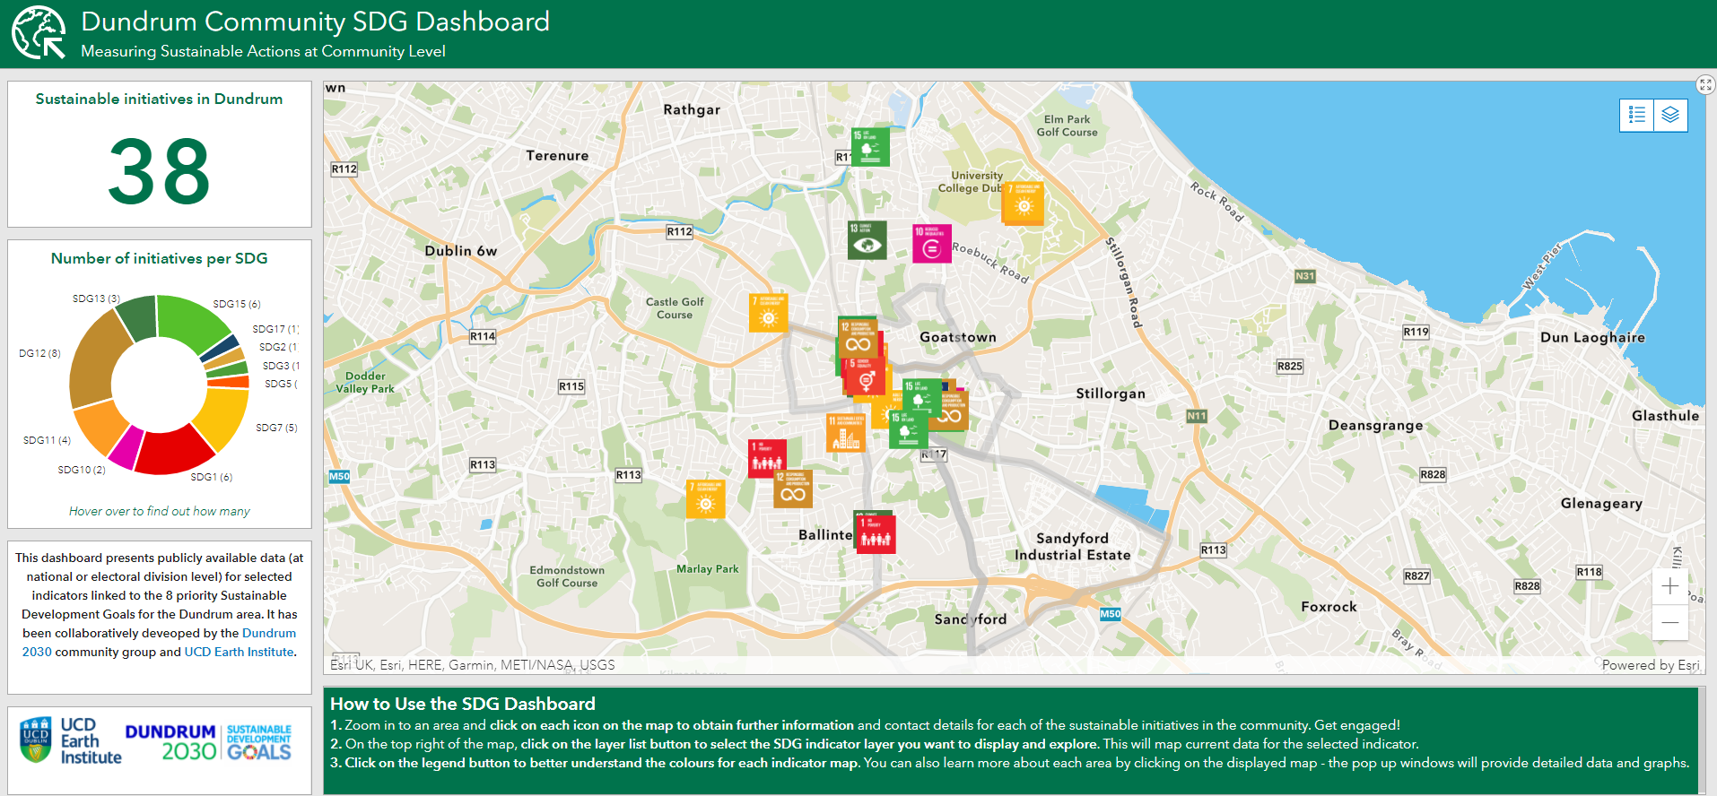

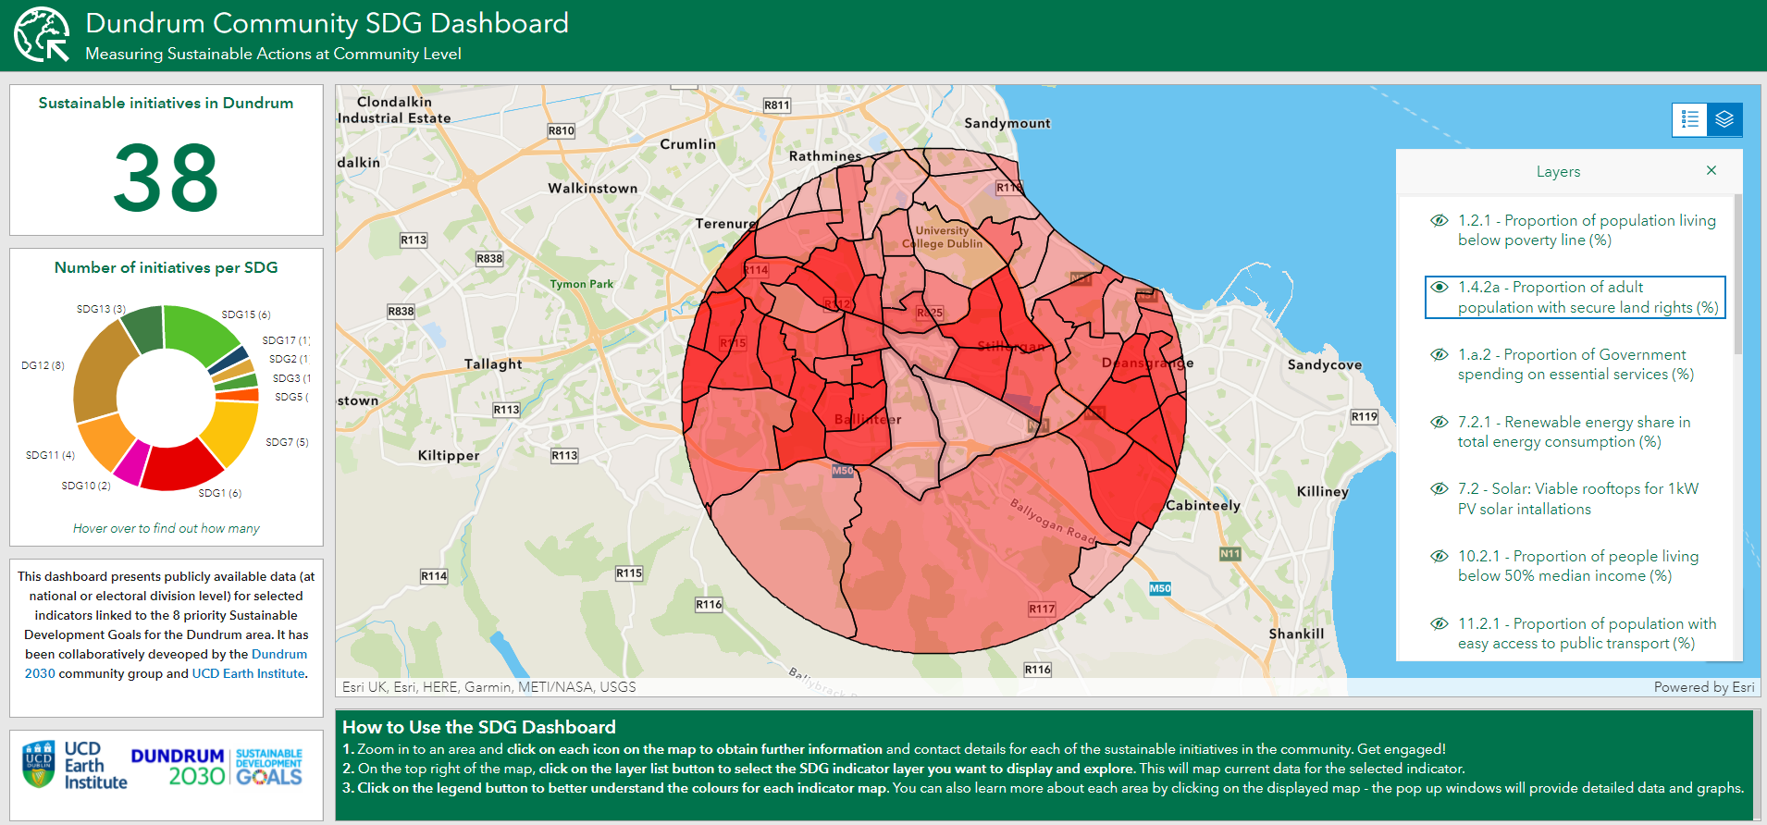
Figure 8.4 Screenshot of the ‘Community SDG Dashboard’: a) illustrating local initiatives/activities and their details (top); and b) baseline values for UN-aligned SDG indicators (bottom).

8.3.2 Tiers and Roles in the Local Partnership
Fundamentally, the partnership was led ‘by the community for the community’ (Figure 8.1). It includes individual residents and local representatives from both the private and public sectors (e.g. NGOs, local authority, charities, residents’ associations, and businesses such as banks, commercial centres and shops). Similarly, it brought together academics and researchers with various research interests and expertise (e.g. urban planning, sustainable development, spatial analysis, community engagements, solar energy, sustainable transport, etc.). Its multi-faceted nature facilitated broad knowledge and attentiveness to local sustainability, which was crucial in informing the selection of the priority SDGs.
Partnership members have engaged to varying degrees in the co-creation of an SDG indicator-led monitoring toolkit and the associated dashboard for communities. The main contributions can be summarised as follows:
- Dundrum 2030 community group: Three of the founding directors of the community group have led the communication strategy and the expansion of the partnership, by identifying ambassadors and by reaching out to their members and the wider community, inviting them to participate in the co-creation of the dashboard and volunteering in indicator data collection efforts.
- Academic researchers: Scientific contributions, particularly with regards to the systematic and transparent identification of UN-aligned SDG indicators, spatial data analysis and technological means for creating an interactive and user-friendly dashboard, were provided by four academics. Specific data inputs for some of the indicators included in the dashboard were also provided by graduate research students.
- Ambassadors: Four ambassadors, leading SDGs 7, 11, 12 and 15, are currently championing sustainability awareness and efforts within the community. Their main role is to mentor and support those in the community with an interest in sustainability, liaising with data collection volunteers to gather local information that will feed into the dashboard. The Dundrum 2030 community group are actively looking to recruit additional ambassadors to champion the remaining priority SDGs (i.e. 1, 10, 13 and 17).
- Data collection volunteers: These were identified and engaged in the second workshop. Four local residents have agreed to liaise directly with the ambassadors to collect data on the ground. These data will be reported back to the core project team (i.e. Dundrum 2030 and UCD researchers), on a quarterly basis, for curation and inclusion in the dashboard.
- Local residents and stakeholders: The partnership involves over 80 individuals and representatives from the community. These have engaged in different ways throughout the co-creation of the SDG indicator-led monitoring toolkit and the associated dashboard. They actively participated in the workshops, and have engaged in online communication with one or various project partners to provide additional detail on initiatives/activities, indicator data sources, and feedback on the usability of the draft dashboard.

8.4 Advantages of Local Partnerships
Given the international focus on the need for a whole-of-society approach to achieve the SDGs (Cázarez-Grageda, 2018; Kindornay and Kocaata, 2019), it must be recognised that building and maintaining bottom-up local-level SDG partnerships provides a crucial means of implementation for the wider 2030 Agenda. Community-driven partnerships are, in particular, a vital component in the implementation and monitoring of SDGs. A shared motivation to transform the community, to make it more environmentally friendly, climate-proof, resilient, inclusive and fair can be described as ‘instrumental’ in bringing local stakeholders together (Stott and Murphy, 2020). Multi-stakeholder partnerships at the local level can enhance responsiveness to sustainability and sustainable development in their broad sense. More importantly in the context of achieving the SDGs, they are central to the identification and recognition of SDG related initiatives/activities, and in fostering community involvement in these through information exchange and awareness raising. This was apparent in the Dundrum case, where a relatively comprehensive inventory of SDG-related initiatives was possible, quickly and at low cost, through wide community engagement.
Community partnerships can also facilitate joint efforts for capturing the contribution of local initiatives towards the achievement of the SDG targets, an important current knowledge gap that needs to be filled. International and national bodies recognise that local level citizen engagement will be required to gather data for understanding SDG progress at a disaggregated local scale, given the lack of resourcing for national bodies to collect data even at national and regional levels (see Murphy and Walsh, 2020). In this regard, local partnerships can perform an essential role in facilitating local level data gathering within a citizen science framework (e.g. participative workshops and/or by volunteered data gathering efforts) to produce locally-specific data that conforms to UN statistical indicators for the SDGs. Similarly, they provide a means for ongoing proactive monitoring. In the context of the ‘Community SDG Dashboard’ project, a framework that prioritised SDGs and specific indicators was created to enable the possibility for local community organisations to gather such data into the future. SDG ambassadors and data collection volunteers will contribute to the implementation of local monitoring efforts that capture changes on indicator values from 2020 to 2030.
Partnerships can also contribute to creating ownership. Involved stakeholders co-learn and co-create to advance shared goals (Oliveira-Duarte et al. 2021). Shared goals and responsibilities for a more sustainable community encourage interest and involvement. Responsibility, resilience and scalability then often follow, ensuring that leadership/stewardship is disaggregated and equitable. They organically build the capacity of the community through knowledge exchange, and can serve as an effective mechanisms for targeted training. Open, transparent, and ongoing communication is key to this (see section 8.3.1).
8.5 Limitations when Setting Up Local Partnerships
Setting up a community MSP can be challenging at the best of times, but particularly so when restrictions exist for face-to-face interaction. While society as a whole has had to adapt to online engagement mechanisms as a result of the global pandemic, creating and expanding a partnership through online communication and engagement alone has proven difficult. Conversely, ICT has been central in easing out some of the hurdles (section 8.3.1), and possibly in allowing a greater number of participants attend the first workshop (anecdotal evidence shows that in the early days of the pandemic, attendance of online seminars and workshops increased). However, the intensiveness of online communication and rampant Zoom meetings, added to the Covid-related changes in circumstances (e.g. caring for relatives), has exhausted the enthusiasm of many; this could arguably be observed in the numbers registered (and attending) the second workshop, as well as the dwindling of residents’ emails and reaction to the various communications circulated by the Dundrum 2030 Community Group. Moreover, previous experience in community engagement attests to the fact that live (in-person) meetings can be more participative, enriching and engaging, while removing the barriers inherent in digital literacy, especially with older and other vulnerable groups. Therefore, there is high a possibility that in the absence of social restrictions, perhaps not wider but a more devoted partnership could have been achieved.
Current restrictions have also affected the actual sustainability of the partnership. Despite having a solid core group of partners, including ambassadors and community volunteers, the partnership faces difficulties with regards to its continuity. Lack of funding, departure of one of the Dundrum 2030 Community Group funding partners, and online-interaction fatigue put at risk the consolidation of efforts to date, as well as the expansion of the partnership to create a solid driver for enduring change towards sustainability in the Dundrum community. Some of these observed difficulties could be overcome by financial resources that help sustain the partnership for the longer-term.
8.6 Final Remarks and Recommendations
The creation of a MSP in the neighbourhood of Dundrum has brought significant knowledge, experiences, and efforts together. It has facilitated the creation of a robust foundation for driving change towards the achievement of the SDGs through local efforts. Without the partnership, co-identification of priority areas of action and co-creation of a solution that would provide a tangible and meaningful means for capturing SDG progress would not have been possible. The community partnership has been central in capturing local sustainable initiatives and sourcing data on the current status of selected indicators, and will be key for monitoring changes in these indicators in the future.
Ongoing communication has been vital in creating the partnership and maintaining its activity. The use of multiple methods of communication and engagement has contributed to the creation of diverse opportunities and windows for engagement, which is vital for initiating and growing a local MSP - and which needs to be highlighted as a key recommendation for any future similar SMP ventures. In this context, ICT has proven a significant aid in reaching a wider audience, facilitating multiple ways of disseminating, gathering and exchanging information. Nevertheless, it can be argued that over-reliance on ICT for engagement, driven by the circumstances of the pandemic, has been a weakness to solidifying the partnership. Personal and professional associations and group dynamics are best created in-person. There is a need for face-to-face interactions in the next stages of the partnership to strengthen relationships and connections. In this context, the role of SDG champions (e.g. Dundrum 2030 community group and ambassadors) is crucial in driving and encouraging engagement for future consolidation of the partnership. It is anticipated that the trust and ownership built between all community partners throughout the lifetime of the project will sustain the initiatives set in motion beyond the lifetime of this project, facilitate the continuity of community engagement, and serve as a model in other community settings nationally.

References
Cázarez-Grageda K. (2018). The whole of society approach: Levels of engagement and meaningful participation of different stakeholders in the review process of the 2030 Agenda. URL: https://sdghelpdesk.unescap.org/e-library/whole-society-approach-levels-engagement-and-meaningful-participation-different
CSO (2017). Census of Population 2016 - Profile 2 Population Distribution and Movements. Dublin, Central Statistics Office. URL: https://www.cso.ie/en/csolatestnews/presspages/2017/census2016profile2-populationdistributionandmovements/
Drundrum 2030 (2022). Vision and Mission. URL: https://dundrumtwentythirty.com/vision-mission/
Escher I, Brzustewicz P (2020). Inter-organizational collaboration on projects supporting sustainable development goals: The company perspective. Sus-tainability 12(12): 4969. Eweje G., Sajjad A., Nath S.D., Kobayashi K. (2021). Multi-stakeholder partnerships: A catalyst to achieve sustainable development goals. Marketing Intelligence and Planning, 39(2): 186-212.
Gabay C., Ilcan S. (2017). The affective politics of the sustainable development goals: Partnership, capacity-building, and big data. Globalizations, 14(3): 468-485.
Kindornay, S., Kocaata, Z. (2019). A whole-of-society approach: Partnerships to realize the 2030 Agenda. Good Practice in 2030 Agenda Implementation Series. Vancouver and Ottawa: British Columbia Council for International Cooperation and Canadian Council for International Co-operation. URL: https://www.bccic.ca/wp-content/uploads/2019/05/Canada-Partnership.pdf
Mohammed, A.J. (2018) Whole-of-Government, Society Approach Essential to Achieve Sustainable Development Goals, Deputy Secretary-General Tells Regional Coordination Leaders Forum. URL: https://www.un.org/press/en/2018/dsgsm1131.doc.htm.
Murphy E., Walsh P.P. (2020). A coded taxonomy of the statistical indicators for global reporting of targets within the UN 2030 Agenda for Sustainable Development. Journal of the Statistical and Social Inquiry Society of Ireland, 49: 100-128.
Murphy, E., Walsh, P.P., Banerjee, A. (2021). Framework for achieving the environmental Sustainable Development Goals (SDGs). Wexford: Environmental Protection Agency. URL: https://www.epa.ie/publications/research/climate-change/Research_Report_397_eb.pdf
Oliveira-Duarte L., Reis D.A., Fleury A.L., Vasques R.A., Fonseca Filho H., Koria M., Baruque-Ramos J. (2021). Innovation ecosystem framework directed to sustainable development goal #17 partnerships implementation. Sustainable Development, 29(5): 1018-1036.
Ordonez-Ponce E., Clarke A., MacDonald A. (2021). Business contributions to the sustainable development goals through community sustainability partnerships. Sustainability Accounting, Management and Policy Journal, 12(6): 1239-1267.
Shulla K., Filho L.W., Sommer J.H., Lange A., Salvia L., Borgemeister C. (2020). Channels of collaboration for citizen science and the sustainable development goals. Journal of Cleaner Production, 264: 121735.
Stott L., Murphy D.F. (2020). An inclusive approach to partnerships for the SDGs: Using a relationship lens to explore the potential for transformational collaboration. Sustainability, 12(19): 7905. doi:10.3390/SU12197905
Wuebben D., Romero-Luis J., Gertrudix M. (2020). Citizen science and citizen energy communities: A systematic review and potential alliances for SDGs. Sustainability, 12(23), p.10096.

https://www.imaginedundrum.ie/
https://dundrumtwentythirty.com/

