Efficacy of cold plasma functionalised water for improving microbiological safety of fresh produce and wash water recycling.
Apurva Patange¹, Peng Lu¹, Daniela Boehm¹, P.J. Cullen^{1,2} and Paula Bourke^{1,3}
¹School of Food Science and Environmental Health, Technological University Dublin, Ireland
²School of Chemical Engineering, University of Sydney, Australia
³School of Biological Sciences, Queens University Belfast, Northern Ireland, United Kingdom
Correspondence:
Paula Bourke, Technological University Dublin, 31 Marlborough Street, Dublin 1, Ireland.
Tel: +353-14027594; Fax: +353-14024495;
E-mail: paula.bourke@dit.ie

Abstract
Atmospheric cold plasma (ACP) is an effective method for microbiological decontamination. This study evaluated an alternative water-based decontamination approach for inactivation of bacterial population from fresh produce and in the wash water generated from fresh produce washing. The study characterised ACP inactivation of attached Listeria innocua and Pseudomonas fluorescens inoculated on lettuce in comparison to chlorine treatment. P. fluorescens was sensitive to ACP treatment and was reduced below detection limit within 3 min of treatment. L. innocua population was reduced by ~2.4 Log₁₀ CFU/g after 5 min of treatment; showing similar inactivation efficacy to chlorine treatment. The microbial load in wash water was continuously decreased and was below detection limits after 10 min of ACP treatment. Micro-bubbling along with agitation assisted the bacterial detachment and distribution of reactive species, thus increasing bacterial inactivation efficacy from fresh produce and wash water. A shift in pH of plasma functionalised water was observed along with high concentration of nitrate and ozone with a relative amount of nitrites which increased with plasma exposure time. Further, L. innocua treated at different independent pH conditions showed minimal or no effect of pH on ACP bacterial inactivation efficacy. Aqueous ACP treatment poses a promising alternative for decontamination of fresh produce and the associated wash-waters which could be applied in the food industry to replace continuous chlorine dosing of process waters.
Keywords: Aqueous atmospheric cold plasma, minimally processed, wash-water treatment, microbial decontamination

Introduction
The role of fresh vegetables and fruits in providing nutrients and for a healthy diet is well recognized. However, as produce is often consumed raw, fresh produce can serve as a vehicle for many food-borne pathogens to survive and cause human infections. In 2016, a total of 4,786 food-borne outbreaks, including waterborne outbreaks were reported in the EU alone, resulting in 49,950 cases of illness, 3,869 hospitalizations and 20 deaths (EFSA, 2017).
The routes of fresh produce contamination are during growth in field, harvesting, post-harvest handling, washing or during storage and distribution. Some of the microbes are capable of colonizing, creating lesions and internalizing in healthy plant tissues. Internal tissues are rich in nutrients (water activity>0.90) and have neutral pH which provides the microorganism ideal conditions for microbial growth inside the produce (Barth et al., 2009). During the production of fresh cut or minimally processed fruits and vegetables, washing with water or different sanitizer solutions is a frequent method to loosen and remove dirt and disinfect produce. Efforts to resolve food safety problems linked to fresh or minimally processed produce are essential and timely, but should also consider end-user concerns, energy demands and the potential for toxicity. New non-residual chemical intervention technologies are needed to ensure microbial safety with minimum effects on sensory and nutritional quality of fresh produce.
Chlorine remains widely used for disinfection in fresh produce preparation. Although several reports have shown great efficiency of chlorine washes in eliminating bacterial populations, the practice of using a higher concentration of chemical sanitizers has raised concern regarding its possible generation of by-products and its impact on human health and environment (Gil et al., 2009; Van Haute et al., 2013). Atmospheric cold plasma is a novel technology which has attracted interest for disinfection of microbial population from different surfaces. The role of cold plasma from air at or near atmospheric pressure and room temperature has been extensively studied and has exhibited excellent antibacterial efficacy against target food pathogens and their spores and biofilms (Bourke et al., 2017). In-package ‘dry’ atmospheric cold plasma (ACP) treatment along with post treatment retention time of plasma reactive species has demonstrated bacterial inactivation efficacy for decontamination of fresh produce (Ziuzina et al., 2014). Besides antimicrobial activity of the gas plasma, application of plasma activated water has recently been introduced in bacterial inactivation studies for food safety (Ma et al., 2015; Schnabel et al., 2015). Until recently, plasma discharged water has been widely studied in the context of environmental and wastewater treatment (Cubas et al., 2016; Patange et al., 2018; Sarangapani et al., 2017). In this study, we investigated the inactivation efficacy and mechanism of plasma activated water against microbial populations on fresh produce. ACP generated using dielectric barrier discharge submerged in water was used in combination with co-axial diffusor assisted micro-bubble generation to disperse the plasma effluent through the treatment chamber. The plasma effluent is at the gas-liquid interface of the bubbles; which facilitates the transfer of oxidative species produced in the plasma directly to the liquid phase. Inatsu et al. (2013) demonstrated micro-bubbles increased oxidation efficiency of ozone which enhanced microbial collapse; micro-bubbles reduced Escherichia coli (E. coli) O157:H7 viability more than ozonated water on the surface of leafy vegetables.
The dissolution of plasma species in liquid phase triggers dynamic chemical reactions and forms several reactive species which are short-lived and difficult to detect. It has been well established that hydrogen peroxide, nitrates, and nitrites are longer-lived species and play important roles for biological effects (Guo et al., 2015). Consequently, quantitative detection of reactive species could serve as a useful indicator for plasma source characterization with regards to biological effects. One of the important advantages of plasma discharge in water is the damage caused to a biological/sensitive product by charged particles, electrons, chemicals, and ultraviolet rays due to etching and degradation of bioactive compounds after the surface treatment (Thirumdas et al., 2018). This can be avoided by this water based form of treatment, which makes it suitable for study with fresh produce. The purpose of this study was to determine the efficacy of a submerged Dielectric Barrier Discharge plasma (DBD)-ACP system with diffusor assisted microbubbles against Listeria innocua and Pseudomonas fluorescens on fresh produce surface and for potential as a continuous process water decontamination treatment. Listeria spp. and Pseudomonas spp. are psychrotolerant and ubiquitous microorganisms that contaminate Ready-To-Eat produce (Møretrø and Langsrud, 2017; Oliveira et al., 2011). The resistance of these species to chemical treatments aids their viability and infection potential in the environment. This research focuses on using alternative methods to remove these organisms from fresh produce as well as process wash water. L. innocua has been frequently proposed as a surrogate of L. monocytogenes because the two species are related closely phylogenetically (den Bakker et al., 2010; Glaser et al., 2001). Previous studies by Vaz-Velho et al. (2001) demonstrated comparable ozone resistance with L. innocua and L. monocytogenes, indicating L. innocua could be used as an appropriate surrogate for L. monocytogenes in experiments with reactive oxygen species as major inactivation factors. Since L. innocua is non-pathogenic, we employ this species directly in trials in custom built submerged DBD-ACP device, to investigate its persistence and sanitizer susceptibility rendering valuable data to predict L. monocytogenes behaviour without causing contamination issues.
The studies also compared the independent and combined effects on bacterial inactivation of cold plasma micro bubbling and agitiation, micro-bubbling and agitation in deionized water without cold plasma to treatment with chlorinated water set at a standard chlorine concentration (100 ppm). Of importance for practical application and to establish potential as a replacement technology for chlorine assisted decontamination, the efficacy of ACP to reduce bacterial load transferred from lettuce wash into wash water was also investigated.

Materials and methods

Strain and inoculum preparation
Pseudomonas fluorescens LZB065 and Listeria innocua NCTC 11288 was obtained from the microbiology stock culture of the School of Food Science and Environmental Health of the Dublin Institute of Technology. Both stock cultures were maintained in the form of protective beads at −70°C. One protective bead of culture of P. fluorescens and L. innocua was streaked onto separate tryptic soy agar (TSA, Biokar Diagnostics, France) plate and incubated at 30°C & 37°C, respectively for 24 h. The plates were further maintained at 4°C.
A single colony was inoculated into tryptic soy broth (Scharlau Chemie, Barcelona, Spain) and incubated overnight (18 h). Bacteria were washed thrice with phosphate buffer saline (1X PBS, Oxoid LTD, UK) by centrifugation at 10,000 x g for 5 min. The final bacteria concentration was adjusted using 0.5 McFarland standard (BioMerieux, Marcyl'Etoile, France) and confirmed by plating on TSA (approx. 7–8 Log₁₀ CFU/mL).

Produce preparation
Fresh iceberg lettuce was purchased from the local supermarket on the day of the experiment and stored 4˚C until use. The outermost leaves of the lettuce were removed and the next layers of leaves were detached and used for the experiments. Lettuce pieces were cut (5 x 5 cm) aseptically and rinsed with sterile distilled water to clean and to remove unattached bacteria. Washed lettuce samples were dried in bio-safety cabinet for 20 min. For lettuce inoculation, 100 μL of prepared bacterial suspension was spot inoculated and dried in bio-safety cabinet with air flow for 2 h to promote attachment. The samples were then transferred to sterile containers and stored for 0 or 24 h at 4˚C.

ACP system
Fig. 1(a) shows the schematics of atmospheric cold plasma (ACP) treatment system used in this study. The ACP treatment system is based on a submerged DBD plasma source. The submerged DBD plasma source employs a conventional coaxial electrode configuration which is submerged into the liquid and held in the direction required. The high voltage electrode is sealed in a quartz tube, and the ground electrode is inserted into the liquid. The gap between the two coaxial quartz tubes was 2 mm. The liquid serves as both an additional dielectric barrier layer and the coolant for the discharge. Therefore, the plasma column length is determined by the depth of the liquid in the beaker. In this study, the liquid was contained in a cylindrical borosilicate glass container (internal diameter of 100 mm and height 135 mm) with a total volume of 800 mL. Air was the plasma working gas and its flow rate controlled by a mass flow controller (KOFLOC DF300C). The diffusion of the post-discharge afterglow plasma effluent into the liquid was assisted using four ceramic gas diffusers attached at the end of the tubes. These gas diffusors generated micro-bubbles, leading to both agitation and the distribution of the plasma effluent in the open cylindrical container. The plasma discharge is driven by a high voltage (HV) AC power supply (PVM500, Information Unlimited). Applied voltage and discharge current were monitored by a HV probe (Tektronix P6015A) and a wideband current transformer (Stangenes Industries CT 0.5 W), respectively. Lissajous Q-V figure was measured to calculate the DBD plasma power. The measurement capacitance is 4.7 nF. Fig.2 (a) shows the waveforms of applied voltage, plasma current, and voltage across the measurement capacitor, the frequency of the applied voltage is 25.8 kHz. Fig.2 (b) shows the Lissajous Q-V figure of the single discharge period, from which it is calculated that the average DBD power is about 7.45 W.
The diffusion of the micro-bubbles was further assisted using a magnetic stirrer at an approximate speed of 450 rpm (IKA C-MAG HS 7). Plasma treatment was operated at voltage of 20 kV for treatment periods of 0-10 min. The temperature of the plasma functionalised water was continuously monitored and remained below 30°C. For each treatment, five inoculated lettuce samples were immersed in the submerged discharge plasma reactor containing 700 mL of sterile distilled water. The ratio of vegetable sample to plasma functionalised wash water was 15 g to 700 mL (~1:50).

Microbiological analysis
Microbiological analysis was carried out immediately after processing. Lettuce samples were aseptically cut and 10 g portions of lettuce (treated/control) were stomached with 10 mL of sterile maximum recovery diluent (MRD, Scharlau Chemie, Spain) for 3 min. Samples treated with sterile distilled water were used as negative control.
Appropriate dilutions were made and plated onto Palcam agar (Scharlau Chemie, Spain) supplemented with Palcam Listeria Selective Supplement (Oxoid Ltd, England) for L. innocua and onto Pseudomonas Agar Base (PAB, Oxoid, England) supplemented with Cetrimide Fucidin Cephalosporin (CFC, Oxoid Ltd, England) for P. fluorescens. Results were expressed as Log₁₀ colony forming units per gram (CFU/g). Wash water samples were assessed to measure the surviving bacterial populations remaining water. Viable bacteria were enumerated according to Standard Methods for Examination of Water and Wastewater (APHA, 2012) by membrane filtration method. Results for wash water analysis are represented in Log₁₀ colony forming unit (CFU) per 10 mL on TSA and selective agar plates.

Antimicrobial effect of the independent pH control
ACP treatment is known to cause a reduction in pH from neutral to acid, therefore to determine the extent to which acidification was responsible for the observed antimicrobial activity, a pH control experiment was performed. Lettuce inoculated with L. innocua was exposed to different acidic conditions (pH 3-5) for exposure time equivalent to those of the plasma functionalised wash water. The working solution was prepared by adding 1 N Hydrochloric acid (HCl) to sterile deionized water and adjusting the pH to 3, 4 and 5. The prepared acid solutions were then exposed to the same ratio of vegetable to water (~1:50) of 10⁷⁻⁸ CFU/mL L. innocua and held for 0-10 min in submerged DBD system with micro-bubbling and agitation without plasma treatment. Colony count assay was performed for quantification of surviving bacteria as described previously.

Scanning electron microscopy (SEM) analysis
Samples treated with ACP treatment with L. innocua and P. fluorescens attached on lettuce piece were analysed by SEM. SEM sample processing was performed as described by Ziuzina et al. (2015) with minor modifications. The treated/untreated lettuce samples were cut in 1x1 cm pieces and immersed in aliquots of 2.5% glutaraldehyde (Sigma Aldrich, Ireland) in 0.05 M sodium cacodylate buffer (pH 7.4) (SCB, Sigma Aldrich, Ireland) for overnight. The samples were then washed with SCB three times and fixed with 1% osmium tetroxide (Sigma Aldrich, Ireland) for 2 h at 4˚C. After 2 h fixing, the samples were washed with the same buffer followed by washing with sterile distilled water for three times. The samples were subjected to series of dehydration process with ethanol solutions (30%, 50%, 70%, 80%, 95%, and 99.5%) followed by dehydration with 33%, 50%, 66%, and 100% of hexamethyldisilazane (Sigma Aldrich, Ireland). The dried samples were then sputter-coated with gold particles using Emitech K575X Sputter Coating Unit resulting in a coating of 10 nm after 30 s. The samples were examined visually using a FEI Quanta 3D FEG Dual Beam SEM (FEI Ltd., Hillsboro, USA) at 5 kV.

Detection of reactive species
Hydrogen peroxide concentrations in plasma treated water were determined using oxidation of potassium iodide to iodine and spectrophotometric measurement at 390 nm. A standard curve of known hydrogen peroxide concentrations was included on each plate and used to convert absorbance into peroxide concentrations. Nitrite concentrations were determined using Griess reagent and spectrophotometric measurement at 548 nm after 30 min incubation and compared to a sodium nitrite standard curve. Nitrate concentrations were assessed by 2,6-dimethyl using the Spectroquant nitrate assay kit (Merck Chemicals, Darmstadt, Germany). Further dissolved ozone concentration was measured by the indigo method as described in Bader and Hoigne (1981).

Chlorine treatment
Sodium hypochlorite solution and its derivatives are commonly used for sanitizing fresh produce (Warriner et al., 2009) and in fact, chlorine is a very potent disinfectant with powerful oxidizing properties (Suslow, 1997). High concentrations of sanitizers (100-300 mg/L) are commonly applied in the food industry (Beuchat, 1998; Martínez-Hernández et al., 2015). Chlorinated water was included as the standard washing agent for comparison in terms of efficacy and prepared by adding sodium hypochlorite (NaOCl) solution containing 6-14% active chlorine (EMPLURA® Sigma-Aldrich Ireland Ltd) to sterile distilled water to obtain concentrations of 100 mg/L free chlorine. The pH of the washing solutions was adjusted to 7.1-7.3 using 1 M hydrochloric acid. The treatment set up and sample analysis were the same as described for ACP treatment, but plasma was not turned on.

Statistical analysis
Each experiment was repeated three times. Statistical mean differences between various treatment groups and controls were compared using a one-way ANOVA using GraphPad Prism 5 (GraphPad Software, La Jolla California USA). Statistical differences among the treatments were performed using Tukey pairwise comparison test. Results were considered significant at p ≤ 0.05.

Results and Discussion
Fresh produce can be contaminated with a range of bacterial population which can pose a serious health risk as this category of product are prepared, distributed, stored and consumed raw. Produce washing is widely used method to minimize the microbial risk and maintain the quality of raw fresh produce from farm to consumer food chain. The efficacy of plasma treatment to control microorganisms is dependent on many systems and process related parameters including inducer gas, the geometry of the system and the type of device used; thus, the key antimicrobial effectors and resulting efficacy may also differ (Han et al., 2016; Liao et al., 2017). This study demonstrated the use of a submerged dielectric barrier discharge into water assisted by coaxial diffusers in addition to the agitation of micro-bubbles to indirectly treat fresh produce with plasma functionalised water.

Inactivation of P. fluorescens on fresh lettuce
Lettuce inoculated with P. fluorescens and refrigerated for 24 h to allow attachment was treated with plasma functionalised water in the treatment chamber. Efficacy in relation to agitation on or agitation off was compared. High speed agitation using magnetic stirrer enhanced the ability of the plasma to inactivate bacteria on lettuce surface (Fig. 3). The purpose of washing fresh produce is to remove dirt and loosen microbial attachment to surfaces so they may be removed or subject to the action of any additive treatment within the water. High speed agitation may help distribute the plasma reactive species in the reaction mixture generated from plasma treatment, thus helping to remove and inactivate firmly attached microbial cells present at different niches on lettuce surface. Moreover, previous studies have demonstrated pre-treatment with sanitizers using micro-bubbles generation improved the bactericidal effect for decontamination of fresh produce (Kim et al., 1999; Soli et al., 2010). Micro-bubbles have demonstrated high stability and surface areas that can maintain ozone, which may improve antimicrobial efficacy. Marui (2013) demonstrated small micro-bubble increased the dissolved potential of ozone and free radicals by cracking of the bubbles. Diffusor assisted bubbling of plasma generated effluent in conjunction with high speed stirrer agitation was efficient and was selected for further experiment conditions.

Antimicrobial effect of micro-bubbling plasma functionalised water on lettuce
The effect of ACP on the microbial load attached on iceberg lettuce, comparing 1 h and 24 h of bacterial attachment time was assessed. The initial level of L. innocua and P. fluorescens on lettuce was 6.2 and 6.8 Log₁₀ CFU/g. Washing the lettuce with sterile deionized water yielded 0.5 Log₁₀ CFU/g reduction after 10 min (Table S1). Plasma bubbling into the produce treatment chamber increased the antimicrobial efficacy for lettuce samples significantly by comparison with bubbling of untreated water alone; Fig. 4 (p<0.05). Washing with untreated water had limited efficacy for microbial reduction regardless of the washing time. Values represent the average population recovered with a detection limit of 1 Log₁₀ CFU/g. The inactivation pattern for P. fluorescens population inoculated on lettuce followed a linear trend, showing significant reduction during 1-10 min of ACP treatment (p<0.05). In the case of L. innocua a significant reduction of 1.9-2 Log₁₀ CFU/g was observed after 3 min of ACP treatment; however, survival curves for L. innocua showed a tailing effect even after increasing the treatment time to 10 min.
Gram negative bacteria have been shown to be more susceptible to ACP than Gram positive bacteria due to differences in cell wall structure (Mai-Prochnow et al., 2016). The thick peptidoglycan layer of the Gram positive bacteria poses a barrier for plasma reactive species to penetrate through the cell wall and impacts its antimicrobial efficacy. This agrees with our study where despite similar initial inoculation levels on lettuce surface, P. fluorescens decreased significantly in number after exposure to ACP treatment compared to L. innocua. In addition to target cell characteristics, the stage, strength, and nature of bacterial attachment to produce may also impact overall ACP inactivation efficacy. Some foodborne pathogens attach and internalize into plant tissue thus contributing to elevated resistance to antimicrobial agents. Rough food surfaces or those characterised by stomata or seeds on surfaces present protective niches requiring longer treatment times. SEM micrographs of lettuce surface show that treatment with plasma functionalised water for 1 and 3 min did not lead to any visible damaging effect on the lettuce surface (Fig. 5), while significantly decreasing the bacterial population. Changes in the bacterial morphology were observed, showing damaging effect after 1 min of plasma treatment in the case of P. fluorescens and after 3 min of treatment, the lettuce integrity was maintained whilst P. fluorescens populations remaining were at the detection limit.

Wash water analysis
Contaminated produce wash water can be a vehicle for microbial cross-contamination through the transfer of microbial contaminants; usually requiring removal from process or addition of chemicals to decontaminate the water prior to re-use. Developing a chemical free intervention to enhance the safe recycle-ability of wash water is an important step for water and energy sustainability as well as microbiological safety. The surviving bacterial load released from lettuce to the process effluent is illustrated in Fig. 6. Continuous bubbling and agitation of plasma effluent through the process water reduced the survival of microbes released into the process effluent. The microbial load in wash water declined continuously and was below the detection limit for P. fluorescens after 10 min contact time with plasma generated reactive species. Limitations associated with common chemical disinfectants include minimal efficacy, operational costs, the safety management of the technology at the processing site, formation of hazardous by-products and the need for monitoring ambient concentration levels (Van Haute et al., 2015). In the case of ACP treatment, the continuous generation of plasma reactive species in the wash water provides a reservoir of active agent that can overcome scavenging by organic debris or contaminants and can also serve as a continuous treatment to either clean or refunctionalise wash water during and after the produce processing. This is advantageous from both cost and water sustainability perspectives.

Effect of pH
Fig. 7 illustrates the changes in pH of the samples after plasma treatment. The initial pH of water used for treatment was 7.2 ± 0.1, which decreased with increasing plasma treatment time. The shift in pH can be attributed to the production of acids including nitrates, nitrites and hydrogen peroxides (Oehmigen et al., 2010). Similar results were obtained where plasma discharges lead to acidification of treated water (Lu et al., 2017; Traylor et al., 2011). Lower pH is favourable for reactive species to penetrate the cell wall, further affecting bacterial membrane system (Bourke et al., 2017; Ikawa et al., 2010). To account for any independent effect of the acidic conditions, L. innocua was treated at different pH conditions. The bacterial inactivation was non-significant at the different pH conditions equivalent to those generated by 1, 3, 5 or 10 min of plasma treatment (Fig. 8), with the exception of pH 5; where the bacterial population was reduced by 1.3 ± 0.13 Log₁₀ CFU/g after 10 min treatment time. Satoh et al. (2007) reported that inactivation of E. coli in an acidified liquid (pH 3.4) needed a longer period of time compared to plasma treatment. However, others have demonstrated that an acidic environment along with the addition of nitrate ions or hydrogen peroxide could not induce significant inactivation of microorganisms comparable to plasma treatment (Ercan et al., 2013; Oehmigen et al., 2010). The acidic environment alone did not have significant bacterial inactivation properties for the contact times used in this study; however, the acid conditions generated may be complementary to the action of plasma functionalised water.

Chemical analysis
Measurement of hydrogen peroxide, nitrite, and nitrate concentrations
Plasma discharged in water produces reactive species such as superoxide, the hydroxyl radical, singlet oxygen, and nitric oxide (Schmidt-Bleker et al., 2016). These short-lived species are converted rapidly to relatively longer lived species such as hydrogen peroxide, nitrites, nitrates and other uncertain intermediate species (Shimizu et al., 2011). These diverse RONS play an important role in antimicrobial activity (Joshi et al., 2011). The concentration of hydrogen peroxide (H₂O₂), nitrate (NO₃⁻) and nitrite (NO₂⁻) reactive species generated after ACP treatment in water is presented in Fig. 9. The plasma functionalised water generated using this submerged DBD diffuser contained higher concentrations of nitrate but no detectable levels of hydrogen peroxide. The concentration of nitrate increased with respect to treatment time in the range of 250-400 μM. However, a very low concentration of 12.63 μM nitrite was detected only after 10 min of ACP treatment.
The concentration of dissolved ozone concentration in water was measured by the indigo degradation method. Ozone is another long lived ROS generated by atmospheric cold plasma discharge and is a powerful oxidant, capable of inactivating various classes of pathogens. ACP treatment for 90 s increased the ozone concentration to 6 mg/L, but this remained constant after 120 s exposure time (Fig. 10). The reactive species content in the plasma functionalised water indicated increased concentrations of nitrate and ozone with increasing plasma treatment time, with some nitrite detectable at 10 minutes. The type and concentration of RONS generated by plasma system depends on several factors including plasma-liquid interactions at the liquid surface (sputtering, high electric field induced hydrated ion emission, and evaporation), plasma source, discharge setup, gases and liquids used for treatment (Lukes et al., 2014). Each plasma system offers differing reactive species composition, with diverse antimicrobial and cytotoxic activities, which points to the need for target or function led design of the appropriate plasma functionalised liquid.

Comparison of plasma functionalised water with sodium hypochlorite washing for bacterial reduction on lettuce
Sodium hypochlorite solution and its derivatives are commonly used for sanitising fresh produce (Warriner et al., 2009). The effectiveness of ACP was compared to commonly used NaOCl for decontamination of L. innocua and P. fluorescens attached on lettuce. The initial number of L. innocua and P. fluorescens attached to lettuce leaves was 5.2-5.6 Log₁₀ CFU/g and 5.0-5.4 Log₁₀ CFU/g, respectively. Both the treatments caused a significant reduction in bacterial counts when compared to corresponding controls. For L. innocua, both treatments (chlorine and ACP) showed a similar reduction of 2.4-2.9 Log₁₀ CFU/g on lettuce after increasing the treatment time to 10 min (p>0.05). However, greater reduction in P. fluorescens population was observed with plasma water washing when compared to chlorine wash. With the same exposure duration, 100 mg/L chlorine wash achieved reduction of 4 Log₁₀ CFU/g while ACP treatment reduced the P. fluorescens population below the detection limit (Fig. 11).
The disinfection efficiency of chlorine washes varies; for example, sanitizing with 0.02% sodium hypochlorite (200 mg/L free chlorine) reduced background microbiota on strawberry, cherry tomato, and red bayberry by approximately 0.20–2.07 log CFU/g (Wei et al., 2017). Other studies reported 0.76 log CFU/g, 0.79 log CFU/g, and 0.47 log CFU/g log reductions of initial coliform from fresh-cut radishes, zucchini, and green bell peppers after washing with 100 mg/L sodium hypochlorite (Sun et al., 2012). Although chlorine is commonly applied as a disinfectant in washing fresh produce, a challenge is to maintain a stable free chlorine concentration during washing, necessitating continuous monitoring and dosing. Plasma functionalised water achieved control comparable to chlorine treatment of L. innocua, but eradicated P. fluorescens populations below the detection limit, offering a potential for delayed spoilage and shelf-life improvement. In addition, micro-bubbling of the plasma effluent and high speed agitation helped distribute RONS, providing greater microbial reactive species interactions.

Conclusions
The efficacy of ACP to inactivate microbial load treatment depends on many factors, for example, the target microorganism, product type, pH of wash water and contact time of treatment. These findings demonstrate aqueous plasma treatment can effectively reduce viable counts of pathogenic and spoilage micro-organisms attached on lettuce. ACP functionalised water was efficient to control L. innocua while reducing P. fluorescens population below detection limit from lettuce, as well as from the wash water used for the treatment. In addition, micro-bubble and high speed agitation aided distribution of the active agents and enhanced microbial: reactive species interactions.
The fresh produce industry currently lacks an effective control method to ensure removal or elimination of food-borne microorganisms from fresh or minimally processed fruits and vegetables, which is compounded by increasing consumer concerns with standard chemicals including chlorine. Extending the safe shelf life of minimally processed fresh produce is of paramount importance to promote increased safe consumption and consumer confidence, pre-washing the fresh cut lettuce in plasma functionalised water could be an efficient replacement or additional technology for commercial processing lines. Moreover, ACP shows potential for improving water recycling by minimizing contaminant load in wastewater. Thereby, significantly lowering the consumption of free chlorine and organic chlorine residues in the wastewaters. The results obtained from this study are using lab scale system, ACP shows potential for scale up to larger industrial installations and wider application for higher organic materials.

Acknowledgments
This work has emanated from research supported in part by a research grant from Science Foundation Ireland (SFI) under the Grant Number SFI/16/BBSRC/3391 and the BBSRC under the Grant Reference BB/P008496/ and the Food Institutional Research Measure (FIRM) administered by Department of Agriculture, Food and the Marine, Ireland (DAFM 13/F/444). The authors thank Dr. Ian Reid for the scanning electron microscopy imaging.

References
APHA, A.W., 2012. Standard Methods for examination of water and wastewater. 22nd ed. Washington: American Public Health Association, Standard Methods. doi:ISBN 978-087553-013-0
Bader, H., Hoigne, J., 1981. Determination of ozone in water by the indigo method; a submitted standard method. Ozone Sci. Eng. doi:10.1080/01919518208550955
Barth, M., Hankinson, T.R., Zhuang, H., Breidt, F., 2009. Microbiological Spoilage of Fruits and Vegetables, in: Compendium of the Microbiological Spoilage of Foods and Beverages. doi:10.1007/978-1-4419-0826-1_6
Beuchat LR., 1998. Surface decontamination of fruit and vegetables eaten raw: a review. Food Saf. Unit World Heal. Organ. WHOFSFFOS982. doi:/entity/mediacentre/factsheets/fs399/en/index.html
Bourke, P., Ziuzina, D., Han, L., Cullen, P.J., Gilmore, B.F., 2017. Microbiological interactions with cold plasma. J. Appl. Microbiol. doi:10.1111/jam.13429
Cubas, A.L.V., Machado, M.M., Pinto, C.R.S.C., Moecke, E.H.S., Dutra, A.R.A., 2016. Biodiesel production using fatty acids from food industry waste using corona discharge plasma technology. Waste Manag. doi:10.1016/j.wasman.2015.05.040
den Bakker, H.C., Cummings, C.A., Ferreira, V., Vatta, P., Orsi, R.H., Degoricija, L., Barker, M., Petrauskene, O., Furtado, M.R., Wiedmann, M., 2010. Comparative genomics of the bacterial genus Listeria: Genome evolution is characterized by limited gene acquisition and limited gene loss. BMC Genomics. doi:10.1186/1471-2164-11-688
EFSA, 2017. The European Union summary report on trends and sources of zoonoses, zoonotic agents and food‐borne outbreaks in 2016. EFSA J. 15, 228. doi:10.2903/j.efsa.2017.5077
Ercan, U.K., Wang, H., Ji, H., Fridman, G., Brooks, A.D., Joshi, S.G., 2013. Nonequilibrium plasma-activated antimicrobial solutions are broad-spectrum and retain their efficacies for extended period of time. Plasma Process. Polym. doi:10.1002/ppap.201200104
Gil, M.I., Selma, M. V., López-Gálvez, F., Allende, A., 2009. Fresh-cut product sanitation and wash water disinfection: Problems and solutions. Int. J. Food Microbiol. doi:10.1016/j.ijfoodmicro.2009.05.021
Glaser, P., Frangeul, L., Buchrieser, C., Rusniok, C., Amend, A., Baquero, F., Berche, P., Bloecker, H., Brandt, P., Chakraborty, T., Charbit, A., Chetouani, F., Couvé, E., De Daruvar, A., Dehoux, P., Domann, E., Domínguez-Bernal, G., Duchaud, E., Durant, L., Dussurget, O., Entian, K.D., Fsihi, H., Garcia-Del Portillo, F., Garrido, P., Gautier, L., Goebel, W., Gómez-López, N., Hain, T., Hauf, J., Jackson, D., Jones, L.M., Kaerst, U., Kreft, J., Kuhn, M., Kunst, F., Kurapkat, G., Madueño, E., Maitournam, A., Mata Vicente, J., Ng, E., Nedjari, H., Nordsiek, G., Novella, S., De Pablos, B., Pérez-Diaz, J.C., Purcell, R., Remmel, B., Rose, M., Schlueter, T., Simoes, N., Tierrez, A., Vázquez-Boland, J.A., Voss, H., Wehland, J., Cossart, P., 2001. Comparative genomics of Listeria species. Science (80-. ). doi:10.1126/science.1063447
Guo, J., Huang, K., Wang, J., 2015. Bactericidal effect of various non-thermal plasma agents and the influence of experimental conditions in microbial inactivation: A review. Food Control. doi:10.1016/j.foodcont.2014.09.037
Han, L., Boehm, D., Milosavljević, V., Amias, E., Cullen, P., 2016. Atmospheric Cold Plasma Interactions with Modified Atmosphere Packaging Inducer Gases for Safe Food Preservation. Innov. Food Sci. Emerg. Technol. doi:10.1016/j.ifset.2016.09.026
Ikawa, S., Kitano, K., Hamaguchi, S., 2010. Effects of pH on bacterial inactivation in aqueous solutions due to low-temperature atmospheric pressure plasma application. Plasma Process. Polym. doi:10.1002/ppap.200900090
Inatsu, Y., Kitagawa, T., Nakamura, N., Kawasaki, S., Nei, D., Bari, M.L., Kawamoto, S., 2013. Effectiveness of stable ozone microbubble containing water on reducing bacteria load on selected leafy vegetables. Acta Hortic. doi:10.3136/fstr.17.479
Joshi, S.., Cooper, M., Yost, A., Paff, M., Ercan, U.K., Fridman, G., Friedman, G., Fridman, A., Brooks, A.D., 2011. Nonthermal dielectric-barrier discharge plasma-induced inactivation involves oxidative DNA damage and membrane lipid peroxidation in Escherichia coli. Antimicrob. Agents Chemother. doi:10.1128/AAC.01002-10
Kim, J.-G., Yousef, A.E., Chism, G.W., 1999. Use of Ozone to Inactivate Microorganisms on Lettuce. J. Food Saf. doi:10.1111/j.1745-4565.1999.tb00231.x
Liao, X., Liu, D., Xiang, Q., Ahn, J., Chen, S., Ye, X., Ding, T., 2017. Inactivation mechanisms of non-thermal plasma on microbes: A review. Food Control. doi:10.1016/j.foodcont.2016.12.021
Lu, P., Boehm, D., Bourke, P., Cullen, P.J., 2017. Achieving reactive species specificity within plasma-activated water through selective generation using air spark and glow discharges. Plasma Process. Polym. e1600207. doi:10.1002/ppap.201600207
Lukes, P., Dolezalova, E., Sisrova, I., Clupek, M., 2014. Aqueous-phase chemistry and bactericidal effects from an air discharge plasma in contact with water: Evidence for the formation of peroxynitrite through a pseudo-second-order post-discharge reaction of H2O 2 and HNO2. Plasma Sources Sci. Technol. doi:10.1088/0963-0252/23/1/015019
Ma, R., Wang, G., Tian, Y., Wang, K., Zhang, J., Fang, J., 2015. Non-thermal plasma-activated water inactivation of food-borne pathogen on fresh produce. J. Hazard. Mater. doi:10.1016/j.jhazmat.2015.07.061
Mai-Prochnow, A., Clauson, M., Hong, J., Murphy, A.B., 2016. Gram positive and Gram negative bacteria differ in their sensitivity to cold plasma. Sci. Rep. doi:10.1038/srep38610
Martínez-Hernández, G.B., Navarro-Rico, J., Gómez, P.A., Otón, M., Artés, F., Artés-Hernández, F., 2015. Combined sustainable sanitising treatments to reduce Escherichia coli and Salmonella Enteritidis growth on fresh-cut kailan-hybrid broccoli. Food Control. doi:10.1016/j.foodcont.2014.07.029
Marui, T., 2013. An Introduction to Micro / ano-Bubbles and their Applications. An Introd. to Micro / ano-Bubbles their Appl.
Møretrø, T., Langsrud, S., 2017. Residential Bacteria on Surfaces in the Food Industry and Their Implications for Food Safety and Quality. Compr. Rev. Food Sci. Food Saf. doi:10.1111/1541-4337.12283
Oehmigen, K., Hähnel, M., Brandenburg, R., Wilke, C., Weltmann, K.D., Von Woedtke, T., 2010. The role of acidification for antimicrobial activity of atmospheric pressure plasma in liquids. Plasma Process. Polym. doi:10.1002/ppap.200900077
Oliveira, M.A. de, Maciel de Souza, V., Morato Bergamini, A.M., De Martinis, E.C.P., 2011. Microbiological quality of ready-to-eat minimally processed vegetables consumed in Brazil. Food Control. doi:10.1016/j.foodcont.2011.02.020
Patange, A., Boehm, D., Giltrap, M., Lu, P., Cullen, P.J., Bourke, P., 2018. Assessment of the disinfection capacity and eco-toxicological impact of atmospheric cold plasma for treatment of food industry effluents. Sci. Total Environ. 631–632. doi:10.1016/j.scitotenv.2018.02.269
Sarangapani, C., Dixit, Y., Milosavljevic, V., Bourke, P., Sullivan, C., Cullen, P.J., 2017. Optimization of atmospheric air plasma for degradation of organic dyes in wastewater. Water Sci. Technol. 75, 207–219. doi:10.2166/wst.2016.471
Satoh, K., MacGregor, S.J., Anderson, J.G., Woolsey, G.A., Fouracre, R.A., 2007. Pulsed-plasma disinfection of water containing Escherichia coli. Japanese J. Appl. Physics, Part 1 Regul. Pap. Short Notes Rev. Pap. doi:10.1143/JJAP.46.1137
Schmidt-Bleker, A., Winter, J., Bösel, A., Reuter, S., Weltmann, K.-D., 2016. On the plasma chemistry of a cold atmospheric argon plasma jet with shielding gas device. Plasma Sources Sci. Technol. doi:10.1088/0963-0252/25/1/015005
Schnabel, U., Sydow, D., Schlüter, O., Andrasch, M., Ehlbeck, J., 2015. Decontamination of Fresh-Cut Iceberg Lettuce and Fresh Mung Bean Sprouts by Non-Thermal Atmospheric Pressure Plasma Processed Water (PPW). Mod. Agric. Sci. Technol. 1, 23–39. doi:10.15341/mast(2375-9402)/01.01.2015/003
Shimizu, T., Iwafuchi, Y., Morfill, G.E., Sato, T., 2011. Formation of thermal flow fields and chemical transport in air and water by atmospheric plasma. New J. Phys. doi:10.1088/1367-2630/13/5/053025
Soli, K.W., Yoshizumi, A., Motomatsu, A., Yamakawa, M., Yamasaki, M., Mishima, T., Miyaji, N., Honjoh, K.I., Miyamoto, T., 2010. Decontamination of fresh produce by the use of slightly acidic hypochlorous water following pretreatment with sucrose fatty acid ester under microbubble generation. Food Control. doi:10.1016/j.foodcont.2010.02.009
Sun, S.H., Kim, S.J., Kwak, S.J., Yoon, K.S., 2012. Efficacy of sodium hypochlorite and acidified sodium chlorite in preventing browning and microbial growth on fresh-cut produce. Prev. Nutr. Food Sci. 17, 210–216. doi:10.3746/pnf.2012.17.3.210
Suslow, T., 1997. Postharvest Chlorination: Basic Properties &amp; Key Points for Effective Distribution. University of California, Division of Agriculture and Natural Resources. doi:10.3733/ucanr.8003
Thirumdas, R., Kothakota, A., Annapure, U., Siliveru, K., Blundell, R., Gatt, R., et al., 2018. Plasma activated water (PAW): Chemistry, physico-chemical properties, applications in food and agriculture. Trends in Food Science and Technology. doi:10.1016/j.tifs.2018.05.007.
Traylor, M.J., Pavlovich, M.J., Karim, S., Hait, P., Sakiyama, Y., Clark, D.S., Graves, D.B., 2011. Long-term antibacterial efficacy of air plasma-activated water. J. Phys. D. Appl. Phys. doi:10.1088/0022-3727/44/47/472001
Van Haute, S., Sampers, I., Holvoet, K., Uyttendaele, M., 2013. Physicochemical quality and chemical safety of chlorine as a reconditioning agent and wash water disinfectant for fresh-cut lettuce washing. Appl. Environ. Microbiol. doi:10.1128/AEM.03283-12
Van Haute, S., Sampers, I., Jacxsens, L., Uyttendaele, M., 2015. Selection Criteria for Water Disinfection Techniques in Agricultural Practices. Crit. Rev. Food Sci. Nutr. doi:10.1080/10408398.2012.705360
Vaz-Velho, M., Fonseca, F., Silva, M., Gibbs, P., 2001. Is Listeria innocua 2030c, a tetracycline-resistant strain, a suitable marker for replacing L. monocytogenes in challenge studies with cold-smoked fish? Food Control. doi:10.1016/S0956-7135(01)00029-9
Warriner, K., Huber, A., Namvar, A., Fan, W., Dunfield, K., 2009. Recent Advances in the Microbial Safety of Fresh Fruits and Vegetables. Adv. Food Nutr. Res. doi:10.1016/S1043-4526(09)57004-0
Wei, W., Wang, X., Xie, Z., Wang, W., Xu, J., Liu, Y., Gao, H., Zhou, Y., 2017. Evaluation of sanitizing methods for reducing microbial contamination on fresh strawberry, cherry tomato, and red bayberry. Front. Microbiol. 9, 2397. doi:10.3389/fmicb.2017.02397
Ziuzina, D., Han, L., Cullen, P.J., Bourke, P., 2015. Cold plasma inactivation of internalised bacteria and biofilms for Salmonella enterica serovar Typhimurium, Listeria monocytogenes and Escherichia coli. Int. J. Food Microbiol. 210, 53–61. doi:10.1016/j.ijfoodmicro.2015.05.019
Ziuzina, D., Patil, S., Cullen, P., Keener, K., Bourke, P., 2014. Atmospheric Cold Plasma Inactivation of Escherichia Coli, Salmonella Enterica Serovar Typhimurium and Listeria Monocytogenes Inoculated on Fresh Produce. Food Microbiol. 42, 109–116. doi:10.1016/j.fm.2014.02.007

Figures
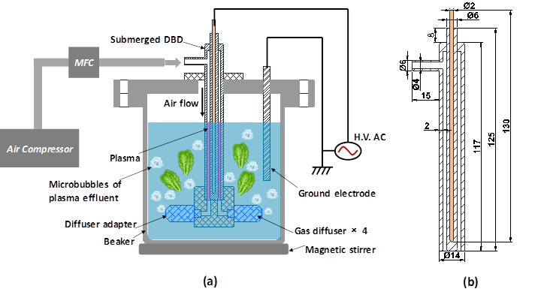
Fig. 1 The experimental setup for treatment of lettuce and wash-water using Submerged DBD-ACP system: (a) system setup, (b) geometry of submerged DBD plasma source.

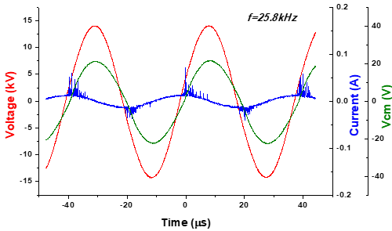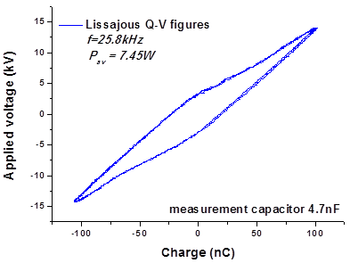
- (b)
Fig. 2 (a) Waveforms of applied voltage, discharge total current and voltage across the measurement capacitor, (b) Lissajous Q-V figure for energy consumption measurement in one period of applied voltage.
Fig. 3 Effect of ACP (▧) with or (∎) without agitation on viable counts of P. fluorescens inoculated on lettuce. Vertical bars indicate standard deviation. Dotted lines indicate limit of detection (1 Log₁₀ CFU/g). Column with different letters indicate a significant difference between treatment method and treatment time (p<0.05).
(a)
(b)
Fig. 4 Effect of ACP on (a) P. fluorescens (b) L. innocua attached to lettuce leaves for (∎) 1 h and (▧) 24 h. Each column represents average bacterial population recovered after ACP treatment. Vertical bars indicate standard deviation. Dotted line indicates limit of detection 1.0 Log₁₀ CFU/g. ND: Not detected (counts below detection limit). Column with different letters indicate a significant difference between bacterial attachment and treatment time (p<0.05).
- Pseudomonas fluorescens (b) Listeria innocua
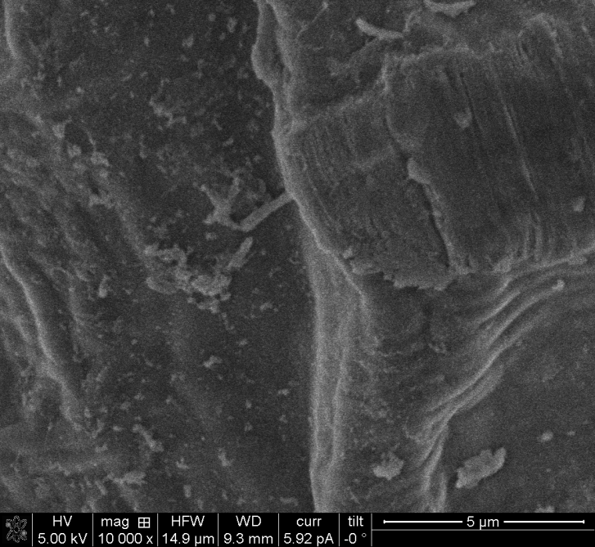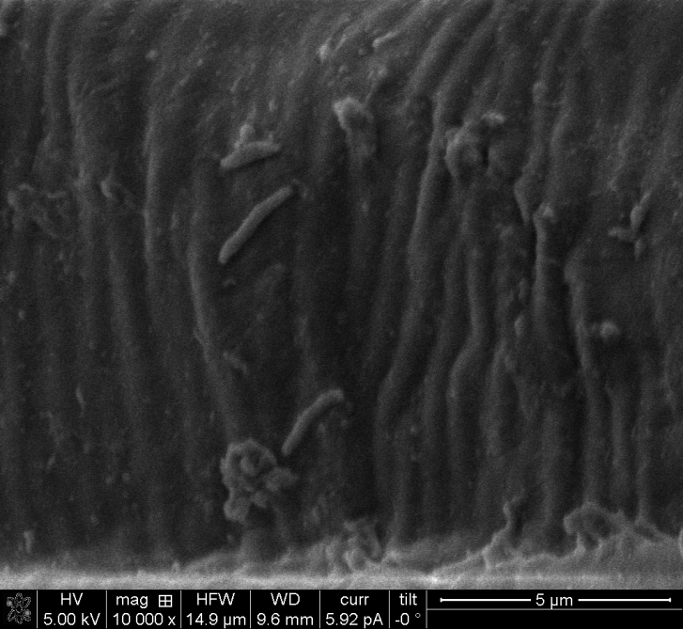
I] After water wash (Control)
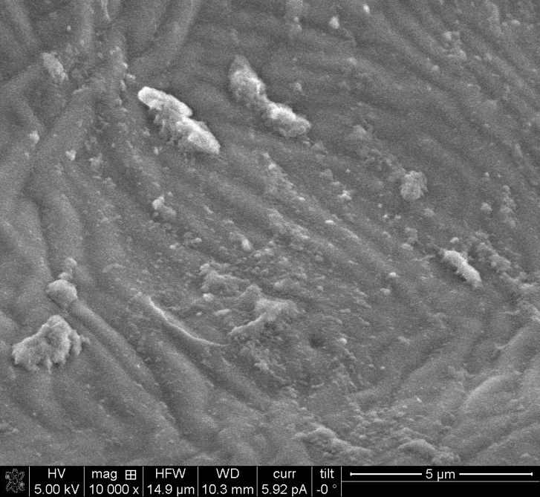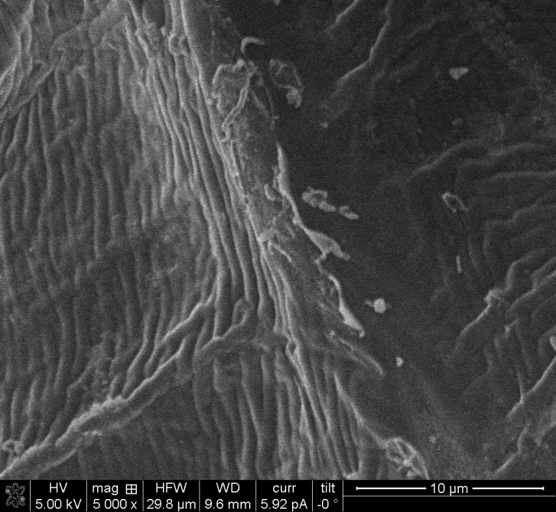
II] 1 min ACP functionalised water treatment
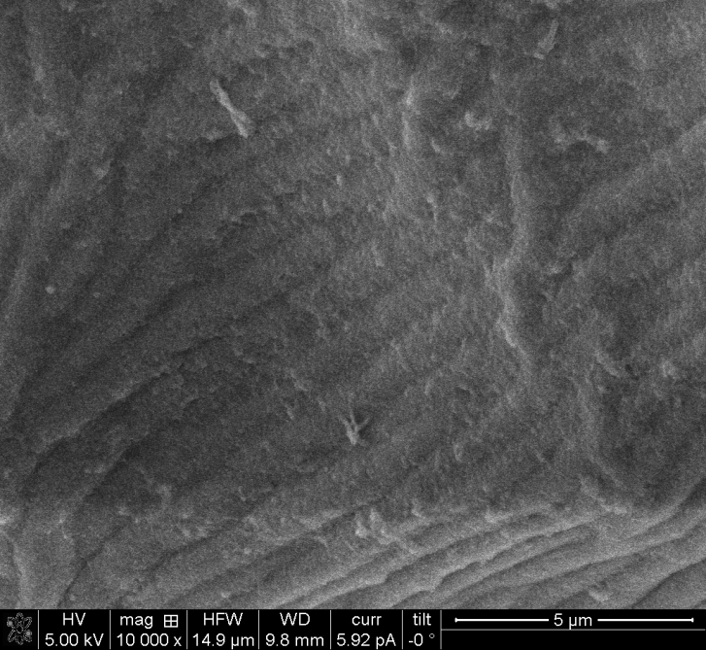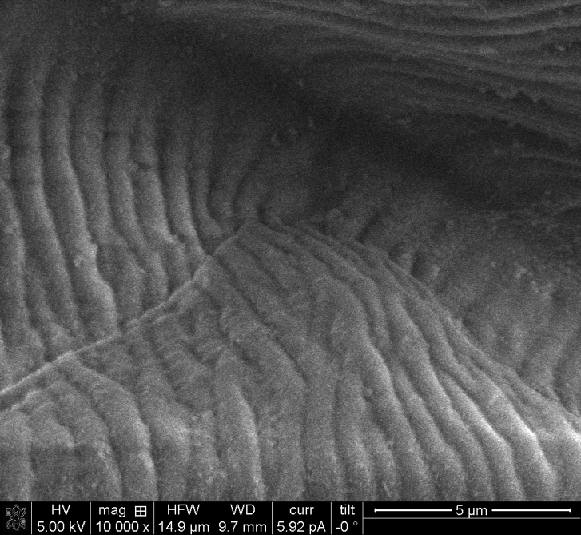
III] 3 min ACP functionalised water treatment
Fig. 5 SEM images of (a) P. fluorescens (b) L. innocua inoculated on lettuce; (I) Untreated control after water-wash, (II) 1 min ACP treatment and (III) 3 min ACP treatment
Fig. 6 Survival of (▧) L. innocua and (∎) P. fluorescens in the wash water after washing lettuce in plasma functionalised water. ND: not detected (below detection limit of 1 Log CFU/10mL); Vertical bars indicate standard deviation. Column with different letters indicate a significant difference between bacteria and treatment time (p<0.05).
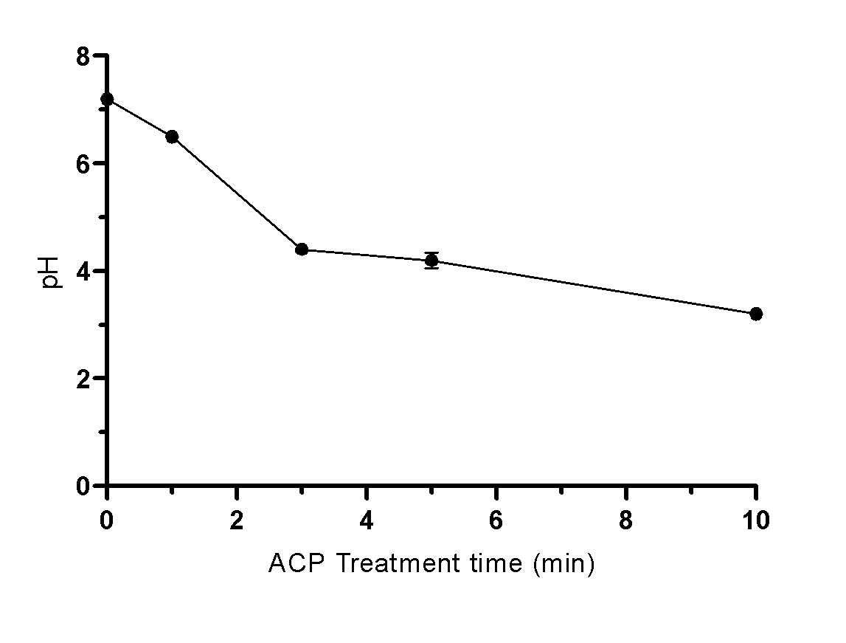
Fig. 7 pH value of wash water after DBD-ACP treatment.
Fig. 8 Bacterial inactivation assay in acidic solutions. L. innocua (10⁷⁻⁸ CFU/mL) inoculated on lettuce exposed to different acidic conditions (∎) pH 3, (●) pH 4 and (▲) pH 5. Dotted line indicates detection limit (1.0 Log CFU/g). Vertical bars indicate standard deviation. Column with different letters indicate a significant difference between L. innocua treated in different pH solutions and treatment time (p<0.05).
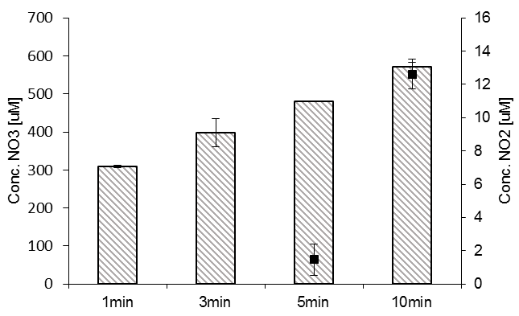
Fig. 9 Concentration of (▧) Nitrate and (∎) Nitrite reactive species in plasma functionalised water. Vertical bars represent standard deviation. Experimental conditions: 1, 3, 5 and 10 min treatment at 80 kV with 0 h post treatment storage time.
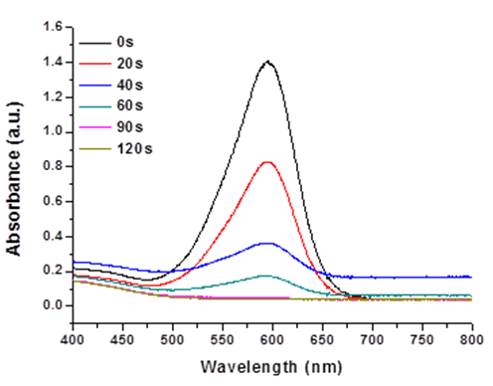
(a)
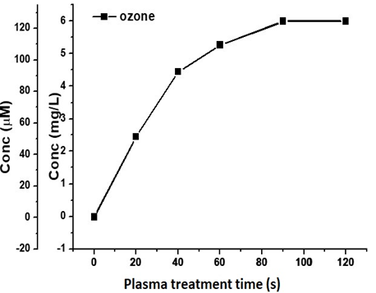
(b)
Fig. 10 (a) Absorption spectra of Indigo Reagent degradation by DBD-ACP Liquid Treatment System and (b) Concentrations of dissolved ozone in water generated during plasma exposure time.
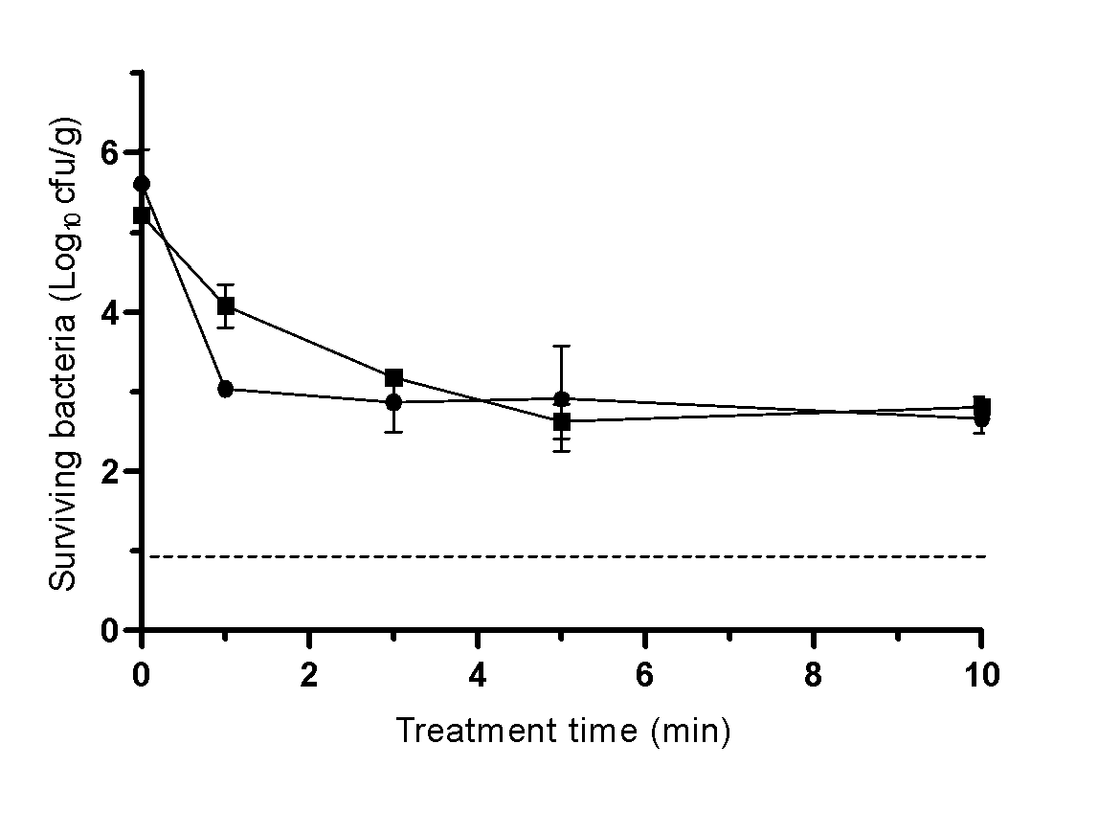
(a)
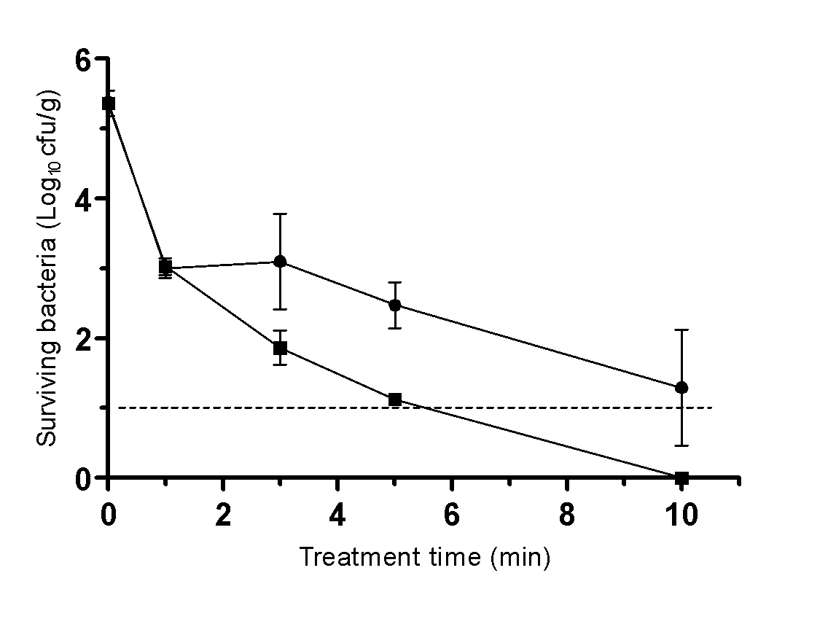
(b)
Fig. 11 Effect of (●) NaOCl or (∎) ACP treatment on (a) L. innocua and (b) P. fluorescens inoculated on lettuce. Dotted line indicates detection limit (1.0 Log CFU/g). Vertical bars indicate standard deviation.

