Assessment of Phase Evolution in Titanium-Niobium based Alloys During Rapid-Solidification Casting

Theo Mossop^{1, 3}, David Heard ² , Mert Celikin ^{1, 3}
¹School of Mechanical and Materials Engineering, University College Dublin, Ireland
²Stryker Advanced Technology & Research, United States
³Materials Design and Processing Laboratory, University College Dublin, Ireland

Corresponding author: theo.mossop@ucdconnect.ie

Keywords: Titanium Alloys, Rapid Solidification, Phase Transformation, Beta-Ti alloys, Niobium, X-ray Diffraction

Abstract
The effect of varying cooling rates is studied on the microstructural evolution of Titanium-Niobium (Ti-Nb) based alloys with Tantalum (Ta) additions. A combined simulation and experimental approach is used to investigate the predictability of differences in microstructural evolution during rapid-solidification casting. Rods of binary Ti-25Nb and ternary Ti-20Nb-10Ta (wt% and hereafter) alloys were synthesized in diameters of 3, 5 and 10 mm using suction casting into copper moulds. Finite element (FE) and thermodynamic modelling was used to calculate the cooling rates and temperature gradients of the alloys. The microstructural and mechanical differences were determined via XRD, SEM/EDS, and mechanical testing.

Introduction
Titanium (Ti) alloys are used in biomedical applications due to their high specific strength, good biocompatibility and excellent fatigue resistance [1]. The most common biomedical Ti alloy, Ti-6Al-4V (Ti64), has a relatively high Young’s Modulus of 115 GPa in comparison to that of cortical bone (up to 30 GPa) [2]. This stiffness mismatch can result in a phenomenon known as stress-shielding, where the bone surrounding an implant loses bone-density, eventually resulting in implant failure. In addition to this, Ti64 also contains significant amounts of aluminium (Al) and vanadium (V) which have been linked to cell toxicity and neurological disorders[3]. Therefore, there is significant impetus to find superior biomedical alloys, both from a mechanical and biocompatibility perspective; β-Ti alloys with their composition space looks promising.
β-phase with a body-centered cubic (BCC) crystal structure has the lowest Young’s modulus of all the allotropes, as low as 50 GPa, and many alloying elements used in β-alloys are biocompatible – especially niobium (Nb), tantalum (Ta) and zirconium (Zr) [4]. In addition to this, binary Ti-Nb alloys can exhibit very high UTS, up to 1100MPa, with elongations as high as 150% [5–7]. This is important for biomedical implants where these properties are critical. Ternary and higher order compositions have been shown to increase mechanical performance even further [5, 8, 9]. As there are many metastable phases that can coexist throughout the range of β-stabilised compositions, understanding the microstructural evolution with varying processing and post-processing conditions is critical for controlling mechanical properties [10, 11].
Additive Manufacturing (AM) with its design flexibility in comparison to traditional manufacturing exhibits high potential for the development of novel biomedical implants [12-14]. However, the design of novel Ti-based alloys suitable for additive manufacturing technology is very complex. This study is a preliminary work which will form a basis to shed light into the development of novel β-Ti alloys for AM. We studied how microstructure of β-Ti alloys evolves as the cooling rate increases, approaching the cooling rates found in additive manufacturing processes. Using suction casting of thin rods, high cooling rates can be studied and compared, to find a trend in how these phases evolve under a broad range of solidification conditions.

Experimental
The binary Ti-25Nb alloys were synthesized using commercially pure (c. p.) titanium (grade 1 - ) and 99.9% pure niobium (99.85% Nb, 0.1% Ta, 0.01% C, 0.01% N, 0.01% O, < 0.005% Si, <0.001% H). The ternary alloy, Ti-20Nb-10Ta (TNT), was in the form of wrought bar with nominal composition. The starting materials were weighed and placed in a Buhler Arc-melter within a water cooled copper hearth. Before melting, the chamber was evacuated to ~5x10⁻⁵ mbar and back-filled with argon (Ar) three (3) times to ensure very low oxygen partial pressure. A pure Ti getter was melted before the sample to scavenge any remaining oxygen. The alloy samples were remelted and flipped 5 times each to ensure homogenous composition. The button shaped alloy ingots were then placed on top of the suction casting apparatus where they were cast into rods of diameters 3, 5 and 10 mm to provide varied cooling rates which were estimated using an ANSYS Fluent solidification model, with material properties informed by ThermoCalc calculations for these compositions.
For SEM and XRD analysis, the cast rods were sectioned by Buehler Isomet 1000 precision cutter and diamond wafering blade, then ground using 220 grit SiC paper to remove influence of cutting and to ensure flatness. The parts were polished with 9 µm diamond suspension and 0.02 µm colloidal silica suspension. XRD analysis was conducted using a Siemens D500 X-ray diffractometer, with Cu-Kα source with a wavelength (λ) of 1.5406 Å. The diffractometer was set to scan the 2θ range of 20°–90°, with a step increment of 0.02° and a dwell time of 4 s/step. SEM/EDS analysis was performed on a Hitachi Regulus 8230 and nano-indentation was performed on 5 different positions with 25 μm spacing using a Keysight G200 Nano-indenter to determine modulus of elasticity. Hardness testing was performed with a Buehler Vickers hardness testing machine using a load of 500gf and a dwell time of 15s.

Results and Discussion

Cooling rate modelling
FEA simulations using ANSYS Fluent software were performed to create a basic model of the heat extraction and solidification of the alloy melt in the Cu cylindrical moulds. This was a simple 1D axisymmetric model informed with material data from Thermo-Calc. The thermal gradient and cooling rate value for each section was taken at the midpoint of the tube length, at half way from the centre to the radius of the rod, to give a representative figure for each rod diameter. The cooling rate and thermal gradient single values were taken at the melting point of the alloy, where these values were approximately maximised. To compare this to an additively manufactured condition, the Rosenthal model for a moving heat source was implemented in Python programming language. This provided an estimation of the cooling rate and thermal gradient under a variety of AM parameters, where a representative scanning speed and laser power of 1200 mm/s and 50W was chosen, respectively. These values are shown in Figure 1.
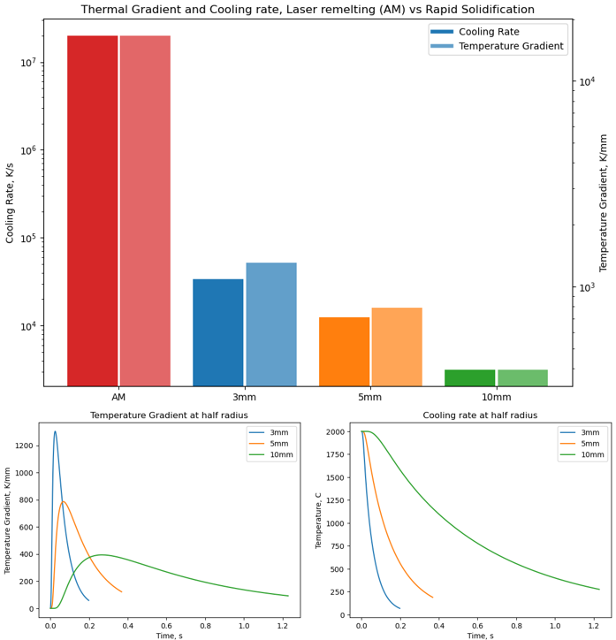
Figure 1: Cooling rates and temperature gradients of suction cast rods and comparison with additive manufactured part

XRD Analysis

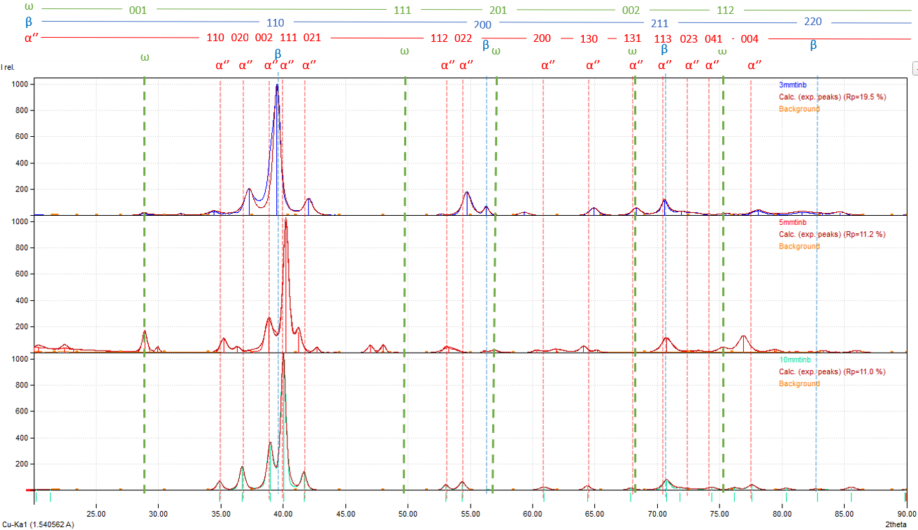
Figure 2: XRD patterns of Ti-25Nb alloys depending on suction casting diameter
As seen in Figure 2, the primary phase in all samples is the orthorhombic α’’ phase. There was a significant formation of the ω phase in the 5mm cast sample when compared to the 10mm sample, however with increasing cooling rate in the 3mm sample, this phase appeared suppressed, instead the β-phase is preferred. Hence, retained β-phase is only observed in 3 mm sample. This suggests that while the cooling rate in the 5mm casting is sufficient to allow ω growth from the high-temperature β phase, when it is increased further, the β-phase will persist to room temperature. It should be noted that these samples have significant texture effects due to the extreme thermal gradients of the solidification, this can affect the relative intensities of the peaks as some crystallographic planes may be under- or over-represented. Significant phase shifts may also be caused by stresses in the as-cast material. Further study is needed to determine fully understand the phase evolution with increasing cooling rate.
The effect of ternary addition is shown in Figure 3. Ti-20Nb-10Ta composition was chosen to have the same equilibrium β-transus temperature as Ti-20Nb predicted via thermodynamic calculations, as such the influence of Ta on the metastability of the system is apparent. The primary phases in the 10mm sample, orthorhombic α’’, β and ω, are similar to the binary alloy, however as the cooling rate increases, the evolution of the metastable phase ω appears suppressed – it is only apparent in the 3mm sample, compared to 5mm in the binary alloy. The retained β-phase that was seen in 3mm binary Ti-20Nb sample was not visible in the 3mm TNT composition. Hence, it can be stated that with ternary alloying addition have changed the phase transformation kinetics and dependency to cooling rates.
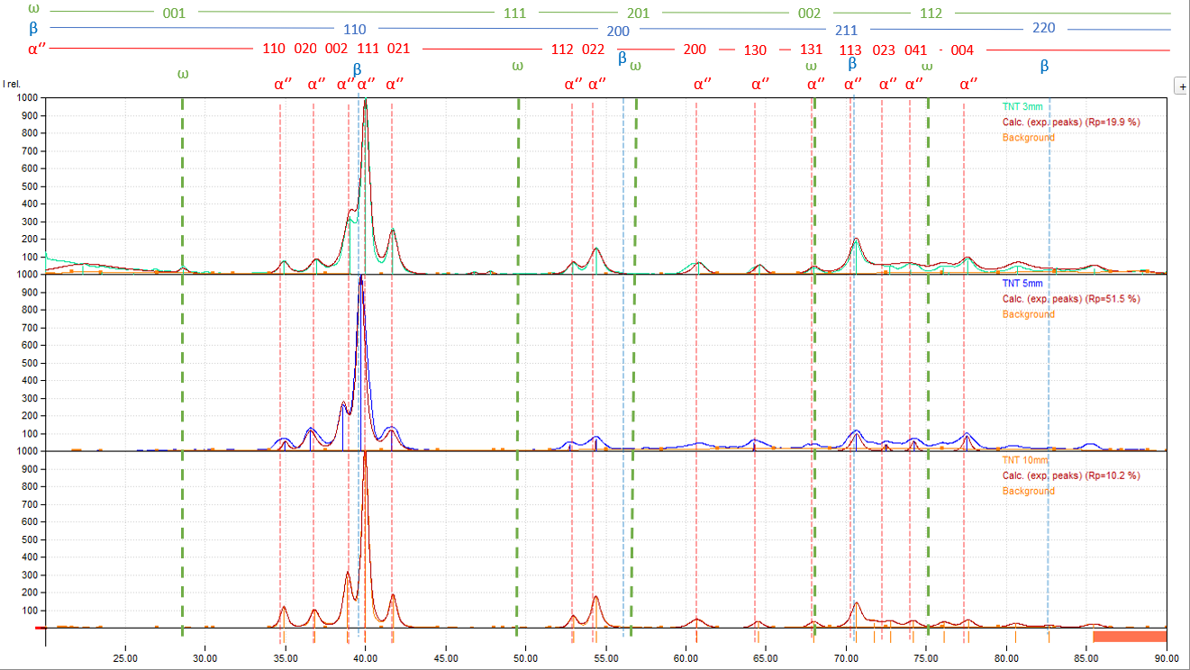
Figure 3: XRD patterns of Ti-20Nb-10Ta alloys depending on suction casting diameter

Microstructural Characterization
Figure 4 exhibits dendritic microstructure, typical for as-cast condition, in all ternary TNT alloy samples with varying cooling rates. The secondary dendrite arm spacing (SDAS) decreased with cooling rates: from 25.3 µm at 10mm diameter to 8.5 µm for the 3mm diameter castings. The reduction in dendrite arm spacing indicates a very significant change of cooling rate with decreasing diameter but further measurements are needed to calculate a SDAS-cooling rate relationship for this alloy system.
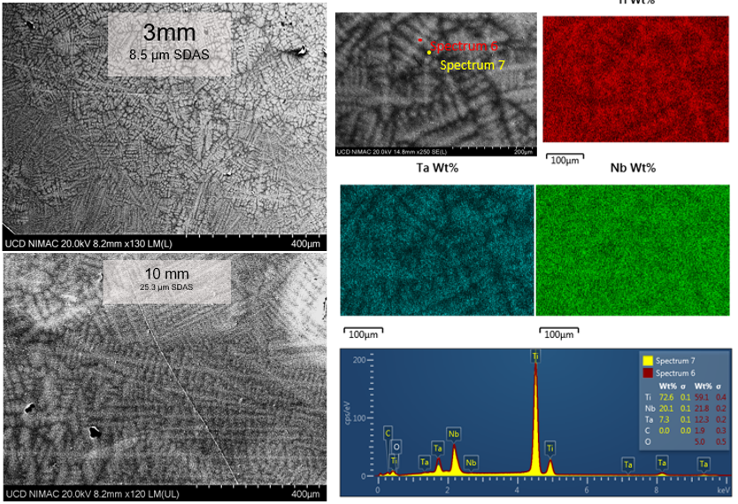
Figure 4: SEM/EDX images of TNT alloy samples showing secondary dendrite arm spacing(SDAS) of 3mm and 10mm samples and Nb, Ta segregation within the dendrites of a 10mm sample
The EDS mapping shows clear segregation between the intra-dendritic and inter-dendritic regions. Higher segregation of Ta than Nb is probably due to a lower diffusion coefficient in Ti matrix. The difference in relative segregation in these elements may be related to the suppression of metastable phases such as β and ω. This is part of an on-going work where the effect of Ta additions on the phase transformation kinetics will be investigated.

Indentation testing

Figure 5: Vickers microhardness of TNT and TiNb samples
Both Vickers microhardness and nanoindentation was performed on the samples. The hardness of the ternary vs binary alloys can be seen in Figure 5. While the SDAS of these samples varied, no significant change in the hardness of the samples were observed. This is probably due to large grain sizes resulting in the indentations lying within a single grain. The addition of Ta increased the microhardness by over 100 HV due to solid solution strengthening.
Nanoindentation was also performed to measure the Young’s modulus of the TNT samples. The modulus did not appear to change depending on casting diameter, with an average value of 90.8GPa. This finding is in line with similar works for this composition and thermal history. However, it should be stated that this is not a modulus measurement of the bulk material, and as such is very sensitive to the individual phase measured.

Conclusions
Based on the results of this work, the following conclusions can be drawn.
- The method of producing rapidly solidified castings was investigated and verified for this alloy system, novel compositions varied and high cooling rates can be easily produced in short timeframes from low-cost feedstock. This methodology has the potential to be used as a guideline for the development of novel Ti-based compositions compatible with additive manufacturing process.
- Rapid solidification casting of these alloy compositions was performed for the first time and showed very promising results in terms of segregation and alloy homogeneity.
- The phase evolution of these compositions (Ti-25Nb, Ti-20Nb-10Ta) were shown to match very closely at lower cooling rates, but deviate as additional metastable phases became favourable with very high cooling rates, in particular, the β- and ω- phases appeared to be suppressed by the ternary alloy addition.
Acknowledgements
This research was co-funded by the Science Foundation Ireland (SFI) and Stryker through I-Form, the SFI Research Centre for Advanced Manufacturing, and the Advanced Metallic Systems Centre for Doctorial Training (AMS–CDT).This publication has emanated from research conducted with the financial support of Science Foundation Ireland under Grant Number 16/RC/3872. For the purpose of Open Access, the author has applied a CC BY public copyright license to any Author Accepted Manuscript version arising from this submission.

References

[1] F.R. Kaschel, M. Celikin, D.P. Dowling, ‘Effects of Laser Power on Geometry, Microstructure and Mechanical Properties of Printed Ti-6Al-4V Parts’, Journal of Materials Processing Technology, v. 278, 116539, 2020
[2] M. Geetha, A. K. Singh, R. Asokamani, and A. K. Gogia, “Ti based biomaterials, the ultimate choice for orthopaedic implants – A review,” Prog Mater Sci, vol. 54, no. 3, pp. 397–425, May 2009, doi: 10.1016/J.PMATSCI.2008.06.004.
[3] R. L. Buly, M. H. Huo, E. Salvati, W. Brien, and M. Bansal, “Titanium wear debris in failed cemented total hip arthroplasty: An analysis of 71 cases,” J Arthroplasty, vol. 7, no. 3, pp. 315–323, Sep. 1992, doi: 10.1016/0883-5403(92)90056-V.
[4] A. Biesiekierski, J. Wang, M. Abdel-Hady Gepreel, and C. Wen, “A new look at biomedical Ti-based shape memory alloys,” Acta Biomater, vol. 8, no. 5, pp. 1661–1669, May 2012, doi: 10.1016/J.ACTBIO.2012.01.018.
[5] I. v. Okulov et al., “Composition optimization of low modulus and high-strength TiNb-based alloys for biomedical applications,” J Mech Behav Biomed Mater, vol. 65, pp. 866–871, Jan. 2017, doi: 10.1016/J.JMBBM.2016.10.013.
[6] F. Sun, Y. L. Hao, S. Nowak, T. Gloriant, P. Laheurte, and F. Prima, “A thermo-mechanical treatment to improve the superelastic performances of biomedical Ti-26Nb and Ti-20Nb-6Zr (at.%) alloys,” J Mech Behav Biomed Mater, vol. 4, no. 8, pp. 1864–1872, Nov. 2011, doi: 10.1016/J.JMBBM.2011.06.003.
[7] S. Miyazaki, H. Kim, and H. Hosoda, “Development and characterization of Ni-free Ti-base shape memory and superelastic alloys,” Materials Science and Engineering A, vol. 438, no. 440, pp. 18–24, 2006, doi: 10.1016/j.msea.2006.02.054.
[8] S. S. Sidhu, H. Singh, and M. A. H. Gepreel, “A review on alloy design, biological response, and strengthening of β-titanium alloys as biomaterials,” Materials Science and Engineering: C, vol. 121, p. 111661, Feb. 2021, doi: 10.1016/J.MSEC.2020.111661.
[9] S. J. Li, T. C. Cui, Y. L. Hao, and R. Yang, “Fatigue properties of a metastable β-type titanium alloy with reversible phase transformation,” Acta Biomater, vol. 4, no. 2, pp. 305–317, Mar. 2008, doi: 10.1016/J.ACTBIO.2007.09.009.
[10] R. Kolli, A. D.- Metals, and undefined 2018, “A review of metastable beta titanium alloys,” mdpi.com, 2018, doi: 10.3390/met8070506.
[11] J. A. Ballor, T. Li, F. Prima, C. J. Boehlert, and A. Devaraj, “A review of the metastable omega phase in beta titanium alloys: the phase transformation mechanisms and its effect on mechanical properties,” https://doi.org/10.1080/09506608.2022.2036401, 2022, doi: 10.1080/09506608.2022.2036401.
[12] F.R. Kaschel, D.P. Dowling, M. Celikin, ‘In-situ XRD study on the effects of stress relaxation and phase transformation heat treatments on mechanical and microstructural behaviour of additively manufactured Ti-6Al-4V’, Materials Science and Engineering A, v. 819,141514, 2021
[13] S. Piazza, B. Merrigan, D.P. Dowling, M. Celikin, ‘The effects of geometry and laser power on the porosity and melt pool formation in additively manufactured 316L stainless steel’, International Journal of Advanced Manufacturing Technology, v.111, n. 5-6, p. 1457 – 14701, 2020
[14] F.R. Kaschel, R.K. Vijayaraghavan, A Shmeliov, E.K. McCarthy, M. Canavan, P.J. McNally, D.P. Dowling, V. Nicolosi, M. Celikin, ‘Mechanism of Stress Relaxation and Phase Transformation in Additively Manufactured Ti-6Al-4V via in situ High Temperature XRD and TEM Analyses’, Acta Materialia, v. 188, p.720-732, 2020

