Biodegradation of pentafluorosulfanyl-substituted aminophenol in Pseudomonas spp.

Marta Saccomanno¹, Sabir Hussain¹, Neil K. O’Connor¹, Petr Beier², Mate Somlyay³, Robert Konrat³ and Cormac D. Murphy^{1*}

1. School of Biomolecular and Biomedical Science, University College Dublin, Belfield, Dublin 4, Ireland
2. Institute of Organic Chemistry and Biochemistry, Academy of Sciences of the Czech Republic, Prague, Czech Republic
3. Max F. Perutz Laboratories, University of Vienna, Austria
*Corresponding author Fax: +353 (0)1 716 1183, Telephone: +353 (0)1 716 1311, email: Cormac.d.murphy@ucd.ie

Abstract
The pentafluorosulfanyl (SF₅-) substituent conveys properties that are beneficial to drugs and agrochemicals. As synthetic methodologies improve the number of compounds containing this group will expand and these chemicals may be viewed as emerging pollutants. As many microorganisms can degrade aromatic xenobiotics, we investigated the catabolism of SF₅-substituted aminophenols by bacteria and found that some Pseudomonas spp. can utilise these compounds as sole carbon and energy sources. GC-MS analysis of the culture supernatants from cultures grown in 5-(pentafluorosulfanyl) 2-aminophenol demonstrated the presence of the N-acetylated derivative of the starting substrate and 4-(pentafluorosulfanyl) catechol. Biotransformation experiments with re-suspended cells were also conducted and fluorine-19 NMR analyses of the organic extract and aqueous fraction from suspended cell experiments revealed new resonances of SF₅-substituted intermediates. Supplementation of suspended cell cultures with yeast extract dramatically improved the degradation of the substrate as well as the release of fluoride ion. 4-(Pentafluorosulfanyl) catechol was shown to be a shunt metabolite and toxic to some of the bacteria. This is the first study to demonstrate that microorganisms can biodegrade SF₅-substituted aromatic compounds releasing fluoride ion, and biotransform them generating a toxic metabolite.

Keywords:
Biodegradation; Emerging pollutant; Fluoride; Pentafluorosulfanyl; Pseudomonas

Introduction
Many important industrial, pharmaceutical and agrochemical compounds contain fluorine, as it enhances relevant properties such as lipophilicity and metabolic stability often resulting in improved biological activity (Gillis et al. 2015; Jeschke 2010). Fluoro- and trifluoromethyl-phenyl moieties are commonly found in drugs and pesticides (Murphy and Sandford 2015), and as fluorine is a small atom, these compounds can be biotransformed by enzymes of the established aromatic degrading pathways in microorganisms (Murphy 2010). Compounds such as fluorobenzoate and fluorophenol can be completely mineralised by bacteria, whereas trifluoromethyl-substituted aromatics are typically partially degraded or co-metabolised (Kiel and Engesser 2015).
Pentafluorosulfanyl (SF₅) is proposed as a replacement for trifluoromethyl (CF₃), owing to SF₅-substituted compounds having enhanced thermal, chemical and hydrolytic stability, coupled with high lipophilicity and biological activity (Altomonte and Zanda 2012). The synthetic methods for preparation of aromatic SF₅-substituted compounds have improved (Savoie and Welch 2015), and the wider availability of these building blocks has resulted in the synthesis of several bioactive SF₅-containing compounds (Figure 1). For example, Welch and Lim (2007) synthesised an SF₅-containing analogue of the appetite suppressant fenfluramine and found that the new compound had improved 5-hydroxytryptamine receptor binding. Similarly, the pentafluorosulfanyl derivative of the pesticide trifluralin was synthesised and demonstrated improved potency in pre- and post-emergence screening (Lim et al. 2007). More recently, Hendricks et al. (2015) synthesised SF₅ analogue of flufenamic acid, which is an ion channel modulator with applications in medicine as a non-steroidal anti-inflammatory drug (NSAID), and determined that it had improved activity as inhibitor of cyclooxygenases (COX-1 and COX-2).
The continuous improvement in synthetic methodologies will likely result in increasing numbers of agrochemical and pharmaceutical analogues containing the SF₅ substituent and it seems almost inevitable that some will be commercialised. Therefore, SF₅-containing compounds can be considered emerging pollutants and it is crucially important that the environmental fate of them is comprehensively understood. Jackson and Marbury (2009) demonstrated that SF₅-substituted aromatics are photo-labile; however, in the natural environment, light does not always penetrate, thus compounds containing this substituent will interact with living systems. To date very few studies on the biodegradation of SF₅-substituted aromatic compounds have been conducted. Intuitively, the electron-withdrawing effect of the SF₅-group should inactivate the phenyl ring to attack by the classic oxygenase enzymes involved in aromatic biodegradation. One study has reported the microbial biotransformation of SF₅-substituted anilines revealing N-acetylation as the predominant reaction (Kavanagh et al. 2014).
Pseudomonads are present in soil and are likely to be among the first bacteria to encounter SF₅-containing pollutants. Moreover, these bacteria are well-known to biodegrade a range of xenobiotic compounds (Diaz et al. 2013), including those containing fluorine (Hughes et al. 2011). In this paper we describe the biodegradation of SF₅-substituted aminophenols 1-3 (Fig. 2) in Pseudomonas spp..

Experimental
Chemicals
All the chemicals and solvents used in this study were of analytical grade. The pentafluorosulfanyl-substituted phenols (Fig. 2) were synthesized following previously reported methods (Beier and Pastyrikova 2011; Vida et al., 2014, Vida et al. 2016). Compound 1 was also acquired from Apollo Scientific (Stockport, UK) and analytical grade 2-aminophenol and N-methyl-N-(trimethylsilyl) trifluoroacetamide (MSTFA) were purchased from Sigma-Aldrich (Arklow, Ireland).

Strains and growth conditions
The bacterial strains Pseudomonas knackmussii B13, Burkholderia xenovorans LB400 Comamonas testosteroni A441 and Pseudomonas pseudoalcaligenes KF707 were obtained from DSMZ, Germany. Pseudomonas putida KT2400 IMD699 and Pseudomonas aeruginosa IMD694 were acquired from the Industrial Microbiology, Dublin (IMD) culture collection. Pseudomonas sp. IMD695 was isolated from rhizospheric soil located in University College Dublin, by enrichment culture with 1 as a sole source of carbon and energy. It was identified by 16S rRNA gene sequencing (GenBank accession number KY308181) and deposited in the IMD culture collection.
The strains were initially cultivated in tryptic soy broth (TSB) medium or in minimal medium (2.44 g l⁻¹ Na₂HPO₄, 1.52 g l⁻¹ KH₂PO₄, 0.5 g l⁻¹ (NH₄)₂SO₄, 0.2 g l⁻¹ MgSO₄.7H₂O, 0.05 g l⁻¹ CaCl₂.2H₂O, pH 7.0) supplemented with 2-aminophenol (2.0 mM) as a source of carbon, at 30°C under shaking (200 rpm). The growth experiments were conducted in mineral medium using pentafluorosulfanyl-substituted aminophenols (1-3) (0.85 mM) as only source of carbon. The pellets were washed in deionised water and inoculated in the mineral media and triplicate flasks were incubated at 30°C under shaking (200 rpm) along with un-inoculated controls. Incubation and sample handling was done in reduced light to prevent UV-induced damage. The growth was monitored by measuring the bacterial density (OD₆₀₀) at different intervals up to 120 h.

Biotransformation experiments
Resting cell experiments were conducted by harvesting previously subcultured in 2-aminophenol and washing in sterile H₂O. The pellets were finally resuspended in a phosphate buffer (1.0 g l⁻¹ K₂HPO₄, 1.0 g l⁻¹ KH₂PO₄, 40 mg l⁻¹ MgSO₄.7H₂O, 4.0 mg l⁻¹ FeCl₃) plus 0.2 mM of pentafluorosulfanyl-substituted aminophenol 1. Replicate suspended cell experiments and uninoculated control flasks were incubated in the dark at 30°C with shaking (200 rpm).
Additional biotransformation experiments were performed with cells that were initially grown in TSB. The cells were washed with H₂O, and resuspended in phosphate buffer (1.0 g l⁻¹ K₂HPO₄, 1.0 g l⁻¹ KH₂PO₄, 40 mg l⁻¹ MgSO₄.7H₂O, 4.0 mg l⁻¹ FeCl₃) and yeast extract (4 g l⁻¹), plus either 0.2 mM of pentafluorosulfanyl-substituted aminophenol 1 or pentafluorosulfanyl-catechol 4. Replicate suspended cell experiments and uninoculated control flasks were incubated at 30°C with shaking (200 rpm).

Inhibition assays
Pseudomonas spp. were grown in mineral medium using pentafluorosulfanyl-substituted catechol 4 (0.85 mM) as only source of carbon, or supplemented with 2-aminophenol (2 mM). The growth was monitored by enumerating the colony forming units (CFU ml⁻¹) and OD₆₀₀.
Agar diffusion assays were performed with Pseudomonas knackmussii B13 Pseudomonas pseudoalcaligenes KF707 and Pseudomonas putida KT2440 and on tryptone soy agar plates. Following inoculation of the plates, a solution of 2 mM pentafluorosulfanyl catechol (50 µl) was added to a well in the agar. The diameter of the inhibition area was recorded after 24 and 48 hours incubation at 30°C

Analysis of metabolites
Culture supernatants were extracted in chloroform, evaporated to dryness and derivatised via silylation with N-methyl-N-(trimethylsilyl) trifluoroacetamide for 1 hour at 100 °C. The organic fractions of samples were analysed by gas chromatography-mass spectrometry on an Agilent 6890 gas chromatograph coupled to a 5973 mass selective detector. Analytes (1µl) were injected onto a HP-5MS column (30m x 0.25 mm x 0.25 µm) employing a 50:1 split ratio and raising the temperature from 150 to 300 °C at 10 °C min⁻¹. The SF₅ compounds 1 and 4 were quantified by high performance liquid chromatography (HPLC) on a Varian Prostar system fitted with a Supelco Ascentis C18 (15 cm×10 mm×5 μm) column. Organic extracts of supernatants were dried, redissolved in methanol and eluted with a mobile phase composed of H₂O (A) and acetonitrile/0.1 % TFA (B) (flow rate 1 ml min⁻¹; 0–30 min, 20–80 % B; 30–35 min, 80–20 % B;) and data analysis was performed with Galaxie software. The aqueous fractions were lyophilised resuspended in deuterated water and analysed by ¹⁹F NMR. All NMR experiments were performed in CDCl₃ or D₂O (10% or 100%) on a Varian VnmrS 400 MHz and Bruker Avance 3HD+ 600 MHz spectrometers operating at ¹⁹F frequencies of 376 and 564 MHz, respectively. The data were acquired for each sample at 25 °C using a spectral width of 50 ppm, an acquisition time of 1.15 s, and 128 or 1024 scans with a relaxation delay of 2.0 s. Data were analysed on Mestrenova 11.0 software
The concentration of fluoride ion released into culture supernatants was measured with an ion-selective electrode (Orion 96-09) by sampling 1 ml of culture supernatant collected at the start and at the end of the experiment and mixing with 8 ml trisodium citrate/KNO₃ buffer (129.0 g l⁻¹ Na₃C₆H₅O₇.2H₂O, 50.0 g l⁻¹ KNO₃) and 1 ml H₂SO₄ (1 M). The probe was calibrated using a two-point calibration of 0.2 mM and 2 mM NaF.

Catechol 1,2 dioxygenase activity
The activity of catechol 1,2 dioxygenase was assayed by incubating 1 mg of wet cell pellet, previously grown in benzoate (2 mM) or 1 (0.85 mM), with catechol (1 mM) in a final volume of 1 ml of buffer for 15 minutes. The assay was stopped by centrifugation at 13 000 rpm and the enzymatic activity was assessed by measuring the formation of cis, cis-muconic acid by HPLC on a Varian Prostar system fitted with a Supelco Ascentis C18 (15 cm×10 mm×5 μm) column. Samples were resolved with phosphoric acid 1 g l⁻¹ (A) versus acetonitrile (B) (0.5 ml min⁻¹; 0–10 min, 40–60 % B) and data analysis was performed with Galaxie software.

Results
Growth of bacteria on SF₅-substituted aminophenol
The bacteria chosen for growth experiments were all able to grow on 2-aminophenol as a sole carbon and energy source (Supplemental Information). Further experiments were conducted to determine if the compounds 1-3 could act as sole carbon and energy sources for the growth of bacteria. Thus, minimal medium containing SF₅-substituted amino phenol 1 (0.85 mM) was inoculated with the selected bacteria and incubated at 30°C with shaking (150 rpm) in darkness. Growth was measured by monitoring optical density and all the bacteria, except B. xenovorans and C. testosteroni (O.D.₆₀₀ ≤ 0.15), could utilise 1 as the sole carbon source. Interestingly, growth on 1 was accompanied by detectable amounts of fluoride ion indicating limited mineralization of the substrate (Table 1). No evidence of substrate autooxidation was observed in -SF₅ 1 growing cultures, whereas an evident black precipitate appeared in 2-aminophenol cultures after 48 hours of incubation, indicating abiotic polymerisation of this substrate.
Three bacteria (Pseudomonas sp. IMD695, P. knackmussii B13 and P. pseudoalcaligenes KF707) were also incubated with the substrates 2 and 3 as sole carbon sources. Only Pseudomonas sp. IMD695 grew on these compounds, with 0.02 and 0.09 mM fluoride release, respectively, and owing to limited availability of the compounds no other bacterium was tested.
The microorganisms investigated are either themselves soil-isolates (IM695) or closely related to bacteria commonly found in the environment, thus the ability to catabolise SF₅-aminophenols is likely to be widespread.

Detection of metabolites
To shed light on the possible catabolic pathways involved in the biodegradation of the SF₅-aminophenol, culture supernatants were extracted with chloroform, the extracts dried and the residues silylated prior to GC-MS analysis. Figure 3 compares the chromatograms from silylated extracts of un-inoculated flasks and following growth of P. knackmussii B-13 on 1. Whilst much of the starting material remained after growth, two metabolites were detectable that were not present in the control flasks. The metabolite that eluted after 6.5 min (Fig 3c) is the acetylated aminophenol previously observed by Kavanagh et al. (2014), whereas the compound that eluted at 4.6 min has not previously been observed. Its retention time and mass spectrum matched that of authentic SF₅-catechol 4 (Vida et al., 2014); this compound was also detected in cultures of P. aeruginosa and Pseudomonas IMD695. No other metabolites were identified using this method, indicating that either no other extractable metabolites accumulated in the supernatant, or that the compounds were not amenable to GC-MS analysis.

Biotransformation of SF₅-aminophenol 1
To probe the biodegradation further, the bacterial strains able to grow on 1 were cultivated in minimal medium containing 2-aminophenol (2 mM) as a carbon source. Cells were harvested, washed and resuspended in phosphate buffer and incubated with 1 (0.2 mM) for up to 120 h. Analysis of the culture supernatants by GC-MS showed very poor biotransformation of the substrate (Fig 4a). However, when the strains were cultured in TSB, harvested and resuspended in a buffer supplemented with yeast extract there was a dramatic effect on the cells’ ability to degrade 1 (Fig 4b). Under these conditions the substrate was either completely converted to the N-acetylated derivative in cultures of P. knackmussii, P. pseudoalcaligenes KF707 and P. aeruginosa or was completely removed generating no apparent metabolite, in cultures of P. putida and Pseudomonas IMD695. Therefore, the combination of healthier cells and additional nutrient promoted the biotransformation of the substrate.
To determine the effect of substrate concentration on biotransformation the concentration of 1 added to P. putida suspended cells supplemented with yeast extract was increased from 0.2 mM to 1 mM. Using a higher concentration of substrate, traces of compounds 4 and 5, not detected at lower concentrations occurred, likely subsequently to a stress response. Whilst more fluoride ion (approx. 0.6 mM) was observed in cultures incubated with the higher concentration of substrate, the degree of defluorination was proportionally the same (approx. 12 %) as with the lower substrate concentration. However, whilst no starting compound was detectable by GC-MS, HPLC and ¹⁹F NMR at the lower concentration, suggesting complete removal, the SF₅-aminophenol was not removed at 1 mM after 120 h incubation.

¹⁹F NMR of culture extracts
¹⁹F NMR has proven to be a useful technique for monitoring the biodegradation of fluorinated compounds in microorganisms with minimal culture processing (Murphy 2007). The -SF₅ group has a distinctive ¹⁹F NMR spectrum reflecting the geometries of the fluorine atoms: a doublet for the four planar fluorine atoms and a quintet for the single axial fluorine (Fig 5a). Therefore, the cell extracts from the various bacterial suspensions were examined by ¹⁹F NMR to determine the presence of new SF₅-bearing intermediates after incubation of 1 in the absence and presence of yeast extract. The degree of biodegradation was much greater in the presence of yeast extract, confirming the GC-MS results. New resonances were observed in all of these experiments (Figure 5), except in those with P. putida, in which no organically extracted SF₅-containing metabolite was detected, which corresponds to the observations by GC-MS. Most apparent was a new doublet at δ 63.3 ppm (d, 4F, J= 150.2 Hz) accompanying a multiplet at δ 85 ppm (p, 1F, J= 150.2 Hz) in cultures of P. knackmussii and P. aeruginosa. It is most likely that the compound is the N-acetyl metabolite, since in the GC-MS analysis of the two cultures this was the most prominent compound. However, an authentic standard would be required to confirm this.
The aqueous fractions from the suspended cultures was concentrated by lyophilisation, redissolved in D₂O and analysed by ¹⁹F NMR. In all the bacteria examined, except for P. knackmussii, a new doublet at δ 73.9 ppm (d, 4F, J= 150.2 Hz) was detected (Figure 5b) along with a prominent broad singlet (δ-120 ppm, not shown), characteristic of fluoride ion (Supplemental Information). This new resonance is likely to be a late SF₅-bearing intermediate of the catabolism of 1 and its hydrophilicity suggests it is a ring-opened metabolite. However, GC-MS analysis of the aqueous fraction did not reveal a new peak suggesting that this metabolite is not detectable with this method. Furthermore, it is clear from the signal-to-noise of the spectra, which hides the signal of the corresponding quintet, that the compound is present at a very low concentration in the supernatant making purification unfeasible.

Catabolism of SF₅-catechol 4
To investigate if the catechol 4 was a shunt product or a productive metabolite, experiments were undertaken to determine if two strains, P. knackmussi and P. putida, could grow on it, but neither could. Table 2 compares the growth of P. knackmussii on 2-aminophenol either alone or in the presence of catechol 4, and suggests that 4 is an inhibitor, since no growth was observed in the presence of this compound. Furthermore, when the cell numbers in the culture flasks were determined by standard plate counting, the cells in the initial inoculum had diminished dramatically when 4 was present, compared to the control flask with no carbon source (Table 2). Therefore, it was proposed that the SF₅-catechol was in fact a toxic product that might be formed via biotransformation. Growth inhibition studies using the disk diffusion assay with 4 (25 µg) revealed zones of clearing of 14 mm and 16 mm in tryptone soya agar plates inoculated with P. knackmussii and P. pseudoalcaligenes KF707, respectively, confirming the toxicity of the compound towards these strains while no inhibition was observed for P. putida. In the degradation of aminophenol in other bacteria, catechol is a suicide substrate of the enzyme 2-aminophenol 1,6-dioxygenase (Davis et al. 1999), which might account for the toxic effect observed here.
As P. putida was not affected by 4, further experiments were conducted in which the catechol was incubated with resting cells in the presence of yeast extract for 120 h. Analysis of culture supernatants and biomass by HPLC determined that approx. 75 % of the catechol was removed by the bacterium. However, no new metabolite was detected by any of the analytical techniques available, but fluoride ion (0.1 mM) was detected in the supernatant, suggesting limited biotransformation that may account for the ability of the bacterium to resist any inhibitory effect of 4. Furthermore, no catechol-1,2-dioxygenase activity in P. putida was detectable when the bacterium was cultured in 1 as a growth substrate, whereas the enzyme was easily assayed upon growing the cells on benzoate (0.17 nmol muconic acid/min.mg cells). This observation is consistent with the absence of growth when 4 was present as the sole carbon and energy source.

Discussion
There is a considerable research activity within the fluorine chemistry community to develop synthetic methodologies to make building blocks containing the pentafluorosulfanyl group (-SF₅). This substituent has been proposed as a replacement for trifluoromethyl (-CF₃), which is very common in drugs and agrochemicals, and there are several reports of SF₅-containing derivatives of bioactive compounds in the literature. The development of these compounds needs to be accompanied with a rigorous assessment of their behaviour in the environment. Microbial biotransformations are crucial to any environmental study and in this paper we investigated the biotransformation and biodegradation of SF₅-substituted aminophenol as representative compound of this group of emerging pollutants. Previously, we had demonstrated that such compounds were not so deactivated that enzymatic transformation of them was impossible (Kavanagh et al. 2014), as one might have expected given the electron-withdrawing effects of the pentafluorosulfanyl group. In this study we showed that aromatic compounds with the SF₅- moiety could not only be biotransformed, but biodegraded by Pseudomonas bacteria, since fluoride ion was detectable in the cultures.
Of the three SF₅-aminophenol isomers examined as potential growth substrates, compound 1 was the most effective as a sole carbon and energy source. All of the bacteria examined grew on 2-aminophenol as a sole carbon and energy source, thus it might have been expected that the pentafluorosulfanyl-substituted derivative 1 would have employed the enzymes of this pathway (Takenaka et al. 2000) to generate pyruvate (Figure 6). However, two of the tested strains, Comamonas testosteroni and Burkholderia xenovorans, did not utilise 1 as sole carbon source even though they could grow on 2-aminophenol. The genome of P. knackmussii B13 and B. xenovorans LB400 share identical copies of the genomic island bearing the 2-aminophenol catabolic pathway (Gaillard et al., 2006), therefore it was expected that both strains would have shown the ability to use 1 as growth substrate. It is possible that the steric bulk of the SF₅ substituent hampers the biodegradation of compound 1 via the known 2-aminophenol pathway (Takenaka et al., 1998), thus alternative degradative steps might be involved that are not present in C. testoseroni and B. xenovorans.
Limited biotransformation was observed in resting cell experiments with the various Pseudomonas spp.. However, when the experiments included yeast extract the conversion of 1 increased dramatically, and the starting material was fully removed from the medium by all the strains tested. While P. knackmussii converted the starting material to 2-acetamido-5(SF₅) phenol, P. putida and Pseudomonas sp. IMD695 consumed 1 but none of the catabolic intermediates could be identified.
The precise biochemical mechanism of the degradation is not clear at this stage, since only two SF₅-containing metabolites were identified, one of which, the N-acteylated form 5, had previously been observed and is likely a shunt product rather than a catabolic intermediate. The other compound identified, SF₅-catechol 4, would not have been a predicted intermediate based on the known 2-aminophenol degradative pathway. However, it could have been formed via deaminase activity similar to that observed in Burkholderia RKJ800, which deaminates 4-chloro-2-aminophenol (Arora et al. 2014). Compounds 4 and 5 were not detected in cultures of P. putida when the starting substrate concentration was 0.2 mM, but traces of these metabolites occurred when the concentration was raised to 1 mM. This suggests that whilst P. putida can tolerate 0.2 mM of the starting substrate 1 better than other bacteria, at higher concentrations, different mechanisms, such as N-acetylation, are required to deal with the additional stress.
Catechols are common intermediates in the degradation of other aromatic xenobiotics in bacteria and intradiol cleavage via a dioxygenase would thus be the next expected step. However, the catechol 4 did not support growth of either P. knackmussii or P. putida, and, in fact, inhibits the growth of some strains. Whilst this suggests that 4 is also a shunt product and not a productive metabolite, in suspended cultures of P. putida, 4 was taken up by the cells about 20% of the provided fluorine was converted to fluoride ion detected in the culture supernatant. It is possible that a minor pathway operates in this strain, for instance via a muconic acid leading to muconolactone from which the SF₅⁻ anion is eliminated. This is unstable and spontaneously degrades to fluoride and SF₄, which has a very low boiling point (-40 °C), thus would instantly evaporate (Fig 6). Such an explanation would account for the absence of other major fluorinated metabolites. The other SF₅ intermediates observed in culture supernatants from compound 1 biotransformation by ¹⁹F NMR occurred in small amounts not suitable for characterisation in this study.
In conclusion, we have demonstrated that environmental bacteria will biodegrade pentafluorosulfanyl-substituted aminophenol, releasing some fluoride ion, and have the potential to produce a toxic by-product. Future work will focus on the metabolic route taken and the mechanism of fluoride release.

Acknowledgements
This work was supported by the Initial Training Network, FLUOR21, funded by the FP7 Marie Curie Actions of the European Commission (FP7-PEOPLE-2013-ITN-607787). SH was supported by an Irish Research Council Government of Ireland Postdoctoral Fellowship.

References
Altomonte S, Zanda M (2012) Synthetic chemistry and biological activity of pentafluorosulphanyl (SF5) organic molecules. J Fluorine Chem 143:57-93. doi:10.1016/j.jfluchem.2012.06.030
Arora PK, Srivastava A, Singh VP (2014) Novel degradation pathway of 4-chloro-2-aminophenol via 4-chlorocatechol in Burkholderia sp. RKJ 800. Environ Sci Pollut Res 21 (3):2298-2304. doi:10.1007/s11356-013-2167-y
Beier P, Pastyrikova T (2011) Hydroxylation of nitro-(pentafluorosulfanyl)benzenes via vicarious nucleophilic substitution of hydrogen. Tetrahedron Lett 52 (34):4392-4394. doi:10.1016/j.tetlet.2011.06.011
Davis KJ, He Z, Somerville CC, Spain CJ (1999) Genetic and biochemical comparison of 2-aminophenol 1,6-dioxygenase of Pseudomonas pseudoalcaligenes JS45 to meta-cleavage dioxygenases: divergent evolution of 2-aminophenol meta-cleavage pathway. Arch Microbiol 172 (5):330-339. doi:10.1007/s002030050787
Diaz E, Jimenez JI, Nogales, J (2013) Aerobic degradation of aromatic compounds. Curr Opin Biotechnol 24: 431-442. doi: 10.1016/j.copbio.2012.10.010
Gaillard M, Vallaeys T, Vorholter FJ, Minoia M, Werlen C, Sentchilo V, Puhler A and van der Meer JR (2006) The clc element of Pseudomonas sp strain B13, a genomic island with various catabolic properties. J. Bacteriol, 188 (5): 1999-2013. doi:10.1128/jb.188.5.1999-2013.2006
Gillis EP, Eastman KJ, Hill MD, Donnelly DJ, Meanwell NA (2015) Applications of Fluorine in Medicinal Chemistry. J Med Chem 58 (21):8315-8359. doi:10.1021/acs.jmedchem.5b00258
Hendriks CMM, Penning TM, Zang TZ, Wiemuth D, Grunder S, Sanhueza IA, Schoenebeck F, Bolm C (2015) Pentafluorosulfanyl-containing flufenamic acid analogs: Syntheses, properties and biological activities. Bioorg Med Chem Lett 25 (20):4437-4440. doi:10.1016/j.bmcl.2015.09.012
Hughes D, Clark BR, Murphy CD (2011) Biodegradation of polyfluorinated biphenyl in bacteria. Biodegradation 22: 741-749. doi: 10.1007/s10532-010-9411-7
Jackson DA, Mabury SA (2009) Environmental properties of pentafluorosulfanyl compounds: Physical properties and photodegradation. Environ Toxicol Chem 28 (9):1866-1873
Jeschke P (2010) The unique role of halogen substituents in the design of modern agrochemicals. Pest Management Science 66 (1):10-27. doi:10.1002/ps.1829
Kavanagh E, Winn M, Gabhann CN, O'Connor NK, Beier P, Murphy CD (2014) Microbial biotransformation of aryl sulfanylpentafluorides. Environ Sci Pollut Res 21 (1):753-758. doi:10.1007/s11356-013-1985-2
Kiel M, Engesser KH (2015) The biodegradation vs. biotransformation of fluorosubstituted aromatics. Appl Microbiol Biotechnol 99 (18):7433-7464. doi:10.1007/s00253-015-6817-5
Lim DS, Choi JS, Pak CS, Welch JT (2007) Synthesis and herbicidal activity of a pentafluorosulfanyl analog of trifluralin. J Pestic Sci 32 (3):255-259. doi:10.1584/jpestics.G06-50
Murphy CD (2007) The application of F-19 nuclear magnetic resonance to investigate microbial Biotransformations of organofluorine compounds. Omics-a Journal of Integrative Biology 11 (3):314-324. doi:10.1089/omi.2007.0002
Murphy CD (2010) Biodegradation and biotransformation of organofluorine compounds. Biotechnol Lett 32 (3):351-359. doi:10.1007/s10529-009-0174-3
Murphy CD, Sandford G (2015) Recent advances in fluorination techniques and their anticipated impact on drug metabolism and toxicity. Expert Opin Drug Metab Toxicol 11 (4):589-599. doi:10.1517/17425255.2015.1020295
Savoie PR, Welch JT (2015) Preparation and Utility of Organic Pentafluorosulfanyl-Containing Compounds. Chem Rev 115 (2):1130-1190. doi:10.1021/cr500336u
Takenaka S, Murakami S, Shinke R and Aoki K (1998) Metabolism of 2-aminophenol by Pseudomonas sp. AP-3: modified meta-cleavage pathway. Arch Microbiol, 170 (2):132-137. doi:10.1007/s002030050624
Takenaka S, Murakami S, Kim YJ, Aoki K (2000) Complete nucleotide sequence and functional analysis of the genes for 2-aminophenol metabolism from Pseudomonas sp AP-3. Arch Microbiol 174 (4):265-272. doi:10.1007/s002030000203
Vida N, Pastyrikova T, Klepetarova B and Beier, P (2014) Synthesis of aliphatic sulfur pentafluorides by oxidation of SF₅-containing anisole, phenols, and anilines. J Org Chem, 79 (18):8906-8911. doi:10.1021/jo501562z
Vida N, Vaclavik J, Beier P (2016) Synthesis and reactivity of aliphatic sulfur pentafluorides from substituted (pentafluorosulfanyl)benzenes. Beilstein J Org Chem 12:110-116. doi:10.3762/bjoc.12.12
Welch JT, Lim DS (2007) The synthesis and biological activity of pentafluorosulfanyl analogs of fluoxetine, fenfluramine, and norfenfluramine. Bioorg Med Chem 15 (21):6659-6666. doi:10.1016/j.bmc.2007.08.012
Table 1. Growth and fluoride release of some Pseudomonas spp. on 5-SF₅-2-aminophenol 1.
 | Growth substrate
Strains | 1 |  | 2-aminophenol
 | Growth (+/-)ª | F- (mM) | Growth (+/-)ª
Pseudomonas sp. IMD695 | + | 0.13 | +
P. knackmussii B13 | + | 0.03 | +
P. putida KT2400 | + | 0.10 | +
P. aeruginosa | + | 0.07 | +
P. pseudoalcaligenes KF707 | + | 0.02 | +
ª Positive growth, was indicated by an OD₆₀₀ > 0.15

Table 2. Effect of SF₅-catechol 4 on the growth of P. knackmussii.
Carbon source | C.F.U. ml⁻¹
Carbon source | Incubation time (hours)
Carbon source | 0 | 15 | 24
No carbon | 2.4 × 10⁶ | 1.3 × 10⁷ | 9.5 × 10⁶
2-aminophenol | 2.3 × 10⁶ | 1.9 × 10⁹ | 2.8 × 10⁹
2-aminophenol + 4 | 2.3 × 10⁶ | ≤1000 | ≤1000
SF₅-catechol 4 only | 1.3 × 10^{7 a} | N.M.^{b} | ≤ 1000
ª Different inoculum used in this experiment
^{b} Not Measured

Figure legends
Fig. 1 Examples of pentafluorosulfanyl derivatives of known drugs
Fig. 2 Structures of the compounds used in this study (1, 2, 3) and the transformation products detected (4, 5)
Fig. 3 Total ion chromatogram of the derivatised organic extract from culture of Ps. knackmussii B13 grown on 1 as a sole carbon and energy source (c). Panel (a) shows the chromatogram of the culture medium without any carbon source and panel (b) shows the abiotic control and the peaks corresponding to the derivatised starting material. Compound 1 elutes at two retention times as partially and fully derivatised compound. The inset in C shows an expansion of the chromatogram with the peak for catechol
Fig. 4 Total ion chromatograms of the derivatised organic extract from suspended cell cultures of Ps. knackmussii B13 and Ps. putida incubated with 1. (a) Cells were grown in 2-aminophenol, harvested and resuspended in buffer only; (b) cells were grown in TSB, harvested and resuspended in buffer containing yeast extract. The other strains examined showed similar biotransformation profiles.
Fig. 5 ¹⁹F NMR spectra of organically extractable metabolites (A) and aqueous soluble metabolites (B) in cell suspensions of different bacteria incubated with 1 and yeast extract.
Fig. 6 Proposed catabolic pathway of 1 biodegradation in bacteria via known 2-aminophenol (Takenaka et al. 1998) or catechol degrading pathways (Diaz et al. 2013). The metabolites that have been detected are coloured blue.

Fig. 1

Fig. 2

Fig. 3
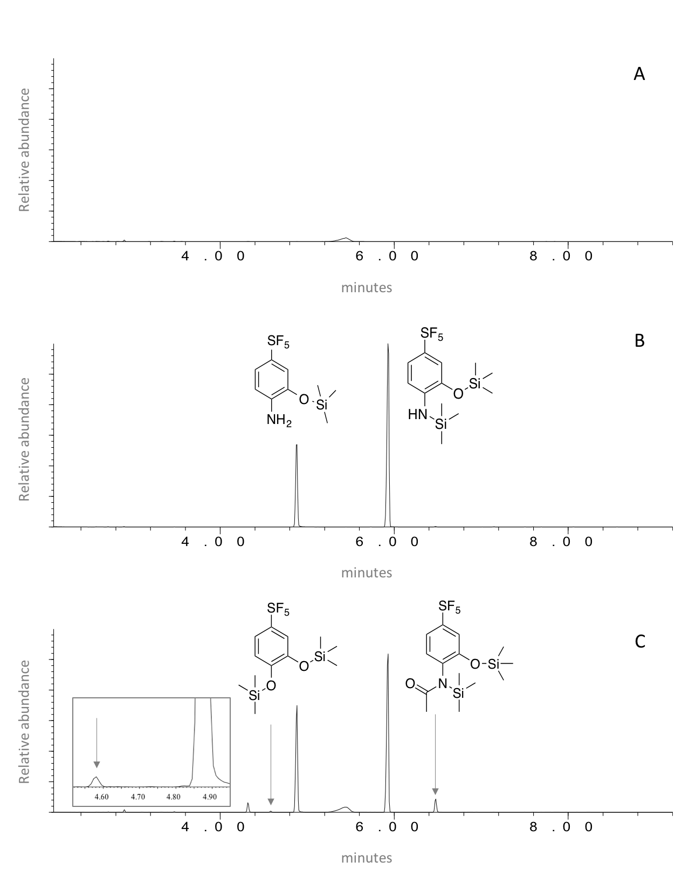
(c)
(b)
(a)
Fig. 4
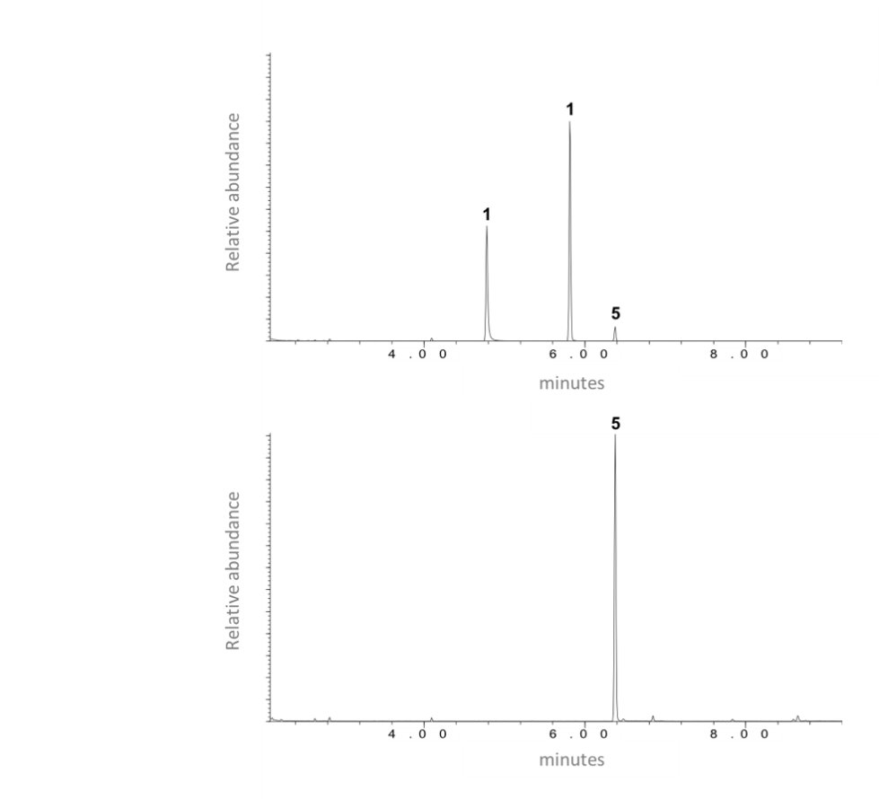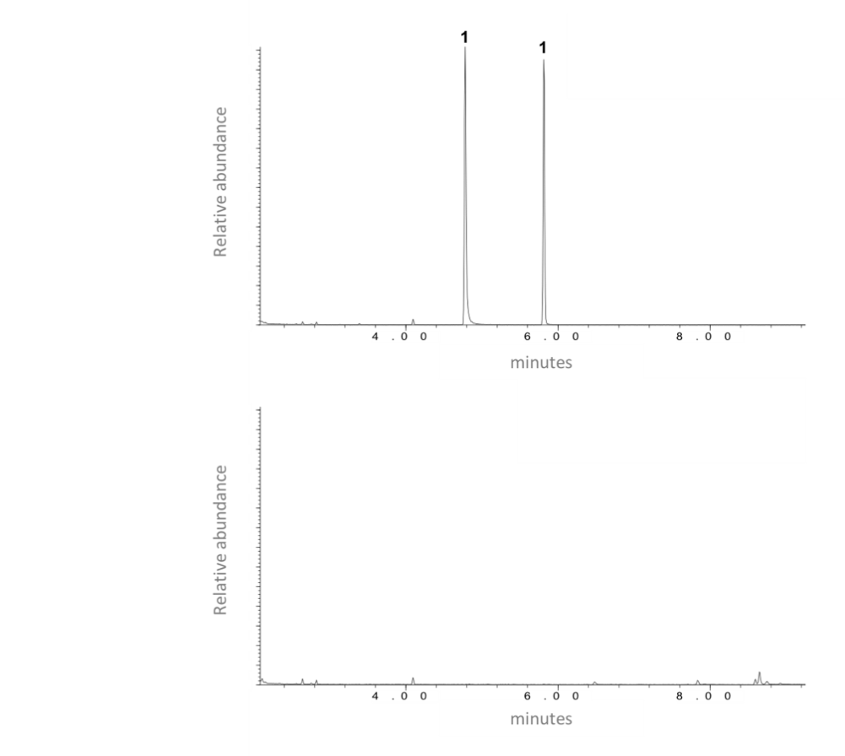
P. knackmussii B-13
P. putida
(a)
(b)
Fig. 5
Sterile control
Pseudomonas IMD 695
P. knackmussii
P. putida
P. aeruginosa
a

Fig. 6
Sterile control
Pseudomonas IMD 695
P. knackmussii
P. putida
P. aeruginosa
b

Present address: Dept of Environmental Science & Engineering, Government College University, Faisalabad, Pakistan

